

***TRUE***



***FALSE***



***TRUE***

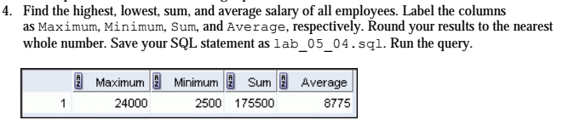

**SELECT** *round*(*MAX*(SALARY), 0) **AS** "Maximum", *ROUND*(*MIN*(SALARY), 0) **AS** "Minimum", *round*(*SUM*(SALARY),0) **AS** "Sum", *ROUND*(*AVG*(SALARY),0) **AS** "Average"

**FROM** EMPLOYEES;

**SAVE** lab_05_04.sql;

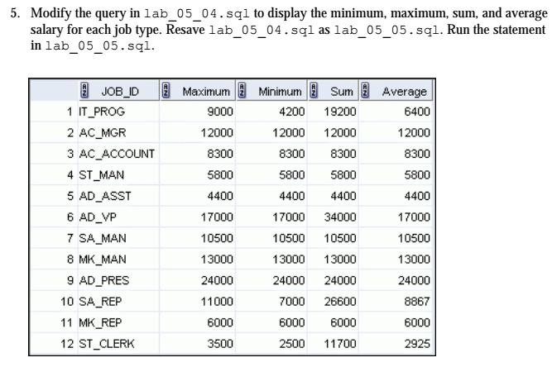

**EDIT** lab_05_04.sql;

**SELECT** JOB_ID, *round*(*MAX*(SALARY), 0) **AS** "Maximum", *ROUND*(*MIN*(SALARY), 0) **AS** "Minimum", *round*(*SUM*(SALARY),0) **AS** "Sum", *ROUND*(*AVG*(SALARY),0) **AS** "Average"

**FROM** EMPLOYEES

**GROUP BY** JOB_ID;

**SAVE** lab_05_05.sql;

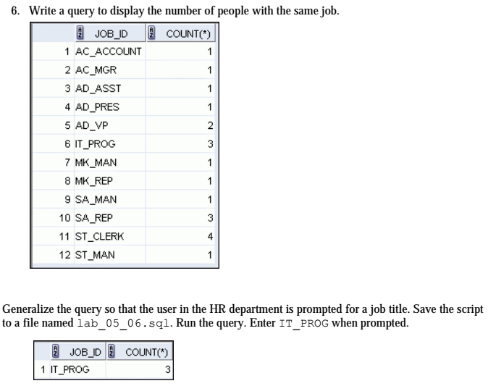

**SELECT** JOB_ID, *COUNT*(*)

**FROM** EMPLOYEESr

**WHERE** JOB_ID = &**job**

**GROUP BY** JOB_ID;

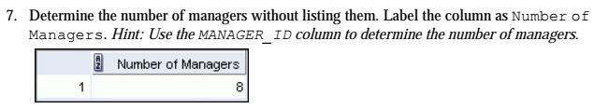

**SELECT** *COUNT*(**UNIQUE** MANAGER_ID) **AS** "Number of Managers"

**FROM** EMPLOYEES;

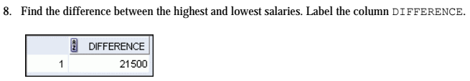

**SELECT** *MAX*(SALARY) - *MIN*(SALARY) **AS** difference

**FROM** EMPLOYEES;

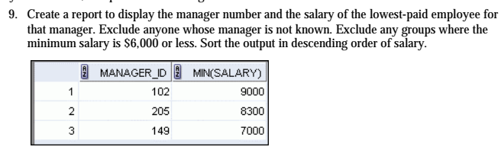

**SELECT** MANAGER_ID, *MIN*(SALARY)

**FROM** EMPLOYEES

**WHERE** MANAGER_ID **IS NOT NULL**

**GROUP BY** MANAGER_ID

**HAVING** *MIN*(SALARY) > 6000

**ORDER BY** *MIN*(SALARY) **DESC**;

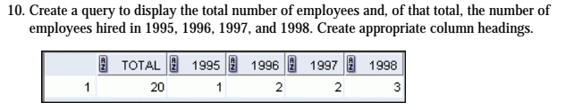

**SELECT** *COUNT*(*) totaal,

*SUM* (*DECODE* (*TO_CHAR*(hire_date,'YYYY'), 1995, 1, 0)) "1995",

*SUM* (*DECODE* (*TO_CHAR*(hire_date,'YYYY'), 1996, 1, 0)) "1996",

*SUM* (*DECODE* (*TO_CHAR*(hire_date,'YYYY'), 1997, 1, 0)) "1997",

*SUM* (*DECODE* (*TO_CHAR*(hire_date,'YYYY'), 1998, 1, 0)) "1998"

**FROM** employees;

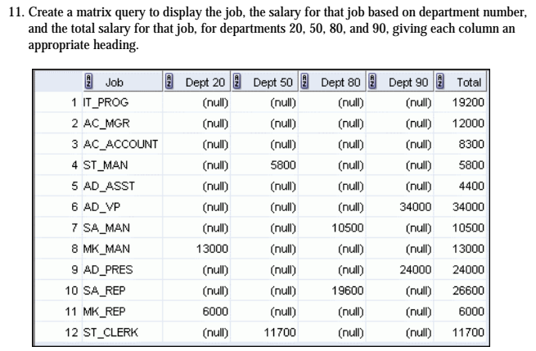

**SELECT** JOB_ID "Job",

*SUM*(*DECODE*(DEPARTMENT_ID, 20, SALARY)) "Dept 20",

*SUM* (*DECODE* (DEPARTMENT_ID, 50, SALARY)) "Dept 50",

*SUM* (*DECODE* (DEPARTMENT_ID, 80, SALARY)) "Dept 80",

*SUM* (*DECODE* (DEPARTMENT_ID, 90, SALARY)) "Dept 90",

*SUM* (SALARY) "Total"

**FROM** EMPLOYEES

**GROUP BY** JOB_ID;