editr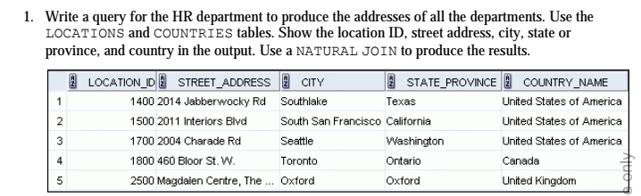

**SELECT** LOCATION_ID, STREET_ADDRESS, CITY, STATE_PROVINCE, COUNTRY_NAME

**FROM** LOCATIONS

**NATURAL JOIN** COUNTRIES;

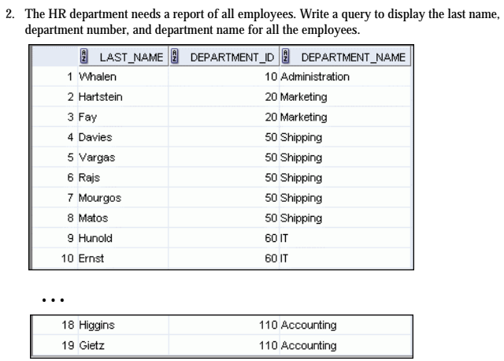

**SELECT** e.LAST_NAME, e.DEPARTMENT_ID, d.DEPARTMENT_NAME

**FROM** EMPLOYEES e **JOIN** DEPARTMENTS d

**ON** (e.DEPARTMENT_ID = d.DEPARTMENT_ID)

**ORDER BY** 2;

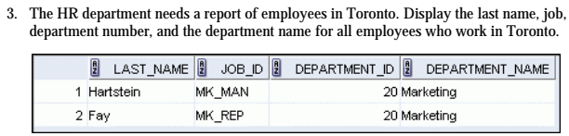

**SELECT** e.LAST_NAME, e.JOB_ID, e.DEPARTMENT_ID, d.DEPARTMENT_NAME

**FROM** EMPLOYEES e

**JOIN** DEPARTMENTS D **ON** e.DEPARTMENT_ID = D.DEPARTMENT_ID

**JOIN** LOCATIONS **l ON** D.LOCATION_ID = **l**.LOCATION_ID

**WHERE l**.CITY = 'Toronto';

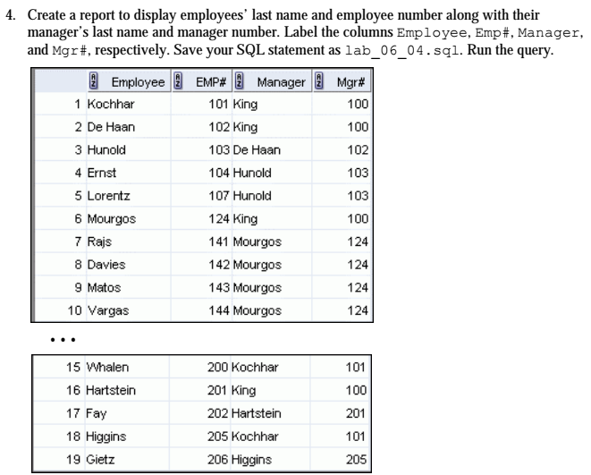

**SELECT** e.LAST_NAME **AS** "Employee", e.EMPLOYEE_ID **AS** emp#, d.LAST_NAME **AS** "Manager", d.EMPLOYEE_ID **AS** "Mgr#"

**FROM** EMPLOYEES e

**JOIN** EMPLOYEES d **ON** (e.MANAGER_ID = d.EMPLOYEE_ID)

**ORDER BY** 2;

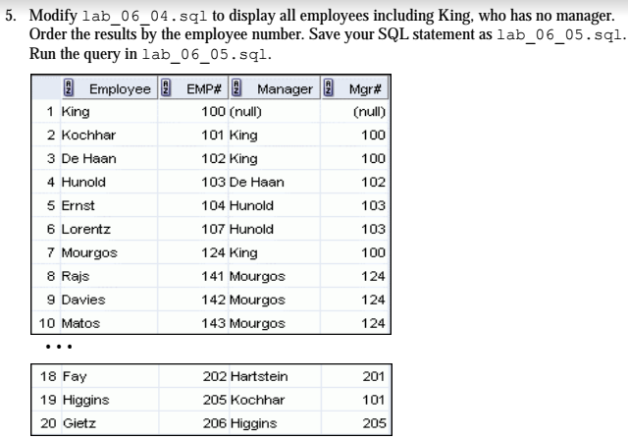

**SELECT** e.LAST_NAME **AS** "Employee", e.EMPLOYEE_ID **AS** emp#, d.LAST_NAME **AS** "Manager", d.EMPLOYEE_ID **AS** "Mgr#"

**FROM** EMPLOYEES e

**LEFT OUTER JOIN** EMPLOYEES d **ON** (e.MANAGER_ID = d.EMPLOYEE_ID)

**ORDER BY** 2;

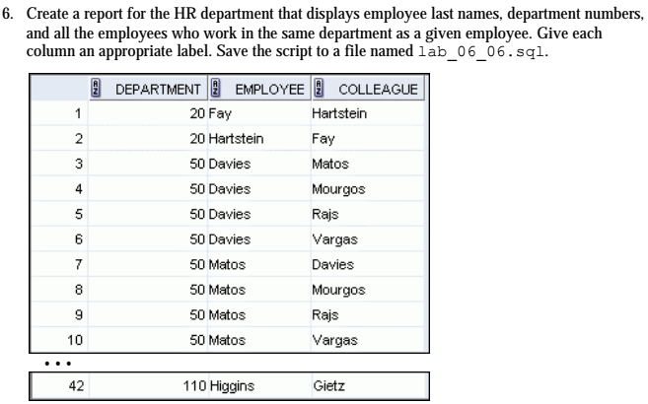

**SELECT** e.DEPARTMENT_ID **AS** department, e.LAST_NAME **AS** employee, d.LAST_NAME **AS** colleague

**FROM** EMPLOYEES e **CROSS JOIN** EMPLOYEES d

**WHERE** (e.DEPARTMENT_ID = d.DEPARTMENT_ID **AND** e.LAST_NAME != d.LAST_NAME)

**ORDER BY** 1, 2;

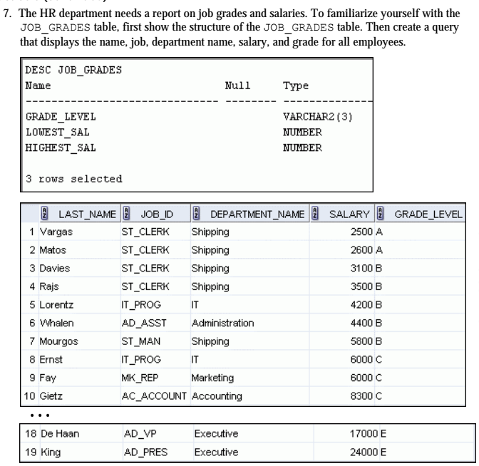

**SELECT** e.LAST_NAME, e.JOB_ID, d.DEPARTMENT_NAME, *ROUND*(e.SALARY, 0) **AS** salary, j.GRADE_LEVEL

**FROM** EMPLOYEES e

**JOIN** DEPARTMENTS D **ON** (e.DEPARTMENT_ID = D.DEPARTMENT_ID)

**JOIN** JOB_GRADES j **ON** (e.SALARY **BETWEEN** j.LOWEST_SAL **AND** j.HIGHEST_SAL)

**ORDER BY** 4;