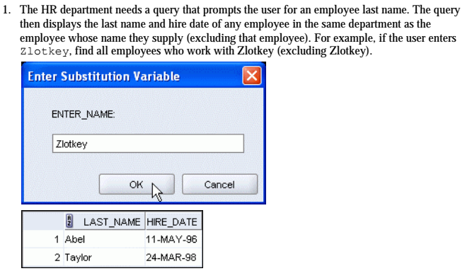

**SELECT** LAST_NAME, HIRE_DATE

**FROM** EMPLOYEES

**WHERE** (**SELECT** DEPARTMENT_ID

**FROM** EMPLOYEES

**WHERE** LAST_NAME = &&naam) = DEPARTMENT_ID

**AND** LAST_NAME != &naam;

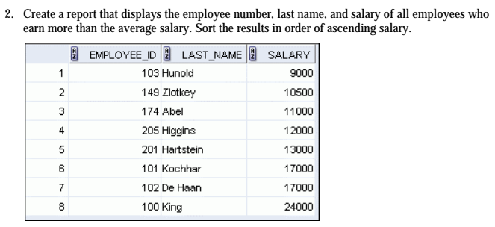

**SELECT** EMPLOYEE_ID, LAST_NAME, *ROUND*(SALARY,0) **AS** salary

**FROM** EMPLOYEES

**WHERE** SALARY > (**SELECT** *AVG*(SALARY)

**FROM** EMPLOYEES

)

**ORDER BY** 3 **ASC**;

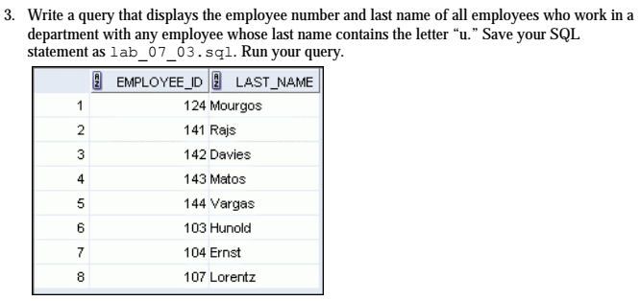

**SELECT EMPLOYEE_ID, LAST_NAME**

**FROM EMPLOYEES e**

**WHERE (SELECT *COUNT*(EMPLOYEE_ID)**

**FROM EMPLOYEES e0**

**WHERE e.DEPARTMENT_ID = e0.DEPARTMENT_ID**

**AND e0.LAST_NAME LIKE '%u%') > 0;**

**SAVE** lab_07_03.sql

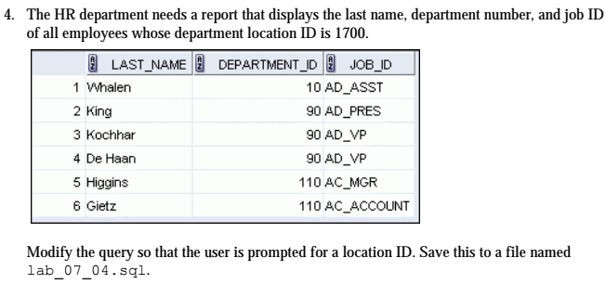

**SELECT** e.LAST_NAME, e.DEPARTMENT_ID, e.JOB_ID

**FROM** EMPLOYEES e

**WHERE** (**SELECT** d.LOCATION_ID

**FROM** DEPARTMENTS d

**WHERE** d.DEPARTMENT_ID = e.DEPARTMENT_ID) = 1700

**ORDER BY** 2, 3;

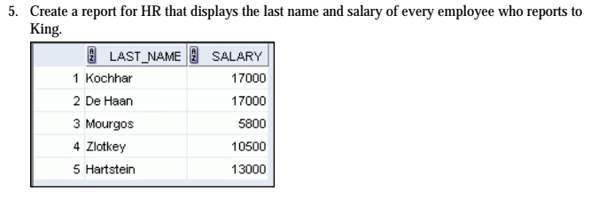

**SELECT** LAST_NAME, *ROUND*(SALARY, 0) **AS** salary

**FROM** EMPLOYEES

**WHERE** MANAGER_ID = (**SELECT** EMPLOYEE_ID

**FROM** EMPLOYEES

**WHERE** LAST_NAME = 'King');

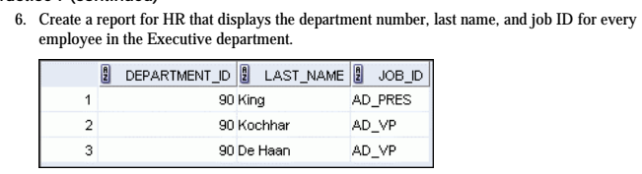

**SELECT** DEPARTMENT_ID, LAST_NAME, JOB_ID

**FROM** EMPLOYEES

**WHERE** (**SELECT** DEPARTMENT_ID

**FROM** DEPARTMENTS

**WHERE** DEPARTMENT_NAME = 'Executive') = DEPARTMENT_ID;

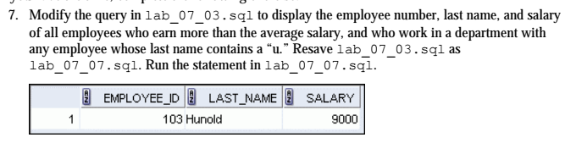

**EDIT** lab_07_03.sql

**SELECT** EMPLOYEE_ID, LAST_NAME, *ROUND*(SALARY, 0)

**FROM** EMPLOYEES e

**WHERE** SALARY > (**SELECT** *AVG*(SALARY)

**FROM** EMPLOYEES)

**AND** (**SELECT** *COUNT*(EMPLOYEE_ID)

**FROM** EMPLOYEES e0

**WHERE** e.DEPARTMENT_ID = e0.DEPARTMENT_ID

**AND** e0.LAST_NAME **LIKE** '%u%') > 0;

**SAVE** lab_07_07.sql

**START** lab_07_07.sql