Field of Valour

Gavin McGuire

Table of Contents

1. Overview
   1. Target Audience
   2. Genre
   3. Visual Style
   4. Platform
   5. Player End-Goals
2. Gameplay
   1. Difficulty
   2. Game Mechanics
      1. Squad Mechanics
      2. Match Mechanics
         1. Conquest
         2. Annihilation
         3. Sabotage
      3. Competitive Mechanics
3. Game Flow and Progression
4. Story
5. Technical
6. Overview

Field of Valour is an FPS meets RTS wargame for PC. Targeted at youth and those with a penchant for field tactics and strategy, the game format will be mildly complex. The player is a captain of an infantry squad and must team up with and face off against other players in a per match basis.

* 1. Target Audience

The target audience is teens and young adults. The PC is a popular choice for FPS games and as such seems a fitting platform for which to develop the game.

* 1. Genre

Field of Valour is a matched-based FPS with some light RTS mechanics. Players will be encouraged to practice strategy by planning out their squad formations between games. Players will also exercise tactics within each match, changing their squad’s formation in response to the enemy team’s own formations and movements.

* 1. Visual Style

The visual style of Field of Valour will be near-future sci-fi with semi-realistic models in a similar style to the movie Edge of Tomorrow.

* 1. Platform

Field of Valour is planned to be released on PC.

* 1. Player End-Goals

Each map will have objectives for the player. The more characters the Player has unlocked the more diverse their options for building their squad, formations, teams and playstyles.

1. Gameplay

Field of Valour is a hybrid FPS and RTS. The player plays as the captain of a squad and commands AI followers to advance on / hold / watch a location as well as shoot on sight / hold fire on enemy targets. Squads are broken up into four teams, two assault squads, a support squad and a recon squad. Recon specialists can reveal enemy locations and discover supply caches. Support specialists carry extra ammo, healing supplies and weapons. Assault specialists will alternate covering and advancing while advancing on a location, and gunning and reloading when holding one.

* 1. Difficulty

Field of Valour will be fairly challenging, with a wide range of mechanics to be learned upon picking up the game. Most of the in-game challenge will be provided by other players, creative and clever strategy will be heavily rewarded.

* 1. Game Mechanics

Field of Valour is a game with a variety of mechanics drawn from both FPS and RTS game styles.

* + 1. Squad Mechanics

Squad mechanics will make up a large proportion of the draw to Field of Valour. Squads will have four internal groups, two for assault, one for support and the final for recon. Formations will affect group interactions as well as the positions of the AI. Squads can be commanded to advance on, hold or watch any specified area. Squad members will be collectable and can be traded out in between matches for any other character in the player’s collection.

* + 1. Match Mechanics

There are multiple maps all with different kinds of objectives.

* + - 1. Conquest

Conquest matches will be competitions between both sides to see who can gain map dominance and hold it for the longest. Players will have to control a point of interest and as long as they are in control they will gain progress to victory continually. The first side to reach the required amount of progress to win earns victory.

* + - 1. Annihilation

In Annihilation matches both sides will compete to wipe out the competition. Support specialists can revive squad mates given enough time. The match is considered complete when all the characters on one side are dead.

* + - 1. Sabotage

Sabotage missions work as a kind of backwards capture the flag. Both sides are trying to deliver an explosive to their enemy’s base. Whichever side manages to plant their bomb and guard it until it explodes first wins.

* + 1. Competitive Mechanics

Competitive play will be ranked on a scale of ten thousand, players will gain a set value of 40 points on a win and lose 35 points on a loss.

1. Game Flow and Progression

The player experience in the main gameplay loop will have a distinct set of phases. The first phase a player will enter every match is the information gathering phase. Nothing is more dangerous in battle than faulty or insufficient information, as such; players should strive to learn everything they can about enemy movements and behaviour. The second phase will be the posturing phase, where both sides push and pull against each other in search of a weakness to exploit. The final phase in the main gameplay loop is the battle phase. The battle phase is entered whenever a squad is caught out of position or finds an advantageous area to take a fight.

1. Story

Field of Valour is based in the near future of an alternate reality in which the Feudal system continues to reign supreme. Separate factions wage religious wars of astronomical proportions, seeking to curry favour with their bloodthirsty gods.

1. Technical

Field of Valour is a match-based game with a core focus on the squad AI

* 1. User Experience Flow

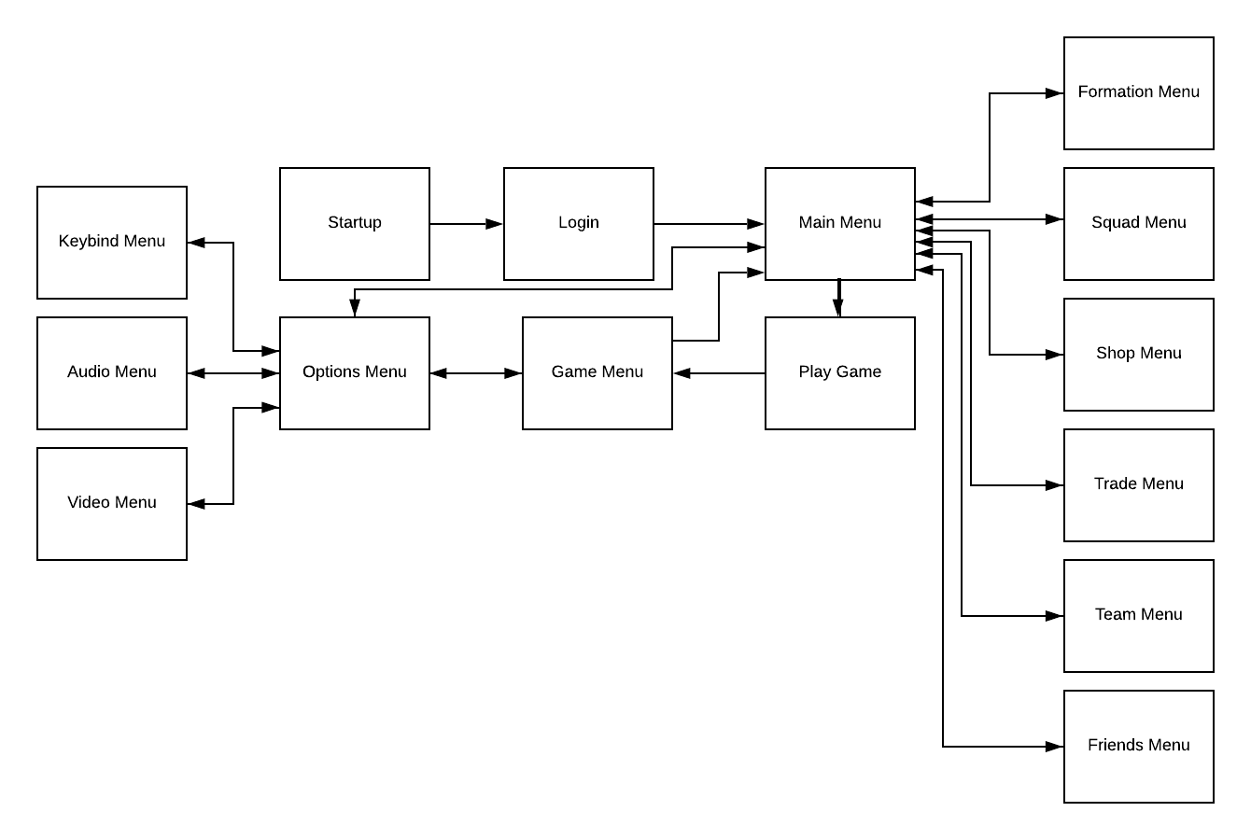

* 1. Project Architecture
  2. Market System

In-game there will be a market where the players can use both premium and non-premium currencies to purchase items. Premium currency can also be exchanged between players for rare items not available in the market.

* 1. Stats System

Every character will have different levels (ranging 1 to 30) in each of the five stats, this will allow for a variety of characters and builds with a small toolset. The stats are as follows:

* Dexterity – movement speed modifier, higher levels unlock more mobility options.
* Strength – damage output modifier, higher levels increases carrying capacity.
* Endurance – damage resistance modifier, higher levels increase armour.
* Intelligence – gear speed modifier, higher levels increase gear capacity.actly
* Perception – detection range modifier, higher levels increase weapon accuracy.

1. Art Style