Microsoft ® Visual Studio ® Extensions for the AT&T API Platform

For the AT&T Developer Program

On the AT&T API Platform

Installation, Setup, and Instruction Guide

Revision 1.0

Revision Date Sept 10, 2012

Legal Disclaimer

This document and the information contained herein (collectively, the "Information") is provided to you (both the individual receiving this document and any legal entity on behalf of which such individual is acting) ("Y ou" and "Y our") by AT&T, on behalf of itself and its affiliates ("AT& T") for informational purposes only. AT&T is providing the Information to You because AT&T believes the Information may be useful to You. The Information is provided to You solely on the basis that You will be responsible for making
Your own assessments of the Information and are advised to verify all representations, statements and information before using or relying upon any of the Information. Although AT&T has exercised reasonable care in providing the Information to You, AT&T does not warrant the accuracy of the Information and is not responsible for any damages arising from Your use of or reliance upon the Information. You further understand and agree that AT&T in no way represents, and You in no way rely on a belief, that AT&T is providing the Information in accordance with any standard or service (routine, customary or otherwise) related to the consulting,
services, hardware or software industries.

AT&T DOES NOT WARRANT THAT THE INFORMATION IS ERROR-FREE. AT&T IS PROVIDING THE INFORMATION TO YOU "AS IS" AND "WITH ALL FAULTS." AT&T DOES NOT WARRANT, BY VIRTUE OF THIS DOCUMENT, OR BY ANY COURSE OF
PERFORMANCE, COURSE OF DEALING, USAGE OF TRADE OR ANY COLLATERAL DOCUMENT HEREUNDER OR OTHERWISE, AND HEREBY EXPRESSLY DISCLAIMS, ANY REPRESENTATION OR WARRANTY OF ANY KIND WITH RESPECT TO THE INFORMATION, INCLUDING, WITHOUT LIMITATION, ANY REPRESENTATION OR WARRANTY OF DESIGN, PERFORMANCE, MERCHANTABILITY, FITNESS FOR A PARTICULAR PURPOSE OR NON-INFRINGEMENT, OR ANY REPRESENTATION OR WARRANTY THAT THE INFORMATION IS APPLICABLE TO OR INTEROPERABLE WITH ANY SYSTEM, DATA, HARDWARE OR SOFTWARE OF ANY KIND. AT&T DISCLAIMS AND IN NO EVENT SHALL BE LIABLE FOR ANY LOSSES OR DAMAGES OF ANY KIND, WHETHER DIRECT, INDIRECT, INCIDENTAL, CONSEQUENTIAL, PUNITIVE, SPECIAL OR EXEMPLARY, INCLUDING, WITHOUT LIMITATION, DAMAGES FOR LOSS OF BUSINESS PROFITS, BUSINESS INTERRUPTION, LOSS OF BUSINESS INFORMATION, LOSS OF GOODWILL, COVER, TORTIOUS CONDUCT OR OTHER PECUNIARY LOSS, ARISING OUT OF OR IN ANY WAY RELATED TO THE PROVISION, NON-PROVISION, USE OR NON-USE OF THE INFORMATION, EVEN IF AT&T HAS BEEN ADVISED OF THE POSSIBILITY OF SUCH LOSSES OR DAMAGES.

Contents

Introduction............................................. 4
Architectural Overview................................... 4
Guidelines and Notes before Installation................. 4
Installing the Visual Studio ® Extensions............... 5
Using the Components..................................... 6
The Components in More Depth............................. 8
  - SMS Sender Control..................................8
  - SMS Voting Control..................................10
  - Speech Control......................................11
  - MMS Sender Control..................................12
  - MMS Coupon Sender...................................13
Included Sample Application...............................14

Introduction

The AT&T API Platform combines the power of Microsoft .NET platform with AT&T services so that developers can quickly bring C# and Visual Basic applications to the market. The Visual Studio ® extensions go beyond that, to deliver pre-packaged controls with a Windows 8 look and feel. These controls can run on any windows environment, desktop, tablet, phone, or touch screen. These controls significantly reduce the complexity of building applications targeted to the AT&T platform services. The extensions include the following controls:

- SMS Sender Control
- SMS Voting Control
- Speech Control
- MMS Sender Control
- MMS Coupon Sender

Architectural Overview

These extensions enhance The AT&T API Platform; it now consists of five components:

- Windows Application - The final developer code, a Windows Application written in VB, C++, or C#.

- Extensions - This package. The controls listed above which can be embedded in Visual Studio Applications; these controls handle all messaging back to the SDK Wrapper Library.

- .NET Wrapper Library - The Visual Studio Extensions provide a special Wrapper, written in C# but available to any .NET runtime language. This layer provides simplifying syntax and API; it gives application developers a set of wrapper functions. This provides uniform and easy to use interfaces with which to address the AT&T REST APIs. These objects inherit from the

- AT&T API Platform - This layer consists of APIs to communicate to AT&T services via REST.

You can find more information about the SDK Wrapper library and the AT&T API Platform on the AT&T website.

Guidelines and Notes Before Installation

This package will run on Windows 8 computers running Visual Studio 2012. The controls require Visual Studio professional or an upgrade version; an internet connection is required to download the tools.
The controls are designed to use in the Microsoft Windows Store ® style applications and will not work with prior versions of the operation system or compilers.

In order to use the AT&T network, you and your organization must abide by the AT&T API agreement. A secret key and an API key are required in order to send messages. You can obtain these keys joining the AT&T developer program.

There are two types of keys: ‘Sandbox’ keys and production keys. Sandbox keys are available for free, and allow programmers to demonstrate proofs-of-concept and perform testing; production keys are designed to handle a much larger amount of traffic. You can learn more about how to obtain these keys by creating an account and signing in to http://developer.att.com.

These controls will only be capable or sending messages to phones on the AT&T network. Sending SMS, MMS, and other messages to phones outside of the network, on other carriers, is not supported.

Installing the Visual Studio ® Extensions for the AT&T API Platform

In Microsoft Visual Studio ®, select (T)ools->()Extensions and Updates. The “Extensions and Updates” Dialog will appear.
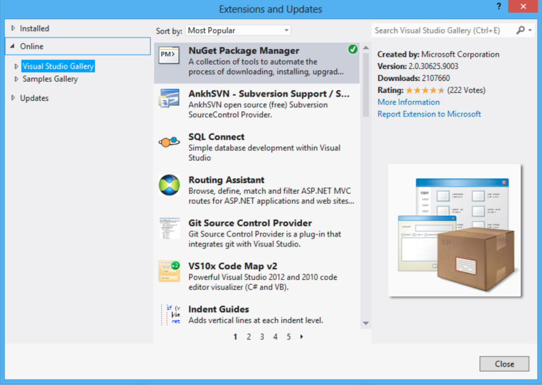

Figure 1: Microsoft Extensions and Updates

Now open Online and click “Visual Studio Gallery.” Wait a few seconds for the tool to retrieve the most popular Extensions. When the gallery is finished loaded, type “AT&T Extensions” into the search box and hit <ENTER> or Return. The Visual Studio ® Extensions for the AT&T API Platform will appear in your list of search results; click to highlight, then click Download to download and install.

When this process has completes, you have installed the components. Congratulations!

Using The Components

To use the components in an application, first create a “Windows Store” project.

(F)ile->(N)ew project, then, under Templates, select “Windows Store.”

Note: These controls are “styled” for Windows Store, and are not intended for traditional windows, WCF, Web, etc, programs.

Select an application name and path and click OK.

Now click on MainPage.xaml; you will see an empty windows store form. To the left, before the (F)ile menu, is a new, vertical toolbar - “Toolbox | Device | Document Outline | Data Store.”

Click to expand the Toolbox, the options appear, including “AT&T Control Category.” Click the triangle to expand the category, and the full list of controls appears.

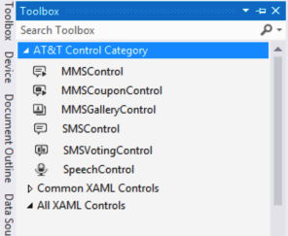
Figure 2: Toolbox with AT&T Visual Studio ® Extension Controls.

Once you see the list of controls, simply drag your preferred control onto the main page and let go; your control will appear!

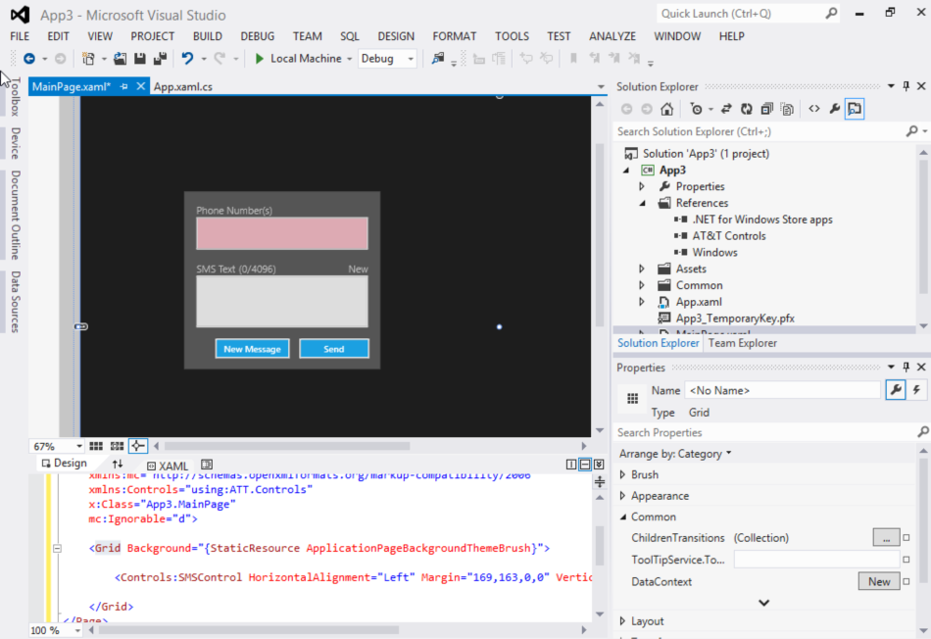
Figure 3: The SMS Control in Microsoft Visual Studio ® 2012 Professional

In order to make this a fully-functioning application, we only need to do one more thing: Provide the application with the APIKey and SecretKey to enable it to connect to to the AT&T network.

In order to do that, click on the control itself, then look at the properties pane at right, to fin the properties of the control. Scroll down to and expand “Miscellaneous.” These fields include both Secret Key and API Key. Obtain your keys and paste them in, and, if the computer running the application has an internet connection, then the application can now send messages on the AT&T Network. If your application uses many controls, you can set these values in the global ATTSetting.SecretKey and ATTSetting.APIKey.

To test the application, select (B)uild->Build Solution followed by (D)ebug->Start Debugging. It really is that easy!

The Components In More Depth

The September Release of the AT&T Extensions contains five controls - SMS Sender, SMS Voting, Speech, MMS Sender, and MMS Coupon Sender.

SMS Sender Control

The simplest of the controls, SMS sender allows a user to send a text message, up to 4096 bytes in length, to a phone or shortcode. Phone numbers should be of the form abbbccccdddd, were ‘a’ is the optional country code (1 for the United States), ‘bbb’ is the three-digit area code, ‘ccc’ is the three-digit switch, and ‘dddd’ is the four digit number.
Figure 4: The SMS Sender control

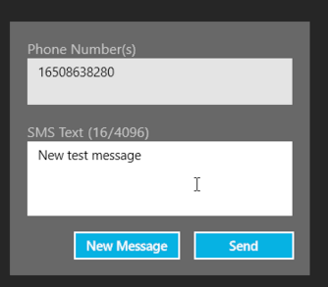
At runtime, the phone number textBox will appear red until a valid number is entered. The SMS control will accept multiple phone numbers; they can be comma or semi-colon delimited. When users click ‘send’, the input textBoxes will be disabled during transmission. After transmission, a ‘message sent’ or error message will appear.

The Maximum length of a message on the AT&T network is 4096 characters of a Sept 10th, 2012.

As with all of these controls, the end programmer must enter the secret and API keys, either on the control or in the global application ATTSetting variables.

SMS Voting

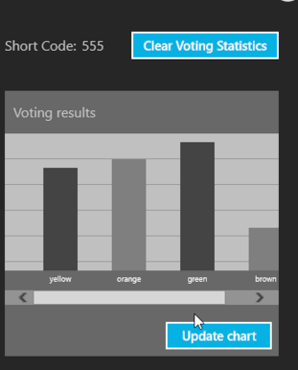
Similar to the SMS Text Control, the SMS voting control displays voting statistics as they appear on a server. In essence, this control brings the web interface in the AT&T Platform API to the desktop. Allowed actions include clear voting statistics and update chart from server. The application programmer must configure short code as a property of the control.
Figure 5: The SMS Voting Control

Speech Control

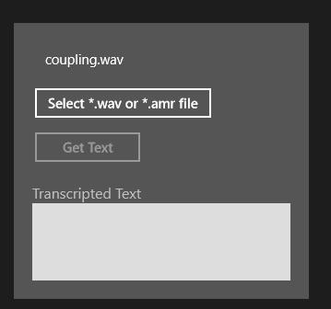
The Speech Control interacts with AT&T servers via REST API. It takes an audio file (currently, WAV and AMR types are supported), uploads that file to an AT&T server, and returns audio text.

As with all of these controls, the end programmer must enter the secret and API keys, either on the control or in the global application ATTSetting variables.

Figure 6: Speech Control

MMS Sender Control

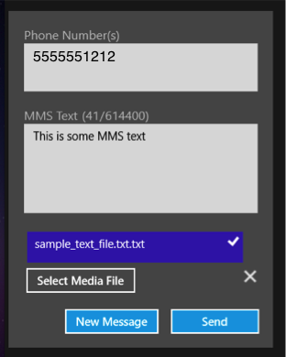
The MMS Sender Control sends a file and text message via REST API over the multi-media message standard. These messages can be up to 600KB in length.

Figure 7: MMS Sender Control (Phone number intentionally obscured)

MMS Coupon Sender

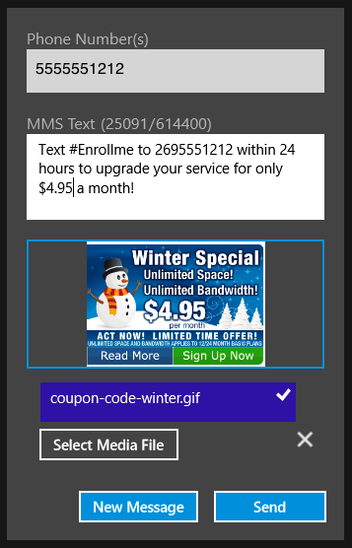
The MMS Coupon Sender is similar to the MMS Sender, but allows the user to preview the image before it is sent. Supported file types include JPEG, GIF, BMP, and PNG. More information about MMS messages is available on the AT&T Website.

Figure 8: MMS Coupon Sender Control

Included Sample Application

In addition to the controls, the Visual Studio ® Extensions for the AT&T API Platform also include a sample application to demonstrate the functionality of all of the applications. You can find it in:

C:\Program Files\Microsoft SDKs\Windows\v8.0\ExtensionSDKs\AT&T Controls\1.1\Sources\ATT.SampleApp [NOTE This May Change]
To run the application, just open ATT.SampleApp.csproj in that directory. [NOTE This May Change]
Load the application in Visual Studio and press F5 to run it; you will see a master screen that allows users to select each of the individual controls. Click on a specific control to explore the application.

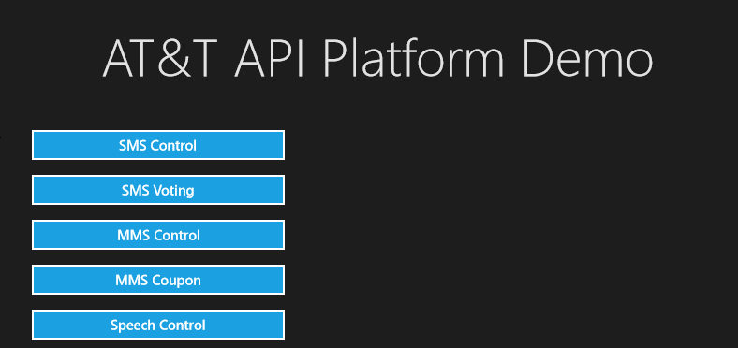

Figure 9: the AT&T API Platform Demo Home Screen

