**The impact emerging technologies will have and do have on the design and development of computer games.**

Ever since computer games had started being developed, they were always improving, from the very beginning until the very end (in which there may not be). They will never ever stop, and it’s all thanks to the technology that allow developers to create music, graphics and program the actual game.

Thanks to emerging technologies, we are now able to create music, without having to get the instruments and then learn to play them, or pay someone to play it. We can make music with only one person!

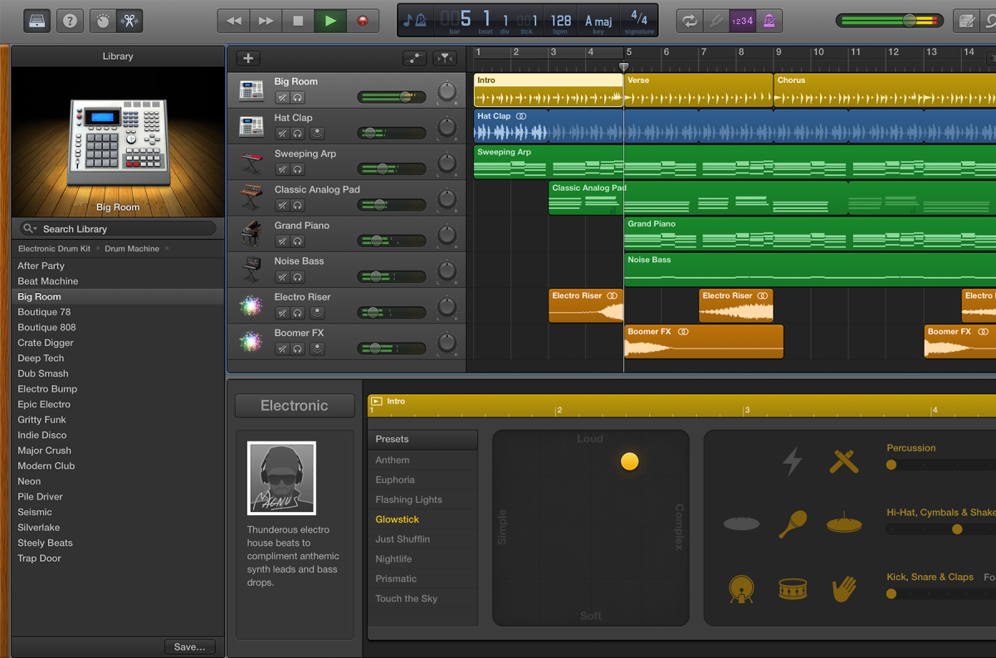

*App: Garage band – Developed by Apple – Designed for iOS & macOS*

The emerging technology and power of mobile devices and desktop PCs have become so much that they can run sophisticated programs that have instruments built in, and even track editors, saving people from so much effort, such as rehearsing the music pieces until it’s right, and the whole song doesn’t need to be played and then restarted because one person made a slight mistake; because of the music editing software that is on our emerging technologies. In fact, saving so much effort from people will also save lots of money for the developers, meaning they can invest it elsewhere, such as running servers if their game is multiplayer, or investing in a graphics designer, investing in launching their game to other platforms, or even investing it into development for a sequel to their game.

Thanks to emerging technologies, we are able to create beautifully designed graphics, and therefore be able to create beautifully designed games, because of the technology used when drawing, painting, 3D-modelling and other design features.



*Screenshot taken (in-game) and driver: Theo Miltiadou – Game: DriveClub™ - Car: BMW e92 M3 GTR*

Because of emerging technologies, we can experience beautiful features that come from games without it causing any framerate problems, although it is required for no framerate issues to occur that the system has high spec hardware, software and components; and unfortunately though, for players, this actually increases the cost of the game. For example, we know that generally games are designed for single platforms only; in this case, DriveClub*™* was designed as a PlayStation® exclusive and therefore not available on PC, Xbox, Switch and mobile devices and this is an issue that is being conquered very slowly, but there is one game that has been heard everywhere in the world, by the developer ‘Epic Games’. They have made Fortnite a cross-platform game, which was eventually allowed by all of the different platform developers (Nintendo, Apple, Sony and Microsoft). Cross platform is becoming a major feature in multiplayer games, finally, we can play with our friends from different platforms! Isn’t that what you’ve always wanted?! Well perhaps you don’t want to play with different platforms? There isn’t really anything you can do about that apart from not playing with people who have a different platform. Lots of games offer the ability to take pictures, like how consoles allow players to take screenshots, however the photo mode in games allows seemingly professional shots to be taken.

Recently, ‘Battle-Royale’ games have been flying onto the scene.



*Game: Call of Duty Black Ops 4, Blackout (game-mode).*

These multiplayer games are incredibly popular, and are raking in a lot of cash. They don’t require nearly as much work as a normal, story mode, focused game, because they needn’t as many of the voice actors, or as many programmers, graphic designers and musicians as they would for a story game, and therefore the net amount will be a much higher number than it would be otherwise. Unfortunately, there are a lot of naïve companies (EA) that believe that making a Battle-Royale game will make them lots of money, well, it needs to actually be good too. Hence, Fortnite; Battle-Royale, Fun to play, interactive and has as story to its multiplayer feature (and no, you don’t have to do anything if you don’t want to). It has a very engaging items in its store and even a special pass (that actually grants items worth lots of in-game currency [you do need to work for them though {and yes, there are other games that have this, but not anywhere near as valuable as this one}]) for people who are really intrigued into the game. This is beneficial for anyone who wants to develop a Battle-Royale game, and want to succeed, because otherwise people will just go to other games offering better content. One of the reasons that these games are incredibly popular, and probably the biggest reason as well, is definitely the cross–platforming. Play on your PlayStation®, PC or Xbox but not near them? Don’t worry, your data is available on Nintendo Switch and mobile too! By far, one of the biggest and best decisions to ever to have been made by developers, for the players.

Also thanks to emerging technologies we are able to enjoy great physics in computer games. Because of how much more powerful computers are and how much better the software is, we are able to physics created that allow our protagonists, cars, items and objects to have realistic effects and cartoon effects and therefore enjoy games as we’ve never seen them before. We see all sorts of physics in every game we play, whether they are realistic of completely unrealistic, they are everywhere, some are very likeable, and some are really not. For example, a great comparison of physics would be driving in Grand Theft auto 5, and Driving in Forza Horizon 4. Grand Theft Auto, is not a simulation game by any means, it is a role-playing game, the only physics that are similar to real life are more or less bullets, and on-foot movement, whereas Forza horizon 4 is an arcade racing game, it’s only real life similarities would be gravity. Unfortunately, what this means though for the market is that the games will require more time when in development to have the physics of everything matching the game’s rules, and therefore more monies.

Thanks to emerging technologies, we can now play our games in several different ways. The most common method used to play video games is with a TV or monitor, but we can now buy 4K resolution screens and enjoy our games enhanced on the big screens.



*4K TV Display.*

A recent way of playing, but still too expensive to really take off, is Virtual Reality, or you may know it as VR.



*PlayStation® VR headset with VR-Aim controller.*

VR is like having the screen connected to your face, but instead it allows a much bigger depth of gameplay, by placing you into the shoes of the character; it’s pretty much a whole new first-person playing perspective. It allows tonnes more interactivity because of the controller support the games have; such as, each hand, a normal gamepad, a gun and a steering wheel. Unfortunately, however, VR is incredibly expensive for the average person and therefore it cannot take off in the way that is should. Also quite recently, mobile gaming has had a major increase in how actually good it is. There are millions of games being published for mobile players, there are games from other platforms designed for mobile as well (but only some will have cross-platform). And finally, mobile devices and PCs have received a huge upgrade in remote-play, what I mean by this is that, if you wanted to play your PlayStation®, but someone else is using the TV, or you are away from it, you can now enjoy and play your games, on your mobile devices, thanks to emerging technologies advancing.

And finally, thanks to emerging technologies, we can experience great audio, and not music, because of emerging technology’s microphone intelligence and power. DriveClub, has an incredible sound experience (and if you’re someone who knows their cars, you will be pleased to know), in fact, they have the correct car sounds to match the cars that you can drive and no, it doesn’t stop there, they have included interior and exterior sounds and they have also included backfiring (exhaust pops and crackles), sounds from the tires screeching. It just goes to show the extent that emerging technology can bring to the table and that the developers really went out of their way to create a really realistic sound experience for the players. Lots of people who play video games, will generally use their TV to play video games because they aren’t as fussed about the quality of sound, but others will play their games with a headset. Some of the biggest reasons why we use headphones are that they have a microphone, or perhaps they have a good surround system and that they are generally just great sounding headphones, which is what you would need if you were going to play a game that has an extraordinary soundtrack and sound effects, and/or games that requires using a microphone to talk to other players.