Spike: 37
Title: 2D Drawing

Author: Milton Plotkin, 9525114

Goals / deliverables:
Demonstrate the use of 2D images (both whole and masked) being updated realtime with SDL.

Technologies, Tools, and Resources used:

- Visual Studio 2010
- www.lazyfoo.net

Tasks undertaken:
- First, create two images. One should be the size of your screen (800 x 600 pixels) and the other should be 3 different images (they can have unique sizes, but would be more convenient the same size arranged in a grid).
- In your programs header code, include <SDL_image.h>. See Spike 35 if the compiler cannot find the library.
- Before our loop, we need to load our images (loading them each loop would unnecessarily waste processing power and slow the game):
// Load images.
SDL_Surface* imgA = SDL_LoadBMP("image1.bmp");
SDL_Surface* imgB = SDL_LoadBMP("image2.bmp");

// Declare the location of the grid image masks.
SDL_Rect img1Source = {0, 0, imgB->w/3, imgB->h};
SDL_Rect img2Source = {imgB->w/3, 0, imgB->w/3, imgB->h};
SDL_Rect img3Source = {(imgB->w/3)*2, 0, imgB->w/3, imgB->h};

// Declare where to draw them on the screen.
SDL_Rect img1Dest = {120, 120, imgB->w/3, imgB->h};
SDL_Rect img2Dest = {450, 300, imgB->w/3, imgB->h};
SDL_Rect img3Dest = {200, 200, imgB->w/3, imgB->h};
SDL_Surface (which was also used for our screen) is now used to store the loaded bitmaps.
Afterwards, we need to set it up so only a portion of our 3-images-in-one image shows per image (a.k.a, split up its individual images). The source rectangles state the location of the mini-image on the main one. A square is created (with width = 1/3 of the 3-image image), and for each segment its top-left corner is stated. Imagine a picture frame being moved along a panorama, and whatever is inside is the image we'll use.
The dest[ination] rectangles state where these segments will appear on screen (again, with the position being the top-left corner).
- Now it's time to show the images. When drawing images to a 2D screen, it is important to remember that later drawn images will be drawn over the old ones. That is why, first, we draw the background:
(The boolean variables in the 'if' statements are used for toggling the images on and off with keypresses).
if (showBG) SDL_BlitSurface(imgA, NULL, sScreen, NULL);

// Draw unique images.
if (showImg[0]) SDL_BlitSurface(imgB, &img1Source, sScreen, &img1Dest);
if (showImg[1]) SDL_BlitSurface(imgB, &img2Source, sScreen, &img2Dest);
if (showImg[2]) SDL_BlitSurface(imgB, &img3Source, sScreen, &img3Dest);
Above, it can be seen that the background image, which does not require a mask (nor a position) is not passed any rectangles. SDL defaults its mask (picture frame) to be the size of itself (so the whole image is shown), and without a destination rectangle, its position defaults to 0,0. The three segmented images are passed their original image ('imgB'), which segments are then 'cut' out of (what actually happens is the image outside the mask isn't drawn) and drawn to the screen. This means we got 3 different images out of one file.
- Like with all allocated memory, be sure to free it when the program ends (after the loop, or when you no longer need the sprites, such as if the level changed):
if(imgA) SDL_FreeSurface(imgA);
if(imgB) SDL_FreeSurface(imgB);

What we found out:

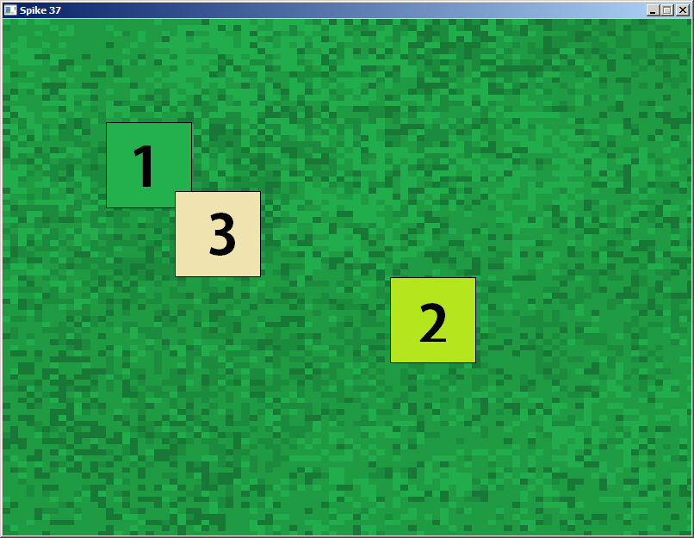
Masking images, outside from saving a lot of time (coding and processing) by not importing multiple files, has many other applications. For example, a grid based environment can have all its different sprites drawn in a grid, and then the program can draw each square individually and build multiple unique worlds from a single file. It can also be used for animation, with the source rectangles position changing (sliding along) the image as the time progresses.

