**Fatema Tuz Zohora** 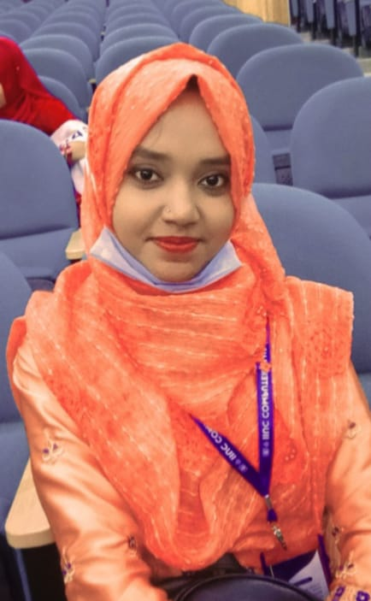

**Phone Number:** +8801843695712

**Email -ID:**  iiucmim880@gmail.com ,Halishahar ,Chittagong,Bangladesh.

* **LinkedIn:** https://www.linkedin.com/in/mim-iiuc-46a98a1b6
* **GitHub:** https://github.com/MimC193232

# Education

* **International Islamic University,Chittagong**

B.Sc. in Computer Science & Engineering October,2019 - Present(Expected Grad Year:2023) CGPA- **3.914/4.0**

* **Chittagong Mohila Polytechnic Institute(Diploma-In-Enginnering)**
* Department of Computer.
* CGPA- **3.75**
* **Academy Labratory School**
* in Science Group

GPA- 4.72

# Competitive Programming Experience

* About 300+ problem solved in different online judge.

|  |  |  |
| --- | --- | --- |
| **Online Judge** | **Profile Link** | **Number of Solved**  **Problem** |
| Codeforces OJ | https://codeforces.com/profile/MimC193232 | **190+** |
| UVA OJ | https://onlinejudge.org/index.php?option=com_comprofiler&Itemid=3 | **120**+ |
| Atcoder OJ | https://atcoder.jp/users/fatema | **100**+ |

* Participated in 35+ online contests.

**Computer Skills:**

Computer Application : M.S Office (Word, Excel, PowerPoint).

Internet Browsing : E-mail, Social networking and other information exchange activities.

Web Design : Html,Css,Java-Script,JQuery,Bootstrap.

# Academic Achievements

* Participated in Ada Lovelace National Girls Programming Contest 2021 and also selected for the national round.
* Participated in International Collegiate Programming(ICPC) Contest as team (IIUC_Swapping Idea)
* Participated in National Girls’ Programming Contest 2021.