

**[VÍDEO: Furacão Irma suga mar e praia 'seca' nas Bahamas](http://g1.globo.com/globo-news/jornal-globo-news/videos/t/videos/v/video-mostra-que-o-furacao-irma-sugou-o-mar-nas-bahamas/6138520/)**

[Mais de 1 milhão de pessoas estão sem energia elétrica nos EUA.](http://g1.globo.com/globo-news/jornal-globo-news/videos/t/videos/v/video-mostra-que-o-furacao-irma-sugou-o-mar-nas-bahamas/6138520/)

[HÁ 2 HORASGLOBONEWS – JORNAL GLOBONEWS](http://g1.globo.com/globo-news/jornal-globo-news/videos/t/videos/v/video-mostra-que-o-furacao-irma-sugou-o-mar-nas-bahamas/6138520/)

**10/09/2017 as 15:25**

**Noticia as 13:25**

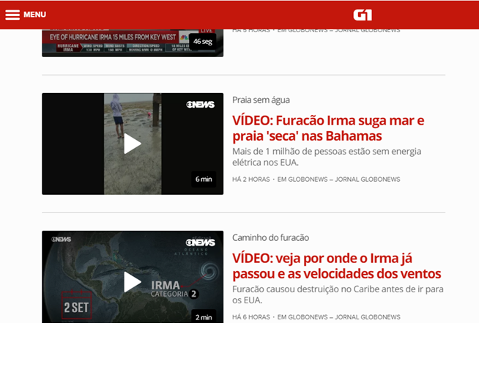

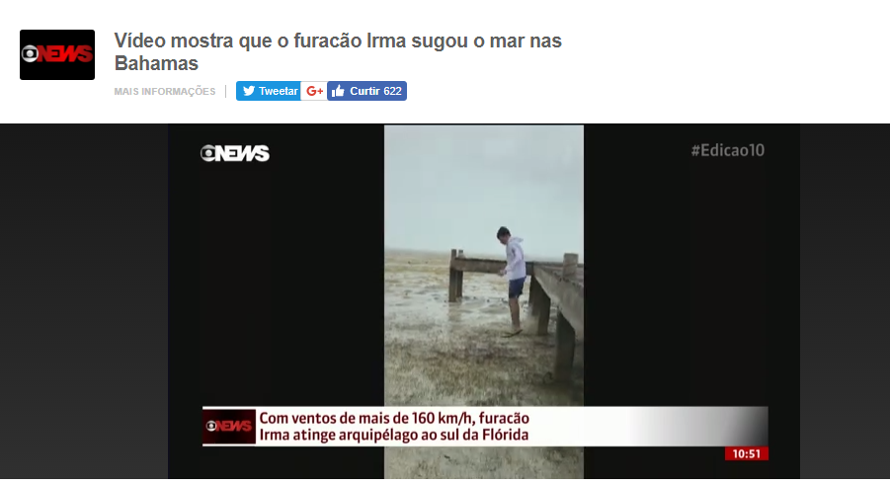



Hoje 10/09/2017 as 15:25

Noticia as 13:01

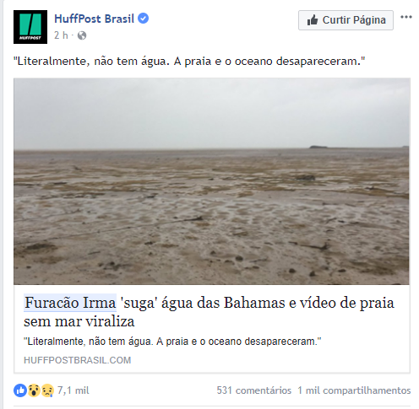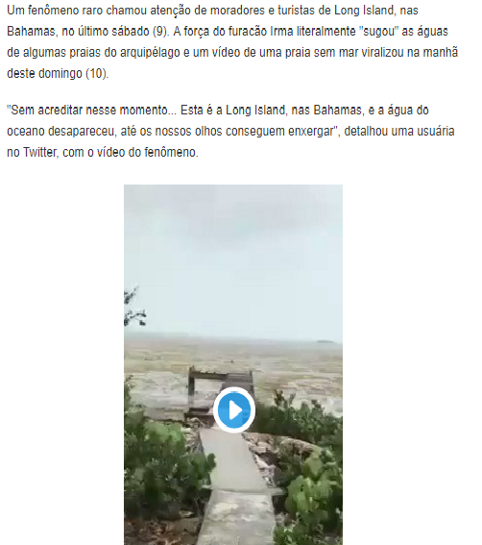



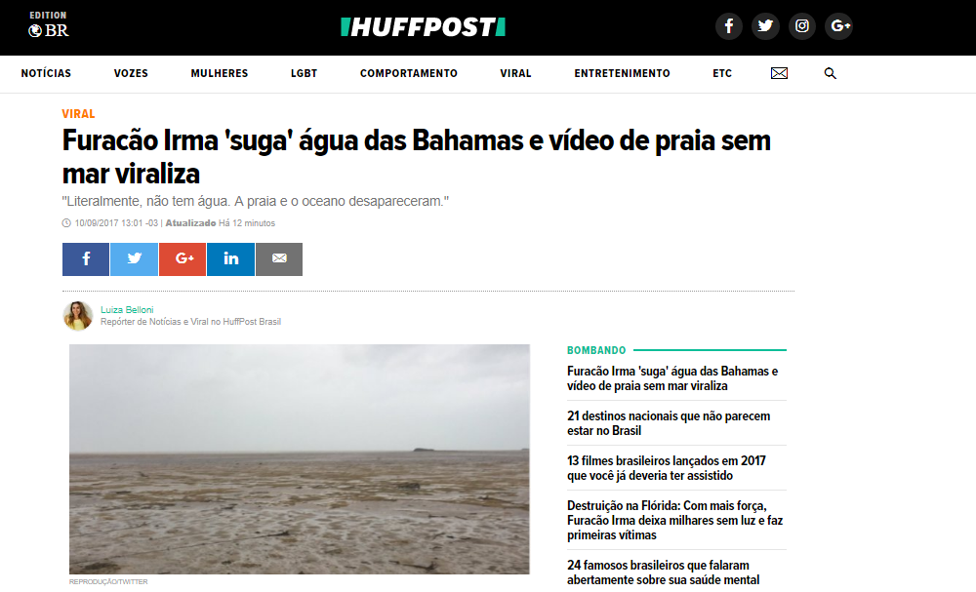



**Hoje 10/09/2017 as 15:25**

**Notícia 08/09/2017 as 22:24**

