Mimi C.S

tEMPERATURE MONITORING SYSTEM SDD

Software Design Document

High-Level Design (HLD)
Version: 1.0
Date: 14-01-2026
Prepared by: Mimi C.S

1. Purpose
The purpose of the design document is to describe how the system will be implemented to satisfy the requirements defined in the Software Requirements Specification (SRS). It translates the requirements, which state what the system must do, into a structured technical solution that explains how the system will achieve those requirements through its architecture, modules, interfaces, data flow, and error-handling mechanisms. The design document maintains clear traceability to the requirements, ensuring that every requirement is addressed by one or more design elements, that no unnecessary functionality is introduced, and that the system can be implemented, tested, and maintained in a controlled and predictable manner.

2. System Overview
Temperature monitoring system is a system which monitors the temperature variations and check if the values are beyond threshold values. This document is to define the software requirements for a Temperature Monitoring System that simulates temperature readings using a random number generator instead of a physical sensor. The system monitors temperature values and generates warnings when thresholds are crossed.

3. Software Architecture
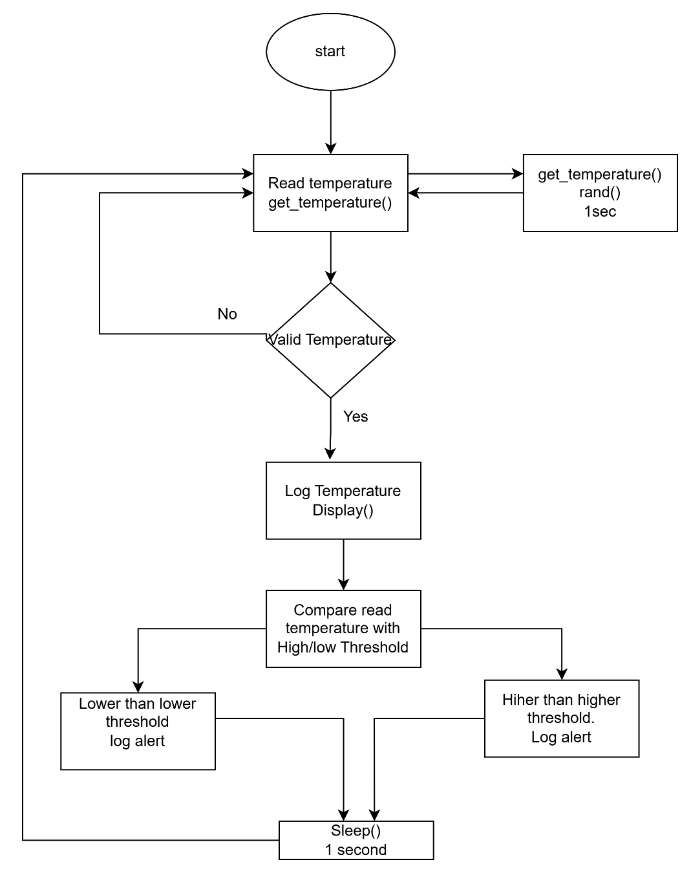

4. Module Descriptions
4.1 Main Module (main.c)
- Initialize the application
- Control execution flow
- Invoke temperature generation
- Perform threshold checks
- Display outputs and alerts
- Handle periodic execution

4.2 Temperature Sensor Module (temperature_sensor.c/.h)
- Simulate temperature values
- Abstract temperature data source
- Provide temperature readings to application layer

5. Interface Design
5.1 Internal Software Interfaces
- Interface Function
- main.c
- temperature_sensor.c
- get temperature ()
5.2 External Interfaces
- User Interface
- Console output
- OS Interface
- POSIX sleep and time functions

6. Data Flow
6.1 Data Flow Description
- Main module triggers temperature read
- Temperature module generates simulated value
- Temperature value returned to main module
- Main module evaluates thresholds
- Output and alerts printed to console
6.2 Data Flow Diagram
- Timer Trigger -> get_temperature () -> Temperature Value -> Threshold Check -> Console Output / Alerts

7. Error Handling & Fault Management
7.1 Error Sources
- Invalid simulated values
- Timing delays
- Unexpected runtime conditions

7.2 Error Handling Mechanisms
- Out-of-range temperature: ignore value: Alerts should be shown
- rand() failure: Use last valid temperature

8. Traceability
No | Requirement Description | Design file
1 | Generate simulated temperature values | temperature_sensor.c  get_temperature ()
2 | Display temperature values | Main.c  Display ()
3 | High temperature alert | main.c  High threshold check
4 | Low temperature alert | main.c  Low threshold check
5 | Periodic monitoring every 1 sec | Main.c  Sleep ()
6 | Continuous operation without crash | Entire application

Low-Level Design (LLD)

1. Purpose
The purpose of this Low-Level Design (LLD) document is to provide a detailed, function-level description of the Temperature Monitoring System based on the High-Level Design (HLD). This document defines internal functions, control logic, error handling, and timing behaviour required for implementation. The LLD ensures that the system can be coded, unit tested and verified in a consistent and traceable manner while fully satisfying the requirements defined in the SRS.

2. Functional Decomposition
2.1 Main Module (main.c)
- System initialization
- Periodic temperature monitoring loop
- Threshold comparison
- Alert generation
- Delay control
2.2 Temperature Sensor Module (temperature_sensor.c)
- Simulated temperature generation
- Temperature value validation

3. Detailed Function Descriptions
3.1 main(void)
- Controls system execution and monitoring loop.
- Initialize random number generator
- Call temperature read function
- Compare temperature against thresholds
- Log temperature and alerts
- Enforce periodic execution
Pseudocode:
initialize random seed
while (true)
{
temperature = get_temperature ()
display temperature
if (temperature > HIGH_THRESHOLD)
log high threshold violation alert
else if (temperature < LOW_THRESHOLD)
log low threshold violation alert
sleep (1 second)
}

3.2 float get_temperature(void)
Generates a simulated temperature value using a pseudo-random number generator.
random_value = rand () / RAND_MAX
temperature = MIN_TEMP + random_value * (MAX_TEMP - MIN_TEMP)
return temperature

4. Data Structures
4.1 Global / Static Constants
#define TEMP_MINIMUM -20
#define TEMP_MAXIMUM 100
#define TEMP_HIGH_THRESHOLD 70
#define TEMP_LOW_THRESHOLD -10
#define SAMPLE_INTERVAL_SEC 1

5. Error Handling
- Out-of-range temperature: ignore value: Alerts should be shown
- rand () failure: Use last valid temperature

6. Timing and Performance
- Temperature sampling interval: 1 second
- Execution mode: Blocking sleep
- CPU utilization: Minimal
- No dynamic memory allocation
- Single-threaded execution

7. Test Points
- Verify temperature generation range
- Verify high threshold alert
- Verify low threshold alert
- Verify normal temperature behavior
- Verify 1-second periodic execution
- Long-run stability test

8. Traceability
No | Requirement Description | Design file
1 | Generate simulated temperature values | temperature_sensor.c  get_temperature ()
2 | Display temperature values | Main.c  Display ()
3 | High temperature alert | main.c  High threshold check
4 | Low temperature alert | main.c  Low threshold check
5 | Periodic monitoring every 1 sec | Main.c  Sleep ()
6 | Continuous operation without crash | Entire application

