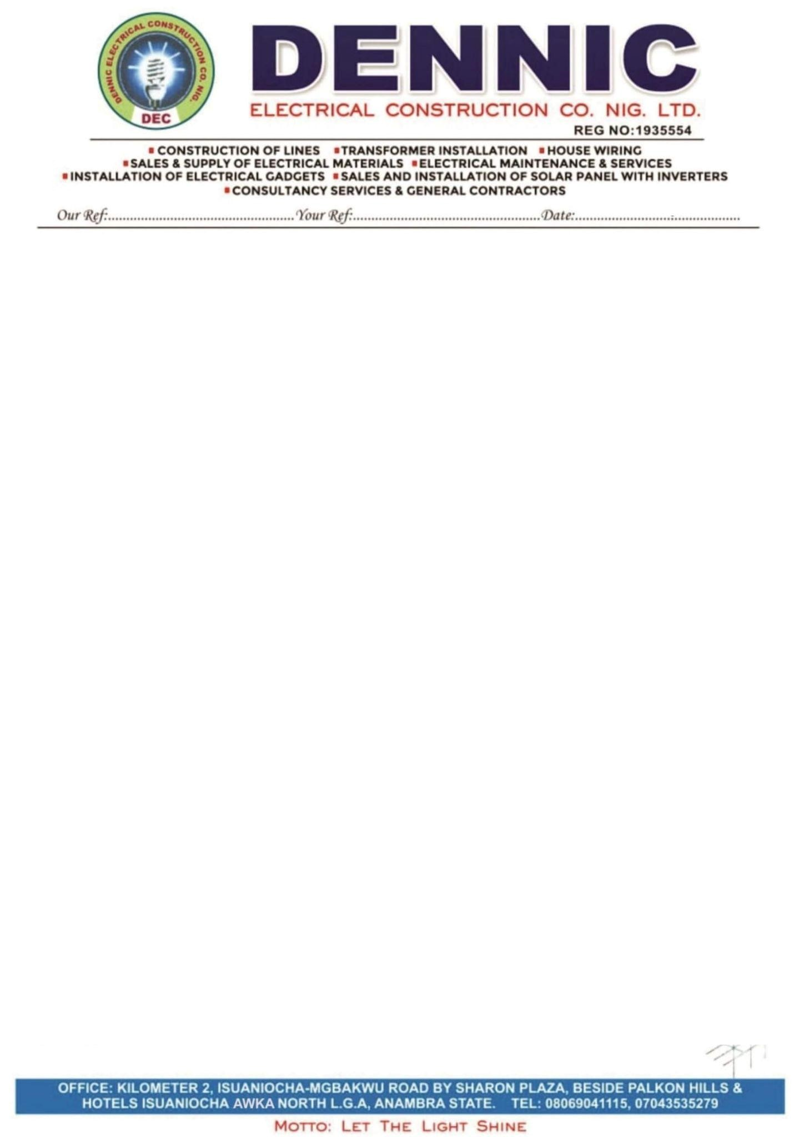

29/07/2025

**REHABILITATION OF 15 MVA, 33/11KV INJECTION STATION AT UPTH**

1. 33KV OVERHEAD LINE RECONSTRUCTION N2,380,000
2. SWITCH YARD RECONSTRUCTION N6,000,000
3. EARTH PROTECTIVE SYSTEM N3,000,000
4. TRANSFORMER DRYING AND OIL FILTRATION N6,360,000

**TOTAL N17, 740,000**

Kindly make payment through our account below;

Acc. No.: 1026319868

Acc. Name: Denmic Electrical Construction Nig. LTD.

Bank: UBA



_______________________________

Dan. Ntukokwu Managing Director



1. **OVERHEAD MATERIALS**

|  |  |  |  |  |  |
| --- | --- | --- | --- | --- | --- |
| S/ N | DESCRIPTION | QT  Y | UNI  T | RATE | AMOUNT |
| 1 | 40Feet Reinforced Concrete Poles | 3 | Nos | 260,000 | 780,000 |
| 2 | 33 Feet Reinforced Concrete Poles  (for overhead protection) | 3 | Nos | 150,000 | 450,000 |
| 3 | Silicon Disc Insulator 33 KVA | 6 | Nos |  |  |
| 4 | Socket Adopter | 6 | Nos |  |  |
| 5 | 6 Bolt Clamp Big Size | 6 | Nos |  |  |
| 6 | 33 KVA Gang Isolator | 1 | Set |  |  |
| 7 | D-Fuse 33KVA | 1 | Set |  |  |
| 8 | Lighting Arrester | 1 | Set |  |  |
|  | Labour |  |  |  | 1,000,000 |
|  |  |  |  | **TOTAL** | 4,380,000 |

1. **SWITCH YARD/SUBSTATION MATERIALS.**

|  |  |  |  |  |  |
| --- | --- | --- | --- | --- | --- |
| S/N | DESCRIPTION | QTY | UNIT | RATE | AMOUNT |
| 1 | Gang Isolator | 2 | Sets |  |  |
| 2 | D-Fuse 33KV | 3 | Set |  |  |
| 3 | Lighting Arrester Silicon | 3 | Set |  |  |
| 4 | Pot Insulator 33kv | 15 | Nos |  |  |
| 5 | Voltage Transformer | 1 | Set |  |  |
| 6 | Current Transformer(Control Breaker) | 1 | Set |  |  |
| 7 | 150mm Aluminum Bare Conductor  ACSR | 150 | M |  |  |
| 8 | Bi-metallic line Tap Copper/Aluminum | 18 | Nos |  |  |
| 9 | XLPE Cable High Voltage 33kv 150mm² Single Core | 45 | M |  |  |
| 10 | Raychem Kit 150mm² 33kv | 2 | Sets |  |  |
| 11 | XLPE Cable 11kv 240mm² Single Core | 210 | M |  |  |
| 12 | Raychem Kit 185/240mm² 11kv | 2 | Sets |  |  |
| 13 | Cable Lugs 240mm² | 15 | Nos |  |  |
| 14 | Scotch Tape | 10 | Nos |  |  |
| 15 | Lassovic Tape PVC | 3 | Rolls |  |  |
| 16 | Cable Lugs 150mm | 140 | Nos |  |  |
| 17 | Angle Boot | 2 | Sets |  |  |
| 18 | Stirrup Insulation For Gang Handle | 3 | Sets |  |  |
| 19 | Bolt and Nuts(21,4,6) | 20 | Pcs |  |  |
| 20 | Installation |  |  | 6,000,000 | 6,000,000 |

**c. EARTHING PROTECTION SYSTEM MATERIALS.**

|  |  |  |  |  |  |
| --- | --- | --- | --- | --- | --- |
| S/N | DESCRIPTION | QTY | UNIT | RATE | AMOUNT |
| 1 | Copper Wire 70mm | 250 | M |  |  |
| 2 | Earth Rod Original Heavy-duty Galvanized | 60 | Nos |  |  |
| 3 | Galvanize Pipe (Fuse) | 8 | Nos |  |  |
| 4 | Charcoal | 12 | Bags |  |  |
| 5 | Earth Clamp | 8 | Nos |  |  |
| 6 | 35mm Copper Wire Overhead  Protection On The Switch | 150 | M |  |  |
| 7 | 25mm Twain Wire | 1 | Roll |  |  |
| 8 | Stir up Slap | 6 | Sets |  |  |
| 9 | Excavation and backfill Of Earth Pit | 6 | Poles | 100,000 | 600,000 |
| 10 | Greasing Of Earth Points | 3 | Tins |  |  |
|  | Labour |  |  |  | 3,000,000 |
|  |  |  |  | **TOTAL** | 3,600,000 |

1. **TRANSFORMER DRYING/OIL FILTRATION.**

|  |  |  |  |  |  |
| --- | --- | --- | --- | --- | --- |
| S/N | DESCRIPTION | QTY | UNIT | RATE | AMOUNT |
| 1 | Hiring of a 20-ton crane to Open the  Transformer Coil And tanking of the  Transformer oil | 2 | Days | 500,000 | 1,000,000 |
| 2 | Drying Of The Coil | 3 | Days | 500,000 | 1,500,000 |
| 3 | Insulation Materials | 8 | Nos | 20,000 | 160,000 |
| 4 | Gasket | 4 | Nos | 50,000 | 200,000 |
| 5 | Filtration Of The Transformer oil | 2 | Days | 350,000 | 700,000 |
| 6 | Topping of Transformer Oil | 2 | Drum  s | 650,000 | 1,300,000 |
|  | Labour |  |  |  | 1,500,000 |
|  |  |  |  | **TOTAL** | 6,360,000 |



_______________________________

Dan. Ntukokwu Managing Director