Public GIT (Github/Bitbucket/Gitlab) url:

<https://github.com/Mimiiiii017/Multimedia_CatRPG_Database>

Public API (Vercel or otherwise) url:

<https://multimedia-cat-rpg-database.vercel.app>

Task 1 Screenshot of your development environment setup: 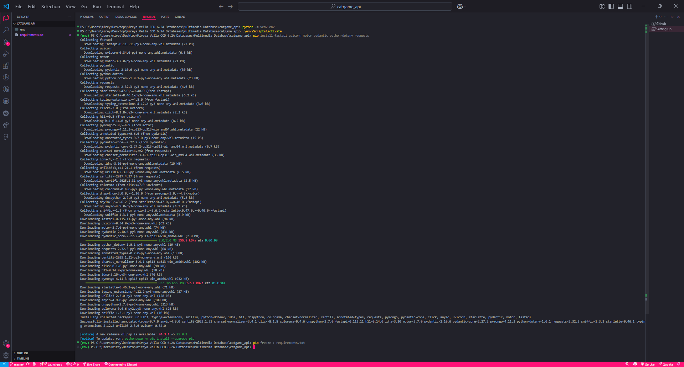

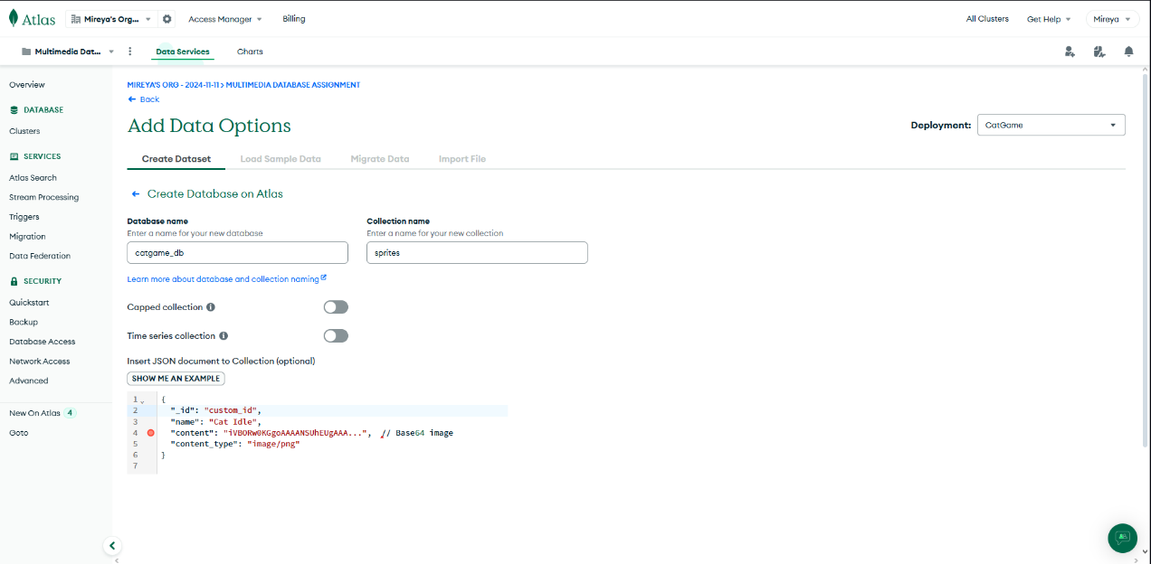

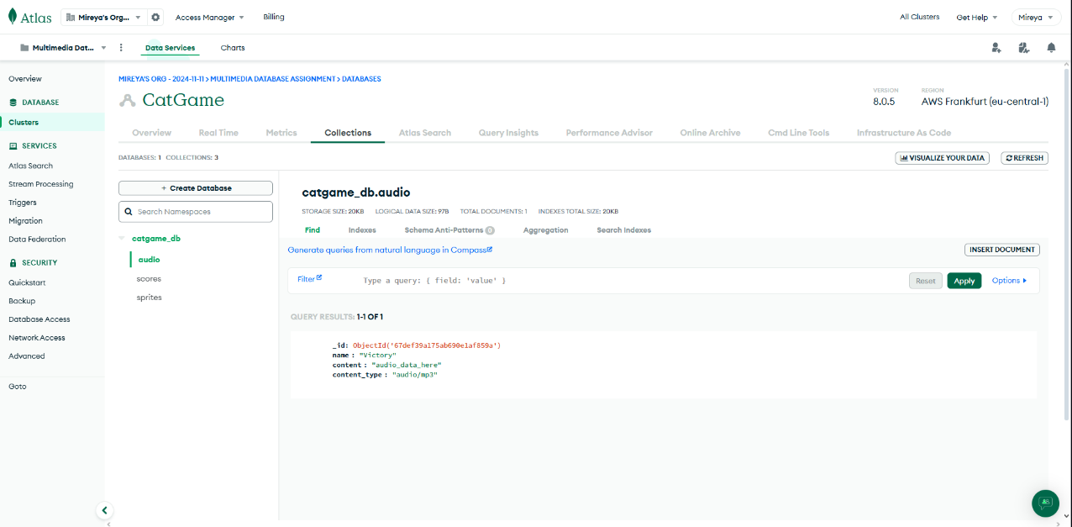

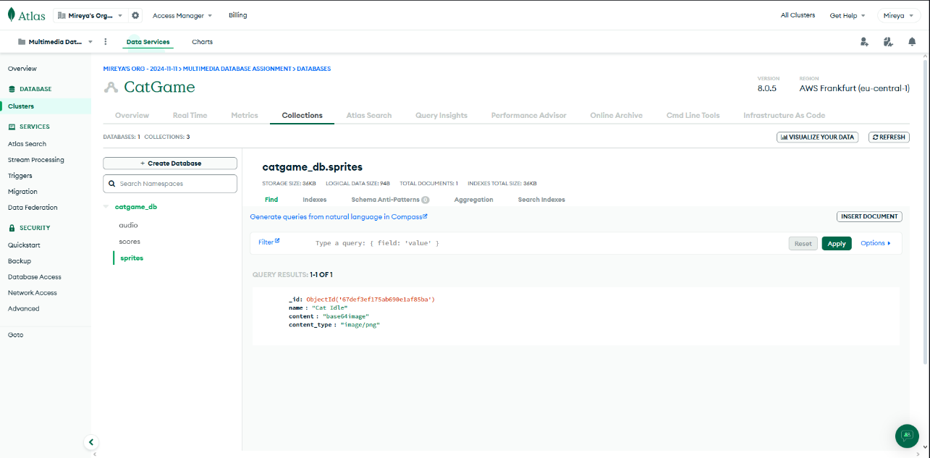

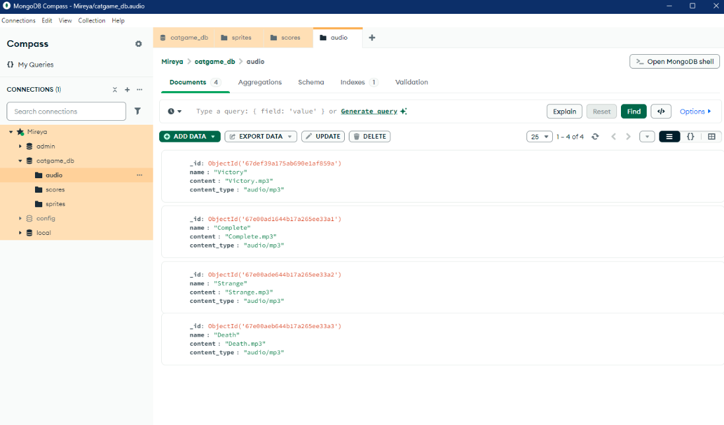

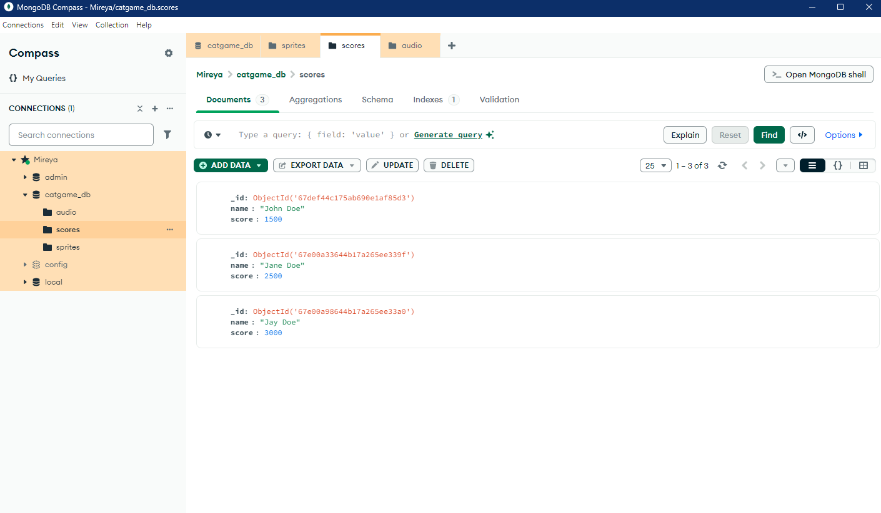

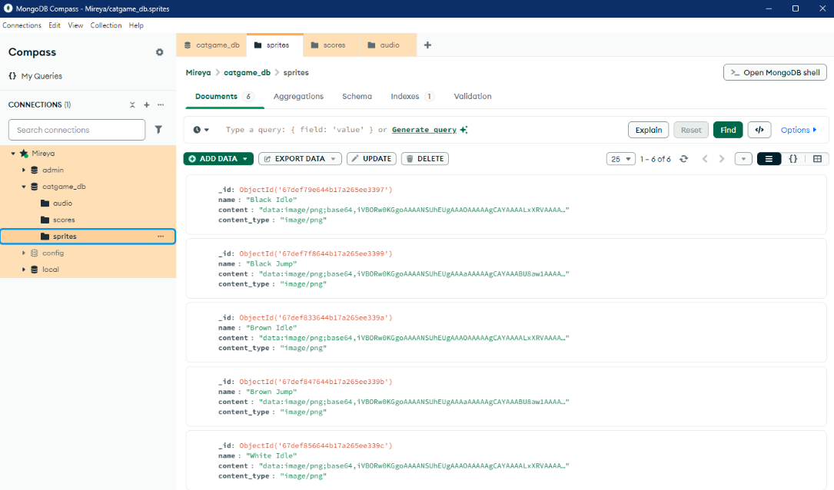

Task 3A: Screenshot of the API running on localhost in your browser:

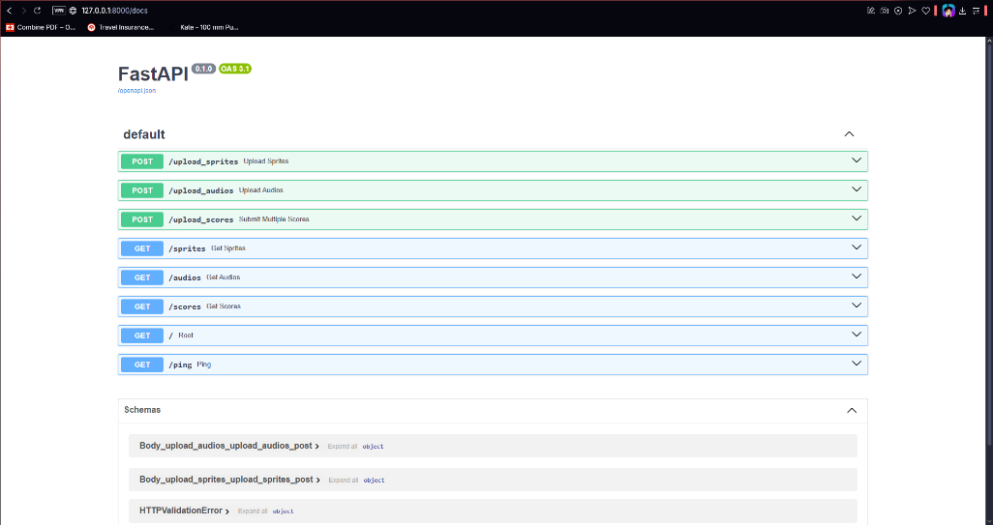

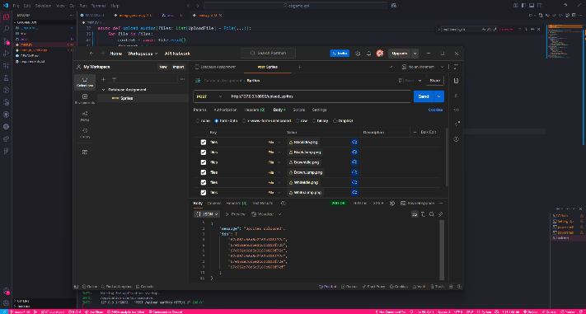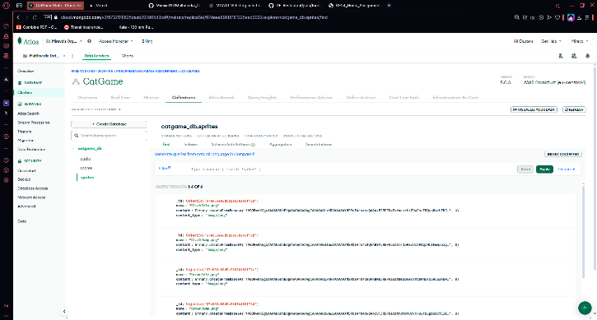

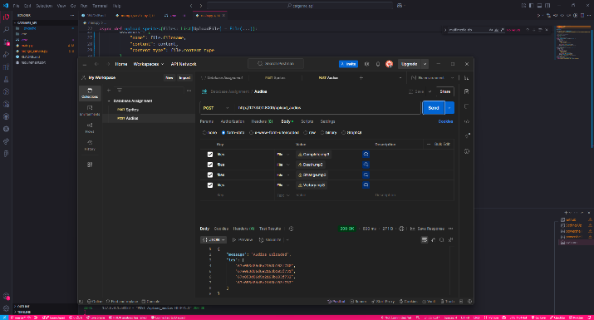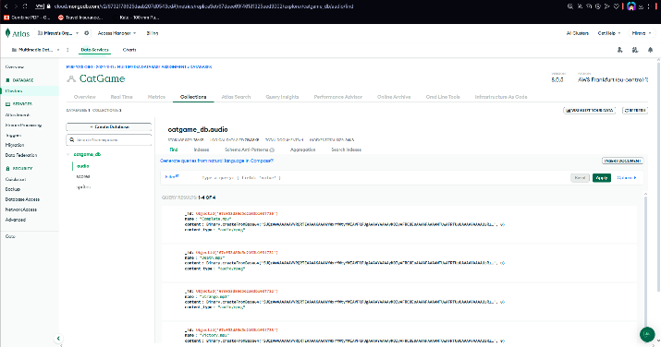

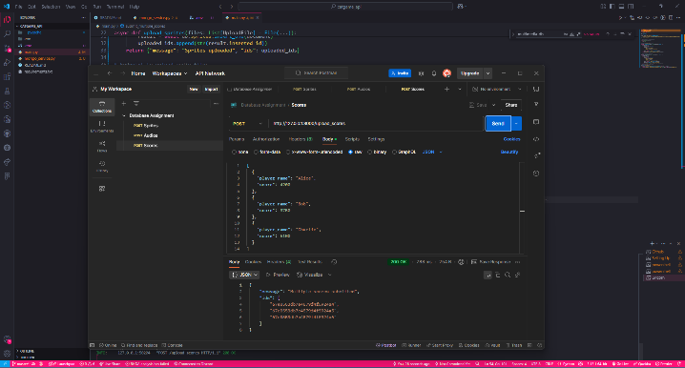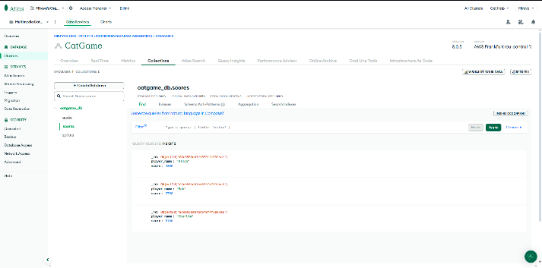

Task 3B: Screenshot of the hosted API running on a public url such as Vercel:

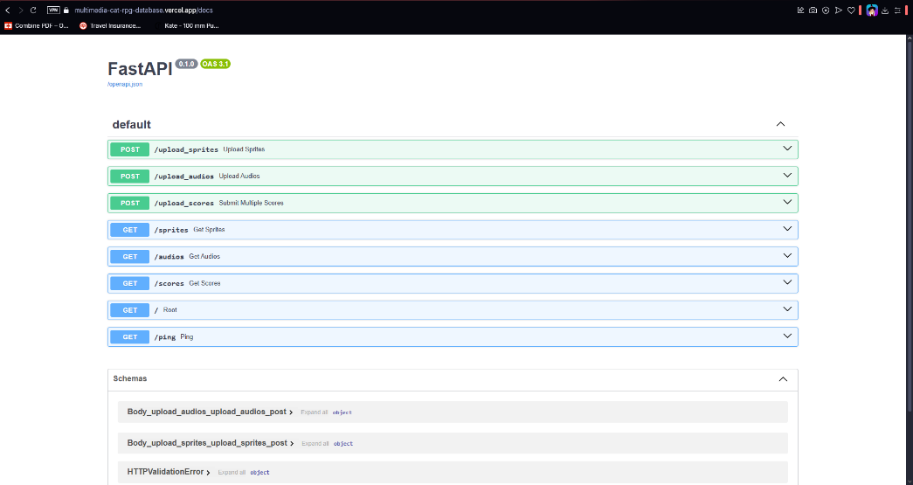

POST

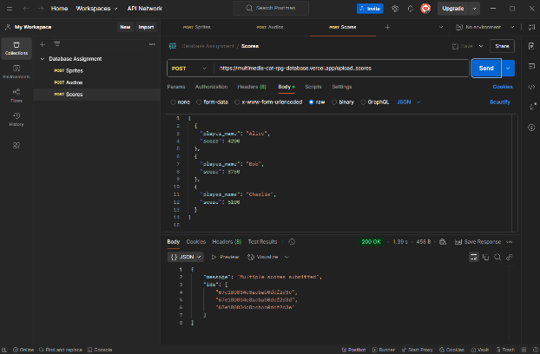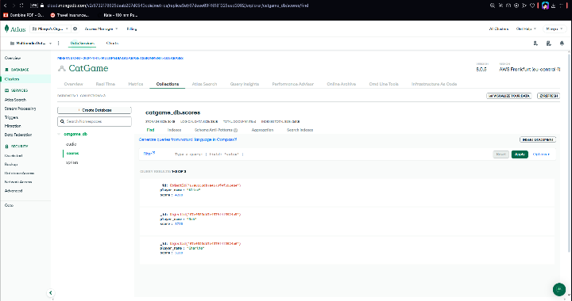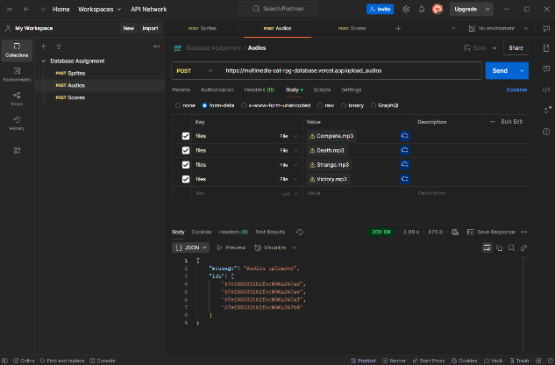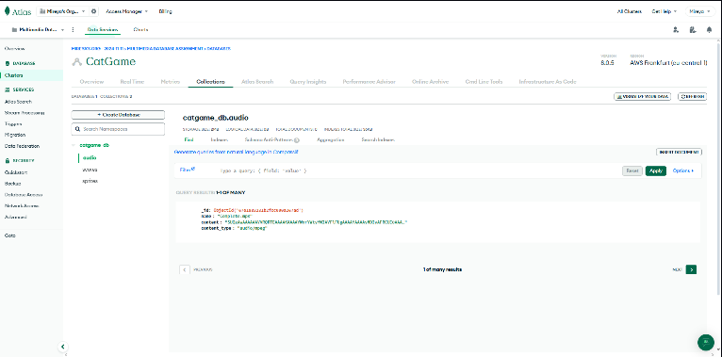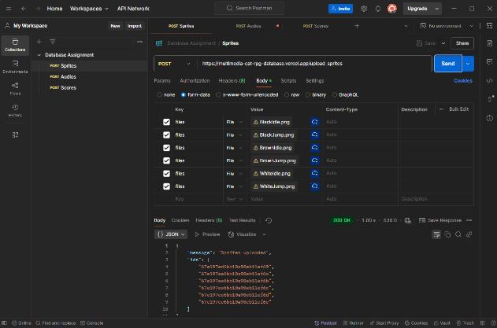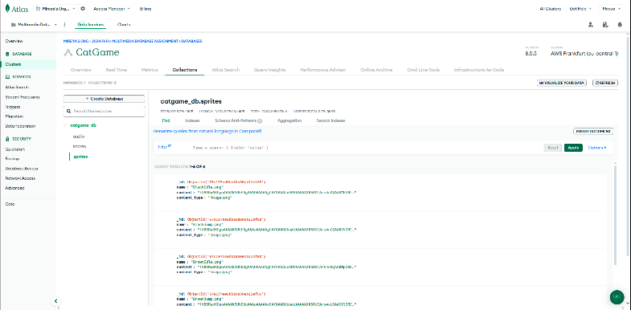

GET

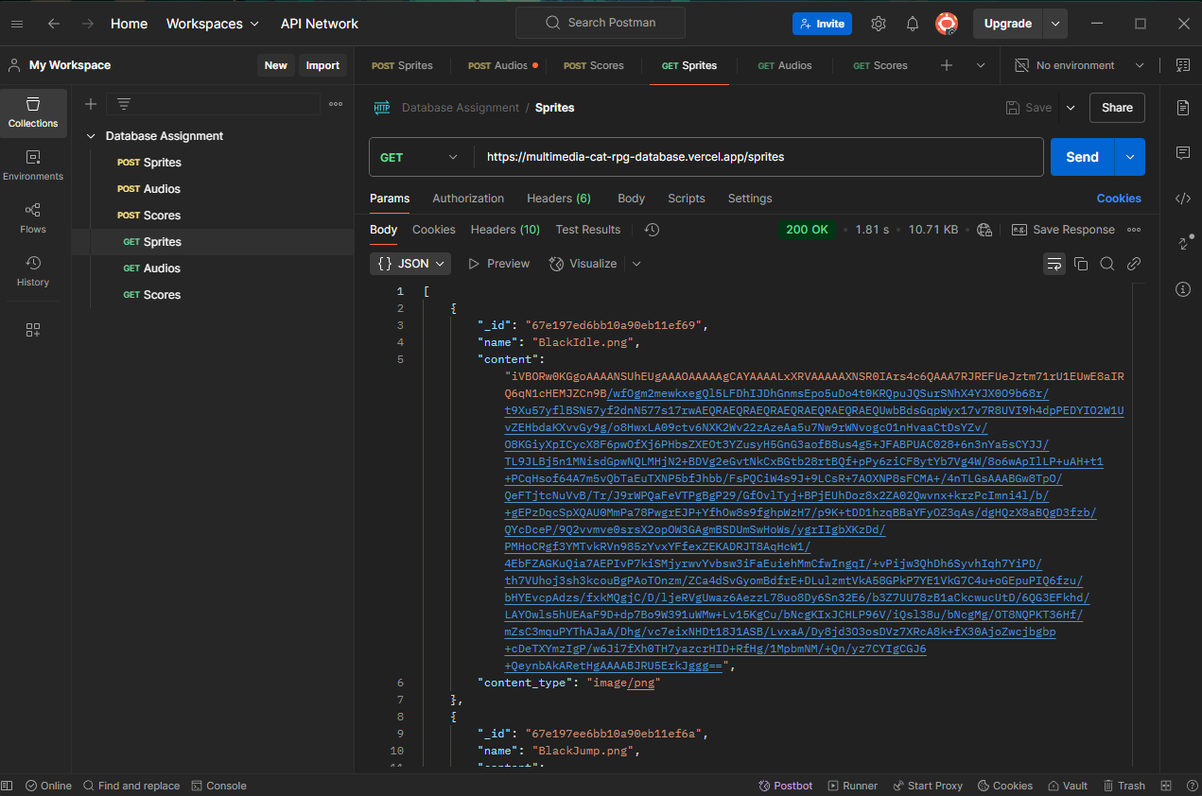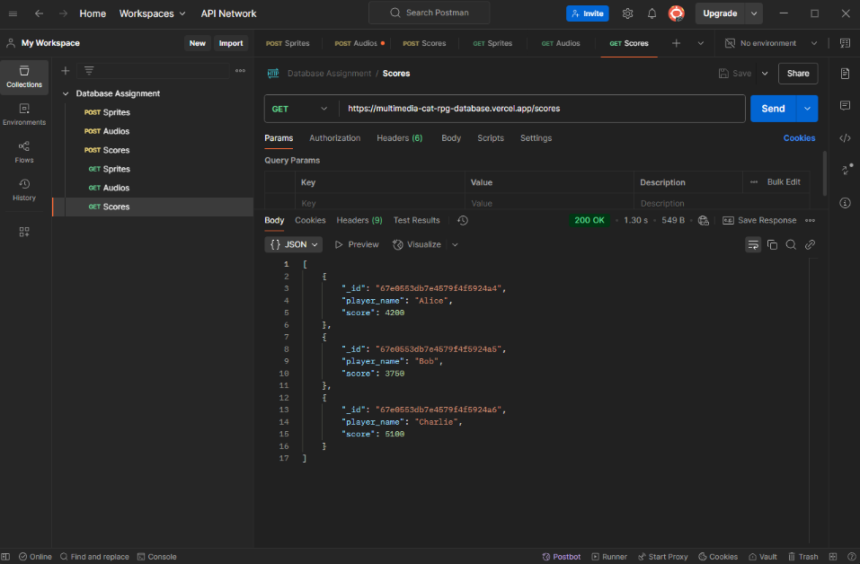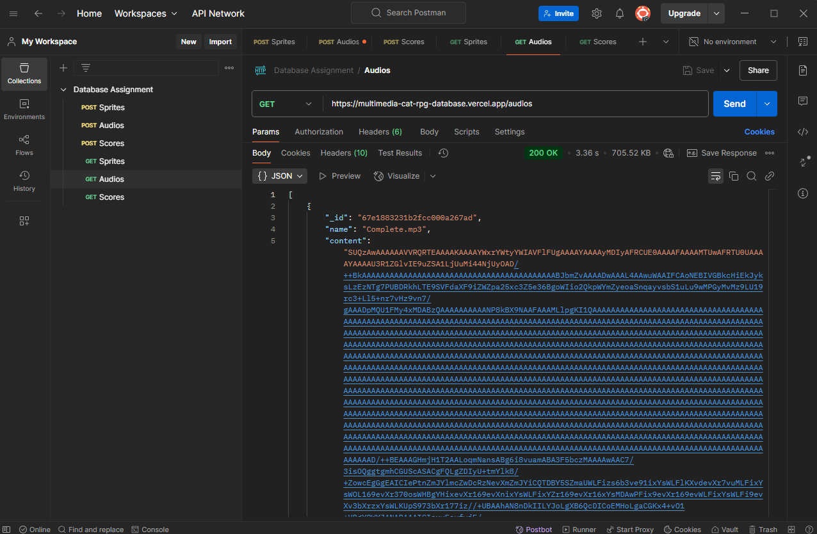

Task 4A: Screenshot showing credential setup.

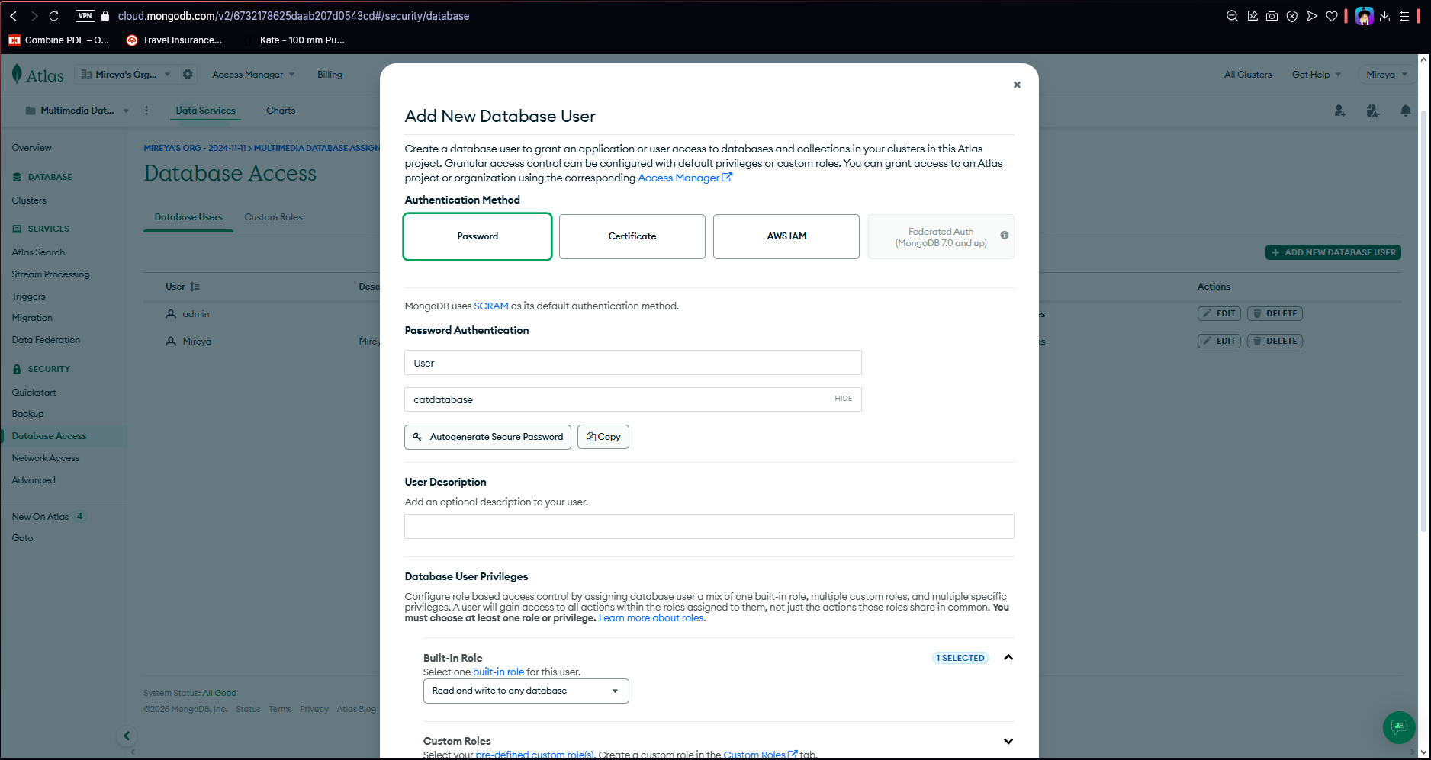

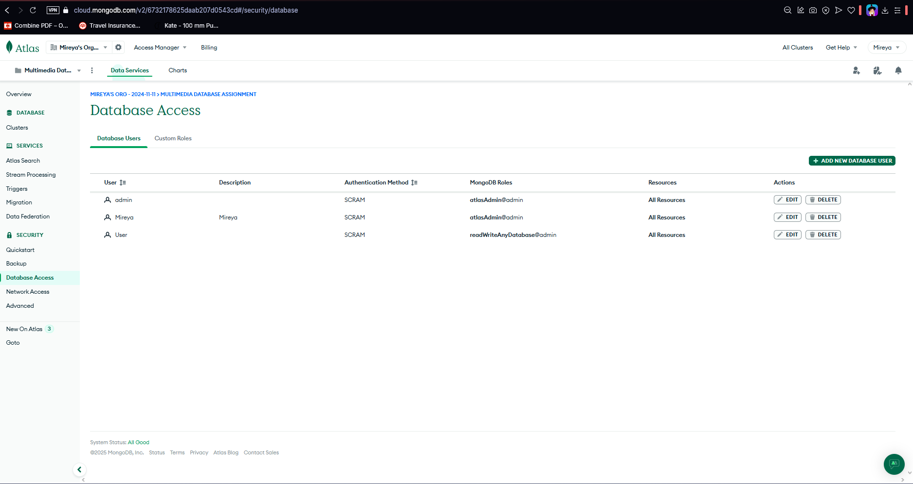

Task 4B: Screenshot showing IP whitelisting.

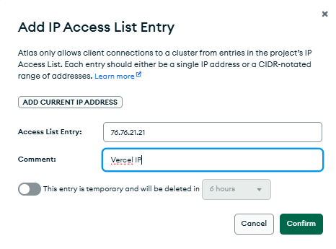

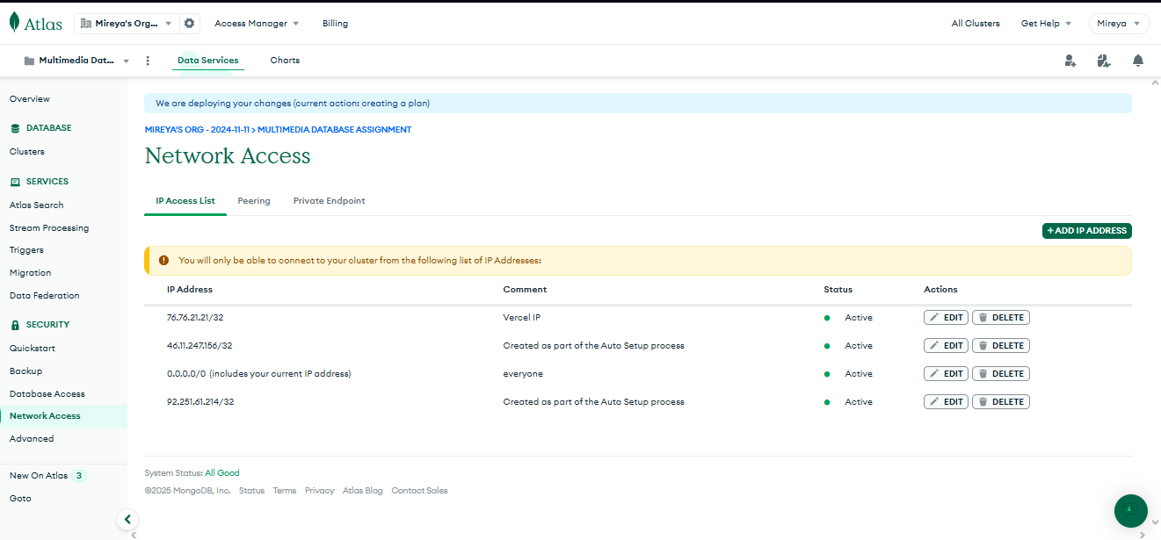

#

Task 4C: Screenshot showing how you are preventing SQL injection

