Vulnerability Management Sprint: Remediation Report
Name: Miracle Chimamanda Ndubuisi
Program: SOC Analyst Training Program
Project: Vulnerability Management Sprint (Standalone One-Week Project)
Date: 17 September 2026
Tools: Wazuh 4.14.6 Vulnerability Detection, CISA KEV, NVD

1. Summary
Wazuh's built-in Vulnerability Detection module was enabled against the two lab endpoints from Project 1 and produced 6,420 findings across 3,218 unique CVEs. After cross-referencing every CVE against the CISA Known Exploited Vulnerabilities catalog and weighting by asset criticality, the estate reduced to one P1, eight P2 and one P3 item. Four remediations were carried out and verified by re-scan, cutting total findings by 50% (6,420 to 3,182) and resolving 100% of P1 and all actionable P2 items. The remaining 3,182 findings sit in the running Ubuntu kernel, for which no patch is currently available, and are recorded as accepted risk with monitoring.

2. Detection setup
Wazuh 4.14.6 ships with the Vulnerability Detection module enabled by default (enabled: yes, index-status: yes, feed-update-interval: 60m) using the Wazuh CTI feed; this was verified rather than configured. Syscollector on both agents was confirmed to collect package inventory (and hotfixes on Windows, which was added explicitly). Both agents reported Active and the scanner module started cleanly after a manager restart.

3. What was found
Endpoint | Criticality | Total | Critical | High | Medium | Low | Unscored | In CISA KEV
linux-endpoint (Ubuntu 22.04.5) | Medium | 6,407 | 371 | 2,207 | 2,383 | 41 | 1,405 | 0
windows-endpoint (Windows 11 Pro) | High | 13 | 0 | 6 | 7 | 0 | 0 | 1
Total |  | 6,420 | 371 | 2,213 | 2,390 | 41 | 1,405 | 1

Three observations shaped the triage. First, 6,368 of the Linux findings (99%) sit in two kernel packages, one of which (5.15.0-187) was installed but not running. Second, Windows was fully patched with zero findings at baseline; an outdated Notepad++ 7.8.9 was installed deliberately to exercise the Windows detection path and produced 13 findings, including the only CISA KEV entry in the estate. Third, no upgrade exists for the running kernel 5.15.0-191, so its 1,284 High/Critical CVEs are already backported or unfixed upstream and were flagged as not actionable.
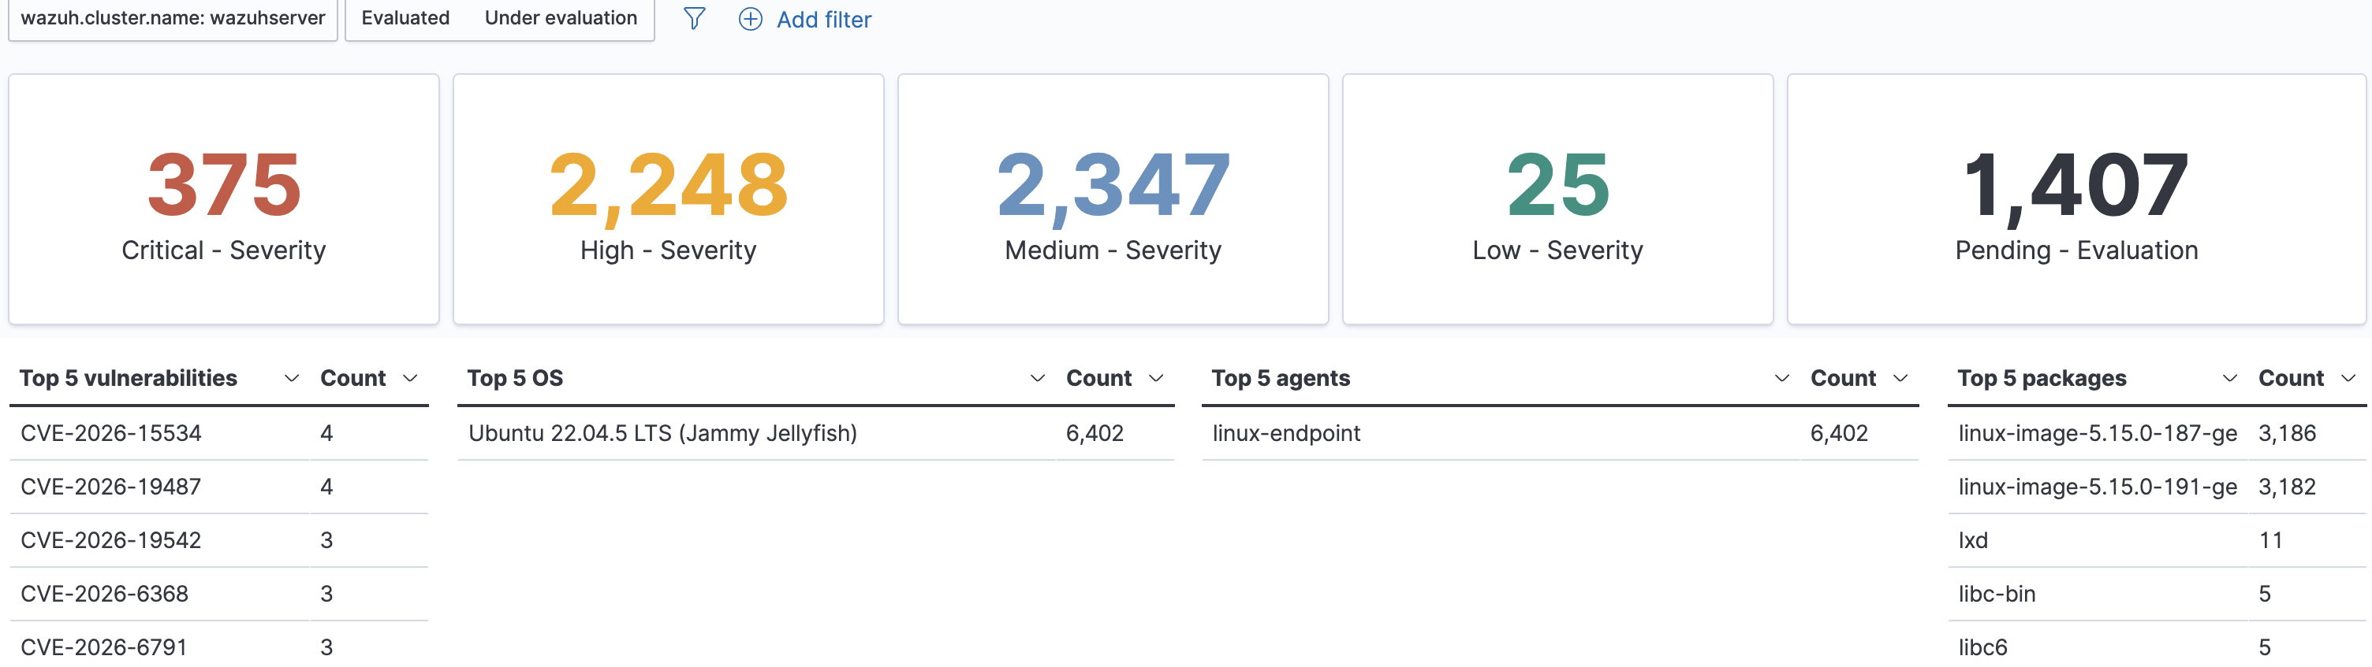
Figure 1. Baseline Wazuh overview for linux-endpoint: 6,402 findings, dominated by two kernel packages.

4. How it was prioritized
Every High/Critical finding was scored on three inputs: NVD CVSS v3.1 base score (fetched by kev_crossref.py), presence in the CISA KEV catalog (1,713 CVEs, downloaded 17 Sep 2026), and asset criticality from the asset inventory. The rule: P1 if in KEV on a High or Medium asset, or CVSS 9.0+ on a High asset; P2 if CVSS 7.0+ on any non-Low asset; P3 otherwise. Kernel packages were tiered as groups because every CVE in a package shares one fix.
Tier | Finding | Asset | CVSS | KEV | Justification
P1 | CVE-2025-15556, Notepad++ 7.8.9 | windows-endpoint (High) | 7.5 | Yes | Only KEV item in the estate, on the user-operated workstation: exploited in the wild plus user-facing asset.
P2 | 5 further Notepad++ CVEs | windows-endpoint (High) | 7.3 to 7.8 | No | Same upgrade clears all of them.
P2 | CVE-2025-54289, LXD 5.0.9 | linux-endpoint (Medium) | 8.1 | No | Privilege escalation, but LXD unused and API not exposed.
P2 | CVE-2026-15308, python3.10 | linux-endpoint (Medium) | 7.5 | No | DoS only on untrusted HTML; security update available.
P2 | Kernel 5.15.0-187 (1,288 High/Crit) | linux-endpoint (Medium) | 10.0 | No | Not the running kernel; zero-risk removal clears 3,186 findings.
P2 | Kernel 5.15.0-191 (1,284 High/Crit) | linux-endpoint (Medium) | 10.0 | No | Running kernel, already newest available; accepted risk, monitor.
P3 | CVE-2023-6401, Notepad++ | windows-endpoint (High) | 5.3 | No | Wazuh labels High, NVD scores 5.3; tier follows the number.

5. What was fixed
Fix | Action taken | Verification
P1: Notepad++ (all 6 High + 7 Medium CVEs) | Upgraded 7.8.9 to 8.9.8 (native ARM64 build) via silent installer; confirmed old 32-bit install fully replaced in registry. | Windows findings 13 to 0 after agent re-scan.
P2: Unused kernel 5.15.0-187 | apt remove linux-image-5.15.0-187-generic and the unsigned variant; apt autoremove. | Package absent from dpkg and from Wazuh inventory; 3,186 findings cleared.
P2: python3.10 CVE-2026-15308 | apt install --only-upgrade to 3.10.12-1~22.04.18 (jammy-security). | 5 findings cleared.
P2: LXD CVE-2025-54289 | snap refresh reported no update; LXD removed as unused attack surface (compensating control). | 11 findings cleared.

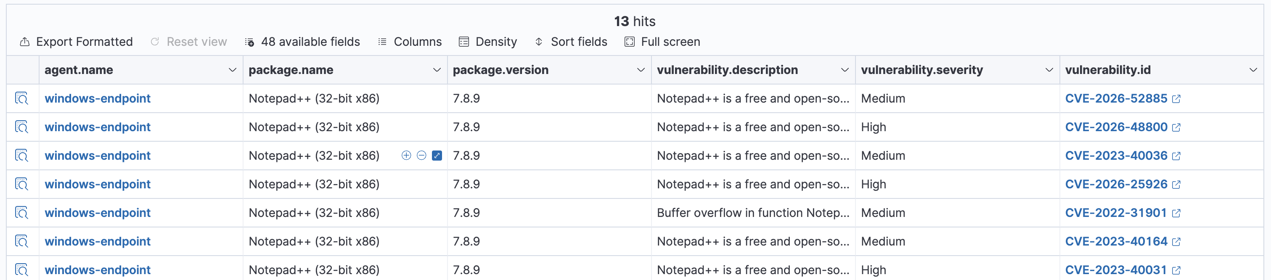
Figure 2. Before: 13 Notepad++ 7.8.9 findings on windows-endpoint, including the KEV-listed CVE-2025-15556.
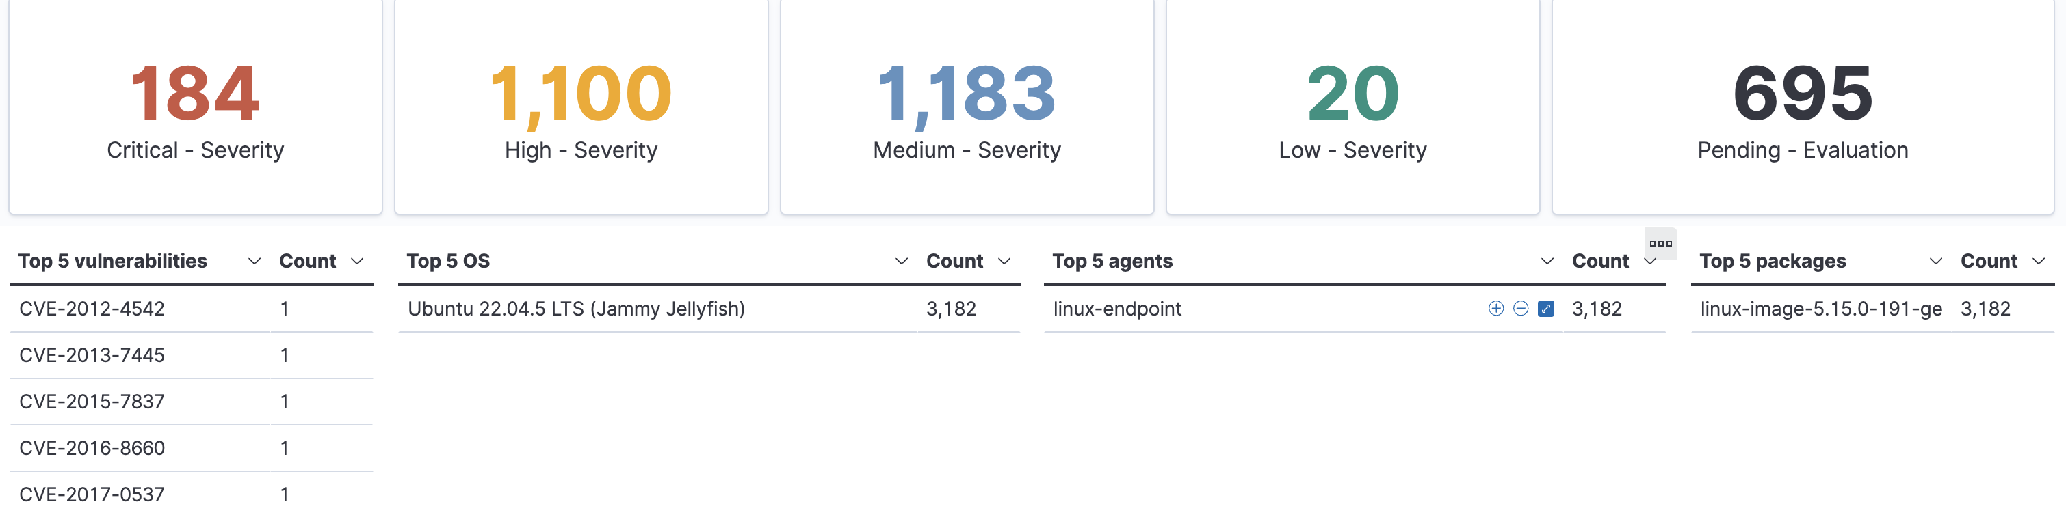
Figure 3. After: estate reduced to 3,182 findings, all in the running kernel; windows-endpoint no longer appears.

6. What remains and next steps
Endpoint | Before | After | Remaining
linux-endpoint | 6,407 | 3,182 | Running kernel 5.15.0-191 only
windows-endpoint | 13 | 0 | None
Total | 6,420 | 3,182 | 50% reduction; 100% of P1 resolved

- Kernel 5.15.0-191: re-check apt weekly for a newer 5.15 build; evaluate moving to the Ubuntu HWE kernel (6.x) as a compensating measure. Until then this is accepted risk on a Medium, LAN-only asset.
- Scanner severity vs NVD: CVE-2023-6401 shows Wazuh can over-rate; keep NVD CVSS in the workflow.
- Coverage gap: agent-based detection only sees installed packages, not network or config weaknesses; an active scanner such as Greenbone is the natural complement.
- Process: export, KEV cross-reference and CVSS enrichment are scripted (kev_crossref.py); the cycle repeats weekly in under 30 minutes. Full evidence is in the project repository.

