PROJECT STATUS REPORT / FIELD OBSERVATION

Project: MOSP Food Cart (red job # 19015)
Project Location: Mount Sinai Medical Center, 4300 Alton Road, Miami Beach, FL
Time: 09:00 AM (tentative)
Site Visit Date: 02-25-26
Weather: Clear / dry conditions
Phase: Construction Administration
Status: Comprehensive field observation update including all shared photos (20 total).
Present: Eduardo Muhiña (RDG)
NOTE: This revision includes all photos shared to date for this report package.
MOSP Food Cart
ITEM # | DESCRIPTION | REFERENCE PHOTO/DETAIL | COMPLETED YES or NO
1 | Field observation record per attached photo evidence. | 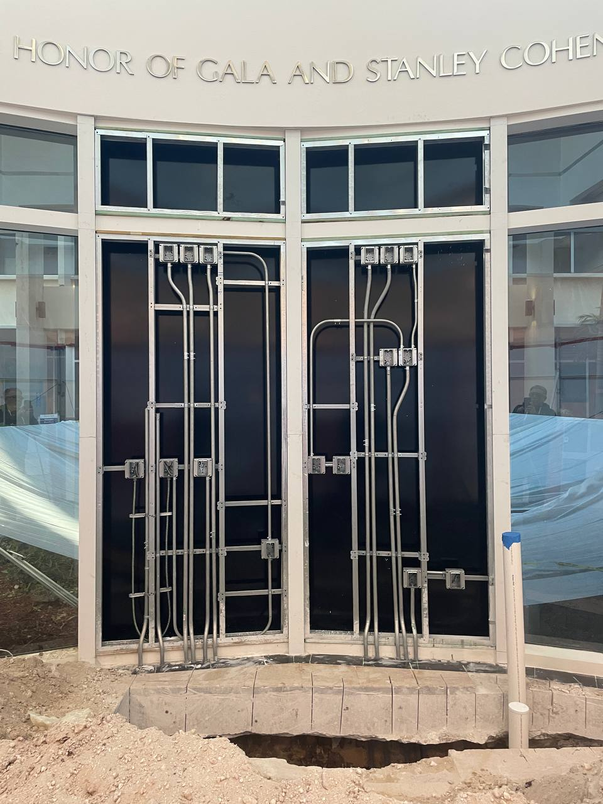 | YES
2 | Field observation record per attached photo evidence. | 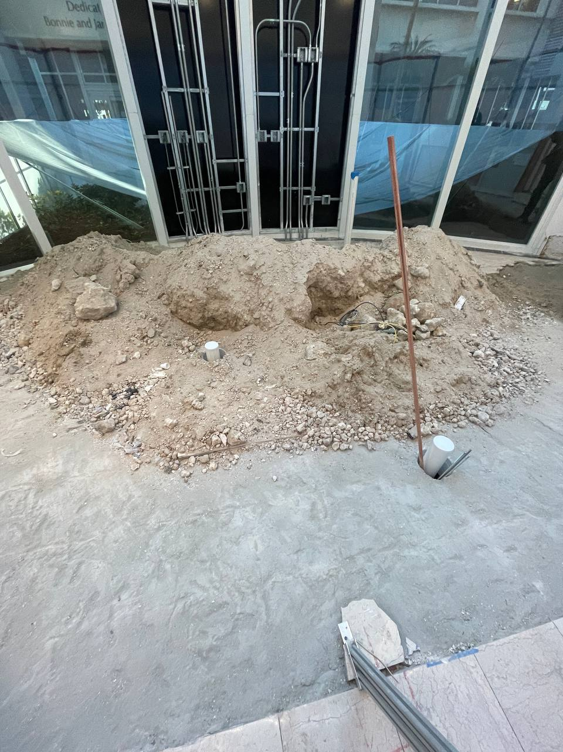 | YES
3 | Field observation record per attached photo evidence. |  | YES
4 | Field observation record per attached photo evidence. | 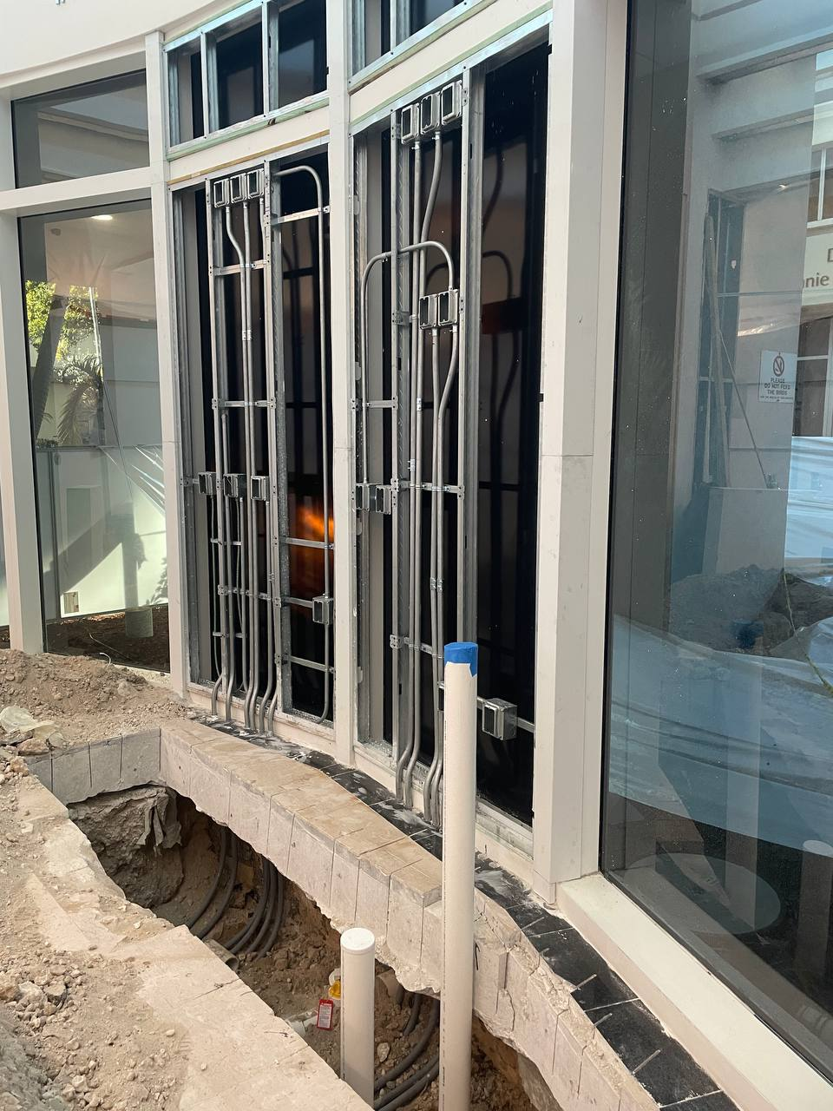 | YES
5 | Field observation record per attached photo evidence. | 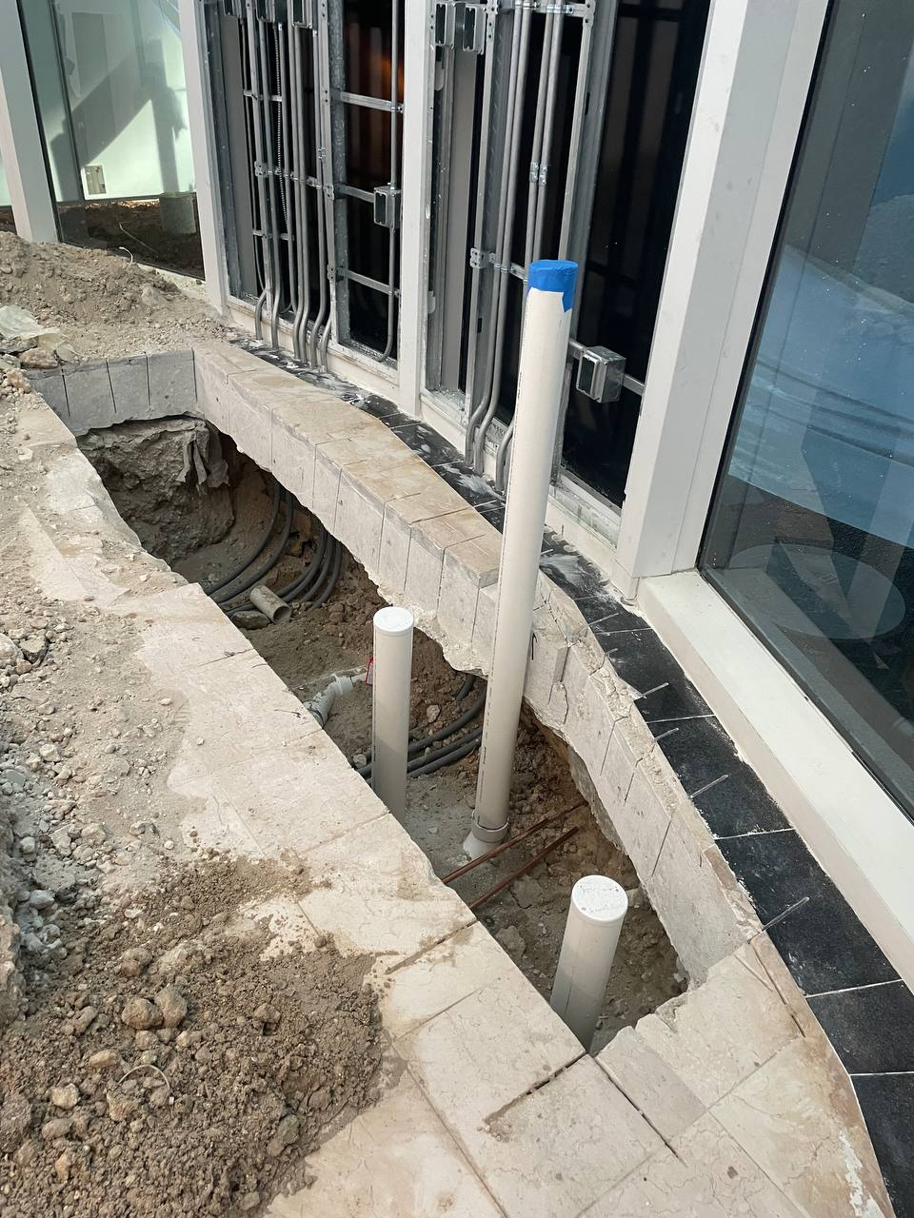 | YES
6 | Field observation record per attached photo evidence. | 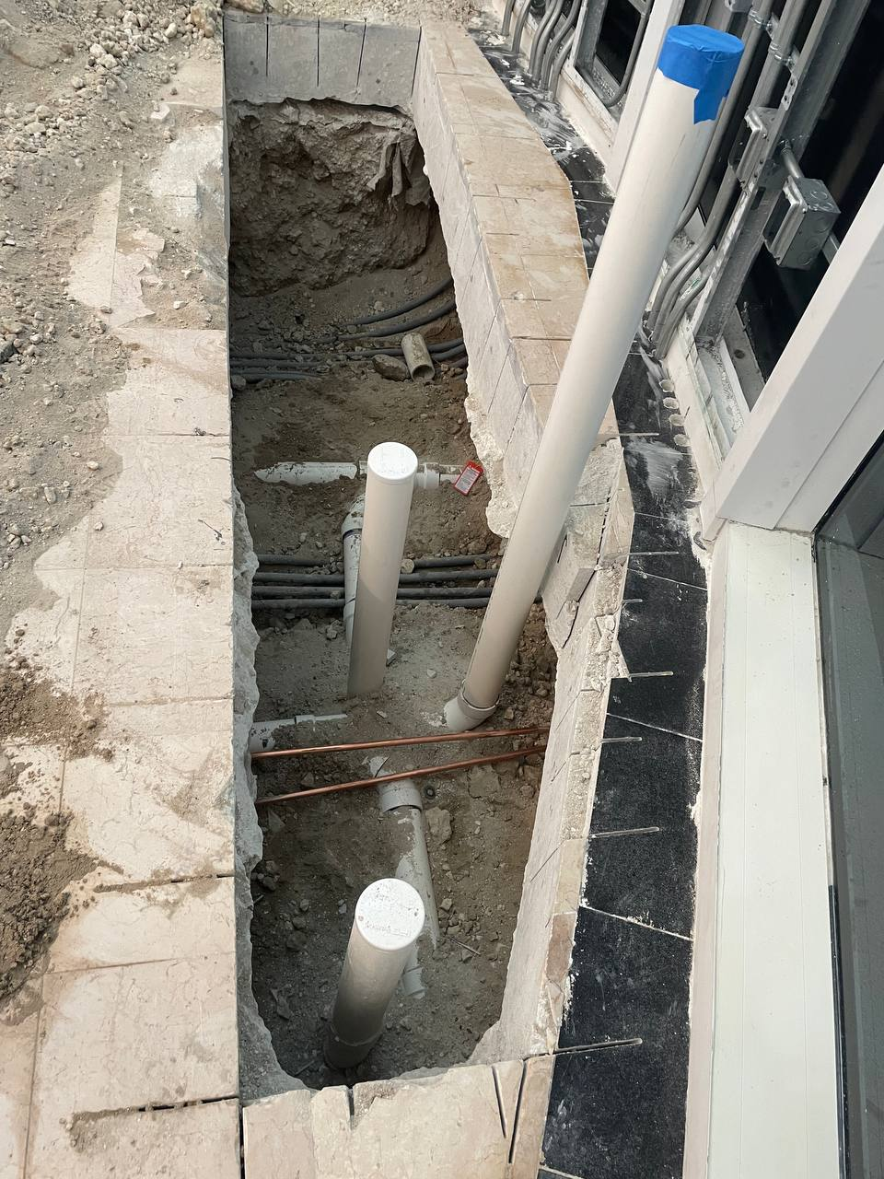 | YES
7 | Field observation record per attached photo evidence. | 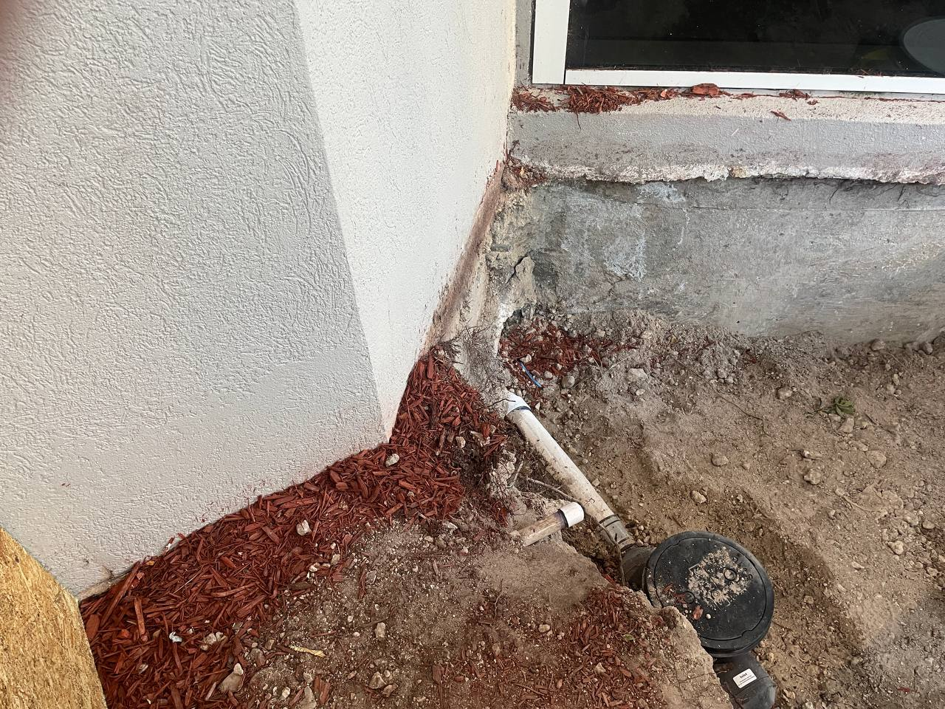 | YES
8 | Field observation record per attached photo evidence. | 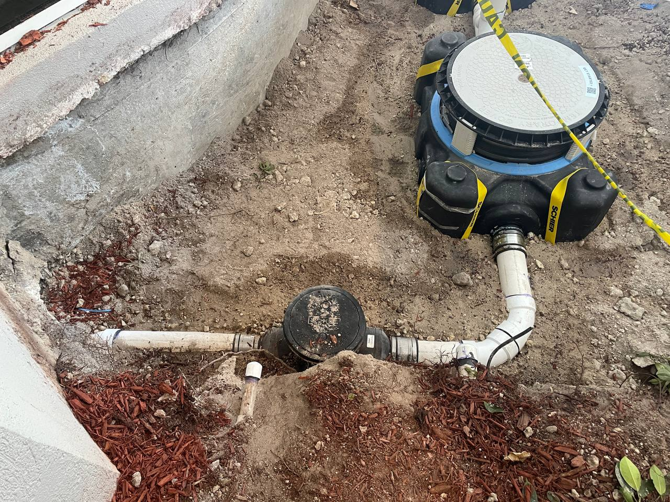 | YES
9 | Field observation record per attached photo evidence. | 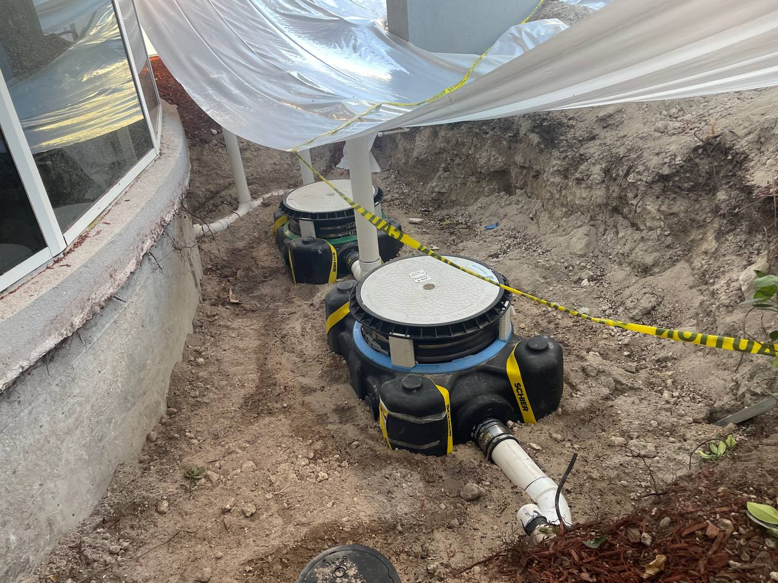 | YES
10 | Field observation record per attached photo evidence. | 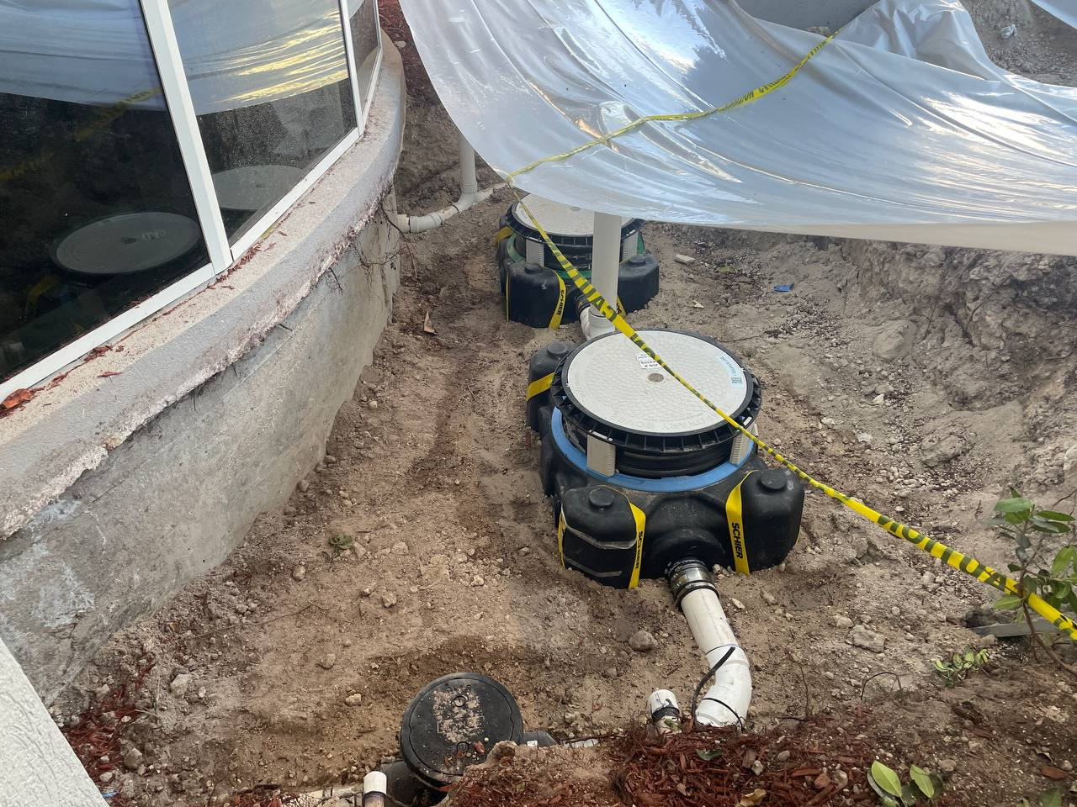 | YES
11 | Field observation record per attached photo evidence. | 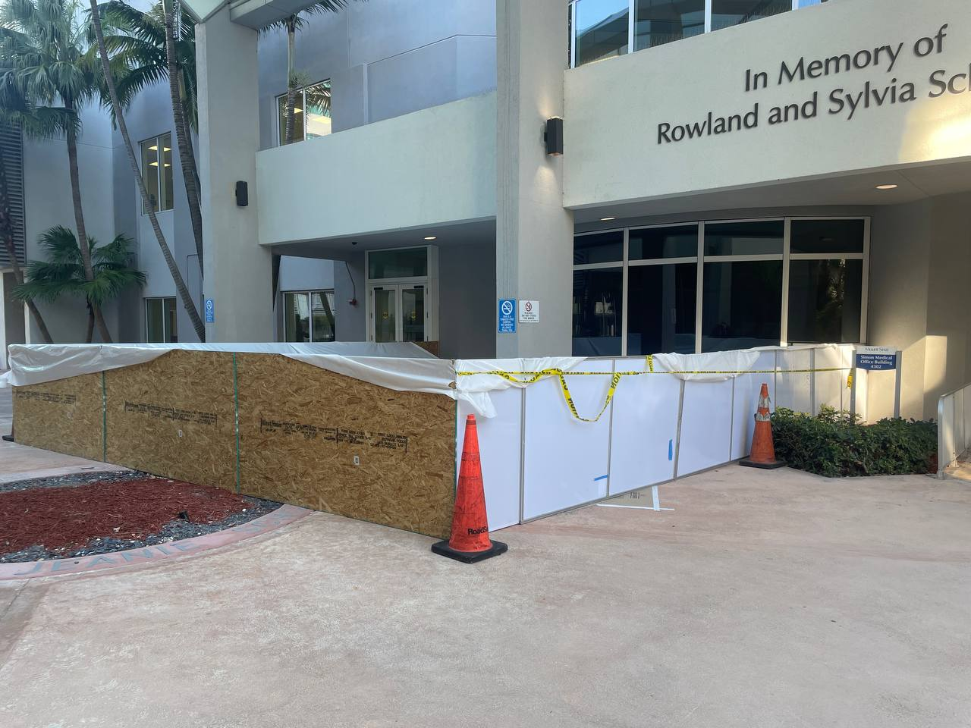 | YES
12 | Field observation record per attached photo evidence. | 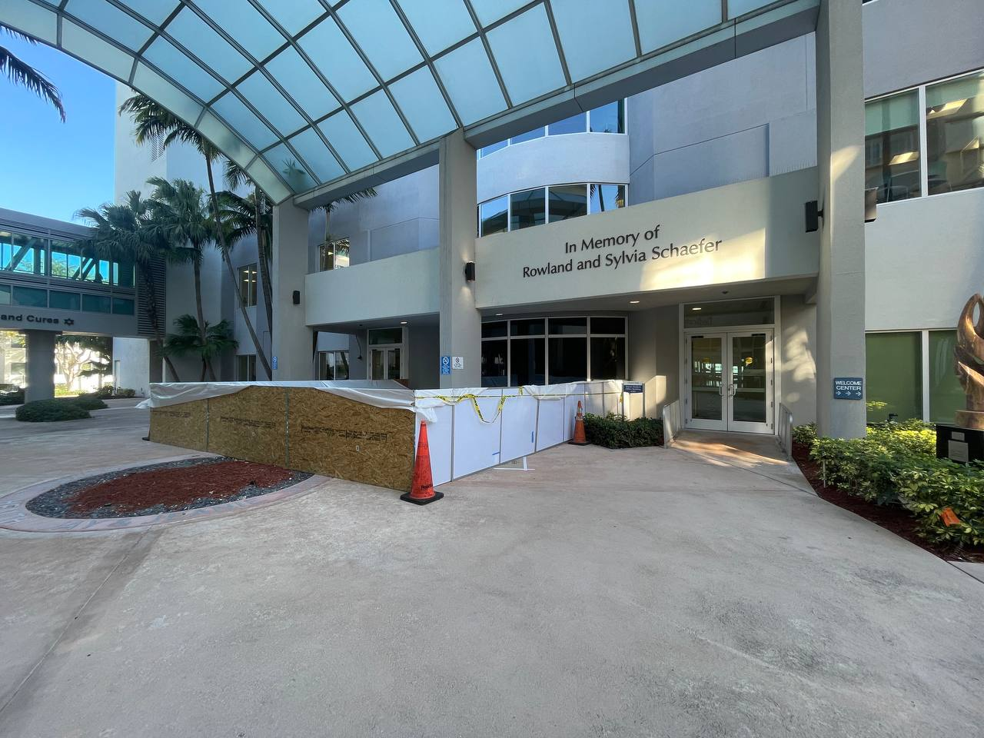 | YES
13 | Field observation record per attached photo evidence. | 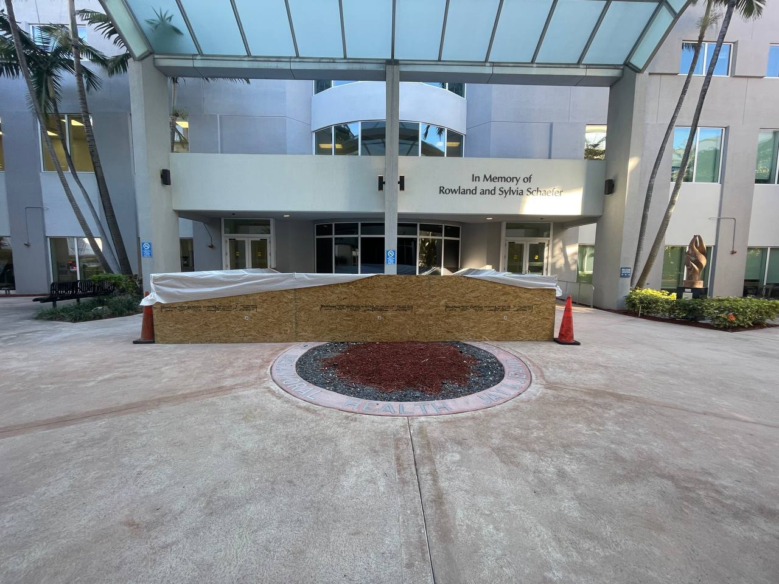 | YES
14 | Field observation record per attached photo evidence. | 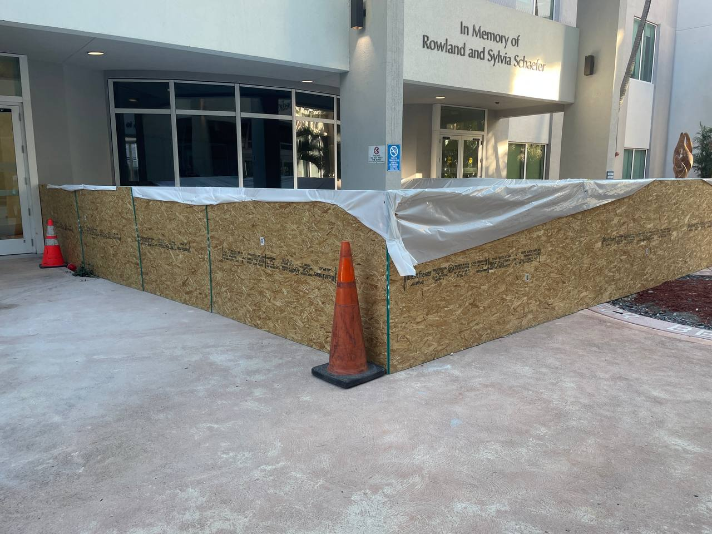 | YES
15 | Field observation record per attached photo evidence. | 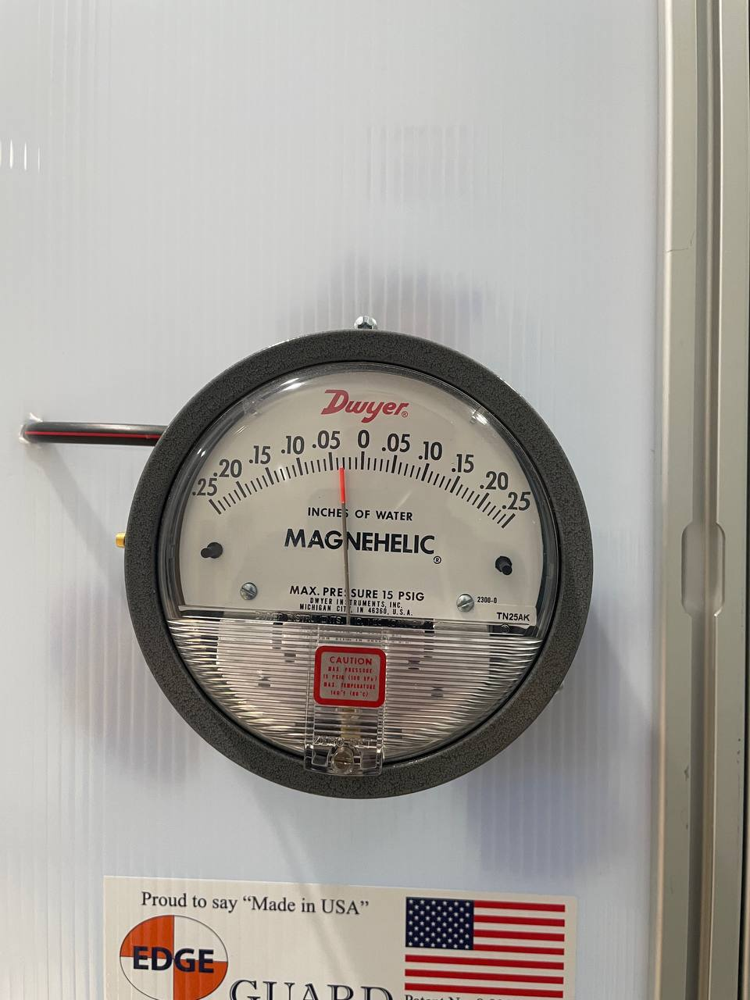 | YES
16 | Field observation record per attached photo evidence. | 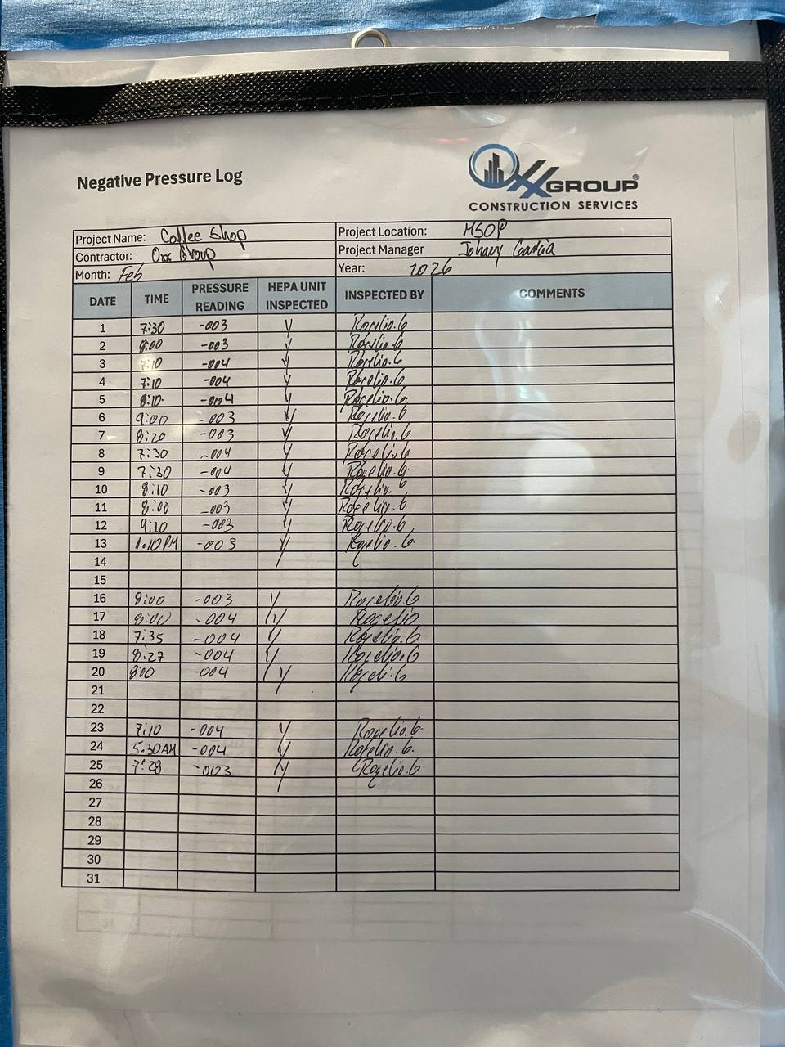 | YES
17 | Field observation record per attached photo evidence. | 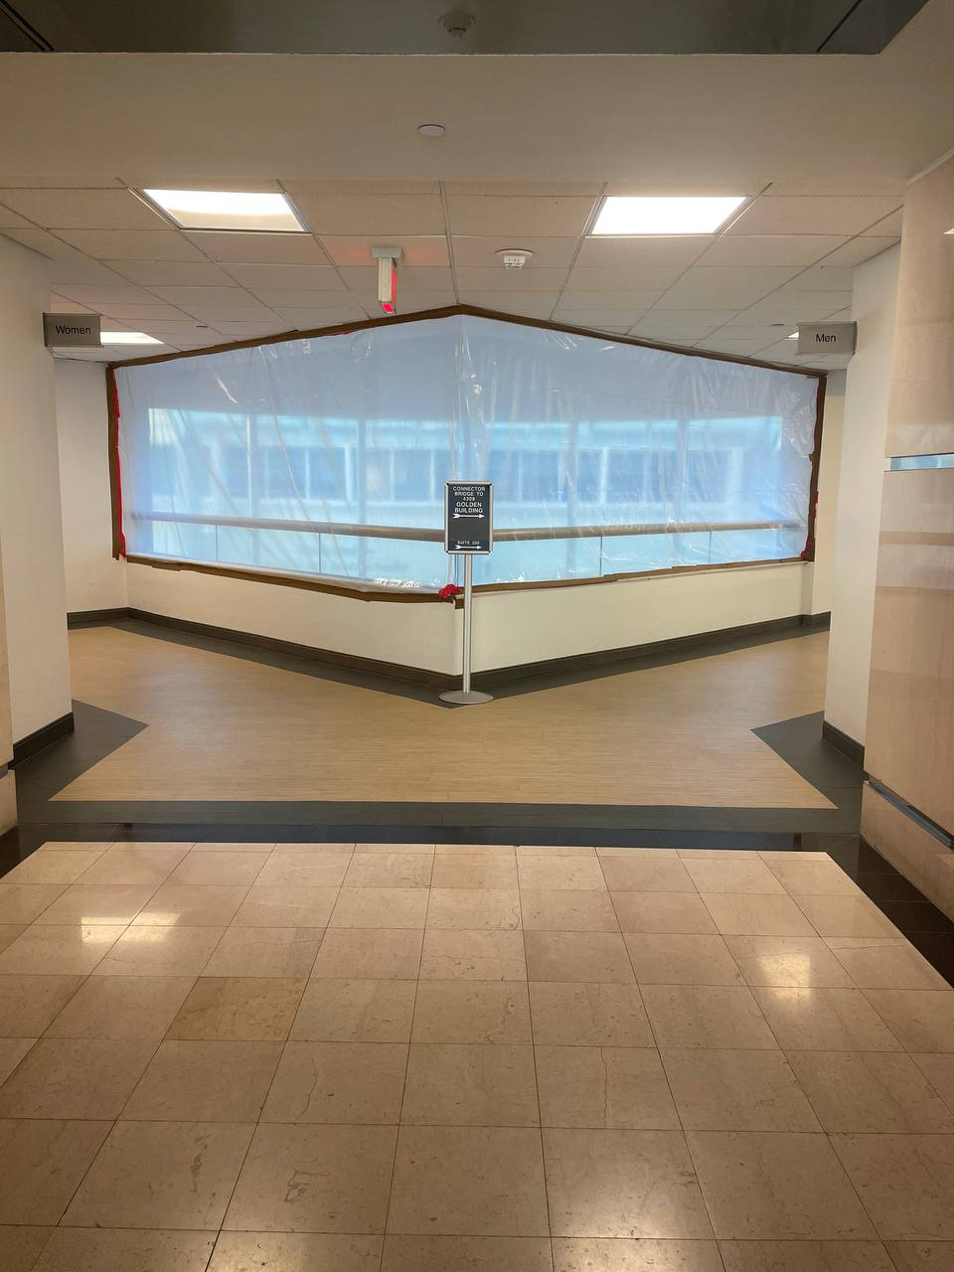 | YES
18 | Field observation record per attached photo evidence. | 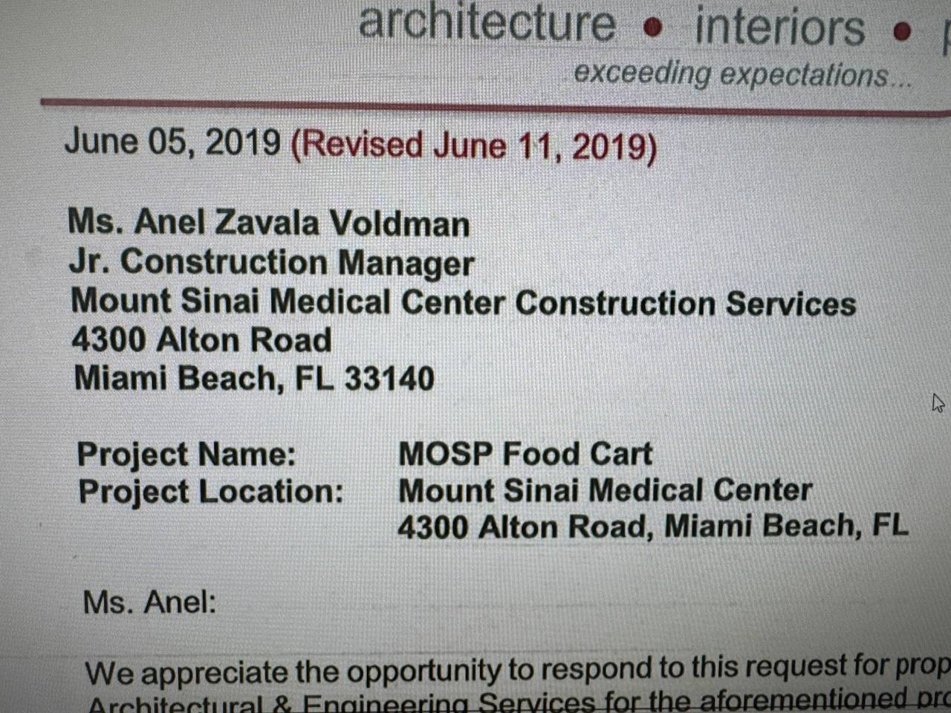 | YES
19 | Field observation record per attached photo evidence. | 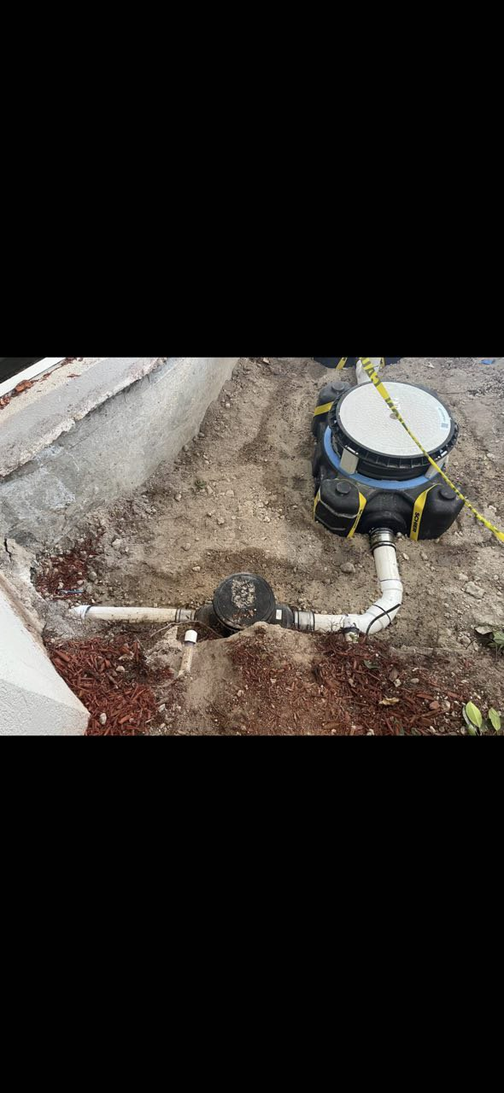 | OPEN
20 | Field observation record per attached photo evidence. | 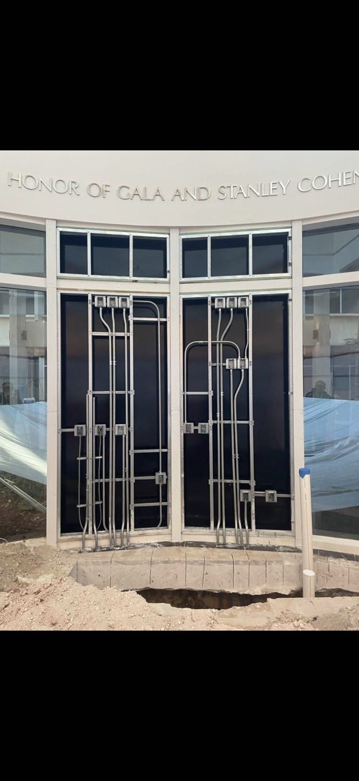 | OPEN

