PROJECT STATUS REPORT / FIELD OBSERVATION

Project: MOSP Food Cart (red job # 19015)
Project Location: Mount Sinai Medical Center, 4300 Alton Road, Miami Beach, FL
Time: 09:00 AM (tentative)
Site Visit Date: 02-25-26
Weather: Clear / dry conditions
Phase: Construction Administration
Status: Field observation performed in active work/containment area.
Present: Eduardo Muhiña (RDG)
NOTE: Omission of any item of non-compliance with the contract documents from this report does not relieve the contractor of responsibility to comply with contract requirements.
MOSP Food Cart
ITEM # | DESCRIPTION | REFERENCE PHOTO/DETAIL | COMPLETED YES or NO
1 | Exterior work-area perimeter with temporary containment visible. Active work conditions observed. | 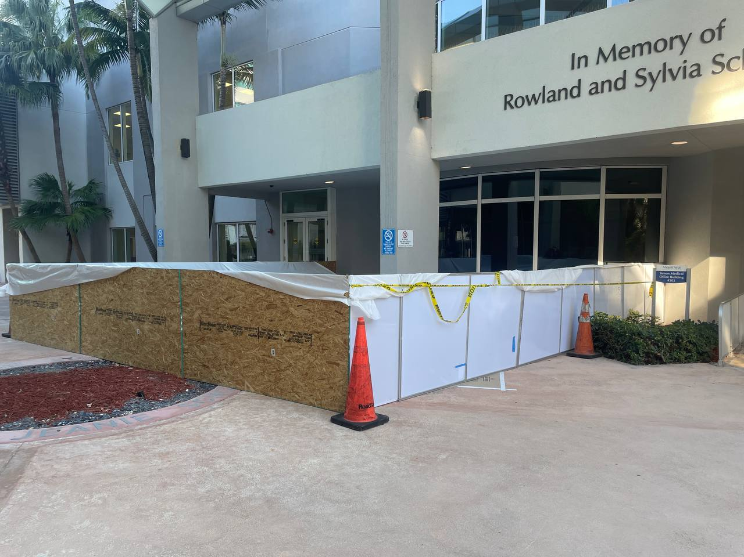 | YES
2 | Perimeter zone with temporary barricade/tape and work access path visible. | 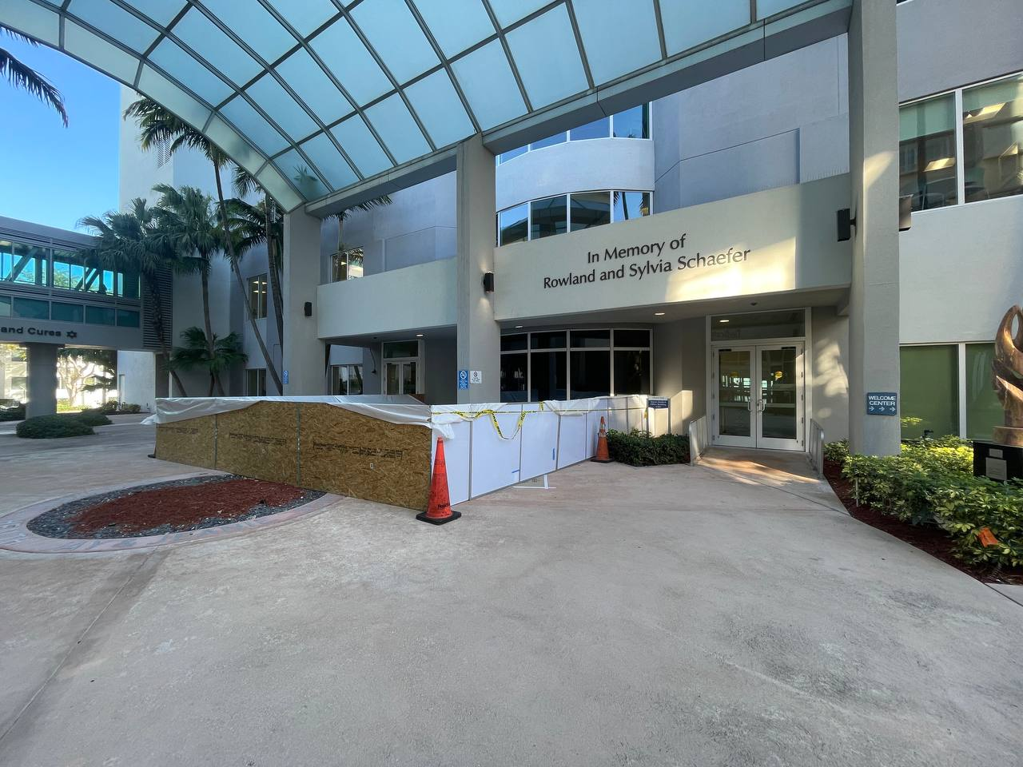 | YES
3 | Temporary containment wall and protected opening observed; access appears controlled. | 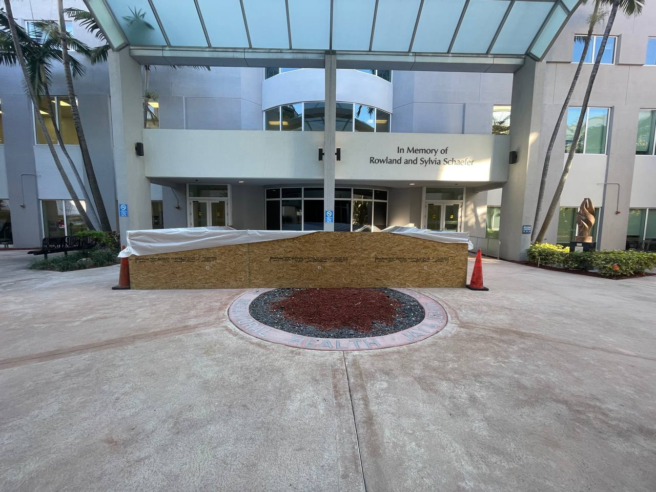 | YES
4 | Additional perimeter view of containment and adjacent paved area. | 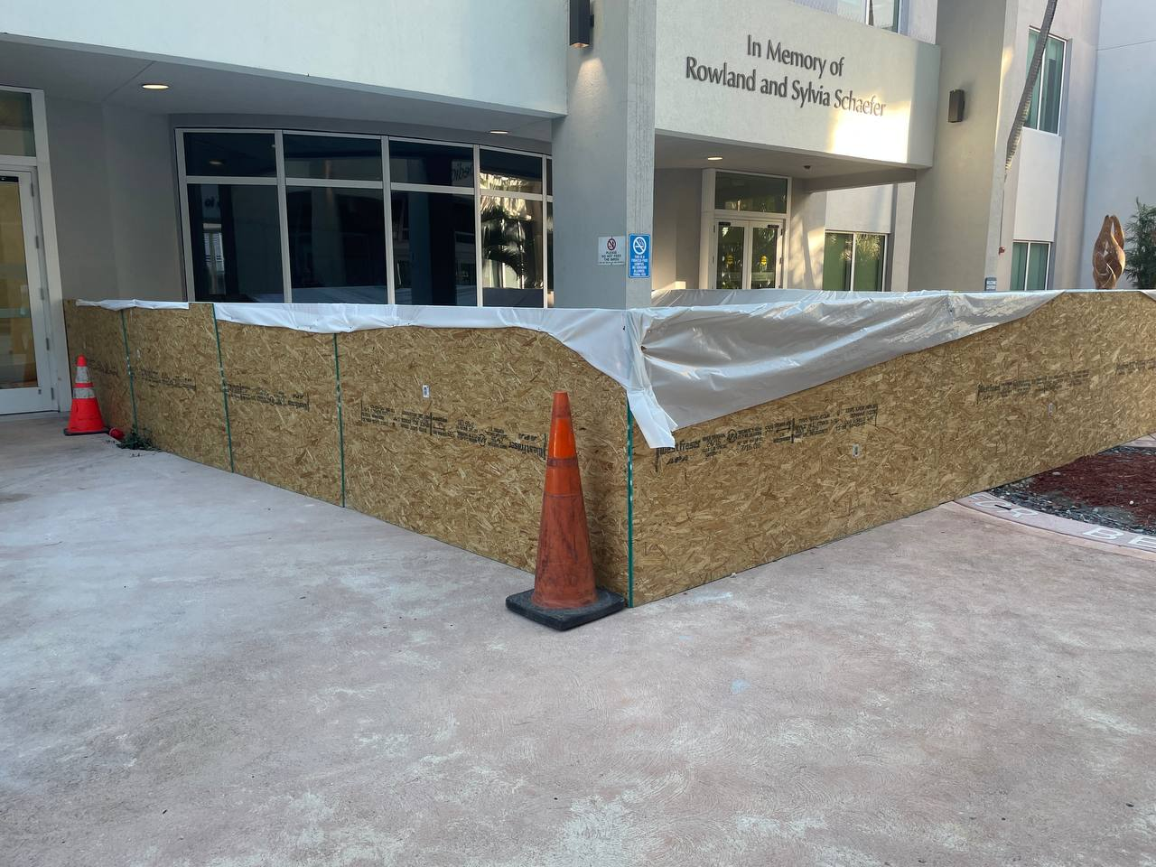 | YES
5 | Pressure monitoring gauge posted at containment area; reading displayed at time of photo. | 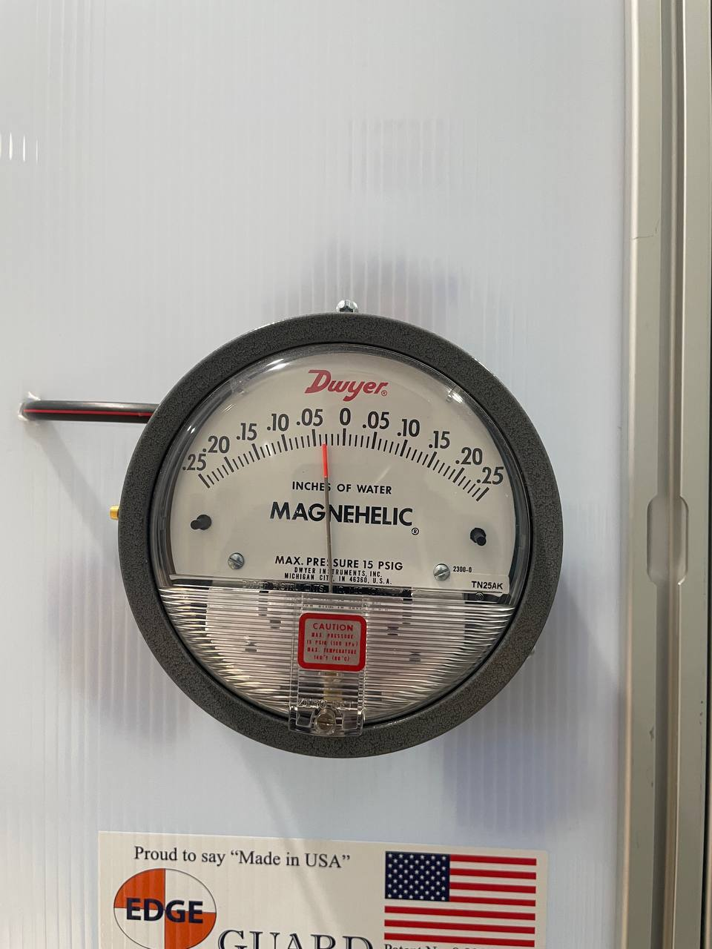 | YES
6 | Pressure log sheet posted/available at field location. | 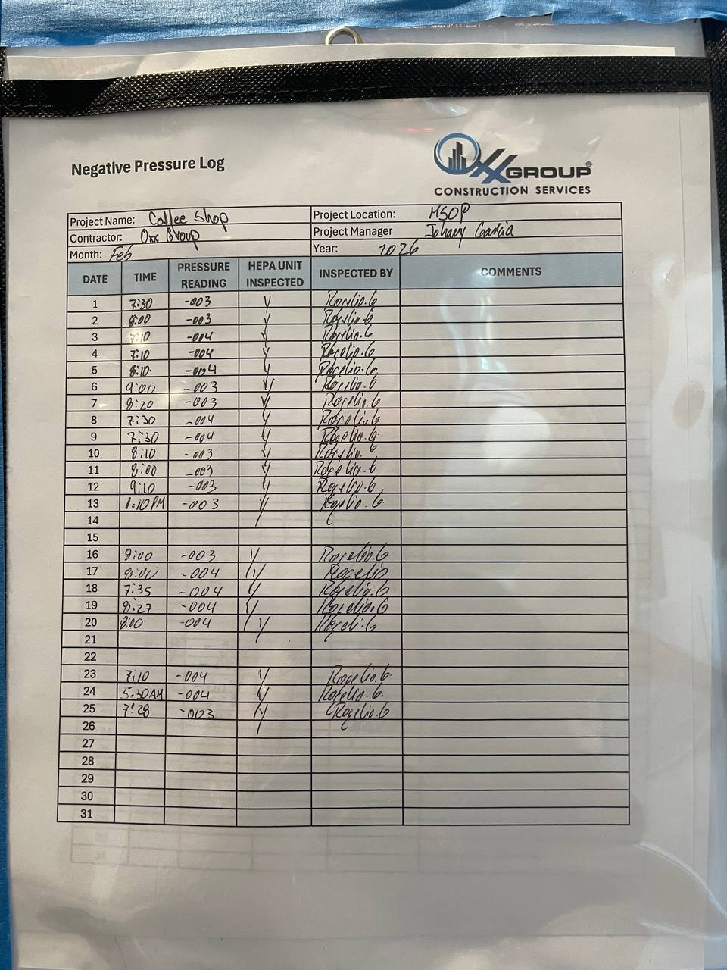 | YES
7 | Interior-side temporary containment barrier and warning tape observed. | 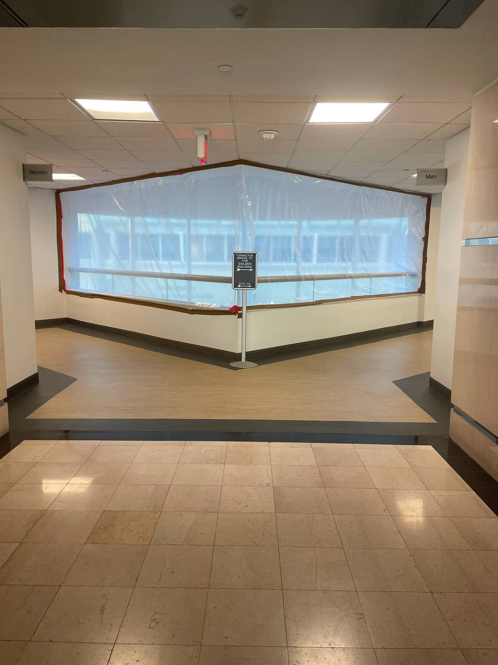 | YES
8 | General site context reference image captured for report file. | 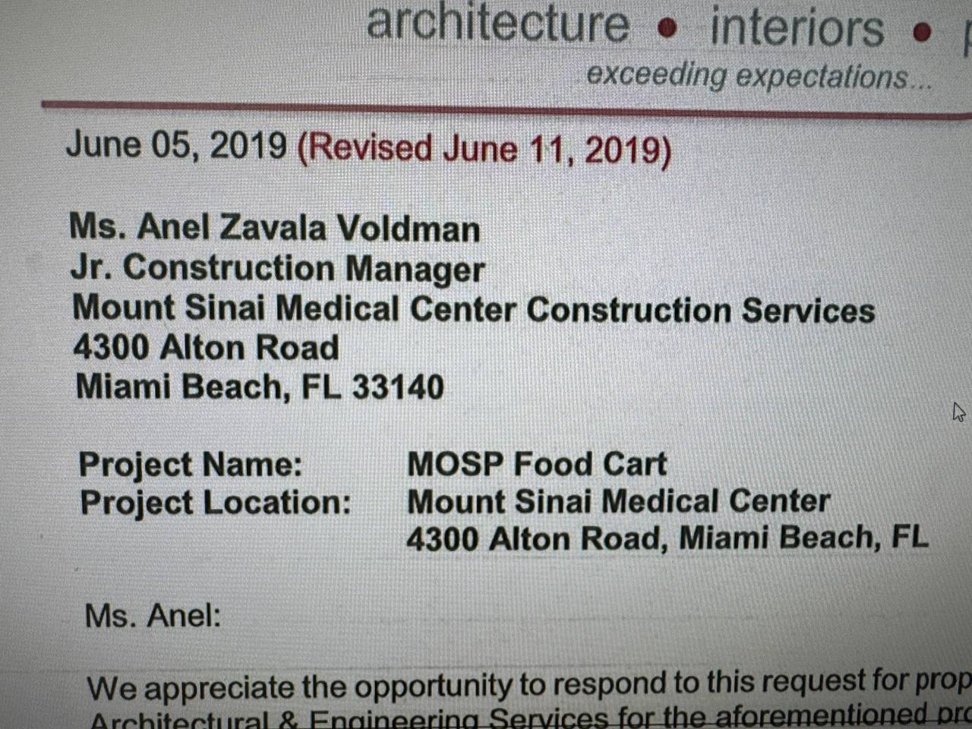 | N/A
9 | Exterior facade opening with visible conduit rough-in; coordinate closure and weather protection sequence before final finish. | 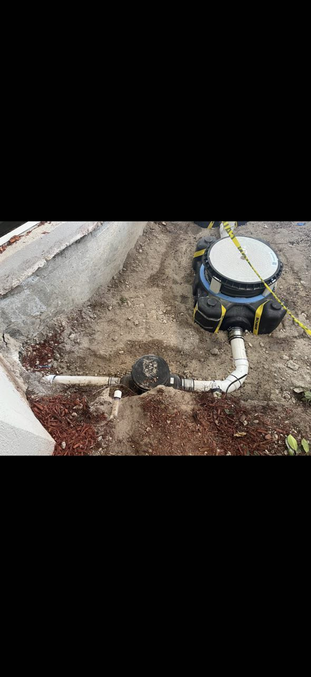 | NO
10 | Additional facade/conduit rough-in view confirms unresolved opening at base; include patch/closure in corrective action tracking. | 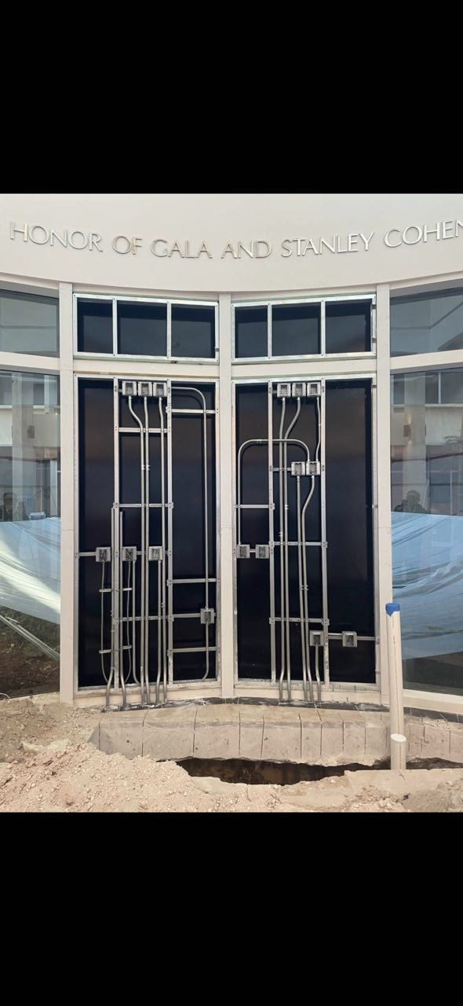 | NO

