1. **(a)**



Emission probabilities:

* Cow
* P (moo | Cow) = 0.9
* P (hello | Cow) = 0.1
* Duck
* P (quack | Duck) = 0.6
* P (hello | Duck) = 0.4

**Step1: The first token is “moo”**

0 1 2 3 4

Start 1 0

0.09

Cow 0 0.9 * 0.1

Duck 0 0 * 0

End 0 0

**Step2: The second token is “hello”**

(If “moo” is from Cow state)

0 1 2 3 4

Start 1 0 0

0.09 0.0045

Cow 0 0.9 * 0.1 0.09*0.1*0.5

0.0108

Duck 0 0 * 0 0.09*0.4*0.3

End 0 0 0

(If “moo” is from Duck state)

0 1 2 3 4

Start 1 0 0

0.09 0.0045

Cow 0 0.9 * 0.1 0*0.1*0.5=0

0.0108

Duck 0 0 * 0 0*0.4*0.3=0

End 0 0 0

“hello” take maximum, set back pointers,

0 1 2 3 4

Start 1 0 0

0.09 0.0045

Cow 0 0.9 * 0.1 ~~0*0.1*0.5=0~~

0.0108

Duck 0 0 * 0 ~~0*0.4*0.3=0~~

End 0 0 0

**Step3: The third token is “quack”**

(If “hello” is from Cow state)

0 1 2 3 4

Start 1 0 0 0

0.09 0.0045 0

Cow 0 0.9 * 0.1 ~~0*0.1*0.5=0~~ 0.0045*0*0.5

0.0108 0.00081

Duck 0 0 * 0 ~~0*0.4*0.3=0~~ 0.0045*0.6*0.3

End 0 0 0

(If “hello” is from Duck state)

0 1 2 3 4

Start 1 0 0 0

0.09 0.0045 0

Cow 0 0.9 * 0.1 ~~0*0.1*0.5=0~~ 0.0108*0*0.3=0

0.0108 0.00081

Duck 0 0 * 0 ~~0*0.4*0.3=0~~ 0.0108*0.6*0.5=0.00324

End 0 0 0

“quack” take maximum, set back pointers

0 1 2 3 4

Start 1 0 0 0

0.09 0.0045 ~~0~~

Cow 0 0.9 * 0.1 ~~0*0.1*0.5=0~~ 0.0108*0*0.3=0

0.0108 ~~0.00081~~

Duck 0 0 * 0 ~~0*0.4*0.3=0~~ 0.0108*0.6*0.5=0.00324

End 0 0 0

**Step4: End state**

(If “quack” is from Cow state)

0 1 2 3 4

Start 1 0 0 0

Cow 0 0.09 0.0045 0

Duck 0 0 * 0 0.0108 0.00324

End 0 0 0 - 0*0.2 = 0

(If “quack” is from Duck state)

End takes maximum, set back pointers

0 1 2 3 4

Start 1 0 0 0 -

Cow 0 0.09 0.0045 0 -

Duck 0 0 * 0 0.0108 0.00324 -

~~0*0.2 = 0~~

End 0 0 0 - .00324*.2=.000648

**Decode:**

moo = Cow, hello = Duck, quack = Duck

So the probability of emitting this sentence from this state sequence is 0.000648.

0 1 2 3 4

Start 1 0 0 0 -

Cow 0 0.09 0.0045 0 -

Duck 0 0 * 0 0.0108 0.00324 -

End 0 0 0 - 0. 000648

**(b)** There is another state sequence:

moo = Cow, hello =Cow, quack =Duck.

The probability is 0.000162

0 1 2 3 4

Start 1 0 0 0 -

Cow 0 0.09 0.0045 0.0045*0*0.5=0 -

0.00081

Duck 0 0 * 0 0.0108 0.0045*0.6*0.3

End 0 0 0 .00081*.2=.000162

1. The output for sentence “Wu meets Jane.” (correct one) and sentence “They have meets every day.” (incorrect one) is shown below.

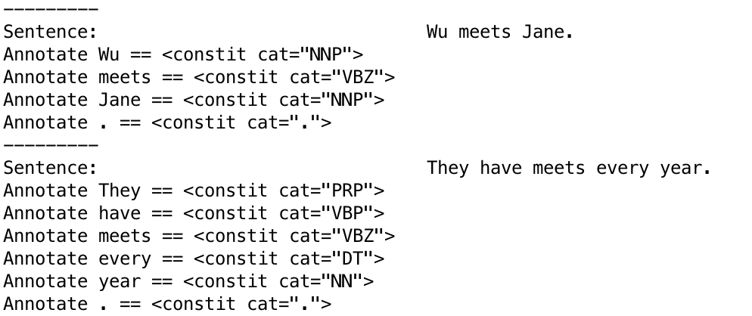

Sentence “They have meets every day.”

Correct situation (“meets” is NNS):

V1 = P(They | PRP) * P (PRP | Start) * P (have | VBP) * P(VBP |PRP) * P (meets | NNS) * P (NNS | VBP) * P (every | DT) * P (DT | NNS) * P (year | NN) * P (NN | DT)

Incorrect situation (“meets” is VBZ):

V2 = P (They | PRP) * P (PRP | Start) * P (have | VBP) * P (VBP |PRP) * P (meets | VBZ) * P (VBZ | VBP) * P (every | DT) * P (DT | VBZ) * P (year | NN) * P (NN | DT)

Since most of parts are the same, we can assume that

V1 = Constant * P (meets | NNS) * P (NNS | VBP) * P (DT | NNS) = (1/ 71914) * (484/14955) * (1233/71914) = (484 * 1233) / (719142 * 14955)

V2 = Constant * P (meets | VBZ) * P (VBZ | VBP) * P (DT | VBZ) = (10/25735) * (39/14955) * (1780/25735) = (390 * 1780) / (257352 * 14955)

So, V(“meets” = VBZ ) is larger than V(“meets” = NNS).