Graduation Project Conference Report

Name | Department | Student ID | Hanyang email
정병윤 | 데이터사이언스 | 2023062760 | burnix159@hanyang.ac.kr
민지홍 | 데이터사이언스 | 2021012660 | mjh2856@hanyang.ac.kr

Pick at least two posters that were interesting. (1) Summarize the methods and findings of the poster, (2) discuss the impact or implications of the result, and (3) take a photo of the poster

Poster pick 1

Summary
Methods
This study proposed a subject wise normalization technique to address the problem of domain shift where wearable based stress detection models experience a sharp degradation in performance when applied to new, unseen users or environments. Utilizing two independent wearable datasets (WESAD, Exercise-Stress), the researchers normalized each subject's bio-signal data against their own baseline. This process successfully removed per-person and per-device offsets, extracting robust, domain invariant features. Furthermore, the detected stress levels were integrated with a LLM agent to build a mobile application system. Using RAG technology, this system is designed to provide users with appropriate psychological support and coping skills.
Findings
Experimental results showed that applying the proposed subject-wise normalization technique significantly improved the model's generalized detection performance across all evaluation settings. Most notably, the largest improvement occurred in the cross dataset transfer evaluation where a model trained on one dataset is applied to a completely different one with the macro-F1 score increasing by 0.136. This empirically proves that the baseline offset between users is the primary source of domain shift. Although the performance gap between environments was not completely closed, this study successfully demonstrated the technical feasibility of significantly enhancing model accuracy through a brief, label-free initial calibration and immediately linking this capability to a practical mental health care service.
Implications
The primary impact of this study lies in mitigating the domain shift problem through label-free initial calibration and subject-wise normalization, which reduces the data collection costs required for model training and secures system scalability. This implies that utilizing relative changes against a personal baseline as features, rather than absolute physiological measurements, is a key requirement for ensuring generalizability in biosignal-based modeling. Furthermore, the study verifies the effectiveness of an active intervention pipeline that links detection results with an LLM agent and RAG technology to provide tailored psychological support, such as CBT and DBT. Finally, it outlines concrete directions for future model refinement by identifying the need for adversarial domain adaptation (DANN) to address the remaining performance gap, alongside an activity filter to distinguish physical exertion from psychological stress.
Photo
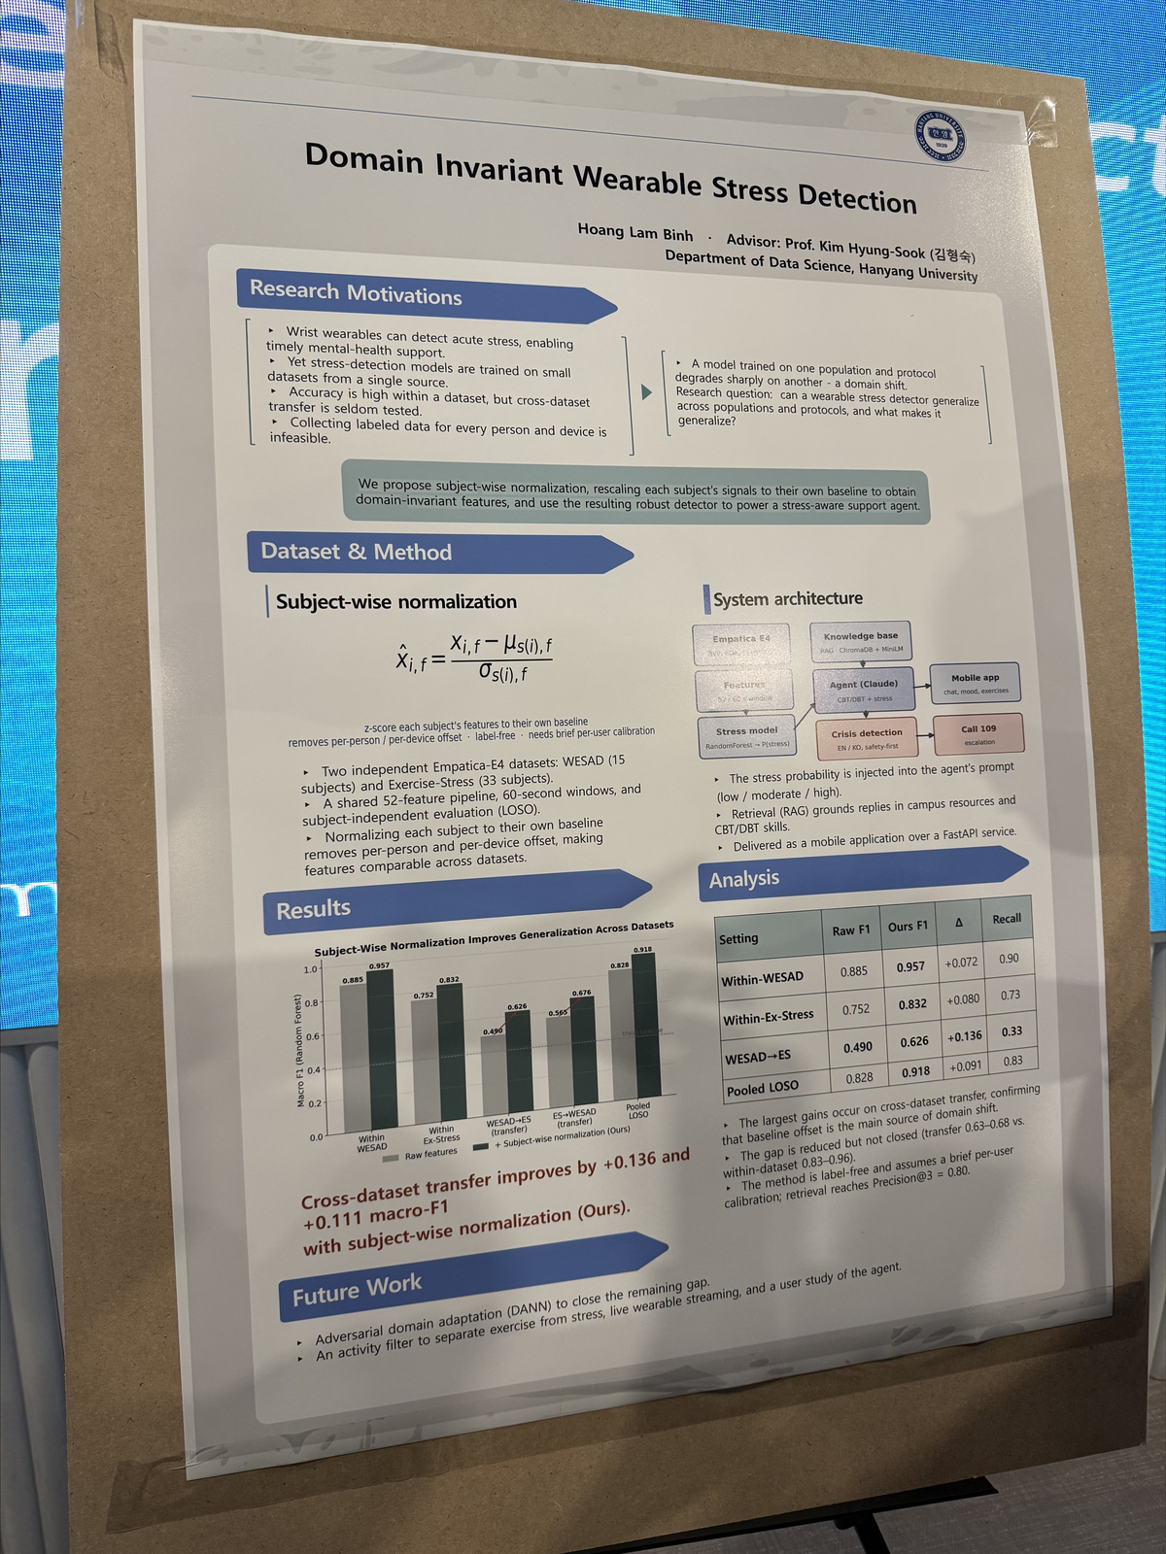

Poster pick 2

Summary
Methods
This study proposed a data-driven decision-support system that combines classical forecasting with an extended Vision-Language Model (VLM) for anomaly detection in a District Heating (DH) network. Using a proprietary dataset consisting of 32,547 hourly records from a real PNS-8 station (2021–2024) across 9 variables, the researchers faced the core obstacle of having nested seasonality without any expert anomaly labels. To overcome this, the study introduced a multi-detector corroboration pipeline based on the thesis that classical forecasting and pretrained multimodal models are complementary rather than competing.
The methodology is divided into two main tracks:
- Track A (Forecasting) : The primary target was predicting the return temperature. The researchers utilized a Direct multi-output (MIMO) structure over a recursive one to prevent error accumulation and ensure robustness against anomalous inputs. The final model implemented Direct LightGBM, optimized via Hyperopt (TPE) tuning and a 24-h rolling-refit backtesting strategy.
- Track B (Anomaly Detection) : Due to the lack of ground truth labels, statistical pseudo-labels (Z-score, IQR, rate-of-change) were generated. The system replicated and extended VLM4TS, where a frozen CLIP ViT-B/16 model screens rendered plots. The extensions included multi-period STL deseasononig, overlapping 6-month slices, and a 3-channel agreement (> 2/3) plus a hard physics checker. Finally, the VLM was redesigned as an arbiter to judge 94 ambiguous intervals, resulting in a triaged 4-tier confidence system.
Findings
The experimental and empirical evaluation demonstrated the high accuracy and practical reliability of the integrated pipeline. In Track A (Forecasting), the final Direct LightGBM model with rolling backtest achieved a highly precise symmetric Mean Absolute Percentage Error (smMAPE) of 8.31%, outperforming naive variants and recursive models that suffered from error accumulation.
In Track B (Anomaly Detection), the system successfully identified 108 anomalies categorized into four distinct tiers based on the level of corroboration. Specifically:
- The system achieved an 80.5% recall rate when compared against statistical labels (increasing the number of detected anomalies from 27 to 108).
- It improved short-event recall from 0/9 to 7/9.
- Out of the detected intervals, 50 anomalies were classified as "strongly corroborated".
- Within the triaged tiers, 14 anomalies were classified as Tier 1 (Ironclad), which demonstrated absolute channel agreement combined with physics validation, while 36 anomalies were classified as Tier 1.5, showing clear physics and VLM coherence.
This proves that leveraging independent detectors (statistical, visual, and physics) can successfully unearth hidden anomalies even in the complete absence of expert-annotated ground truth.
Implications
The primary impact of this study lies in establishing an actionable, triaged fault-detection tool tailored for aging Soviet-era infrastructure that is highly prone to leaks and sudden shutdowns. By demonstrating that classical forecasting and vision-language models are complementary, this research provides a framework for trustworthy industrial AI where critical decisions do not rely on a single black-box model but on cross-detector corroboration.
From a data engineering perspective, it implies that the severe limitation of lacking expert ground-truth labels can be effectively bypassed through the strategic combination of dense statistical pseudo-labels, hard physics-based rules, and the visual reasoning capabilities of pre-trained VLMs. Furthermore, the study outlines clear pathways for future operational deployment, highlighting the necessity of integrating weather as an exogenous driver for multivariate forecasting, infusing more physics-informed constraints, and leveraging VLM-generated narratives for the top anomalous intervals to provide human operators with easily interpretable, natural language explanations of system faults.
Photo
