|  |  |
| --- | --- |
| Name: | MG AUNG KYAW SANN |
| Date of Birth: | 25.8.2000 |
| Age: | 23 |
| Gender: | Male |
| Phone Number: | 09- 967316793 |
| Email Address: | channmin211@gmail.com |
| Contact Address: | Hpa-an Township, Kayin State |
| Permanent Address: | Thanbyuzayat Township, Mon State |

**INTERNSHIP RESUME**

**University of Computer Studies (Hpa-an)**

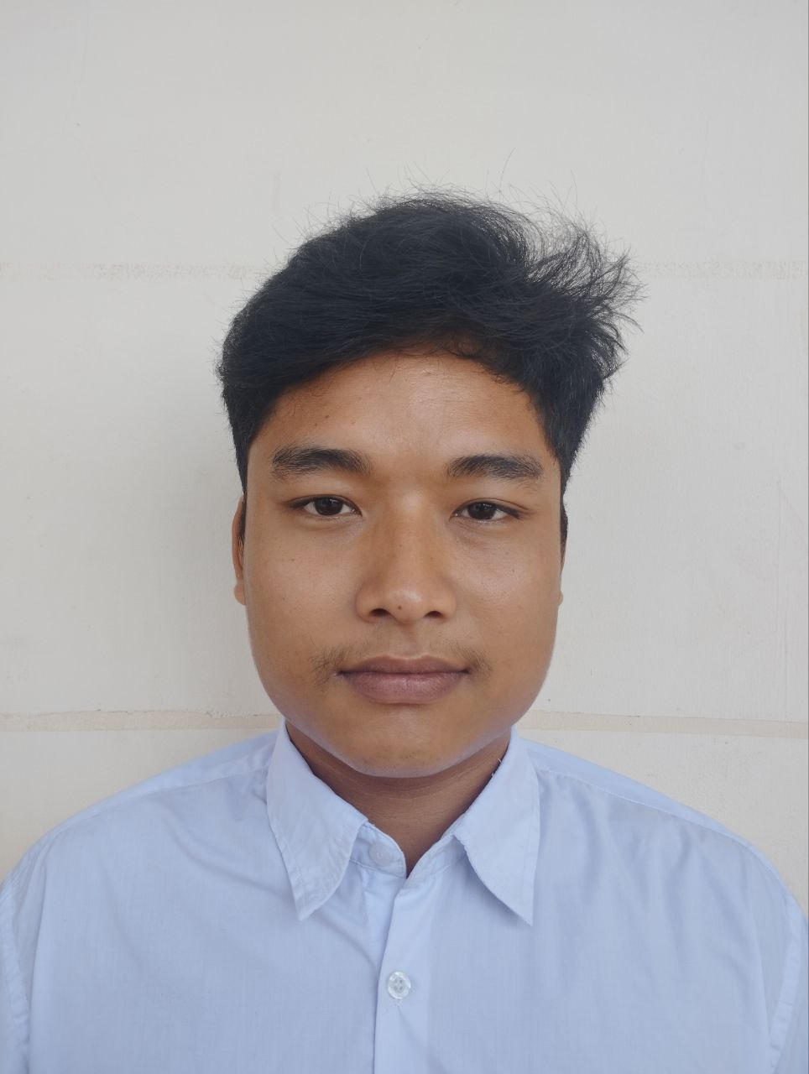

|  |
| --- |
| Education Background: |
| Final Year of Computer Technology |
| Experience (Project, Internship, Training Course, etc.): |
| |  |  | | --- | --- | | * Word |  | | * Powerpoint |  | |
| Technical Skills: |
| |  |  | | --- | --- | | * Networking |  | | * Embedded System |  | |
| Language Skills: |
| * Medium English * Native Burmeses |
| Soft Skills (Communication, Collaboration, Enthusiasm, etc.): |
| * Teamwork * Communication * Presentation |
| Fields of Interest: |
| * Networking * Cyber Security * Database * Device Installed |
| Hobbies: |
| * Machine Learning * Creativity |