JQery Mobile에 대한 학습

기본 문법은 HTML 방식과 동일

필요 리소스 :

<link rel =”stylesheet” href = <http://code.jquery.com/mobile/1.1.0/jqery.mobile-1.1.0.min.css> />  
<script src = “http://code.jquery.com/jquery-1.7..min.js”> </script>  
<script src = <http://code.jquery.com/mobile/1.1.0/jquery.mobile-1.1.0.min.js>> </script>

data-role 은 JQuery Mobile에서 해당 엘리먼트가 어떤 UI인지 지정. 주로,

<div data-role = “page”>

<div data-role = “header”> </div> //페이지 상단 툴바

<div data-role = “main” class=”ui-content”> </div>   
//ui-content 클래스는 페이지 내용에 여분의 여백을 추가한다.

<div data-role = “footer”> </div> //페이지 하단 툴바

</div>

로 이루어진다.

<div data-dialog= “true”시 대화상자로 구성됨

모바일 전환 효과

<a href = “URI” data-transition =”slide | fade | flip | flow | pop | slide | slidefade | slidup | slidedown } turn | none”> </a>

현재까지 구현 내용

구현 코드

<html>

<head>

<meta http-equiv = "Content-Type" content="text/html; charset=utf-8">

<meta name = "viewport"

content = "width=device-width, initial-scale = 1">

<link rel = "stylesheet"

href = "https://code.jquery.com/mobile/1.4.5/jquery.mobile-1.4.5.min.css">

<script src="https://code.jquery.com/jquery-1.11.3.min.js"> </script>

<script src = "https://code.jquery.com/mobile/1.4.5/jquery.mobile-1.4.5.min.js"></script>

<title> test </title>

</head>

<body>

<div data-role="page" id = "pageone">

<div data-role = "header">

1p 입니다.

</div>

<div data-role = "main" class ="ui-content">

<p> hi</p>

<p> 내용</p>

<a href = "#pagetwo" data-transition= "turn" >go two</a>

<a href = "#pagethree" data-transition = "flow" data-direction="reverse" >go three</a>

</div>

<div data-role = "footer">

</div>

</div>

<div data-role="page" data-dialog = "true" id = "pagetwo" >

<div data-role = "header" class = "ui-content">

&nbsp&nbsp&nbsp&nbsp&nbsp&nbsp&nbsp&nbsp&nbsp2p 입니다.

</div>

<div data-role = "main" class ="ui-content">

<p> bye</p>

<p> 내용</p>

<a href = "#pageone" data-transition="flow" data-direction = "reverse">go one</a>

<a href = "#pagethree">go three</a>

</div>

<div data-role = "footer">

</div>

</div>

<div data-role="page" data-dialog = "true" id = "pagethree" >

<div data-role = "header" class = "ui-content">

&nbsp&nbsp&nbsp&nbsp&nbsp&nbsp&nbsp&nbsp&nbsp3p 입니다.

</div>

<div data-role = "main" class ="ui-content">

<p> bye</p>

<p> 내용</p>

<a href = "#pageone" data-transition="reverse">go one</a>

<a href = "#pagetwo" data-transition="reverse">go two</a>

</div>

<div data-role = "footer">

</div>

</div>

</body>

</html>

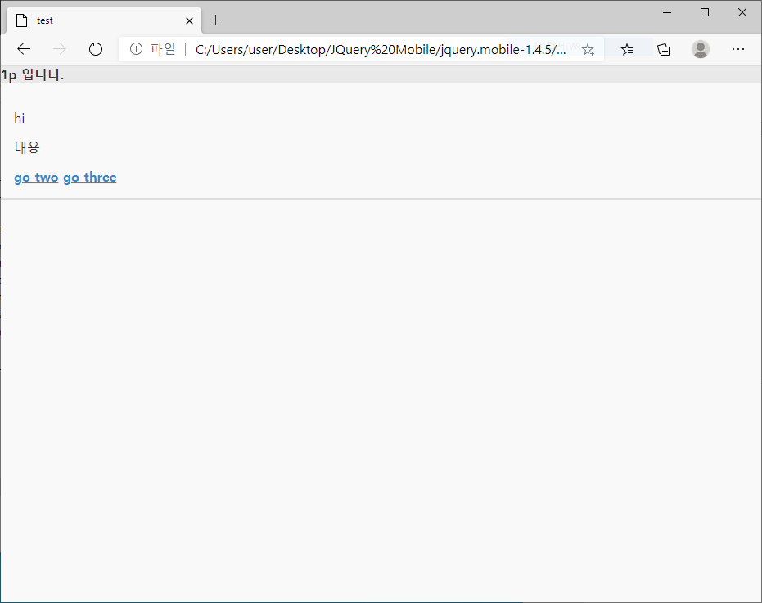

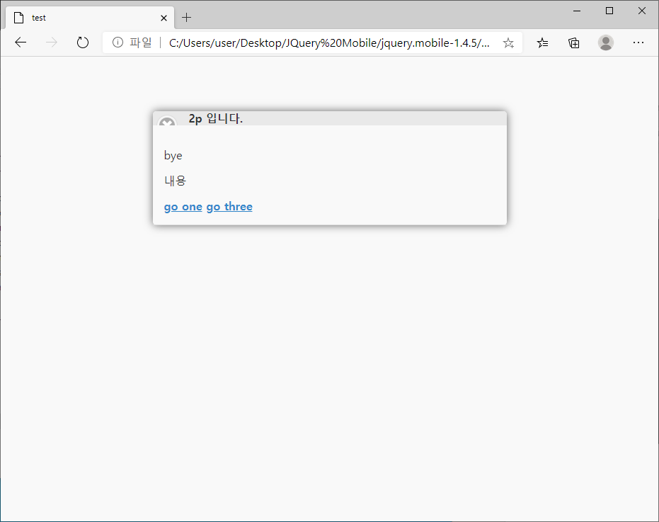

심심해서 넣어본 구글 맵과 테이블

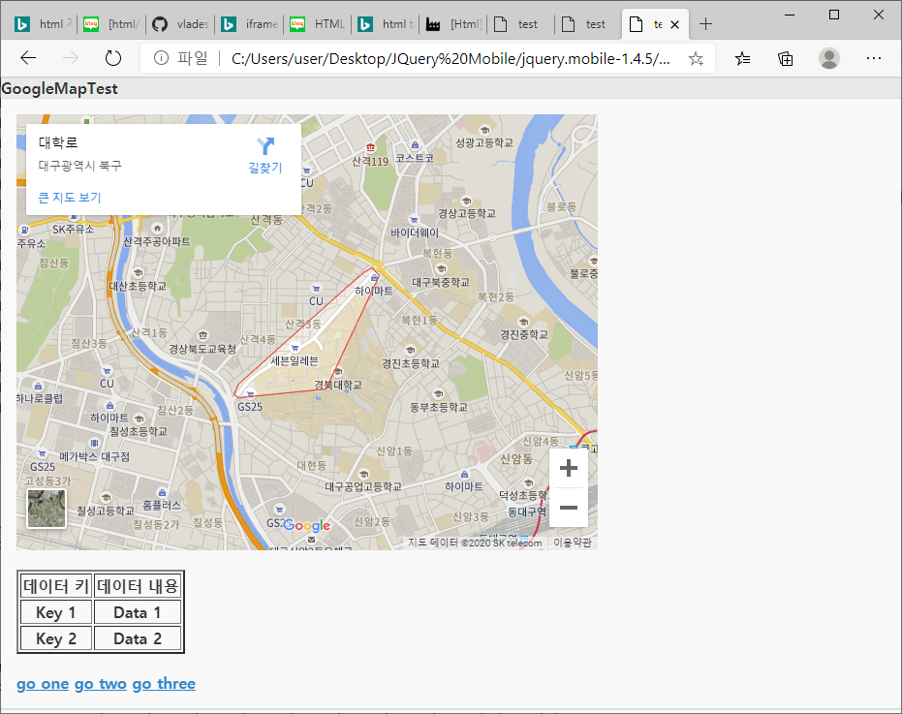

<div data-role="page" id = "Map">

<div data-role = "header">

GoogleMapTest

</div>

<div data-role = "main" class ="ui-content">

<iframe src="https://www.google.com/maps/embed?pb=!1m18!1m12!1m3!1d12928.844685401846!2d128.59981137059276!3d35.89284343076651!2m3!1f0!2f0!3f0!3m2!1i1024!2i768!4f13.1!3m3!1m2!1s0x3565e17503d6077d%3A0xbfc5020d466ac440!2z64yA6rWs6rSR7Jet7IucIOu2geq1rCDrjIDtlZnroZw!5e0!3m2!1sko!2skr!4v1593412276430!5m2!1sko!2skr" width="600" height="450" frameborder="0" style="border:0;" allowfullscreen="" aria-hidden="false" tabindex="0"></iframe><br><br> <table border= "2">

<tr> <th>데이터 키</th><th>데이터 내용</th> </tr>

<tr> <th>Key 1</th><th>Data 1 </th> </tr>

<tr> <th>Key 2</th><th>Data 2 </th> </tr>

</table><br>

<json>{} </javascript>

<a href = "#pageone" data-transition= "turn" >go one</a>

<a href = "#pagetwo" data-transition= "turn" >go two</a>

<a href = "#pagethree" data-transition = "flow" data-direction="reverse" >go three</a>

</div>

<div data-role = "footer">

</div>

</div>

<a href ="#popuplink" data-rel = "popup" class="ui-btn ui-btn-b">팝업창</a>

<div data-role="popup" id="popuplink" data-arrow = "b"><img src="고양이.jpg" width = "300" height="300"></div>

<div data-role = "footer">

팝업 창으로 귀여운 고양이도 달아 보았다.

