20_07_16 학습내용

1. **AWS API GateWay Delete 메소드 추가**
2. **웹 뷰 앱  
   2-1. GPS 위치 잡기**

**2-2. GPS 좌표 값 서버로 전송**

**2-3. 앱에서도 Alert 볼 수 있도록 하기**

**2-4. Notification Service**

**1. AWS API GateWay Delete 메소드 추가**

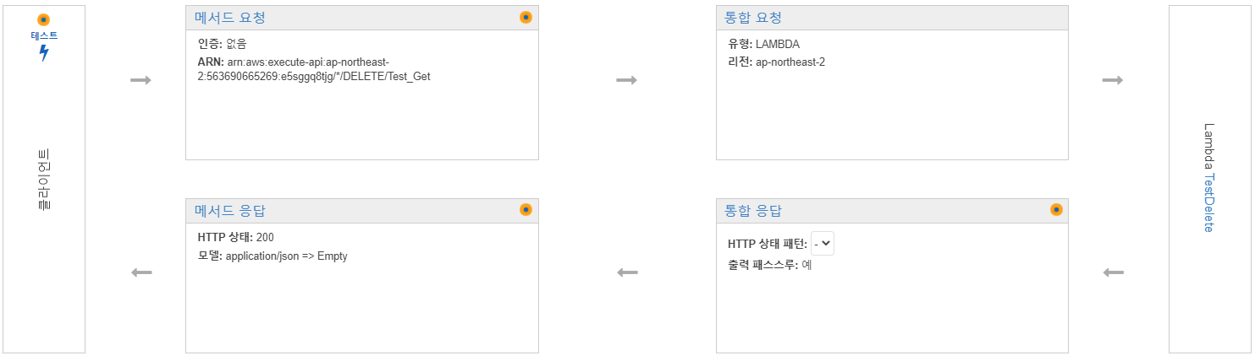

클라이언트 -> 서버 요청 패킷의 바디에

{

"TableName":"TestTable",

"Key":

{

"ID":"3"

}

}

람다 함수

const AWS = require('aws-sdk');

const dynamo = new AWS.DynamoDB.DocumentClient();

exports.handler = async (request,context)=>{

var body = await dynamo.delete(request).promise();

return request.Key.ID+" is deleted";

}

참고로 promise 안붙히면 테이블에서 삭제 안된다.

매핑 템플릿

$input.json('$')

로 설정하여 테스트 해본 결과는 아래와 같다.

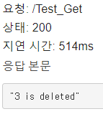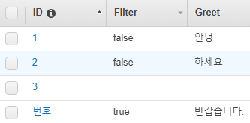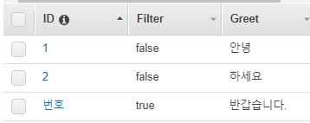

**2. 웹 뷰 앱 - 전체코드는 추후** [**https://github.com/Mindoridori/rgblab**](https://github.com/Mindoridori/rgblab)**에 올릴 예정**

**2-0. 웹 뷰 세팅**

**mWebSettings.setJavaScriptEnabled(true); // 웹페이지 자바스클비트 허용 여부**

**webView <- mWebView**

**webView.setWebChromeClient(new WebChromeClient(){ ~ })**

**해줘야함.**

**2-1. GPS 위치 잡기**

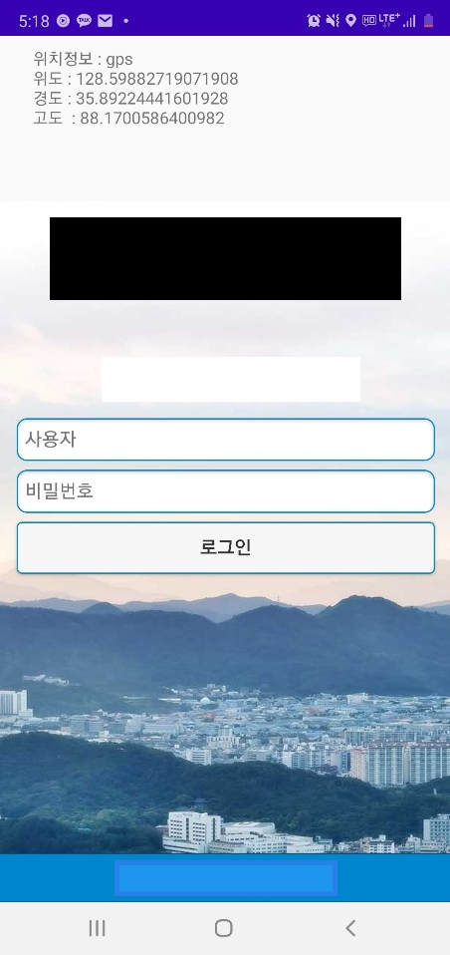

**private void get_lofaction()**

**{**

**final LocationManager lm = (LocationManager)getSystemService(Context.*LOCATION_SERVICE*);**

**if ( Build.VERSION.*SDK_INT* >= 23 && ContextCompat.*checkSelfPermission*( getApplicationContext(), android.Manifest.permission.*ACCESS_FINE_LOCATION* ) != PackageManager.*PERMISSION_GRANTED* )**

**{**

**ActivityCompat.*requestPermissions*( MainActivity.this, new String[] { android.Manifest.permission.*ACCESS_FINE_LOCATION* }, 0 );**

**}**

**else{**

**Location location = lm.getLastKnownLocation(LocationManager.*GPS_PROVIDER*);**

**if(location != null) {**

**String provider = location.getProvider();**

**double longitude = location.getLongitude();**

**double latitude = location.getLatitude();**

**double altitude = location.getAltitude();**

**send_latitude = latitude;**

**send_longitude = longitude;**

**}**

**lm.requestLocationUpdates(LocationManager.*GPS_PROVIDER*,1000, 1, gpsLocationListener); //일정 시간마다 업데이트**

**lm.requestLocationUpdates(LocationManager.*NETWORK_PROVIDER*, 1000, 1, gpsLocationListener); //일정 시간마다 업데이트**

**}**

**}**

**final LocationListener gpsLocationListener = new LocationListener() {**

**public void onLocationChanged(Location location) {**

**String provider = location.getProvider();**

**double longitude = location.getLongitude();**

**double latitude = location.getLatitude();**

**double altitude = location.getAltitude();**

**send_latitude = latitude;**

**send_longitude = longitude;**

**}**

**public void onStatusChanged(String provider, int status, Bundle extras) {**

**}**

**public void onProviderEnabled(String provider) {**

**}**

**public void onProviderDisabled(String provider) {**

**}**

**};**

**2.2 서버로 전송**

**mWebView.addJavascriptInterface(new AndroidBridge(), "HybridApp");**

**mWebSettings.setJavaScriptEnabled(true); // 웹페이지 자바스클비트 허용 여부**

**private class AndroidBridge {**

**@JavascriptInterface**

**public void sendMessage(final String a) { //sendMessage() -> sendMessage(final String arg)**

**handler.post(new Runnable() {**

**@RequiresApi(api = Build.VERSION_CODES.*O*)**

**public void run() {**

**//실행할 코딩**

**String string_latitude = send_latitude+"";**

**String string_longitude = send_longitude+"";**

**System.*out*.println("위도 : "+string_latitude+"경도 : "+string_longitude);**

**mWebView.loadUrl("javascript:androidCall("+string_latitude+","+string_longitude+")");**

**//loadUrl이 실제 전송 부분임.**

**System.*out*.println("Send To Server");**

**}**

**});**

**}**

**}**

이걸 받아줄 function에 대해서도 (여기선 androidCall() )이 javascript로 구현되어 있어야한다.



이런식으로..

**2.3 Alert 보이게**

**public void alertSetting(WebView webView){ //alert창은 모바일에서 나오지 않기 때문에 따로 설정**

**final Context myApp = this;**

**webView.setWebChromeClient(new WebChromeClient() {**

**@Override**

**public boolean onJsAlert(WebView view, String url, String message, final android.webkit.JsResult result) {**

**new AlertDialog.Builder(myApp).setTitle("From Server").setMessage(message).setPositiveButton(android.R.string.*ok*,**

**new AlertDialog.OnClickListener()**

**{**

**public void onClick(DialogInterface dialog, int which)**

**{**

**result.confirm();**

**}**

**}).setCancelable(false).create().show();**

**return true;**

**};**

**});**

**}**

**2-4. Notification Service**

일단은 push 성격상, 앱에서도 종료되지 않도록 ForgroundService로 구현해 두었다.



매니패스트

<uses-permission android:name="android.permission.FOREGROUND_SERVICE"/>

<service

android:name=".Push"

android:enabled="true"

android:exported="true">

</service>

MainActivity 중

Intent intent = new Intent(getApplicationContext(), Push.class);

startForegroundService(intent);

Push

package com.example.webview;

import android.app.Notification;

import android.app.NotificationChannel;

import android.app.NotificationManager;

import android.app.PendingIntent;

import android.app.Service;

import android.content.Context;

import android.content.Intent;

import android.graphics.BitmapFactory;

import android.os.Build;

import android.os.IBinder;

import androidx.annotation.Nullable;

import androidx.annotation.RequiresApi;

import androidx.core.app.NotificationCompat;

public class Push extends Service

{

@RequiresApi(api = Build.VERSION_CODES.*O*)

@Override

public void onCreate() {

super.onCreate();

PendingIntent mPendingIntent = PendingIntent.*getActivity*(

Push.this,

0, // 보통 default값 0을 삽입

new Intent(getApplicationContext(),MainActivity.class),

PendingIntent.*FLAG_UPDATE_CURRENT*

);

String CHANNEL_ID = "channel 1";

NotificationChannel channel = new NotificationChannel(CHANNEL_ID, "Push", NotificationManager.*IMPORTANCE_HIGH*);

NotificationManager notificationManager = ((NotificationManager) getSystemService(Context.*NOTIFICATION_SERVICE*));

notificationManager.createNotificationChannel(channel);

NotificationCompat.Builder notificationbuilder = new NotificationCompat.Builder(this, CHANNEL_ID)

.setLargeIcon(BitmapFactory.*decodeResource*(getResources(), R.drawable.*dico*))

.setSmallIcon(R.drawable.*dico*)

.setContentTitle("알림")

.setContentText("내용")

.setAutoCancel(true)

.setPriority(NotificationCompat.*BADGE_ICON_SMALL*)

.setContentIntent(mPendingIntent);

Notification notification = notificationbuilder.build();

// notificationManager.notify(0,notification);

startForeground(2, notification);

}

@Nullable

@Override

public IBinder onBind(Intent intent) {

return null;

}

}