docker-compose를 통한 개발 환경 구성하기

예정  
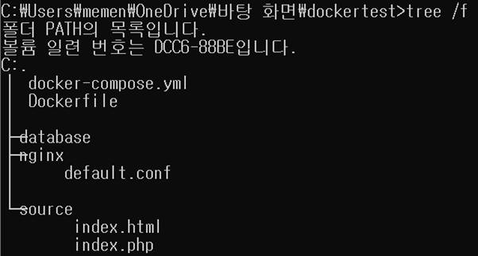

version: '3'

services:

web:

image: nginx:latest

depends_on :

- mysql

expose:

- "8080"

volumes:

- ./source:/source

- ./nginx/default.conf:/etc/nginx/conf.d/default.conf

php:

image: php:7.3-fpm

expose:

- "9000"

volumes:

- ./source:/source

mysql:

image: mysql

container_name: mysql-server-80

command: --default-authentication-plugin=mysql_native_password

volumes:

- ./database:/var/lib/mysql

restart: always

environment:

- MYSQL_ROOT_PASSWORD=rgblab

- MYSQL_DATABASE= rgblab

- MYSQL_USER= rgblab

- MYSQL_PASSWORD= rgblab

ports:

- "8082:3306"

에러 발생해서 수정하였음

