**Webscraping the emart& tesco**

**Why do I pick those?**

Emart and tesco is the most popular distribution company for Korean & English. It has grown over the years and has become the latest company for FMCG in the nation respectively.

**Objective**

to scrape data associated with best selling and delivery service and to use this data to gain insight on the different purchasing pattern between two countries as well as how different the delivery service is among them.

**Description of Data to be scrapped**

The data that will be collected for each website includes the service type, whether is payed or not payed in case of using delivery service, the name of product, rank.

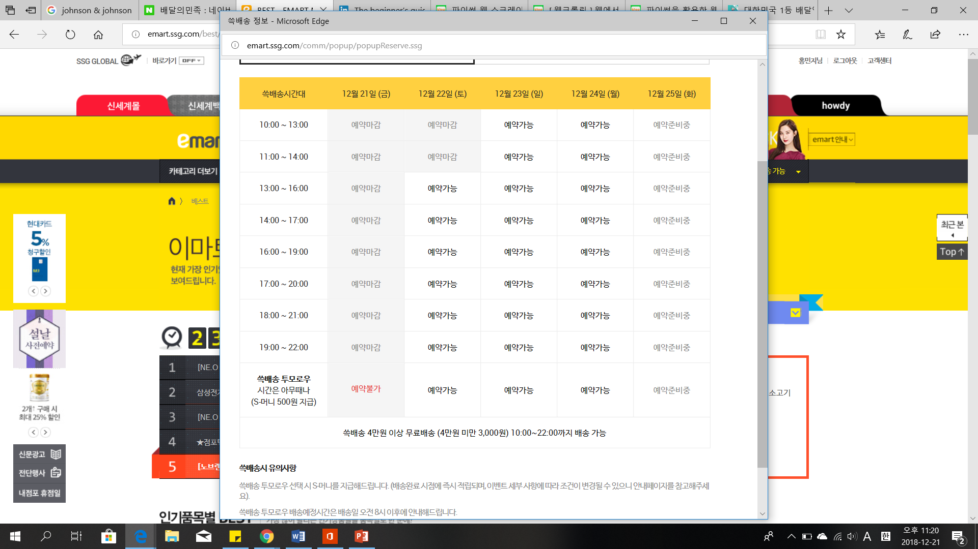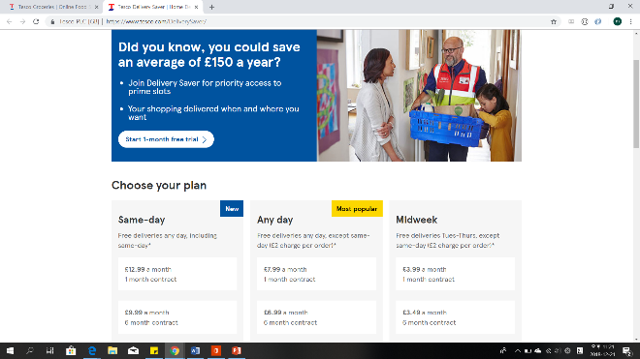

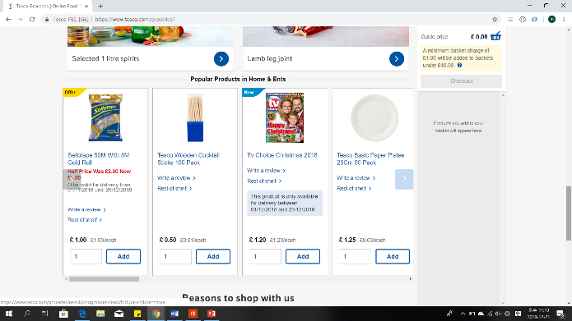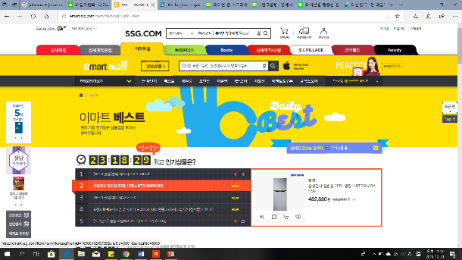

**Challenge Encountered**

-picking up the topic

While scaping, I encountered a few challenges. First, the volume of data is not enough to be scrapped. I assumed the meaning of scaping is collecting the data on web efficiently. But the volume of data is too few for that. Also it would be meaningless to compared with two different type if there is no meaningful difference. In that view, there isn’t both.