ASSIGNMENT 1

Part 2

Tran Thanh Minh

103809048

COS10026 – COMPUTER TECHNOLOGY INQUIRY PROJECT

Swinburne University of Technology

# Introduction

## Introduction

This is the integration project from the assignment 1 part 1. The PHP language has been implemented into the webpages to minimize the code and add more features to manage the data of the user using SQL and PHP.

## Objective of report

The objective of the report is to give the reader to understand of the newly added functions, new webpages and how PHP and SQL have been implemented. The report also helps the user visualize the role of each person in the team to build up this project. In addition, the reader can see how we have combined different programming languages to build up the projects.

## Outline

Introduction 2

Introduction 2

Objective of report 2

Outline 2

Website 3

Website introduction 3

Innovative features 8

Contribution 9

Reflection and Discussion 10

Conclusion 11

Appendix 11

# Website

## Website introduction

**Enquiry page**

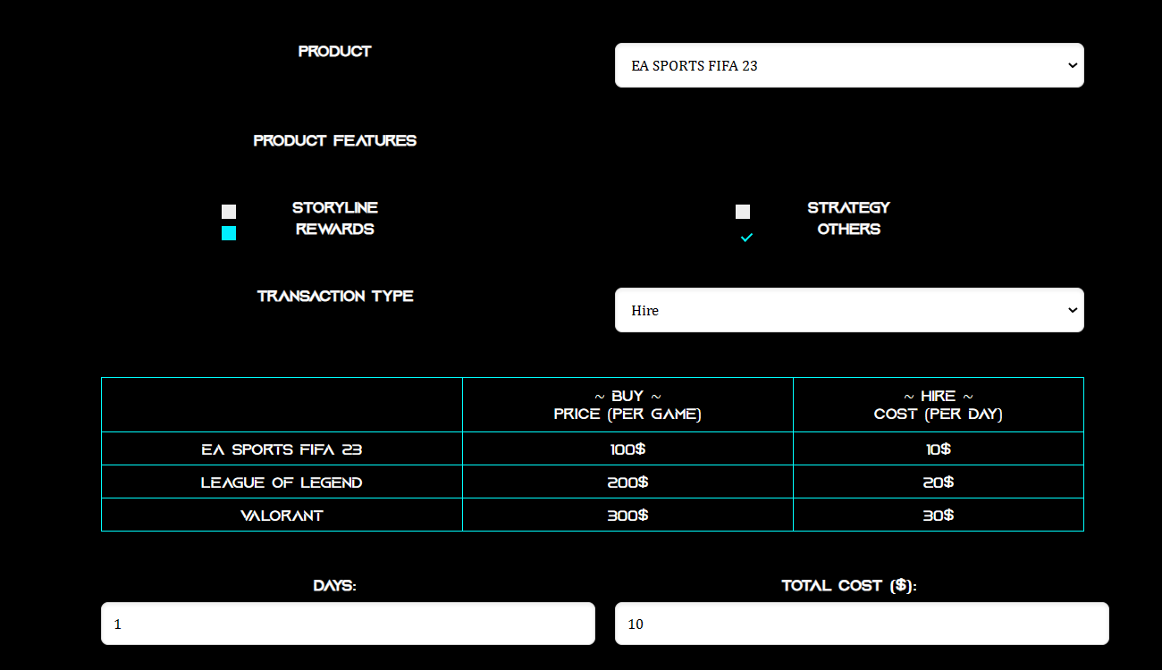

*Image 1: new feature of Enquiry page*

For this page, I have implemented a new feature to calculate the price of the game. Whenever the clint choose the price when want to buy, the quantity field will display and when the client wants to hire a game, the cost will display. I have used JavaScript for this feature so that it can calculate the cost in the most efficiency whenever the client enters number, they want into the quantity field or days field. But it can only be displayed and entered after the user has chosen one of the products. Overall, it is not too different with the previous version from assignment 1. I just added a little bit of JavaScript and CSS to implement the feature for the web. I also have removed all the form validate method so that later, on the process_order.php.

*Image 2: when the client wants to buy (Enquiry page)*

**Payment page**

*Image 3: Payment page*

For the Payment page, it is only used for collecting the card detail for later processing. All the validated methods will be implemented in the process_order.php to check the card details. For this page, I have reused the HTML classes and CSS from the previous page for minimizing the code and may help the webpages to run faster.

**Process order page**

This page is the backend page where to check all the validated fields from the enquiry and payment form. Because the two forms that were submitted haven’t checked the format so at this stage, it will be checked. If there is any occurred error, the page will proceed to the fix order page to fix the input field and details, if all the data is in correct format and then it will be uploaded to the database and the page will direct the user to the receipt page.

PHP mainly used on this page is to validate and process the event and connect to the database. If the table is not created yet, the process order page will create and upload the information.

This page works with $_SESSION[] a lot to transfer the state of fields through webpages and store to proceed to the database. It keeps checking the data whenever it is submitted from the payment and fixes the order page.

All the errors will be stored in to the array errMsg[] with the appropriate format and when in the file fix order, it will be called to check whenever the error is empty or not.

**Fix order page**

*Image 4: Fix order form*

All the errors from the previous pages will be printed out and will be said clearly for each fill so that the customer will know where to fix. For each error, the description will be printed out. This page also includes the method to check the field for radio, select, checkbox by using the if else. If the session for that field is not empty, then it will compare the current option with the one store in the session. If it matches, then the PHP will echo out the ‘selected’ or ‘checked’ inside the HTML input tag.

**Management page**

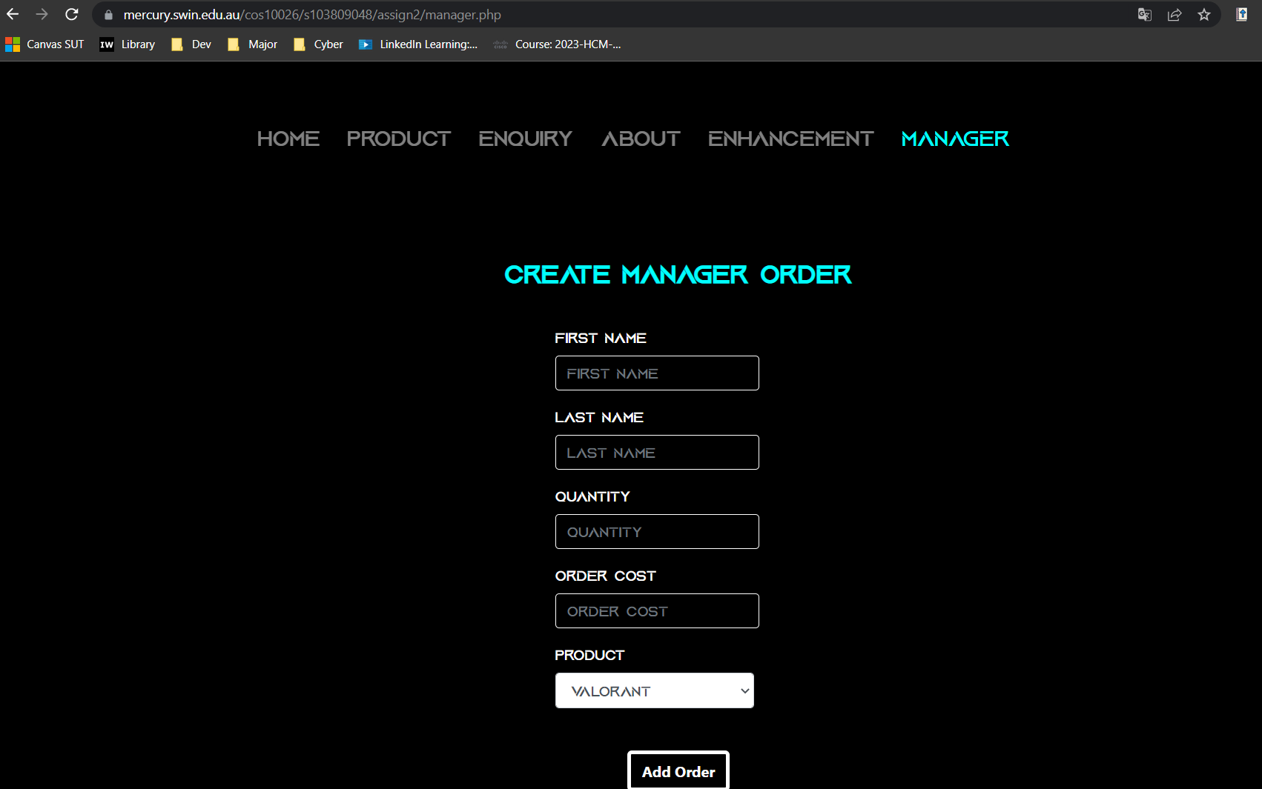

*Image 5: First part of the manager page*

*Image 6: Second part of the Manager page*

This is the page where the authorized user can query to the database to receive the information about the orders. Most of the code for this page is using the PHP to generate the HTML and connect to the MySQL to query for taking out the information. With the use of small forms, for each query, there is a distinction form to take out the data from the database. A lot of mysqli_query() and mysqli_fetch_assoc() were used to create queries and take the information from the database then display with the use of PHP and HTML.

A lot of small forms are used so that whenever submitted, the result for that search will display. And there is some PHP code to check whenever the input field is empty or not to process the event such as isset($_POST[“*name of field*”]).

Whenever the error occurs, the die(mysqli_error($conn)) will display the error.

**Enhancements 2 page**

*Image 7: Part of enhancements 2 page*

I have reused elements from the assignment 1 part 1 so I don’t need to change anything much except the button below the page to change to the enhancements 1. The enhancements 2 page will be the default page on the navigation bar. All the descriptions for the new enhancements for part 2 have been included on this page.

## Innovative features

For this part, my group has some innovative features which are quite difficult for us at first but then my team has researched about PHP in-built library and SQL command which are suitable to be used in the current context. My teammate has added:

1. Show the predicted cost when selecting the product.
2. Show error for each field.
3. Advanced report query.
4. Login and log out.

For the first feature, I have used JavaScript to calculate the total cost when the customer wants to buy or hire. Whenever the customer has selected the product and the type of service (buy or hire) then the field for the quantity of product will be displayed, if the value is entered then the field next to it will calculate the cost for the order.

For the second feature, my teammate has understood the PHP in-built libraries so that they can use it effectively to check the errors and display the error near the field. This can help the user to know exactly where to fix the information and submit again.

For the third feature, SQL query combines with PHP to take the information from the server to display, the manager or authorized user can interact with the UI to query the output or the result they want to find.

For the last feature, it helps to minimize the number of people who can access the personal information of the customers. It is created by using PHP for checking the log in fields, and request to the database using the SQL command and check whenever the login details are in the database or not and are they match with the details.

# Contribution

Throughout the process of developing the Assignment 1 part 2, compared to the part 1, I have made more contributions due to more required work. Same with the last part of the assignment, I have taken an active role in organizing the team’s work and understand all the parts of the assignment so that whenever they need help, I can contribute my ideas and fix minor errors of their work.

For my part, I have done my work sooner than others so that I can send files and they can start their part. I can help them by giving them my opinions of how to minimize the code, improve the code. I also remind other teammates about the project regularly so that they won’t forget to do it and try to assist those who are struggling with the project. After all, I have been involved in the process of checking the code based on the rubrics to make the project built based on the rubrics as close as possible.

In addition, I have redesigned the user interface for the receipt page to make it prettier and attract the customer. I also have designed part of the UI of the managers (the advanced part) to improve the appearance of the webpage.

Furthermore, I have edited the code for others to delete the navbar and the footer and create files .inc to minimize the code and match the requirements. With the contribution to create the table on the MySQL server and create payment.php, I also involve in checking work before submitting the work to Canvas.

# Reflection and Discussion

For the comments for the teamwork, I have tried to eliminate unnecessary meetings and only meetings or have discussions about important things so that each member can focus on their work and have time for researching for their part. For the first part, from my perspective, there is a lot of work, so some members haven’t met the deadlines which we have agreed. But for the second part, we have tried to finish it early and meet the deadlines on time. However due to the amount of massive work and the difficulties of the assignments, we have submitted the assignment right on time even those it is not perfect yet. If I have chanced to do it again, I will improve the user interface to make it more colorful and has more interesting features. I also will try to improve PHP code for validating the information to make the collected data more accurate, I also will try to make the receipt page more colorful and attractive and display more information to be accurate on each customer and realistic.

In this project, there are still issues related to the security, specifically, the card details when there are a lot of type of attack, and we only apply some protected methods to prevent the common attacks such as code injection … If we want to make the project become more realistic, we must research more about the methods of attack and how to prevent them to implement these methods in the similar future project. If we cannot maintain the security of the card details, a high chance of losing the personal details (client details) will happen and no one will trust this project. Protecting user data is part of the project and we will try to research and implement any possible solution to protect it so that we can remove the security issues and their consequences. Maintaining the security of this information is crucial for building trust with users and other companies when they want to collaborate with us.

# Conclusion

With more innovative features and enhancements have been implemented to the project and described in this report, the evidence has shown that both I and my teammates have put a lot of effort and attention to create an attractive webpage and bring the realistic definition to our project. There are methods that have been implemented to keep privacy and security so that the personal details and card details.

In conclusion, coming to the end of the project, from my perspective, this project is successful. All members have tried to bring the project from nothing to succeed. From this project, all of us have gained experience in working in groups and project planning and other skills which will be necessary for our future career.

# Appendix

[Link to mercury](https://mercury.swin.edu.au/cos10026/s103809048/Assign2/index.php)