Test Specification Document
Test Specification ID : TS-GLDB-001
Name of Tester : Eaint Tu Han, Hsu Myat San
Use Case ID : UC-COMP-001 (Regulatory Compliance Management)
Date of Test : July 2026
Description of Test : Functional testing of GLDB Automated Regulatory Monitoring and Compliance Management System covering all 9 dashboard modules, 7 AI agents, and core features.
S/No | Test Case | Expected Result | Pass/Fail | Remarks
Authentication & Home Page
1. | Login with valid credentials (officer@gldb.com / 123456) | - Login overlay disappears  - Home page displayed with GLDB logo, quick stats (Alerts, Open Gaps, Pending Tasks), and "Go to Dashboard" button  - Sidebar is hidden | Pass | 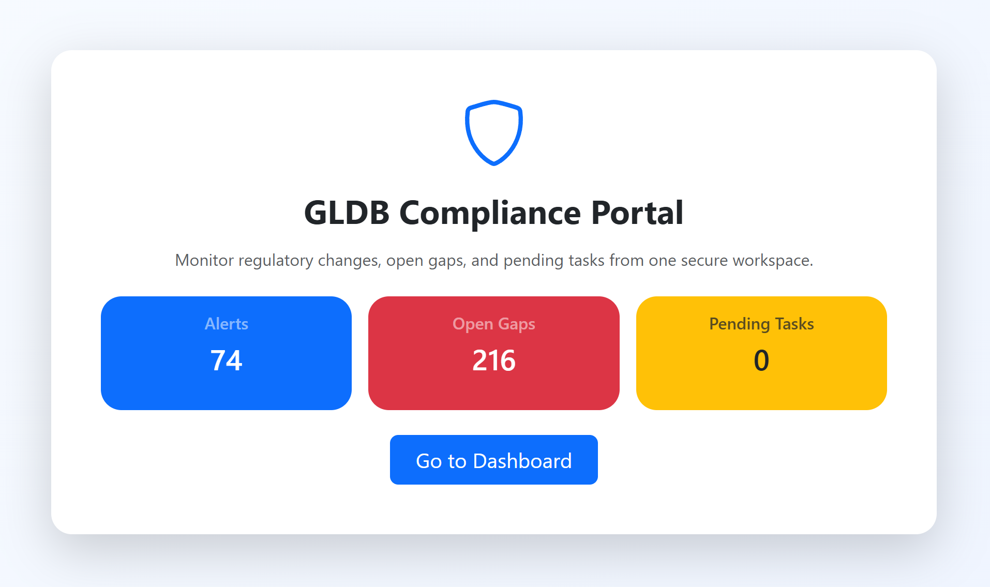
2. | Login with invalid credentials | - Error message "Invalid email or password" shown in red alert box  - User remains on login screen | Pass | 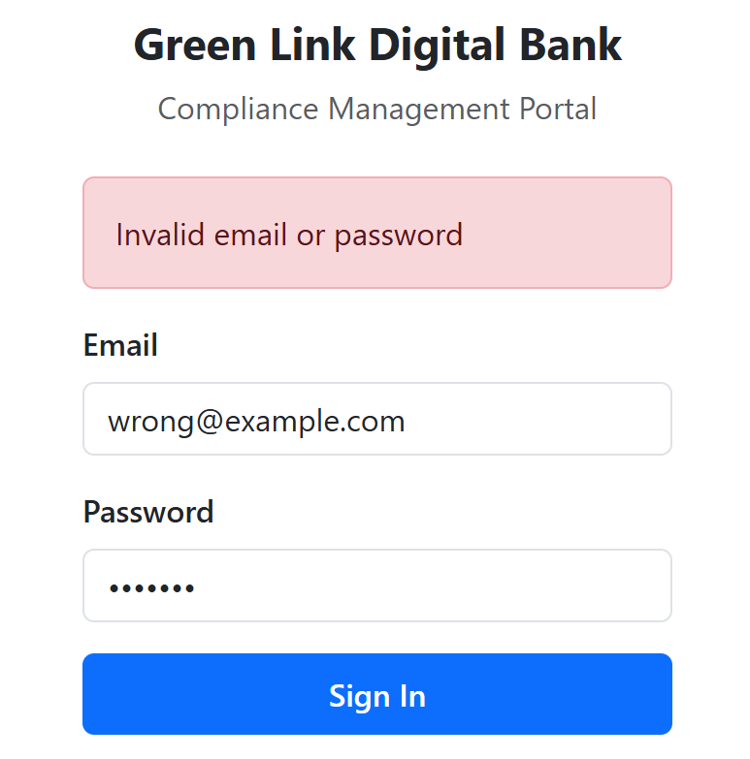
3. | Click "Go to Dashboard" button on home page | - Sidebar navigation appears  - Alerts tab loads with summary cards and table | Pass
4. | Click GLDB logo in navbar from any tab | - Returns to home page  - Sidebar hidden again  - Quick stats refreshed | Pass
5. | Click Logout button | - Login overlay reappears  - Session cleared | Pass
Alerts Tab
6. | View Alerts tab with summary cards | - 5 summary cards displayed: Total Alerts, Unread, Immediate Action, Review Recommended, Informational  - Counts match database data | Pass
7. | Filter alerts by severity "Immediate Action Required" | - Table shows only Immediate Action Required alerts  - Other severity levels hidden | Pass
8. | Change alert status from Unread to Read using dropdown | - Status updates immediately  - Summary card counts refresh  - Toast notification "Alert status updated to Read" | Pass
9. | Click "Mark All Read" bulk action button | - All alerts updated to Read status  - Toast shows number of affected alerts  - Unread count becomes 0 | Pending
10. | Click "Dismiss Info" bulk action button | - Only Informational alerts set to Dismissed  - Critical/High alerts unchanged | Pass
11. | Click "View Change" link on a Critical alert | - Navigates to Changes & Impact tab  - Opens the detail panel for that specific change | Pass | 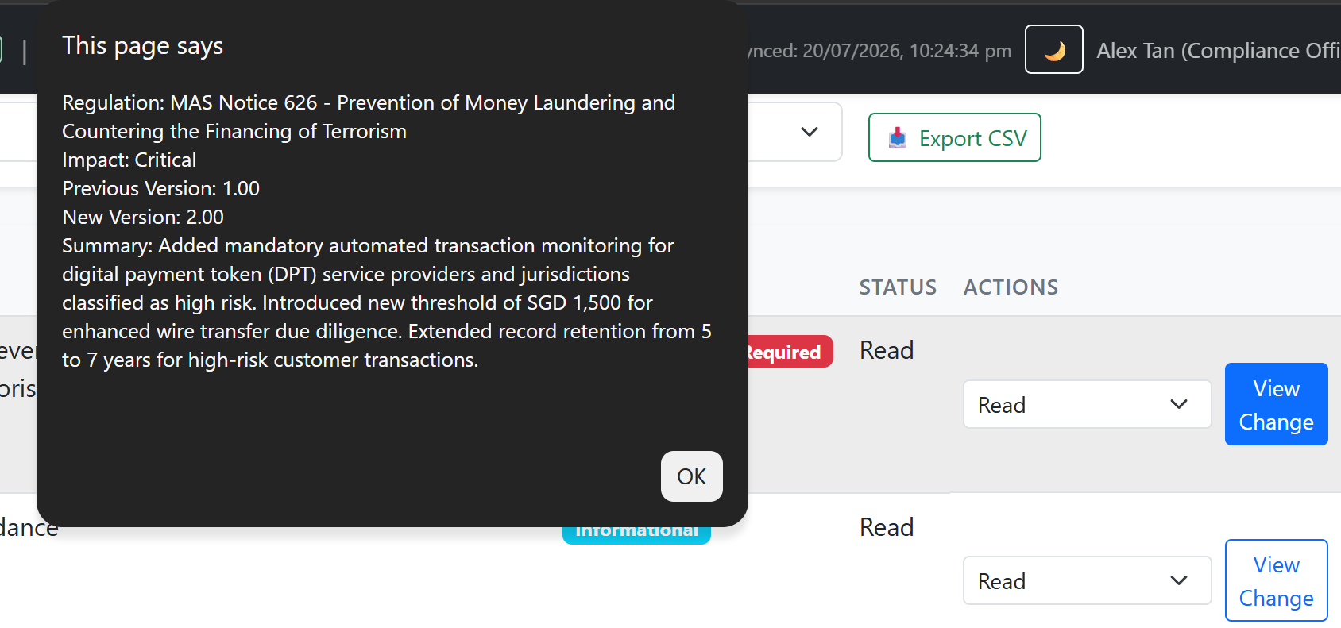
12. | Click "Send Test Alert Email" button | - Toast shows "Summary digest email sent to [email]"  - Email received in Gmail inbox with formatted digest containing 3 sample alerts | Pass | 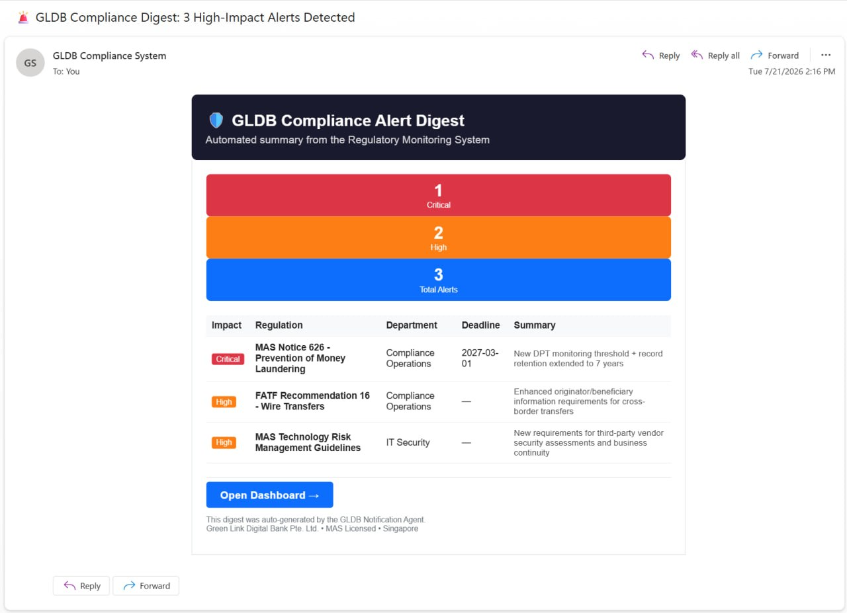
Changes & Impact Assessment Tab
13. | View Changes & Impact tab with summary cards | - 5 cards displayed: Total Changes, Critical, High, Medium, Auto-Tasks Created  - Table shows all regulation changes sorted by impact (Critical first) | Pass | 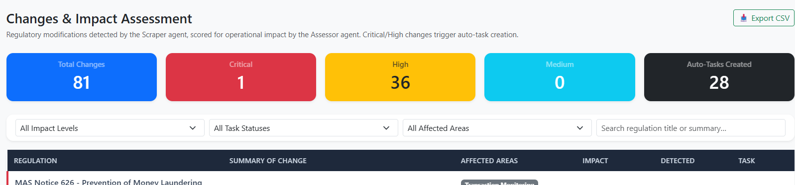
14. | Filter by Impact Level "Critical" | - Only Critical changes displayed  - Red left border visible on each row  - ⚠️ PENALTY badge shown if deadline exists | Pass | 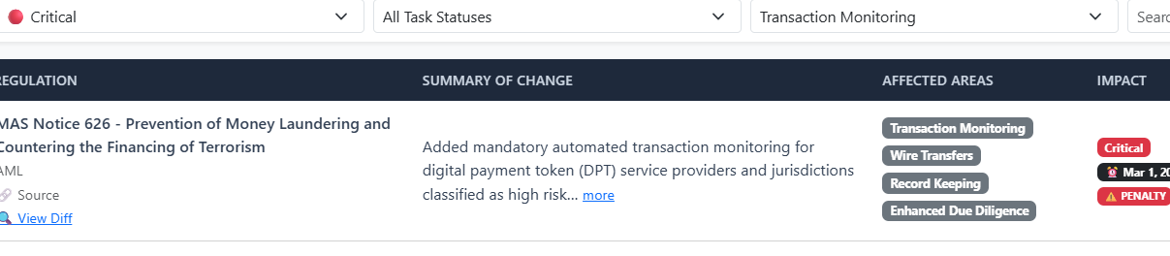
15. | Filter by Affected Areas (e.g. "Transaction Monitoring") | - Table shows only changes with "Transaction Monitoring" in affected areas | Pass | 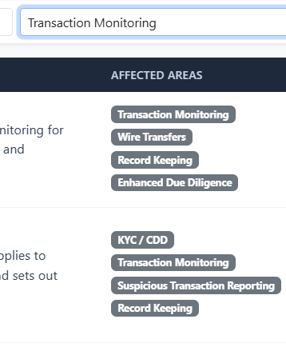
16. | Click "View Diff" on a change with old_content (first row - MAS Notice 626) | - Detail panel opens showing side-by-side: Previous Version (left, red border) and Current Version (right, green border)  - Change type badge, affected areas badges, compliance deadline, and detected date shown | Pass | 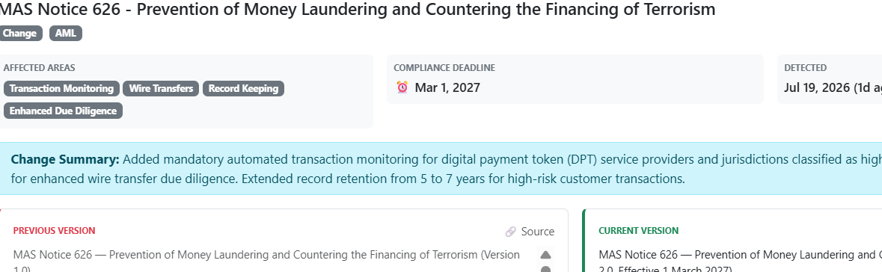
17. | Click "View Details" on a change without old_content | - Detail panel opens  - Only Current Version panel visible (full width)  - Previous Version panel hidden | Pass | 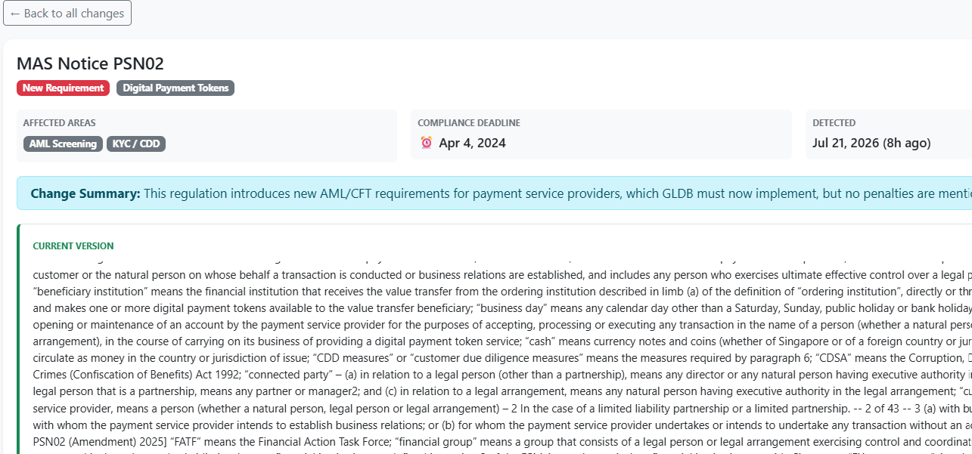
18. | Verify auto-task column shows "Pending" badge for Critical/High changes | - Critical/High rows show ⚡ Pending/In Progress badge with "View" button  - Medium/Low rows show "+ Create" button for manual task creation | Pass
19. | Search for a regulation by title in search box | - Table filters in real-time as user types  - Only matching rows displayed | Pass | 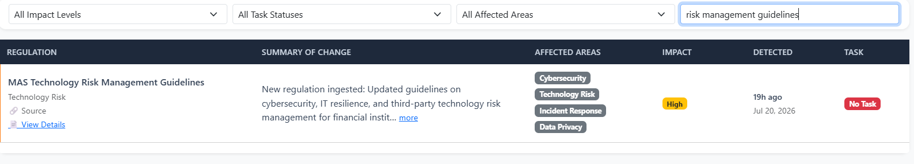
Tasks Tab
20. | View auto-generated tasks from Dispatcher agent | - Tasks displayed with title, department, deadline, and status  - Clickable 📋 changes badge showing linked regulatory changes  - Clickable 🔗 gaps badge showing linked compliance gaps | Pass | 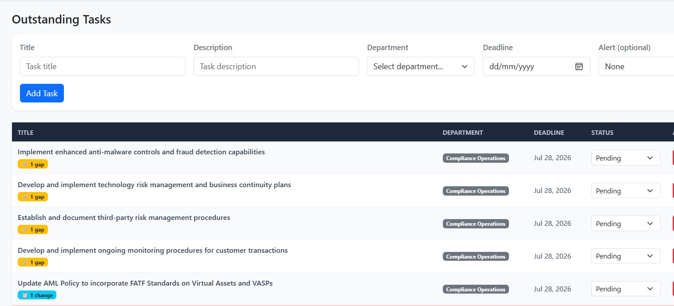
21. | Click 📋 changes badge on a task | - Navigates to Changes & Impact tab filtered to only the linked regulatory changes for that task | Pass | 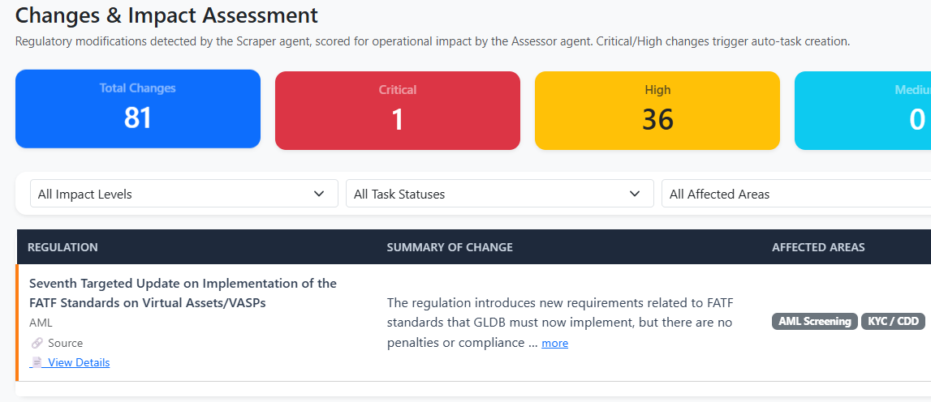
22. | Click 🔗 gaps badge on a task | - Navigates to Gaps tab and highlights/scrolls to the linked gaps | Pass | 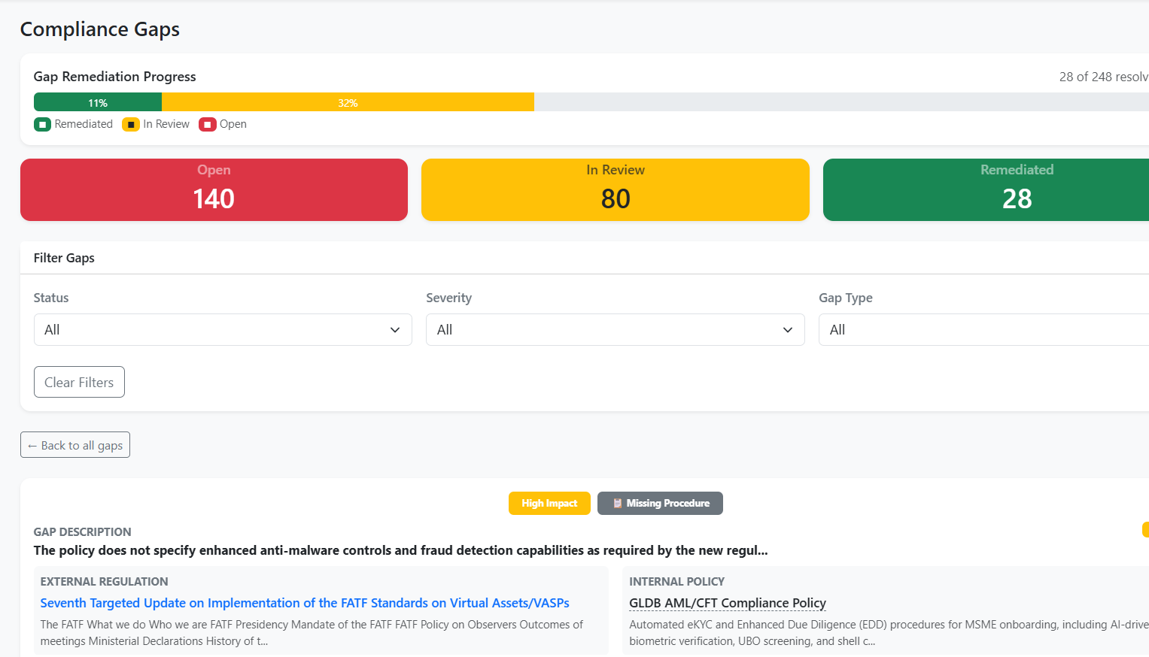
23. | Change task status to "Completed" | - Task status updates  - All linked compliance gaps automatically set to "Remediated"  - Audit log entry created | Pass | 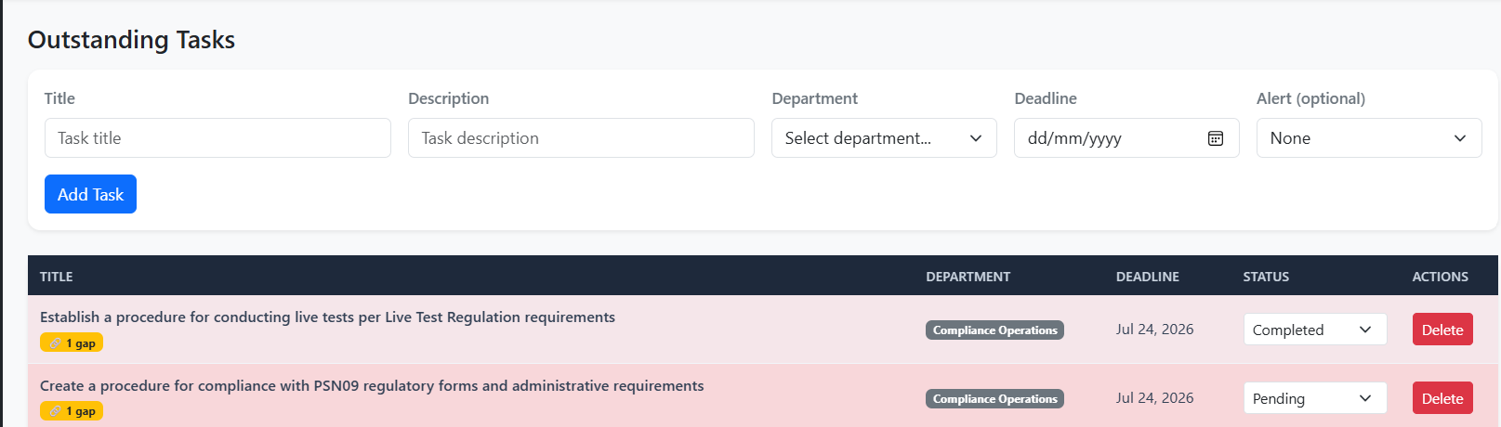
24. | Create a manual task using the form | - Task created with title, department, deadline  - Appears in table  - Toast confirmation shown | Pass | The task is created and appears in the table. Audit log entry is also created.
25. | Delete a task | - Task removed from table  - Audit log entry created | Pass
Compliance Gaps Tab
26. | View Gaps tab with progress bar and summary cards | - Progress bar shows Remediated (green), In Review (yellow), Open (red) proportions  - 3 summary cards: Open, In Review, Remediated counts | Pass | 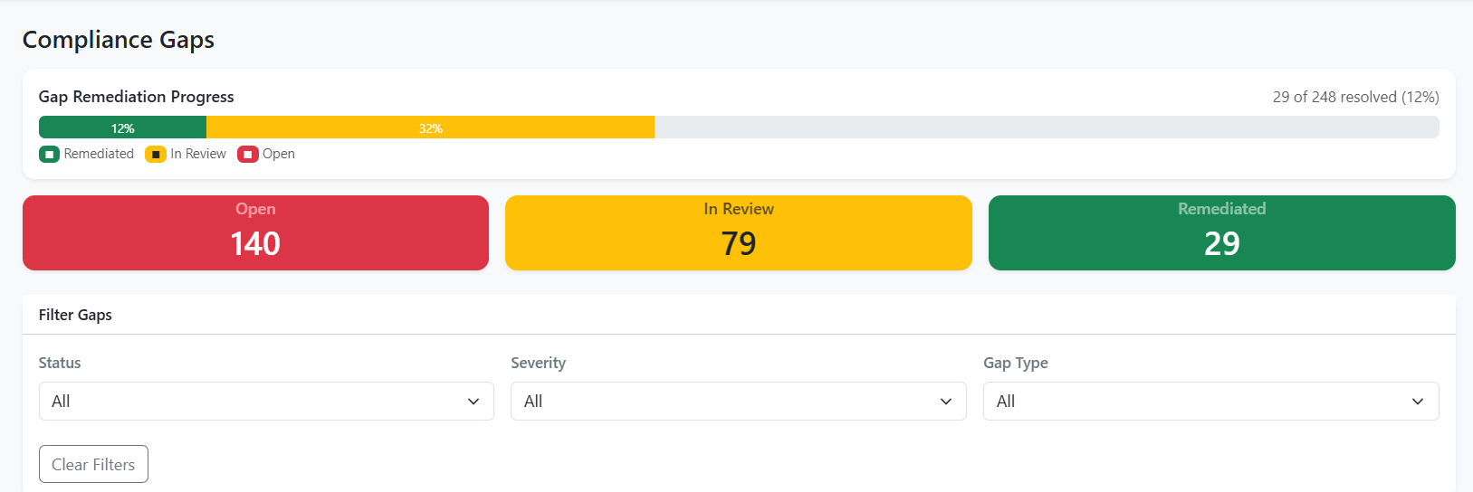
27. | Filter gaps by type "Missing Procedure" | - Only gaps with [Type: Missing Procedure] displayed | Pass | 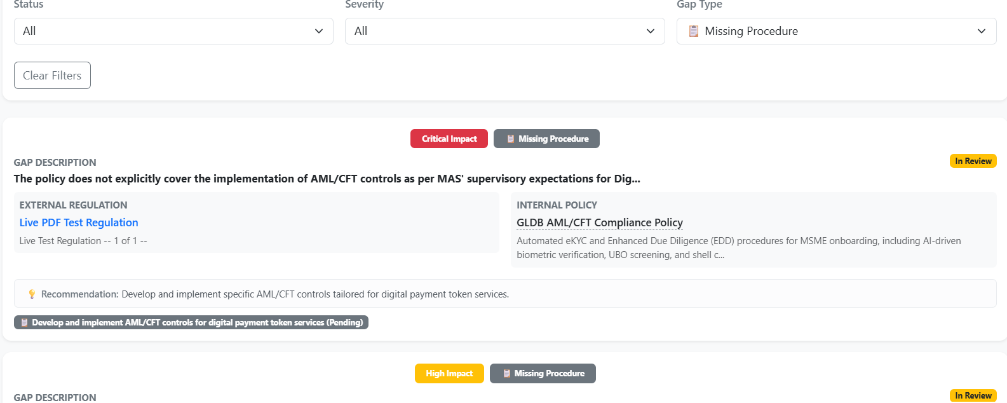
28. | Filter gaps by type "Insufficient Detail" | - Only gaps classified as Insufficient Detail displayed  - Verifies AI agent produces varied gap types (not all "Missing Procedure") | Pass | 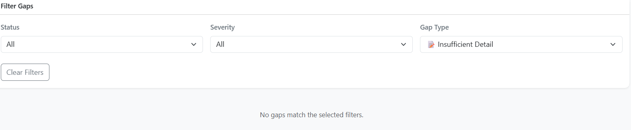
29. | Click "Create Task" button on an open gap | - Modal opens with pre-filled gap info  - Form fields: Title, Description, Department, Deadline  - Submitting creates task linked to gap via task_gaps table  - Gap status changes to "In Review" | Pass | After creating task form, gap status changes from “Open” to “In Review” as expected.
30. | Change gap status manually (e.g. Open → In Review) | - Status updates  - Progress bar recalculates  - Audit log entry created | Pass | 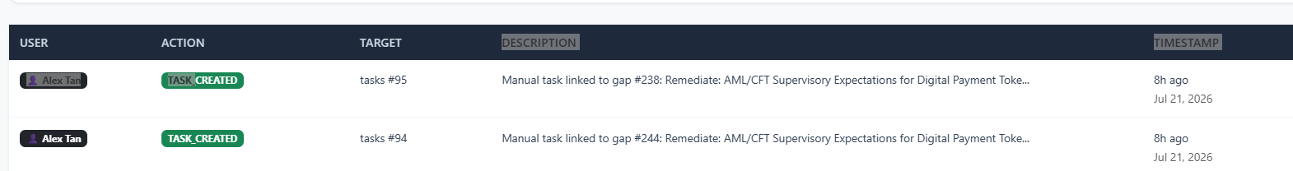
Regulations Knowledge Base Tab
31. | View Regulations tab with filters | - Table shows all scraped regulations with title (clickable to source), source badge, category badge, version, published date, status  - Filter dropdowns: Category, Source, Status (Assessed/Pending) | Pass | 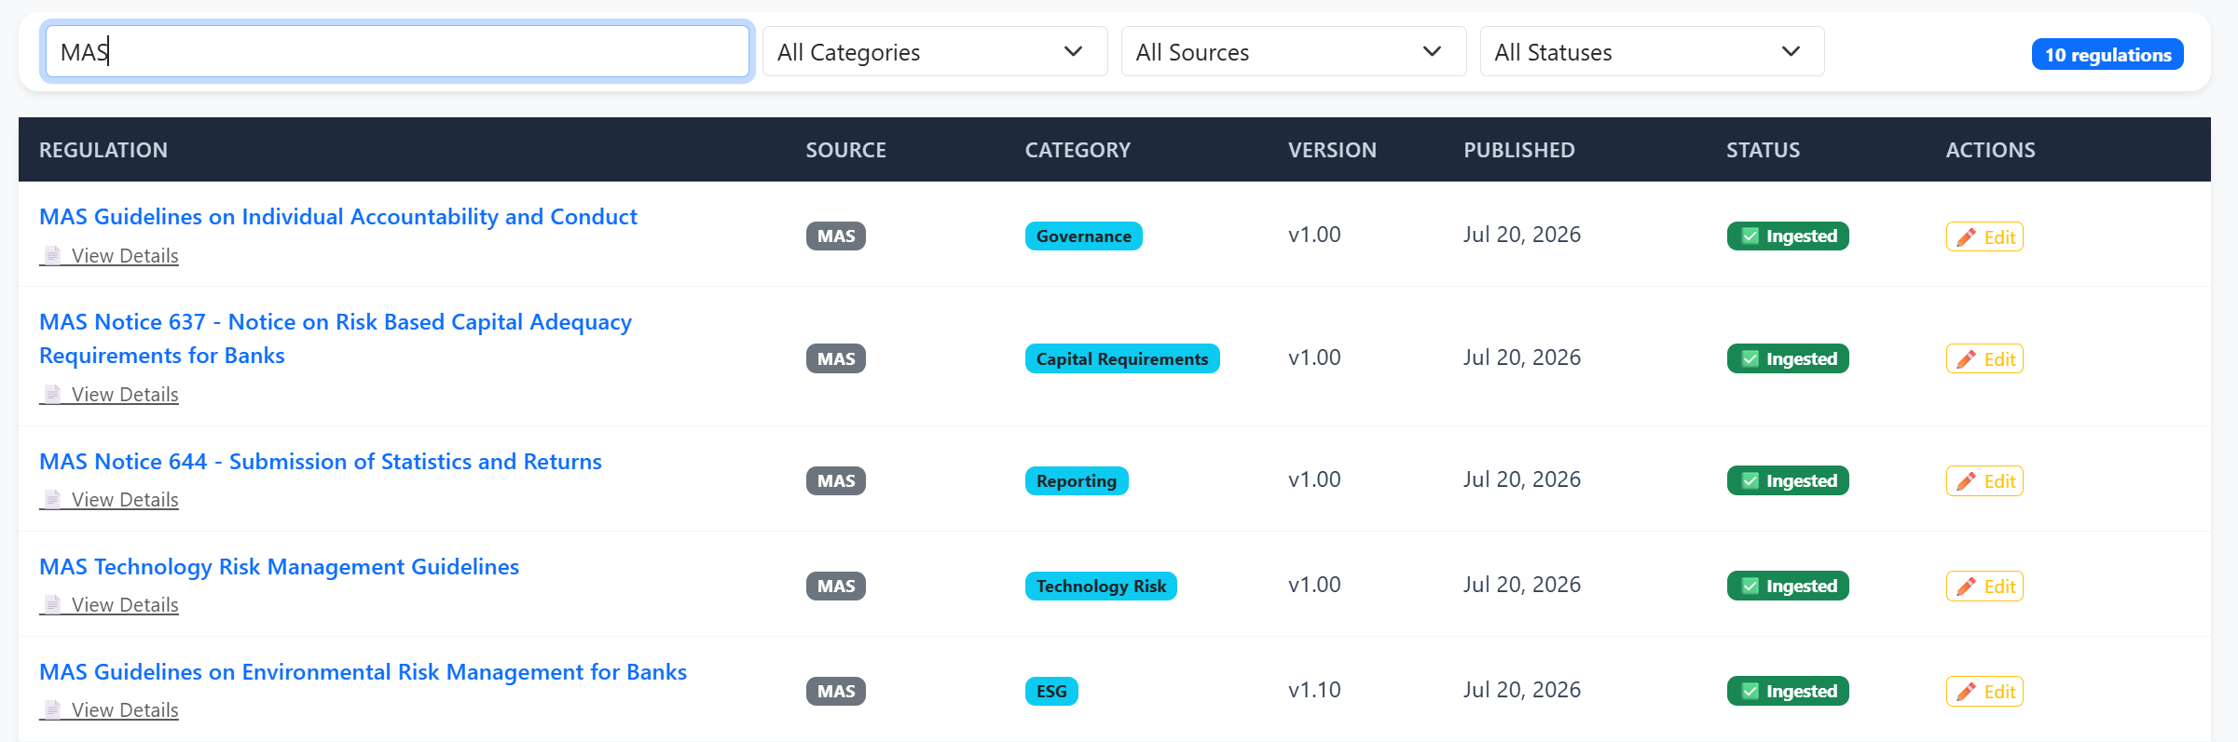
32. | Click regulation title link | - Opens official regulatory source URL in new browser tab | Pass | 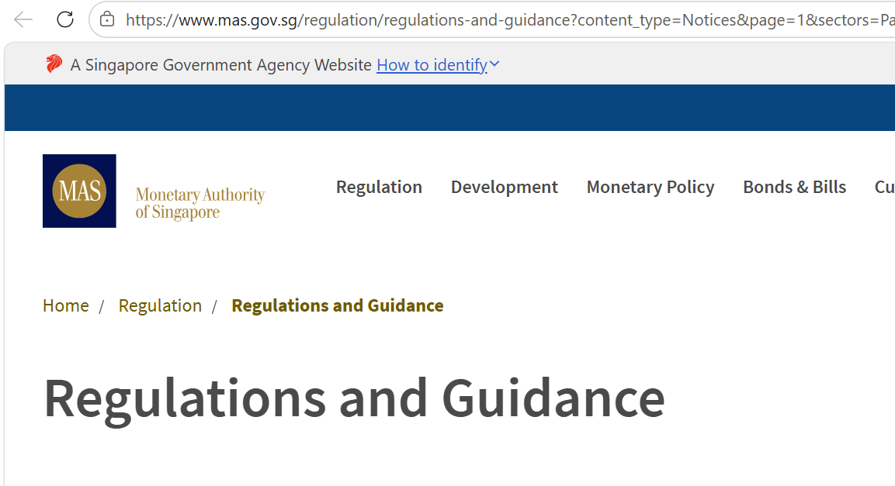
33. | Click "View Details" on a regulation | - Detail panel opens showing full content, source, category, version, date  - Related section shows impact changes detected + compliance gaps linked to this regulation | Pass | 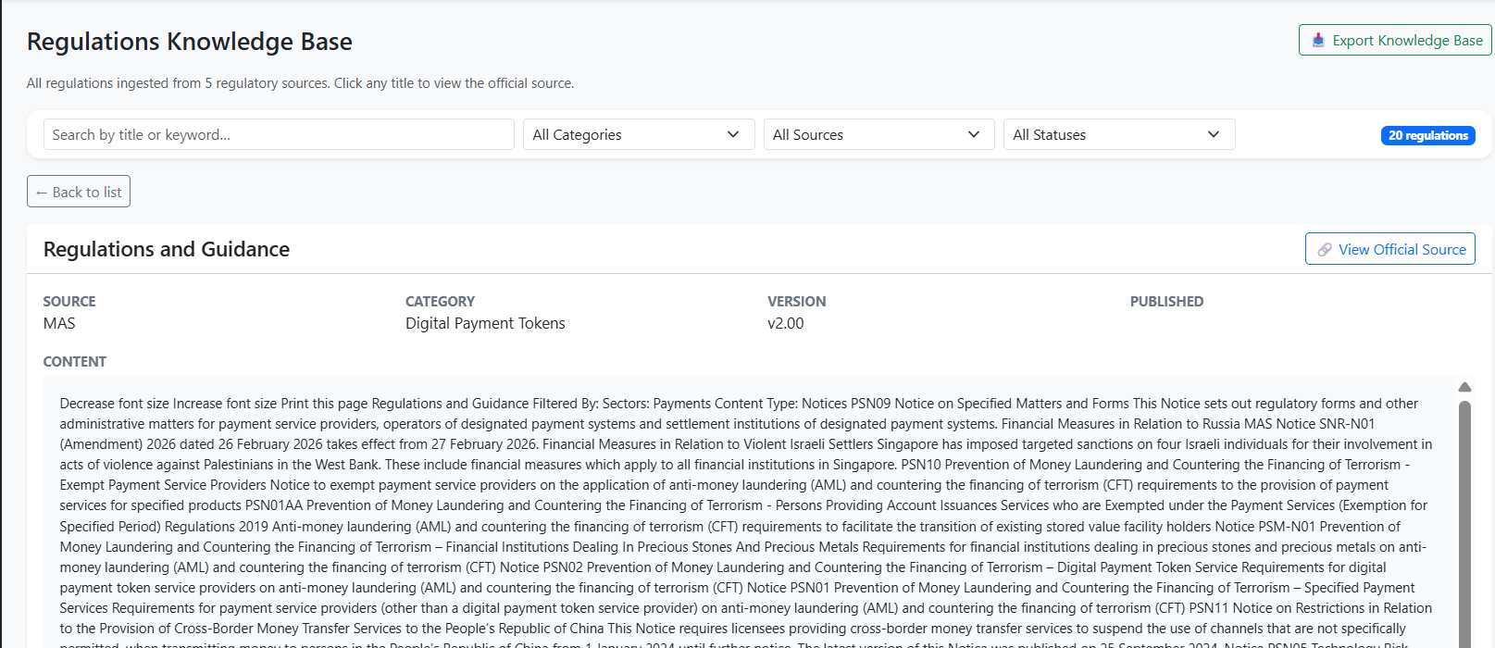
34. | Upload a PDF regulation via "Upload PDF Regulation" form | - Success message: "PDF uploaded and regulation created. AI pipeline triggered."  - Shows chars extracted and page count  - Regulation appears in table  - AI agents process it (visible in server logs): Assessor scores impact, Analyzer finds gaps, Dispatcher creates tasks if Critical/High | Pass
35. | Upload a scanned/image-only PDF (no extractable text) | - Error message: "Could not extract meaningful text from PDF. File may be scanned/image-based."
36. | Filter regulations by Category "Digital Payment Tokens" | - Only DPT-category regulations displayed | Pass | 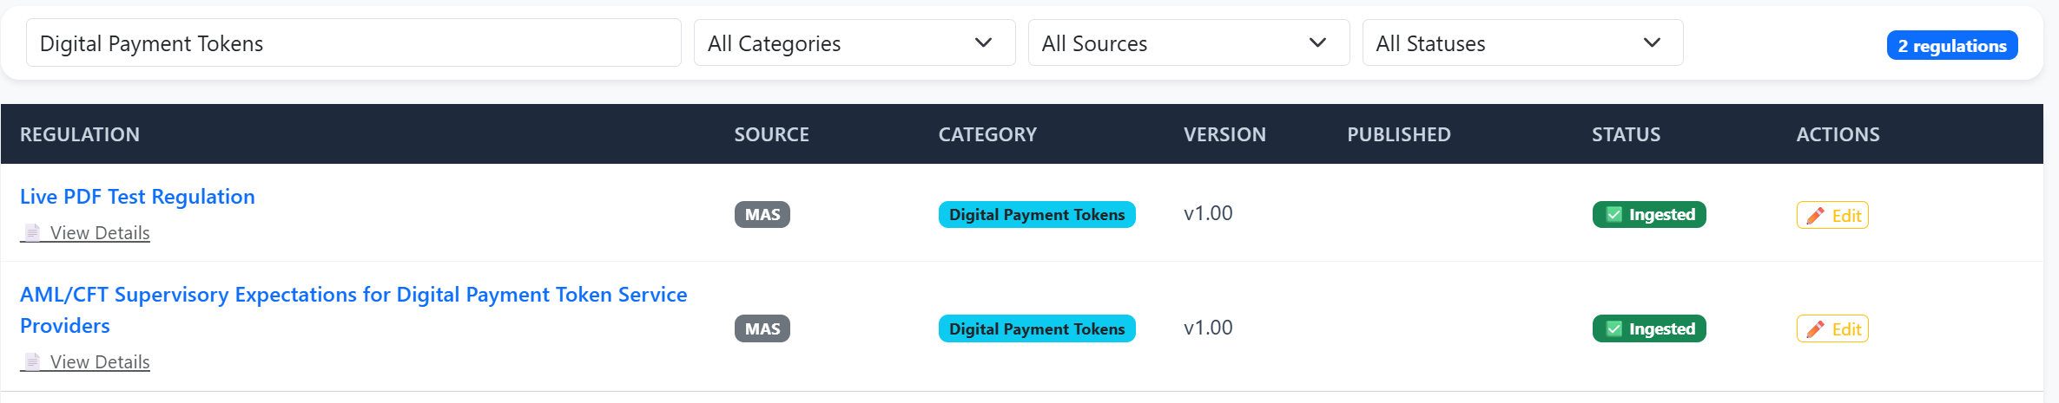
Policies Tab — Current Policies
37. | View Policies tab in card-based layout | - 15 policies displayed as cards (2 per row)  - Each card shows: policy name (bold), brief description, "View Procedures" link, Edit + History buttons  - 🤖 AI badge shown on AI-generated/updated policies | Pass | 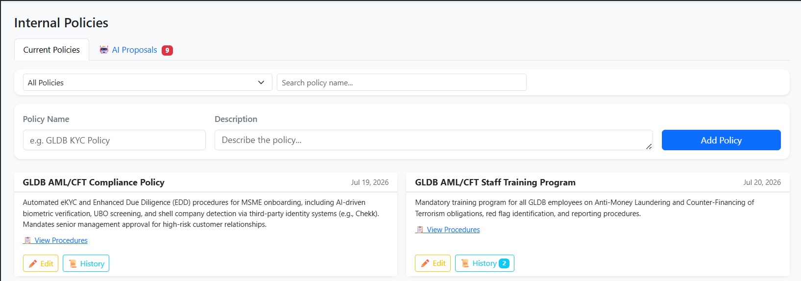
38. | Click "View Procedures" on a policy card | - Procedures section expands below description  - Shows numbered steps with bold titles  - Toggle text changes to "▲ Hide Procedures" | Pass | 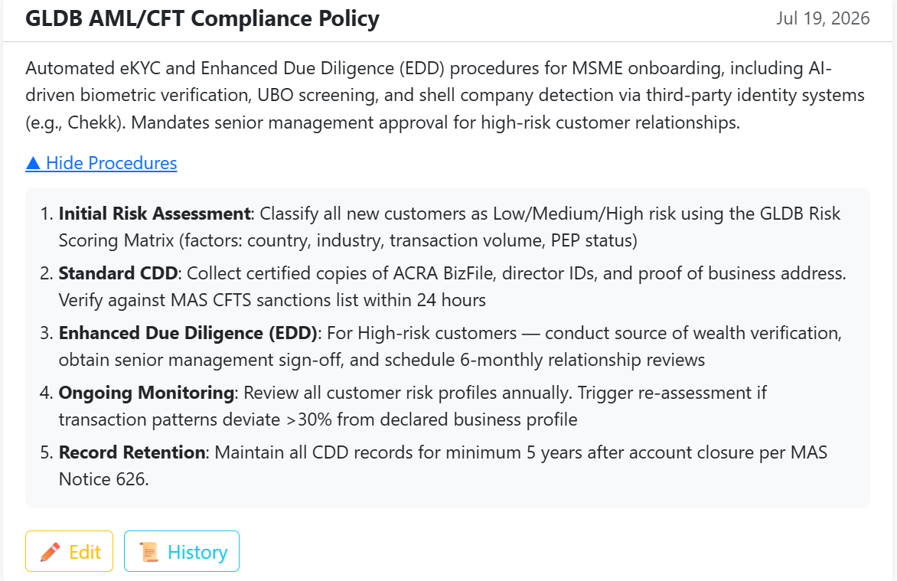
39. | Filter policies by "Has Version History" | - Only policies with version_count > 0 displayed | Pass | 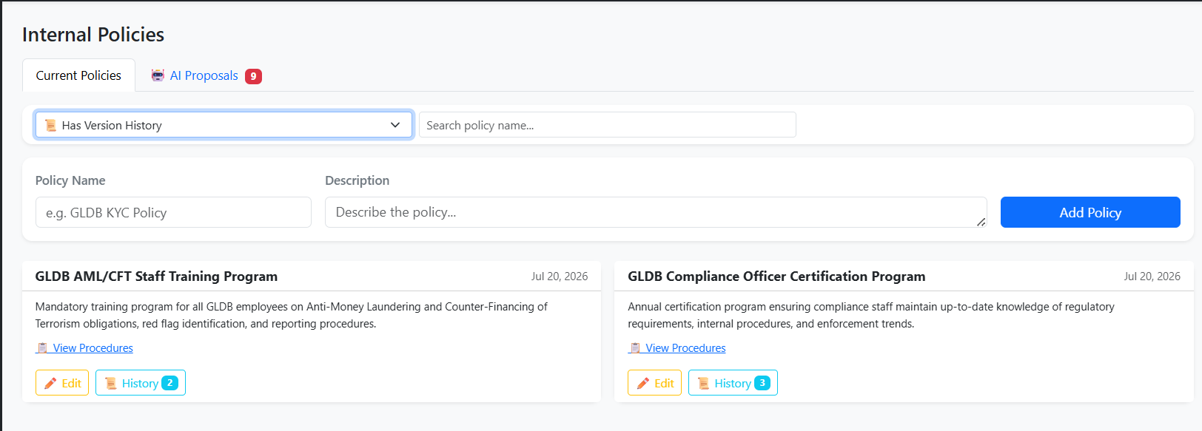
40. | Filter policies by "🤖 AI Generated" | - Only policies created/updated via AI proposals displayed | Pass | 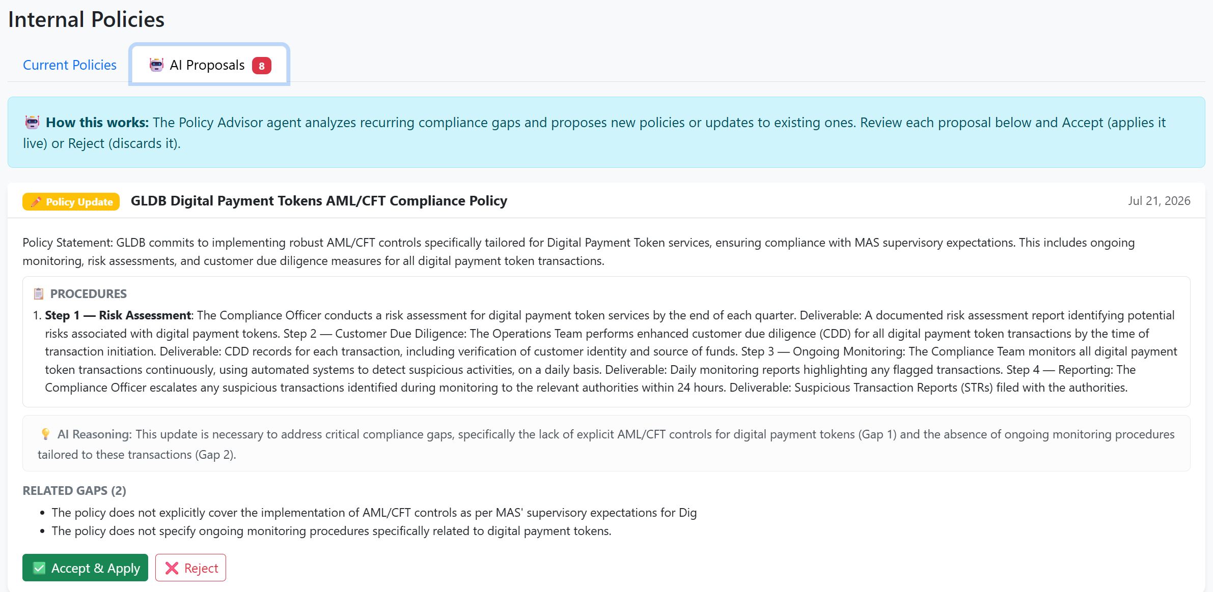
41. | Click "Edit" on a policy, modify description, save | - Old version saved to policy_versions table  - Policy updated with new description  - History button count increments  - Audit log entry created | Pass | -
42. | Click "History" button on a policy with versions | - Modal shows current version + all historical versions  - Each version shows: version number, change reason, date | Pass | 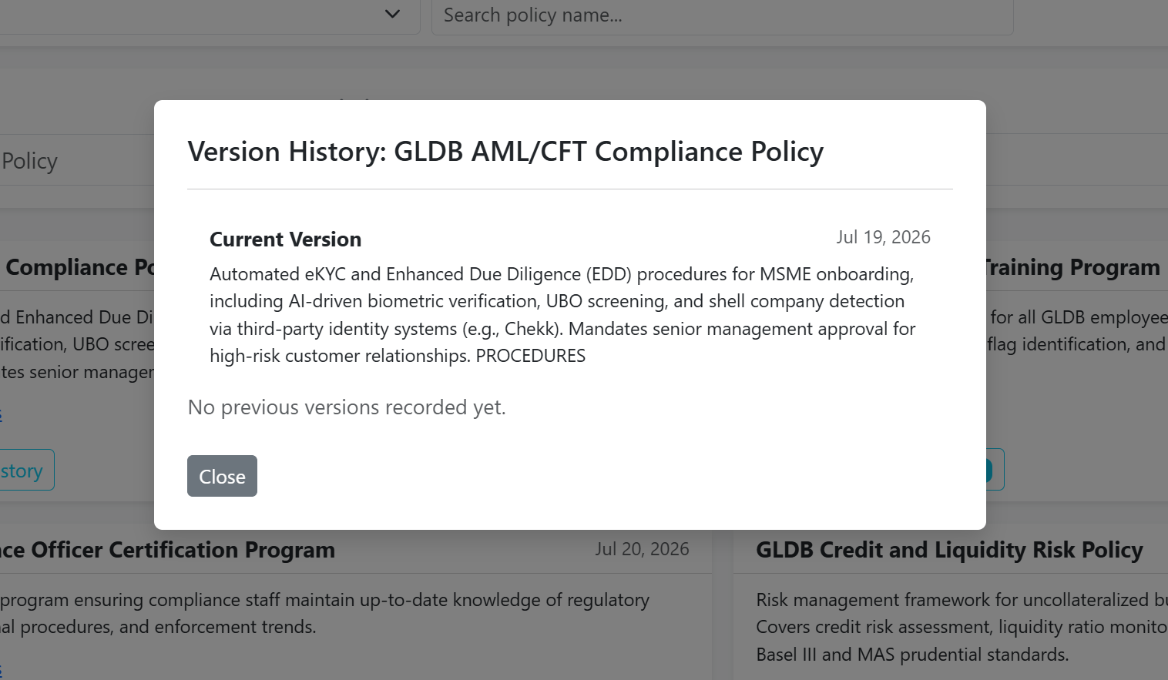
Policies Tab — AI Proposals
43. | View AI Proposals sub-tab | - Pending proposals displayed as cards with: type badge (New Policy / Policy Update), policy name, proposed description with formatted procedures, AI reasoning, related gaps (max 3)  - Accept & Reject buttons visible | Pass | 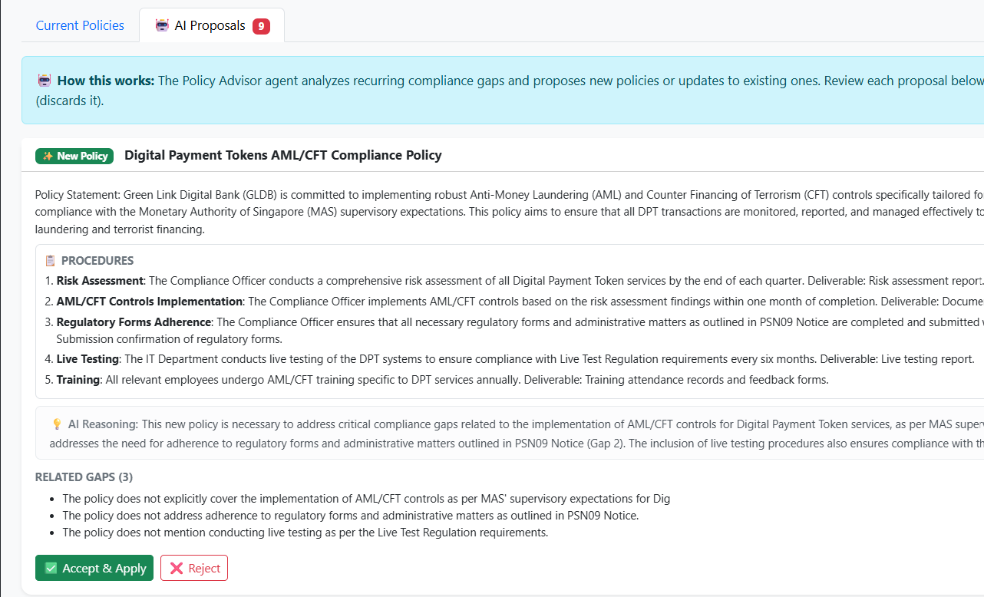
44. | Accept an AI proposal (New Policy) | - New policy created in internal_policies table  - Appears in Current Policies tab with 🤖 AI badge  - Proposal status changes to "Accepted"  - Policy embedded into Pinecone for future RAG  - Audit log: AI_POLICY_CREATED | Pass | 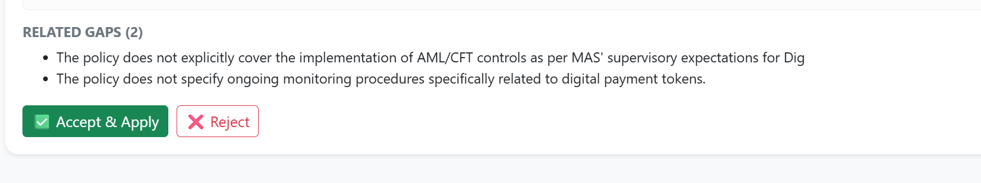
45. | Accept an AI proposal (Policy Update) | - Old policy version saved to history  - Policy description updated with new text + procedures  - 🤖 AI badge appears on the policy card  - Audit log: AI_POLICY_UPDATED | Pass | Policy updated successfully, history saved, AI badge displayed, and audit log recorded.
46. | Reject an AI proposal | - Proposal disappears from Pending list  - No changes made to policies  - Proposal status set to "Rejected" in DB | Pass | Proposal rejected successfully, no policy changes made, and status updated in the database.
Reports & Analytics Tab
47. | View Regulatory Changes report tab | - 4 KPI cards: Total Changes, Critical/High count, Penalty-Linked count, Sources (5)  - Impact Distribution doughnut chart  - Changes by Category bar chart  - Changes Over Time line chart | Pass | 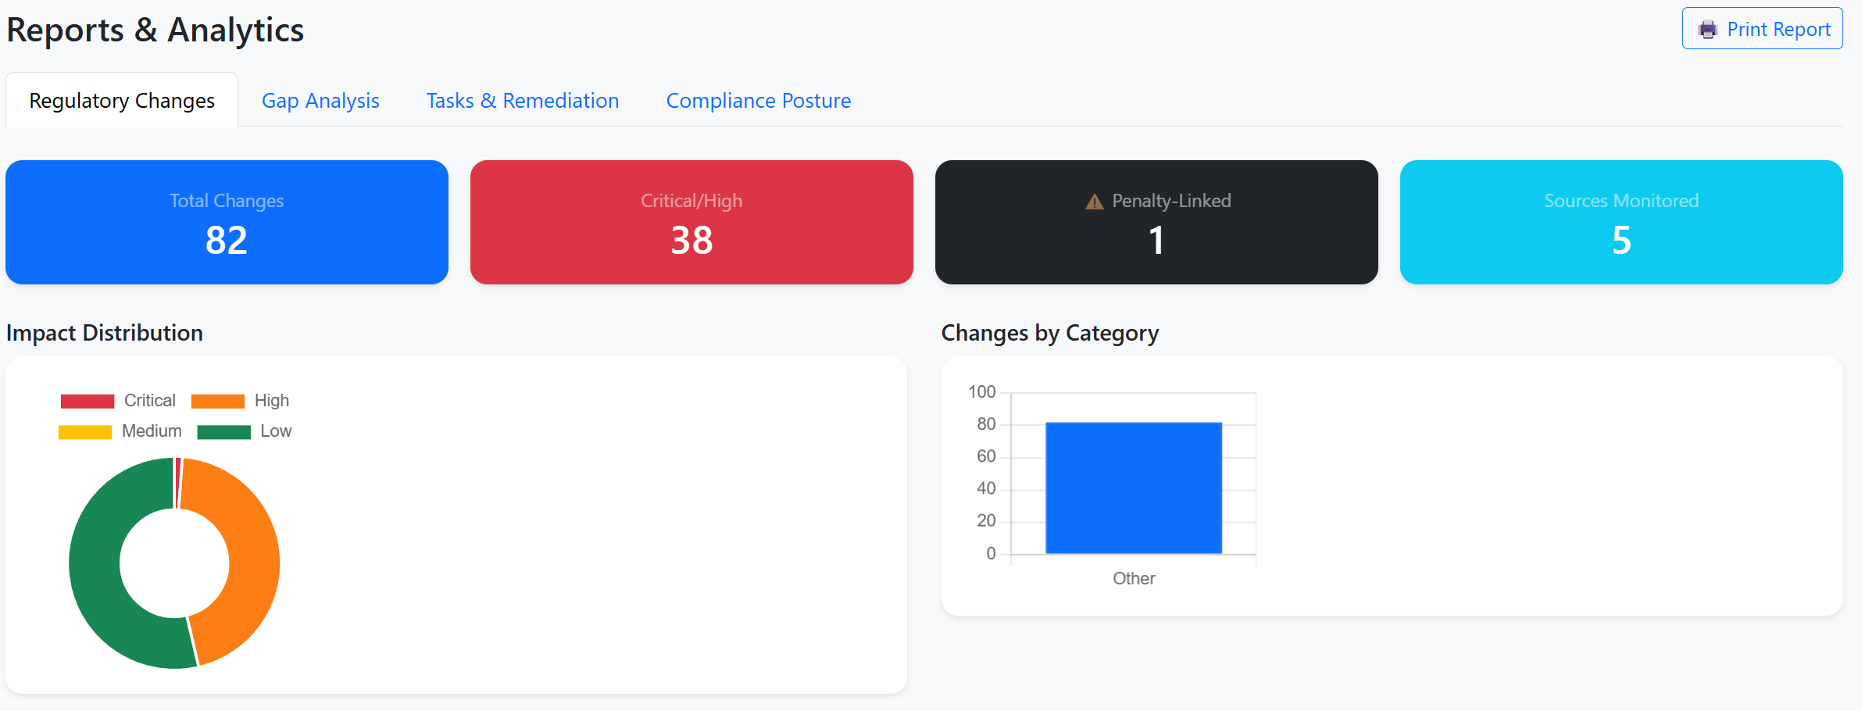
48. | View Gap Analysis report tab | - 4 KPI cards: Open, In Review, Remediated, Resolution Rate %  - Gap Type Distribution pie chart (5 types)  - Gaps by Policy bar chart  - Gap Status bar chart | Pass | 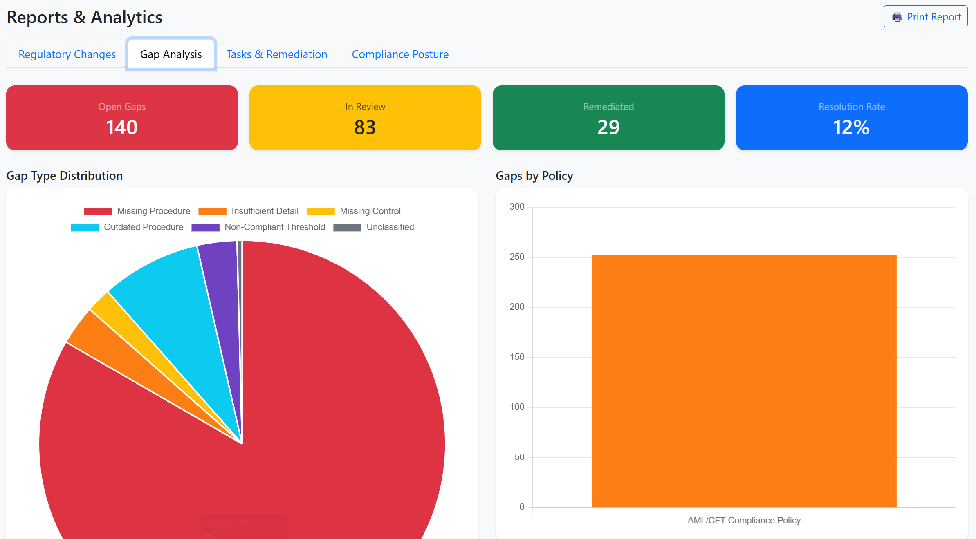
49. | View Tasks & Remediation report tab | - 4 KPI cards: Total, Pending, In Progress, Completed  - Task Status doughnut chart  - Tasks by Department bar chart  - Task Deadline Burndown chart | Pass | 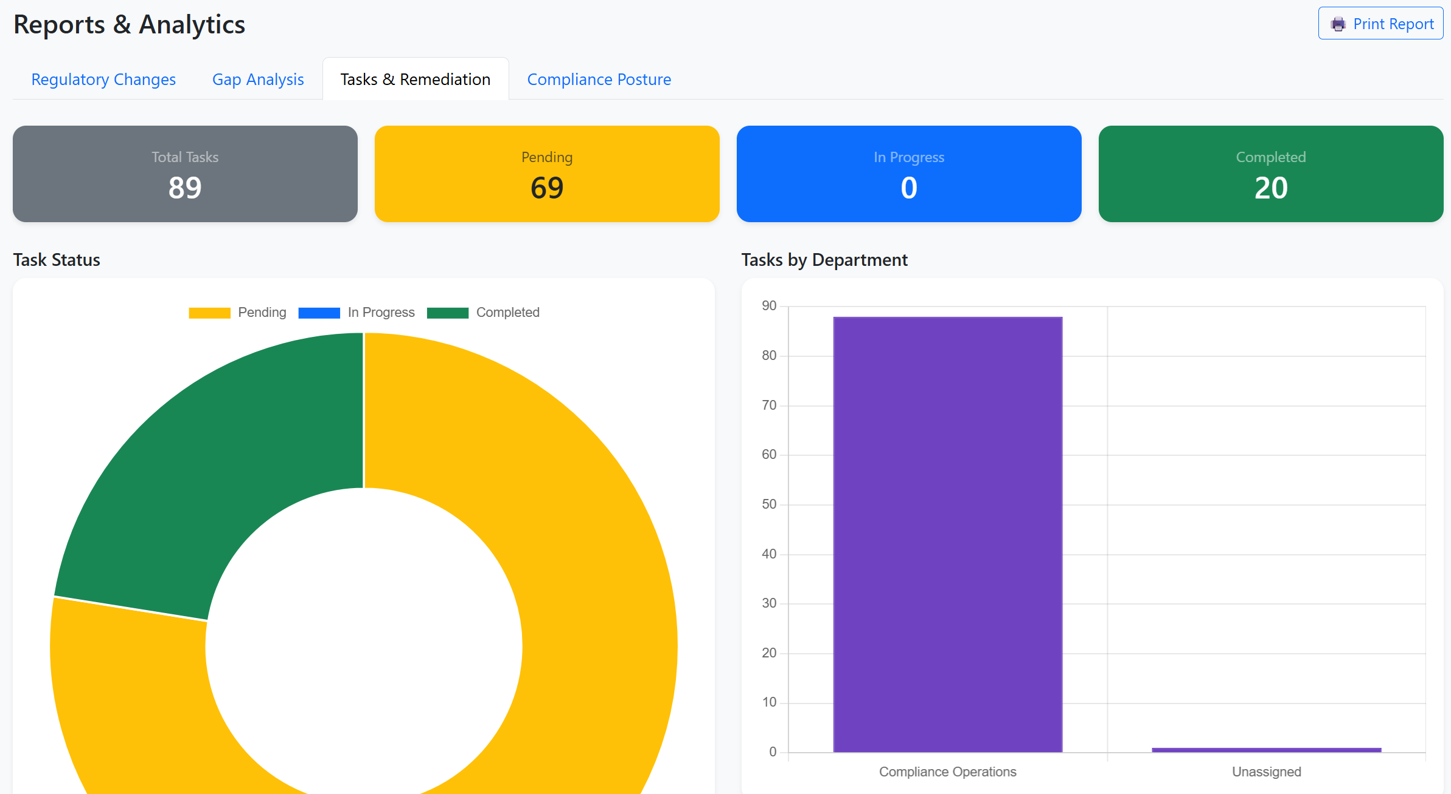
50. | View Compliance Posture report tab | - Overall Compliance Score % (large number, color-coded: green ≥80%, yellow ≥50%, red <50%)  - Regulations Monitored count  - Policies Maintained count  - Policy Coverage Heatmap table (green/yellow/red cells per policy) | Pass | 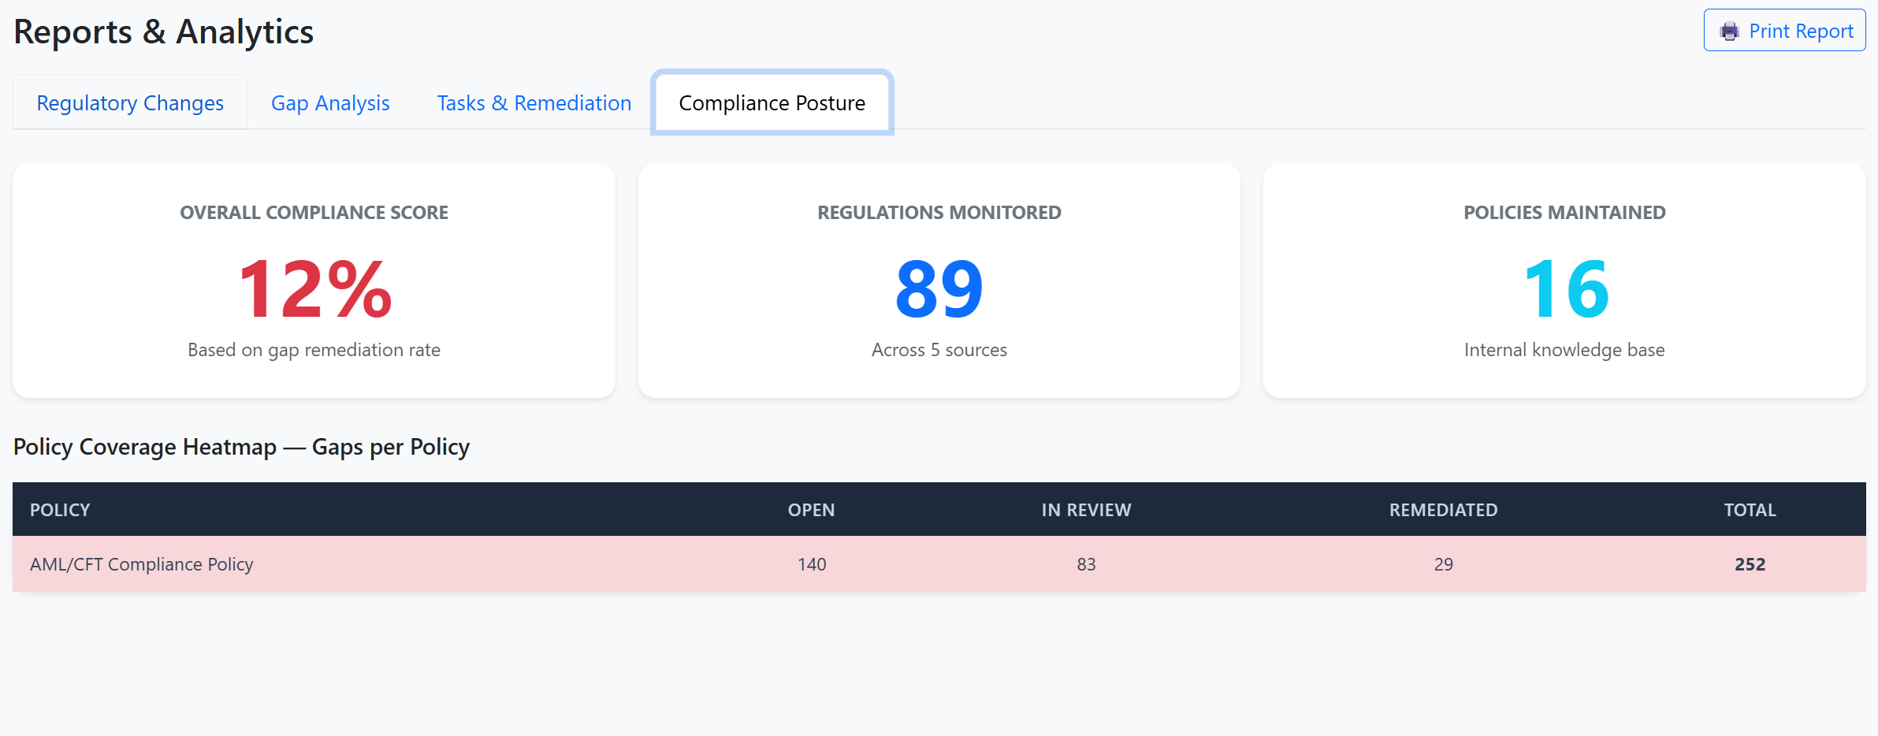
51. | Click "Print Report" button | - Print dialog opens with formatted report containing Executive Summary, Changes, Tasks, and Gaps sections | Pass
Audit Trail Tab
52. | View Audit Trail with summary cards | - 4 cards: Total Actions, This Week, 🤖 AI Agent Actions, 👤 Human Actions  - Agent Activity Breakdown: Scraper, Assessor, Analyzer, Dispatcher, Advisor counts | Pass | 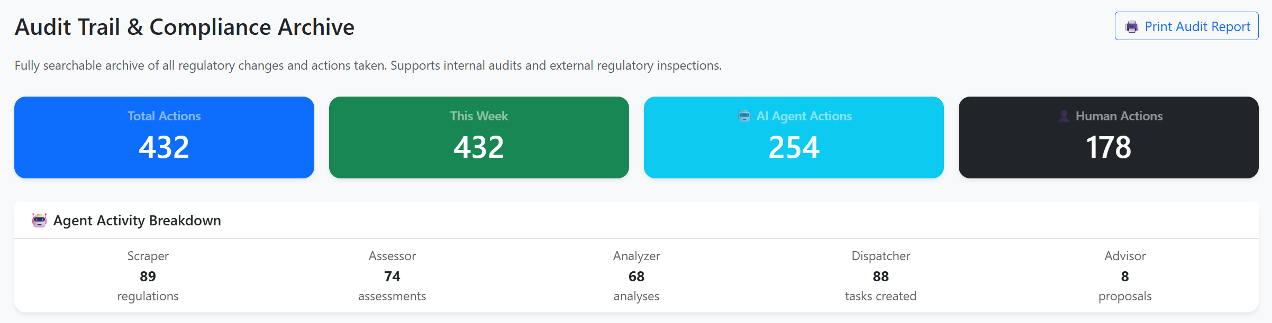
53. | Filter by "🤖 AI Agent Only" | - Table shows only agent actions (IMPACT_ASSESSED, TASK_AUTO_CREATED, etc.)  - Human actions hidden | Pass | 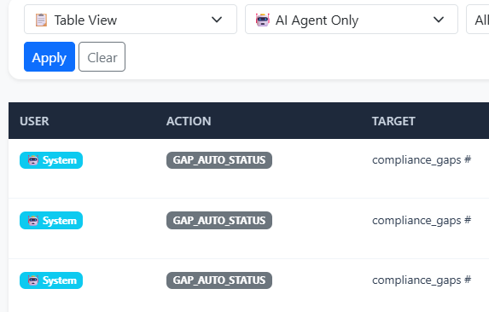
54. | Switch to Timeline View | - Events displayed as chronological timeline items  - Color-coded left border (blue = AI, grey = human)  - Icons: 🤖 for agent, 👤 for human | Pass | 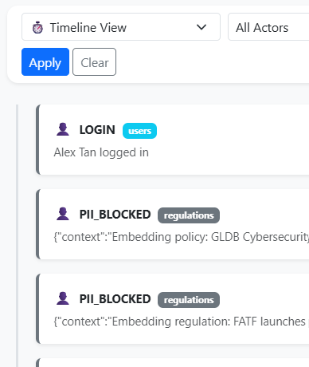
55. | Switch to Response Chain View and select a regulation | - Full compliance response chain displayed: Step 1 (Scraped) → Step 2 (Assessed + impact score) → Step 3 (Alerts) → Step 4 (Gaps) → Step 5 (Tasks + status)  - Final status shown: Fully Remediated / In Progress / Gaps Open | Pass | 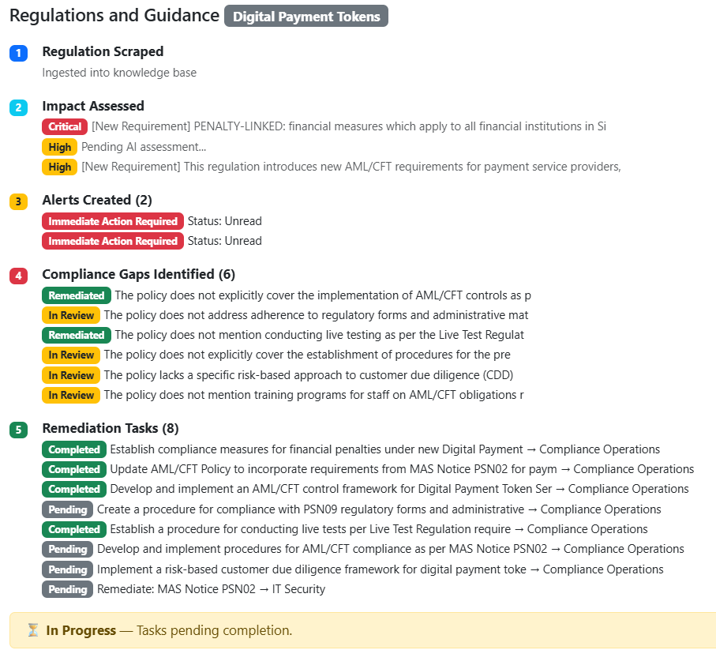
56. | Click "Print Audit Report" button | - Generates formatted audit report with: Summary stats, Agent Activity table, Last 50 actions table  - Print dialog opens | Pass
AI Agent Pipeline (Automated)
57. | Verify Scraper agent runs on startup (empty DB) | - Server logs show: "[IngestionAgent] Scraping MAS..."  - Regulations table populated with scraped content  - PDFs and binary files skipped  - Only HTML content stored (no %PDF garbage) | Pass | Passed after minor debugging and configuration refinements. HTML content stored correctly and PDFs excluded.
58. | Verify Assessor agent processes new regulations | - Logs: "[ImpactAgent] Assessing: [title]"  - Three-step assessment visible: Classification done → Initial assessment done → Final  - regulation_changes table populated with impact_score, affected_areas, explicit_deadline  - Alerts created for each assessed regulation | Pass | Passed after several debugging iterations. Assessment results and alerts generated successfully.
59. | Verify Analyzer agent identifies gaps with varied types | - Logs: "[GapAnalysisAgent] Analyzing cluster: AML"  - Gaps created with types: Missing Procedure, Outdated Procedure, Insufficient Detail, Missing Control, Non-Compliant Threshold  - Not all gaps labeled "Missing Procedure" | Pass | Passed after refining the analysis logic. Multiple gap types were correctly identified.
60. | Verify Dispatcher agent creates consolidated tasks for Critical/High | - Logs: "[TaskOrchestrationAgent] Buffered High alert..."  - Groups related changes by category + department  - Creates ONE task covering multiple related changes (not one-per-change)  - Tasks linked to alerts via task_alerts table | Pass | Dispatcher agent successfully grouped related High/Critical alerts into consolidated tasks and correctly linked associated alerts.
61. | Verify Policy Advisor agent proposes policies | - Logs: "[PolicyAdvisorAgent] Generated X proposal(s) for [category]"  - Proposals include PROCEDURES section (3-6 steps)  - Related gap IDs limited to max 3  - Proposals visible in Policies → AI Proposals tab | Pass | Passed after prompt and logic refinements. Policy proposals were generated and displayed correctly.
62. | Verify Notifier agent buffers alerts (no auto-email) | - Logs: "[NotificationAgent] Buffered alert (X): High — [title]"  - No email sent automatically  - Email only sent when user presses "Send Test Alert Email" button | Pass | Passed after minor debugging. Alerts were buffered correctly, and emails were only sent when triggered manually.
63. | Verify Versioner agent saves policy history on edit | - Edit any policy → old version stored in policy_versions table  - History button shows version trail with change reason | Pass | Policy history and change reasons were recorded correctly.
Sources Tab
64. | View regulatory sources | - Table shows 5 sources: MAS, FATF, FinCEN, ECB, FCA  - Base URL and creation date displayed | Pass | 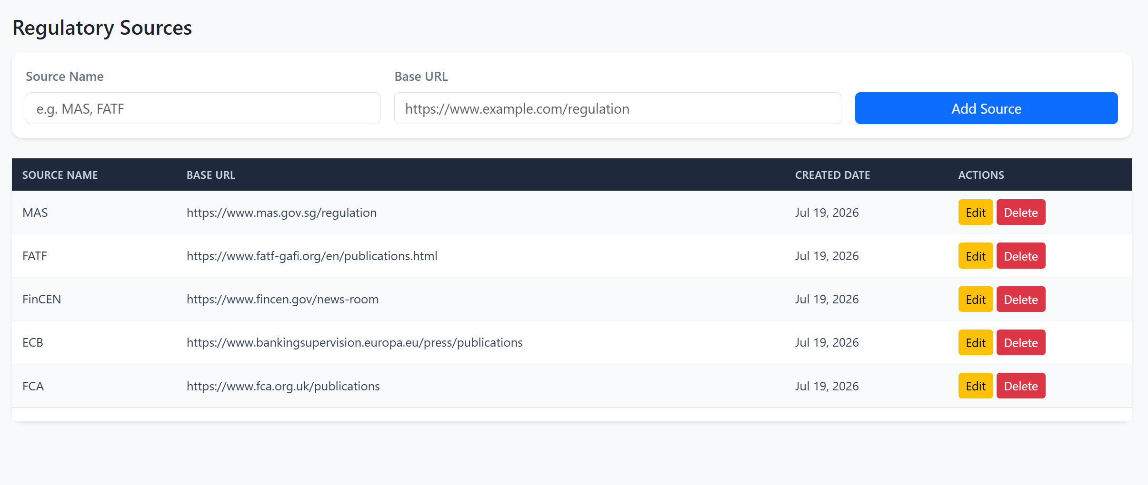
65. | Add a new regulatory source | - Source added to table  - Available in regulation source dropdowns | Pass | Sources added to the table.
66. | Edit an existing source | - Edit section appears with current values pre-filled  - Update saves changes | Pass | The source updated successfully.
Penalty Detection & Prioritization
67. | Verify penalty-linked regulation (MAS Notice 626 seed data) shows correctly | - Impact: Critical  - ⚠️ PENALTY badge (pulsing red) displayed  - ⏰ Compliance deadline shown (Mar 1, 2027)  - Auto-task created with 3-day deadline | Pass | 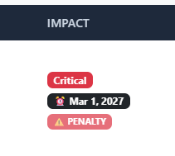
68 | Upload a PDF with penalty/fine clauses | - Assessor detects penalty keywords  - Scores as Critical or High (never downgraded if penalty found)  - Reasoning includes "PENALTY-LINKED: [quoted clause]" | Pass
UI & Navigation
69. | Verify sidebar stays fixed when scrolling content | - Sidebar remains visible and sticky at left side  - Content scrolls independently  - Sidebar does not scroll away | Pass
70. | Toggle dark mode | - All elements switch to dark theme  - Tables, cards, backgrounds update  - Preference saved in localStorage | Pass | 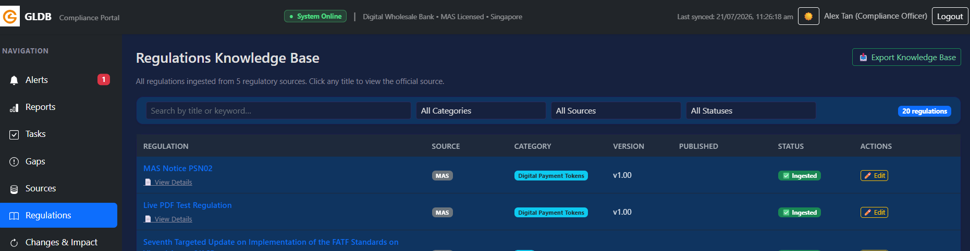
71. | Verify consistent table styling across all tabs | - All tables have same dark header, same font size (0.85rem), same padding  - Uppercase column headers with consistent spacing  - Subtle hover effect on rows | Pass
72. | Verify pagination works on all paginated views | - Previous/Next buttons functional  - Page numbers clickable  - Active page highlighted | Pass

AI Usage Declaration for Test Specification Document

This test specification was generated with AI assistance (Kiro/Claude). The AI was provided with full access to the system's source code, database schema, frontend HTML/JS, and agent logic to produce comprehensive test cases covering all implemented features.

What AI did:

- Analyzed the codebase to identify all testable features across 9 dashboard tabs
- Generated 72 test cases with detailed steps and expected results
- Structured the document to match the provided template format
- Ensured coverage of both automated (agent) and manual (human) functionality

What the human did:
- Provided the test case template format
- Reviewed and validated the generated test cases against actual system behavior
- Executed each test case manually on the running system
- Filled in Pass/Fail results and Remarks columns based on actual test execution
- Captured screenshots as testing evidence for key functional areas
- Identified and reported any discrepancies between expected and actual results

