Proposal: Agentic Compliance System
Multi-Agent Architecture (ADK Framework)
1. Executive Summary
This proposal outlines the evolution of our current regulatory compliance POC into a multi-agent (agentic) system. The current system operates as a linear pipeline. The proposed system introduces autonomous agents that reason, plan, coordinate, and act with minimal human intervention.
Current state: Working POC with RAG pipeline, auto-scraping, LLM impact assessment, 9-view dashboard.
Proposed evolution: 6 specialized agents orchestrated via an ADK framework, with human-in-the-loop approval for all final decisions.
2. Motivation
• Agentic AI is the fastest-growing area in applied AI research (2024-2026)
• Current system still requires significant human effort for task creation, gap analysis, reporting
• Industry leaders (Goldman Sachs, JPMorgan) are piloting agentic compliance systems
• Academic novelty - multi-agent regulatory compliance is under-researched
3. Agent Definitions
Agent | Role | Capabilities
Orchestrator | Master coordinator | Receives goals, plans steps, routes to specialists
Monitoring Agent | Regulatory watcher | Scrapes MAS, detects changes, triggers pipeline
Analysis Agent | Impact assessor | RAG + LLM to score regulation impact
Compliance Agent | Gap identifier | Compares regulations against policies
Task Agent | Work assigner | Auto-creates tasks, checks workload, sets deadlines
Reporting Agent | Summary generator | Drafts executive summaries, escalation decisions
Guardrail Agent | Safety enforcer | PII scan, hallucination check, audit logging
4. Reasoning Strategies (Reusable)
Reasoning strategies are modular and can be used by any agent:
Strategy | What It Does | Used By
Chain of Thought | Step-by-step reasoning before answer | Analysis, Compliance
Reflection Loop | Generate, review own output, improve | Reporting, Compliance
Plan and Execute | Break goal into ordered sub-tasks | Orchestrator, Monitoring
ReAct Loop | Reason, Act, Observe, Repeat | Task Agent, Monitoring
Self Critique | Critique own answer for accuracy | Analysis, Compliance
Multi-Perspective | Evaluate from legal/ops/risk angles | Compliance, Reporting
Confidence Scoring | Rate confidence 0-100%, escalate if low | All agents
5. Global Rules (Agent Constitution)
NEVER:
• Send PII to external services
• Delete production data without human approval
• Override another agent without orchestrator routing
• Execute more than 3 retries on same task
ALWAYS:
• Log every decision with reasoning to audit trail
• Include confidence score in every output
• Pass through guardrail agent before any LLM call
• Cite source regulation/policy when making claims
REQUIRE HUMAN APPROVAL:
• Change gap status to Remediated
• Any action with confidence below 50%
6. Escalation Policy
Confidence | Action
80-100% | Proceed autonomously
50-79% | Proceed but flag for human review
Below 50% | Stop and require human approval
7. Permission Matrix
Agent | CAN | CANNOT
Orchestrator | Delegate, plan, route | Modify DB, call LLM directly
Monitoring | Scrape, read DB | Write DB, delete, assign tasks
Analysis | Read DB, call LLM, vector search | Write DB, delete
Compliance | Read DB, call LLM, create gaps | Delete, change to Remediated
Task | Read DB, create tasks, assign | Delete tasks, modify compliance
Reporting | Read DB, call LLM | Write DB, delete, assign
Guardrail | Read all, block, log | Modify anything
8. Token Budget
Agent | Max per Task | Max per Day
Monitoring | 500 | 5,000
Analysis | 2,000 | 20,000
Compliance | 3,000 | 30,000
Task | 1,000 | 10,000
Reporting | 2,000 | 15,000
Guardrail | 500 | 5,000
TOTAL |  | 80,000
9. Communication Protocol
Standard message format between agents:
• id: unique message ID
• from/to: sending and receiving agent
• type: goal | result | error | escalation | approval_request
• priority: critical | high | normal | low
• payload: data/results
• confidence: 0.0 - 1.0
• reasoning: why this decision was made
10. Current System vs Agentic System
Area | Current System | Agentic System
Architecture | Linear pipeline | Agent network via orchestrator
Decision Making | Hardcoded rules + single LLM | Agents reason and adapt
Autonomy | Semi-automated | Autonomous, humans approve
Memory | Stateless | Persistent across sessions
Error Recovery | Fails silently | Retries or escalates
Gap Analysis | Manual selection | Proactive scanning
Task Assignment | Human creates manually | Auto-assigned by workload
Audit Trail | Logs actions | Logs full reasoning chains
11. Tech Stack
Component | Technology
Runtime | Node.js
LLM | OpenAI GPT-4o-mini (single model, multiple personas)
Vector DB | Chroma
Database | MySQL (Azure)
Frontend | HTML/JS/Bootstrap
Agent Framework | Custom ADK
Architecture
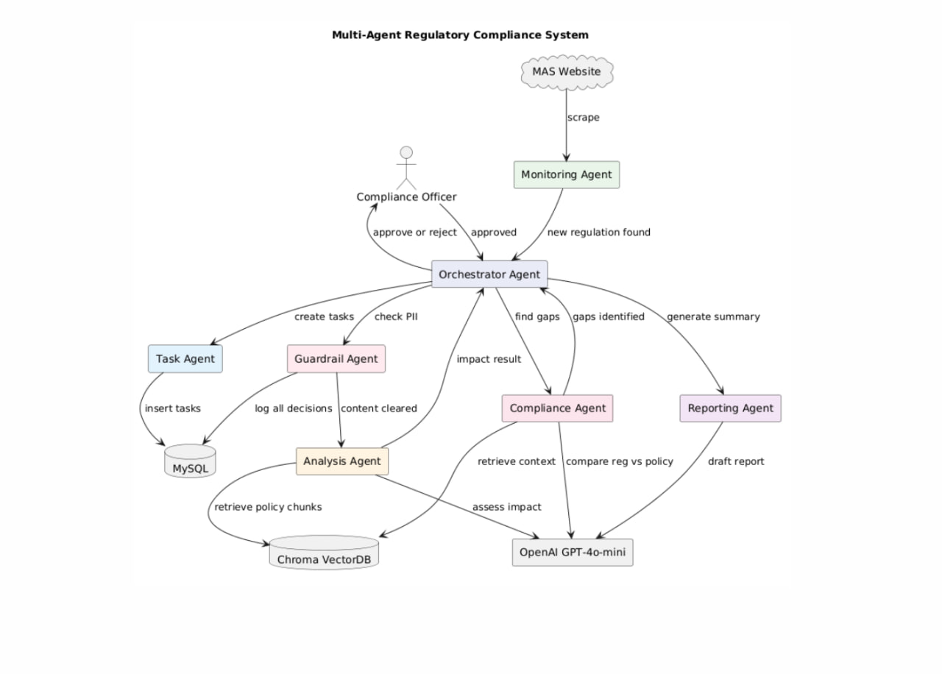

File structure
