A. Sample of AS without area configuration
Multicast Group Ma: hosts are located on N2, N6 and N11.
Multicast Group Mb: hosts are located on N1, N2 and N3.
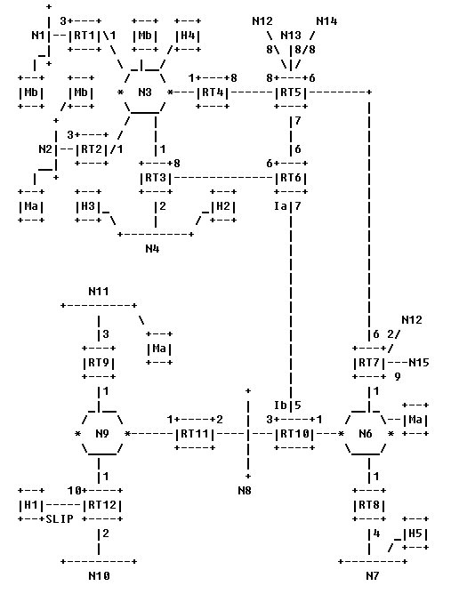
Hosts H2, H3, H4, H5: sources for multicast datagrams.
A-1. Local group database (group-membership-LSA is flooded throughout the AS)
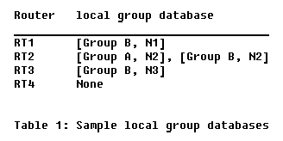
A-2. A datagram's shortest-path tree
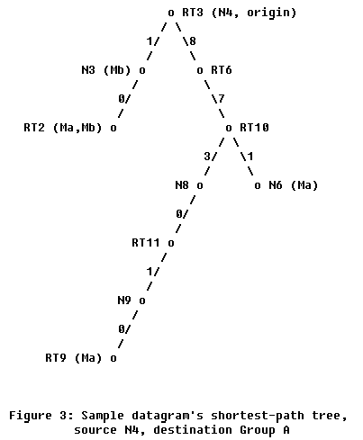
In order to forward the multicast datagram, each router must find its own position in the datagram's shortest path tree.
B. Sample of AS with area configuration
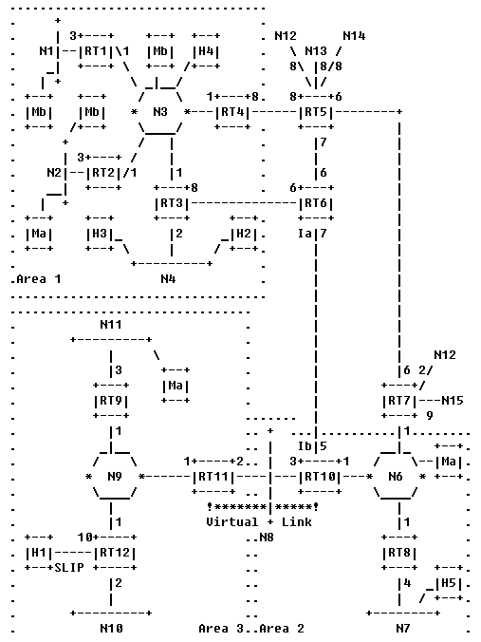
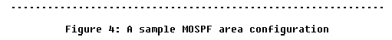
B-1. Extent of group-membership-LSAs
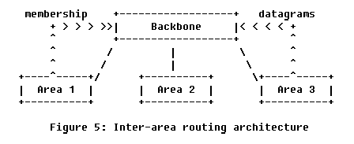
B-2. Building inter-area datagram shortest-path trees
