A. Sample of AS without area configuration
Multicast Group Ma: hosts are located on N2, N6 and N11.
Multicast Group Mb: hosts are located on N1, N2 and N3.
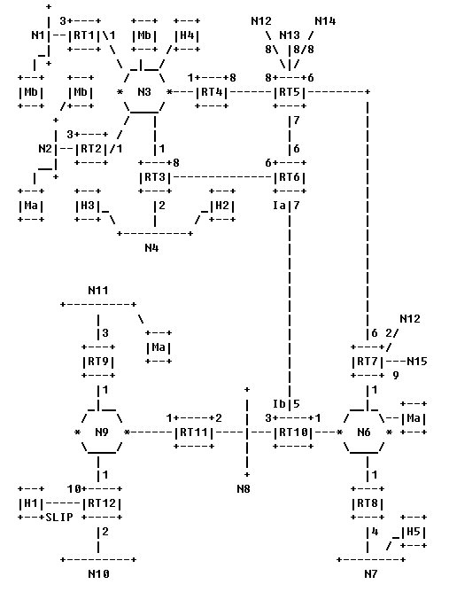
Hosts H2, H3, H4, H5: sources for multicast datagrams.
A-1. Local group database
The local group database keeps track of the group membership of the router's directly attached networks. Each entry in the local group database is a [group, attached network] pair, which indicates that the attached network has one or more IP hosts belonging to the IP multicast destination group. This information is then used by the router when deciding which directly attached networks to forward a received IP multicast datagram onto, in order to complete delivery of the datagram to (local) group members.
The local group database is built through the operation of the Internet Group Management Protocol (IGMP). When a MOSPF router becomes Designated Router on an attached network (call the network N1), it starts sending periodic IGMP Host Membership Queries on the network. Hosts then respond with IGMP Host Membership Reports, one for each multicast group to which they belong. Upon receiving a Host Membership Report for a multicast group A, the router updates its local group database by adding/refreshing the entry [Group A, N1]. If at a later time Reports for Group A cease to be heard on the network, the entry is then deleted from the local group database.
The existence of local group members must be communicated to the rest of the routers in the Autonomous System. This ensures that a remotely originated multicast datagram will be forwarded to the router for distribution to its local group members. This communication is accomplished through the creation of a group-membership-LSA. Like other link state advertisements, the group-membership-LSA is flooded throughout the Autonomous System. The router originates a separate group-membership-LSA for each multicast group having one or more entries in the router's local group database. The router's group-membership-LSA (say for Group A) lists those local transit vertices (i.e., the router itself and/or any directly connected transit networks) that should not be pruned from Group A's datagram shortest-path trees. The router lists itself in its group-membership-LSA for Group A if either 1) one or more of the router's attached stub networks contain Group A members or 2) the router itself is a member of Group A. The router lists a directly connected transit network in the group-membership-LSA for Group A if both 1) the router is Designated Router on the network and 2) the network contains one or more Group A members.
Consider again the example pictured in Figure 1. If Router RT3 has been elected Designated Router for Network N3, then Table 1: lists the local group database for the routers RT1-RT4.
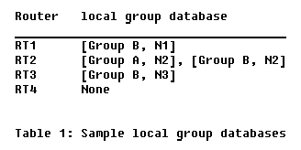
A-2. Forwarding mechanism
To illustrate the forwarding of a multicast datagram, suppose that Host H2 (attached to Network N4) sends a multicast datagram to multicast group B. This datagram originates as a data-link layer multicast on Network N4. Router RT3, being a multicast router, has "opened up" its interface data-link multicast filters. It therefore receives the multicast datagram, and attempts to forward it to the members of multicast group B (located on networks N1, N2 and N3). This is accomplished by sending a single copy of the datagram onto Network N3, again as a data-link multicast. Upon receiving the multicast datagram from RT3, routers RT1 and RT2 will then multicast the datagram on their connected stub networks (N1 and N2 respectively). Note that, since the datagram is sent onto Network N3 as a data-link multicast, Router RT4 will also receive a copy. However, it will not forward the datagram, since it does not lie on a shortest path between the source (Host H2) and any members of multicast group B.
A-3. A datagram's shortest-path tree
A datagram's shortest path tree is built "on demand", i.e., when the first multicast datagram is received having a particular [source net, multicast destination] combination. To build the datagram's shortest-path tree, the following calculations are performed. First, the datagram's source IP network is located in the link state database. Then using the router-LSAs and network-LSAs in the link state database, a shortest-path tree is built having the source network as root. To complete the process, the branches that do not contain routers/transit networks that have been labeled with the particular multicast destination (via a group- membership-LSA) are pruned from the tree.
As an example of the building of a datagram's shortest path tree, again consider the Autonomous System in Figure 1. When a router initially receives a multicast datagram sent by Host H2 to the multicast group A, the following steps are taken: Host H2 is first determined to be on Network N4. Then the shortest path tree rooted at net N4 is calculated, pruning those branches that do not contain routers/transit networks that have been labelled with the multicast group A. This results in the pruned shortest-path tree pictured in Figure 3. Note that at this point all the leaves of the tree are routers/transit networks labeled with multicast group A (routers RT2 and RT9 and transit Network N6).
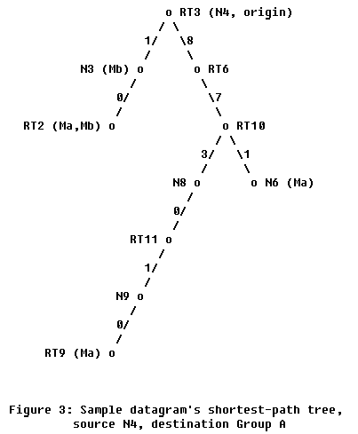
In order to forward the multicast datagram, each router must find its own position in the datagram's shortest path tree.
B. Sample of AS with area configuration
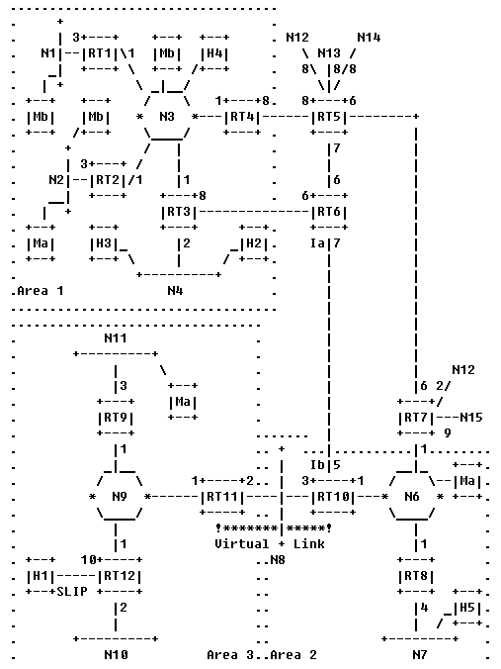
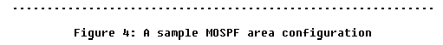
Inter-area multicast brings up the following issues:
1. Are the group-membership-LSAs specific to a single area? And if they are, how is group membership information conveyed from one area to the next?
2. How are the datagram shortest-path trees built in the inter-area case, since complete information concerning the topology of the datagram source's neighborhood is not available to routers in other areas?
3. In an area border router, multiple datagram shortest-path trees are built, one for each attached area. How are these separate datagram shortest-path trees combined into a single forwarding cache entry?
B-1. Extent of group-membership-LSAs
In OSPF, the area border routers forward routing information and data traffic between areas. In MOSPF, a subset of the area border routers, called the inter-area multicast forwarders, forward group membership information and multicast datagrams between areas. Whether a given OSPF area border router is also a MOSPF inter-area multicast forwarder is configuration dependent. In Figure 4 we assume that all area border routers are also inter-area multicast forwarders.
In order to convey group membership information between areas, inter-area multicast forwarders "summarize" their attached areas' group membership to the backbone. This is very similar functionality to the summary-link-LSAs that are generated in the base OSPF protocol. An inter-area multicast forwarder calculates which groups have members in its attached non-backbone areas. Then, for each of these groups, the inter-area multicast forwarder injects a group-membership-LSA into the backbone area. For example, in Figure 4 there are two groups having members in Area 1: Group A and Group B. For that reason, both of Area 1's inter-area multicast forwarders (Routers RT3 and RT4) inject group-membership-LSAs for these two groups into the backbone. As a result both of these routers are labeled with Groups A and B in the backbone link state database (see Figure 7).
This yields the inter-area routing architecture pictured in Figure 5. All group membership is advertised by the non-backbone areas into the backbone. Likewise, all IP multicast traffic arising in the non-backbone areas is forwarded to the backbone. Since at this point group membership information meets the multicast datagram traffic, delivery of the multicast datagrams becomes possible.
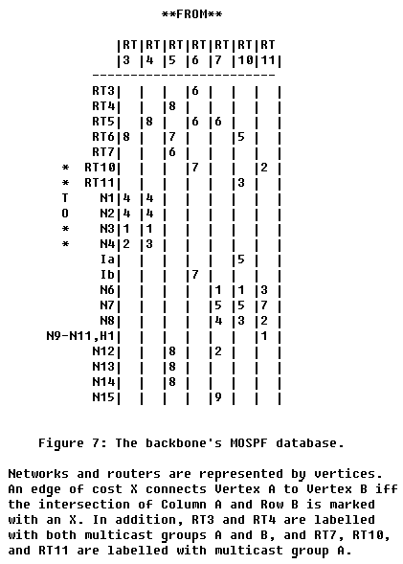
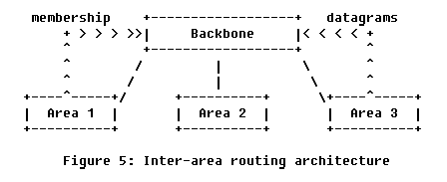
B-2. Building inter-area datagram shortest-path trees
When building datagram shortest-path trees in the presence of areas, it is often the case that the source of the datagram and (at least some of) the destination group members are in separate areas. Since detailed topological information concerning one OSPF area is not distributed to other OSPF areas (the flooding of router-LSAs, network-LSAs and group-membership-LSAs is restricted to a single OSPF area only), the building of complete datagram shortest-path trees is often impossible in the inter-area case. To compensate, approximations are made through the use of wild-card multicast receivers and OSPF summary-link-LSAs.
When it first receives a datagram for a particular [source net, destination group] pair, a router calculates a separate datagram shortest-path tree for each of the router's attached areas. Each datagram shortest-path tree is built solely from LSAs belonging to the particular area's link state database. Suppose that a router is calculating a datagram shortest-path tree for Area 1. It is useful then to separate out two cases.
The first case, Case 1: The source of the datagram belongs to Area 1 has already been described in Part A. However, in the presence of OSPF areas, during tree pruning care must be taken so that the branches leading to other areas remain, since it is unknown whether there are group members in these (remote) areas. For this reason, only those branches having no group members nor wild-card multicast receivers are pruned when producing the datagram shortest-path tree.
As an example, suppose in Figure 4 that Host H2 sends a multicast datagram to destination Group A. Then the datagram's shortest-path tree for Area 1, built identically by all routers in Area 1 that receive the datagram, is shown in Figure 8. Note that both inter-area multicast forwarders (RT3 and RT4) are on the datagram's shortest-path tree, ensuring the delivery of the datagram to the backbone and from there to Areas 2 and 3.
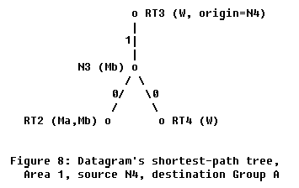
Case 2: The source of the datagram belongs to an area other than Area 1. In this case, when building the datagram shortest-path tree for Area 1, the immediate neighborhood of the datagram's source is unknown. However, there are summary-link-LSAs in the Area 1 link state database indicating the cost of the paths between each of Area 1's inter-area multicast forwarders and the datagram source. These summary links are used to approximate the neighborhood of the datagram's source; the tree begins with links directly connecting the source to each of the inter-area multicast forwarders. These links point in the reverse direction (towards instead of away from the datagram source) from the links considered in Case 1 above. All additional links added to the tree also point in the reverse direction. The final datagram shortest-path tree is then produced by, as before, pruning all branches having no group-members nor wild-card multicast receivers.
As an example, suppose again that Host H2 in Figure 4 sends a multicast datagram to destination Group A. The datagram's shortest-path tree for the backbone is shown in Figure 9. The neighborhood around the source (Network N4) has been approximated by the summary links advertised by routers RT3 and RT4. Note that all links in Figure 9's datagram shortest-path tree have arrows pointing in the reverse direction, towards Network N4 instead of away from it.
The reverse costs used for the entire tree in Case 2 are forced because summary-link-LSAs only specify the cost towards the datagram source. In the presence of asymmetric link costs, this may lead to less efficient routes when forwarding multicasts
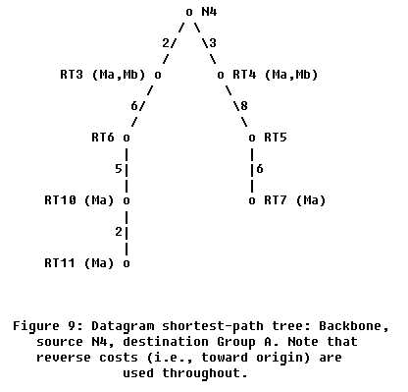
Consider again the example of Host H2 in Figure 4 sending a multicast datagram to destination Group A. Router RT3 will calculate two datagram shortest-path trees, one for Area 1 and one for the backbone. Since the source of the datagram (Host H2) belongs to Area 1, the Area 1 datagram shortest-path tree determines RT3's upstream node: Network N4. Router RT3 calculates two downstream interfaces for the datagram: the interface to Network N3 (which comes from Area 1's datagram shortest-path tree) and the serial line to Router RT6 (which comes from the backbone's datagram shortest-path tree). As for Router RT10, it calculates two trees, determining its upstream node from the backbone tree and its two downstream interfaces from the Area 2 tree. Finally, Router RT11 calculates three trees, determining its upstream node from the Area 2 tree and its downstream interface from the Area 3 tree.
Appendix: Inter-AS multicasting
Certain AS boundary routers in a MOSPF system will be configured as inter-AS multicast forwarders. It is assumed that these routers will also be running an inter-AS multicast routing protocol. This specification does not dictate the operation of such an inter-AS multicast routing protocol. However, the following interactions between MOSPF and the inter-AS routing protocol are assumed:
(1) MOSPF guarantees that the inter-AS multicast forwarders will receive all multicast datagrams; but it is up to each router so designated to determine whether the datagram should be forwarded to other Autonomous Systems. This determination will probably be made via the inter-AS routing protocol.
(2) MOSPF assumes that the inter-AS routing protocol is forwarding multicast datagrams in an RPF (reverse path forwarding) fashion. In other words, it is assumed that a multicast datagram whose source (call it X) lies outside the MOSPF domain will enter the MOSPF domain at those points that are advertising (into OSPF) the best routes back to X. MOSPF calculates the path of the datagram through the MOSPF domain based on this assumption.
MOSPF designates an inter-AS multicast forwarder as a wild-card multicast receiver in all of its attached areas. As in the inter-area case, this ensures that the routers remain on all pruned shortest-path trees and thereby receive all multicast datagrams, regardless of destination.

