Data Visualization

## Table of Contents

Table of Contents 2

Section 1: Regional and Campus Comparisons 3

Responses Count by Regions and Campuses 3

Number of Responses Showing Primary Concerns for Eco-Friendly Seekers and Not Considered Eco-Friendly Options 4

Products Used Responses Count by Campus 5

Products Used Allergic Reactions Responses Count 6

For Individuals Who Experienced Menstrual Education Before Campus, Did They Experience Period Stigma? 7

Graph Comparing Perception of Eco-Friendly Period Products 8

Products Affordability Responses Count by Campus 9

Products Affordability Responses Count by Regions 10

Section 2: Period Stigma and Reusable Products 11

How Are Individuals Interested in Learning About Reusable Products in Response to Period Stigma? 11

How Do People Who Respond to Having Experienced Period Stigma Respond to Being Allergic to Period Products? 12

What Are the Perceptions of Reusable Products Taking Into Account Having Experienced Period Stigma? 13

How Did Individuals Who Have Experienced Period Stigma Respond to the Importance of Having Period Products Variety on Campus? 14

Experienced Period Stigma Responses by Campuses 15

For Those Who Have Experienced Period Stigma, What Are Their Period Products' Affordability Perception? 16

Section 3: Recommendations and Reactions 17

For Those Who Have Experienced Period Stigma, How Likely Are They to Recommend Products? 17

Section 4: Environmental Concerns and Current Products 18

Proportions of Campuses Concerned by Environmental Impact 18

Proportions of Responses by Campus Concerned by Environmental Impact 19

Proportions of Responses by Campus Not Concerned by Environmental Impact 20

Comparing the Proportions of Responses by Campus in Concerned and Not Concerned Categories of Current Products' Environmental Impact 21

## Section 1: Regional and Campus Comparisons

### Responses Count by Regions and Campuses

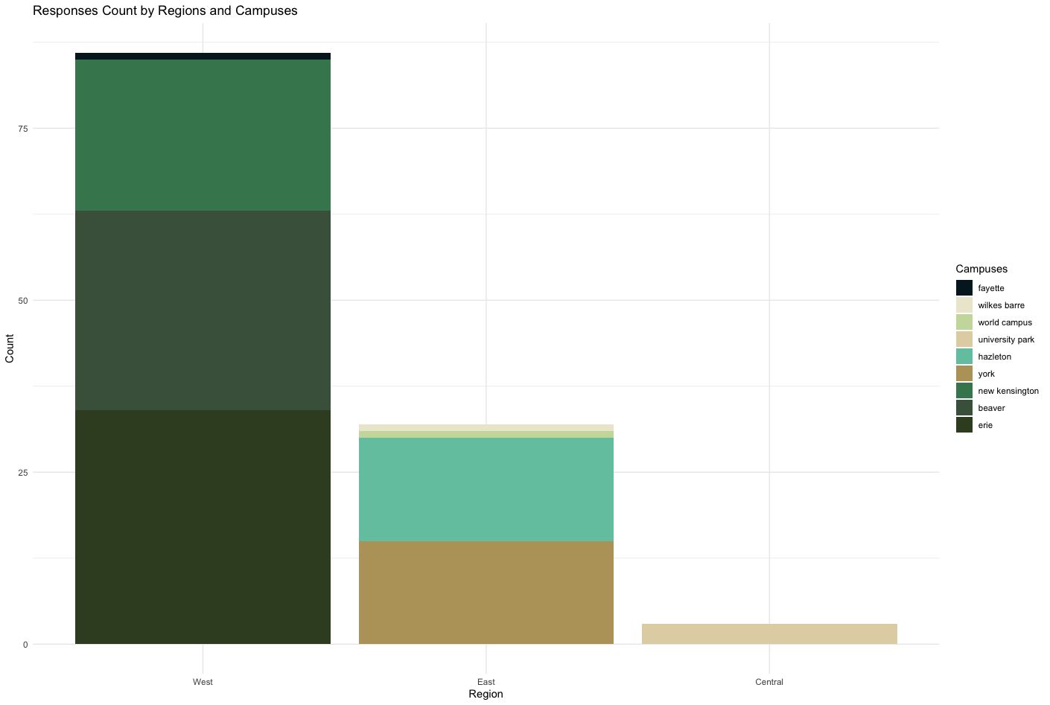

Figure : Responses Count by Regions and Campuses

### Number of Responses Showing Primary Concerns for Eco-Friendly Seekers and Not Considered Eco-Friendly Options

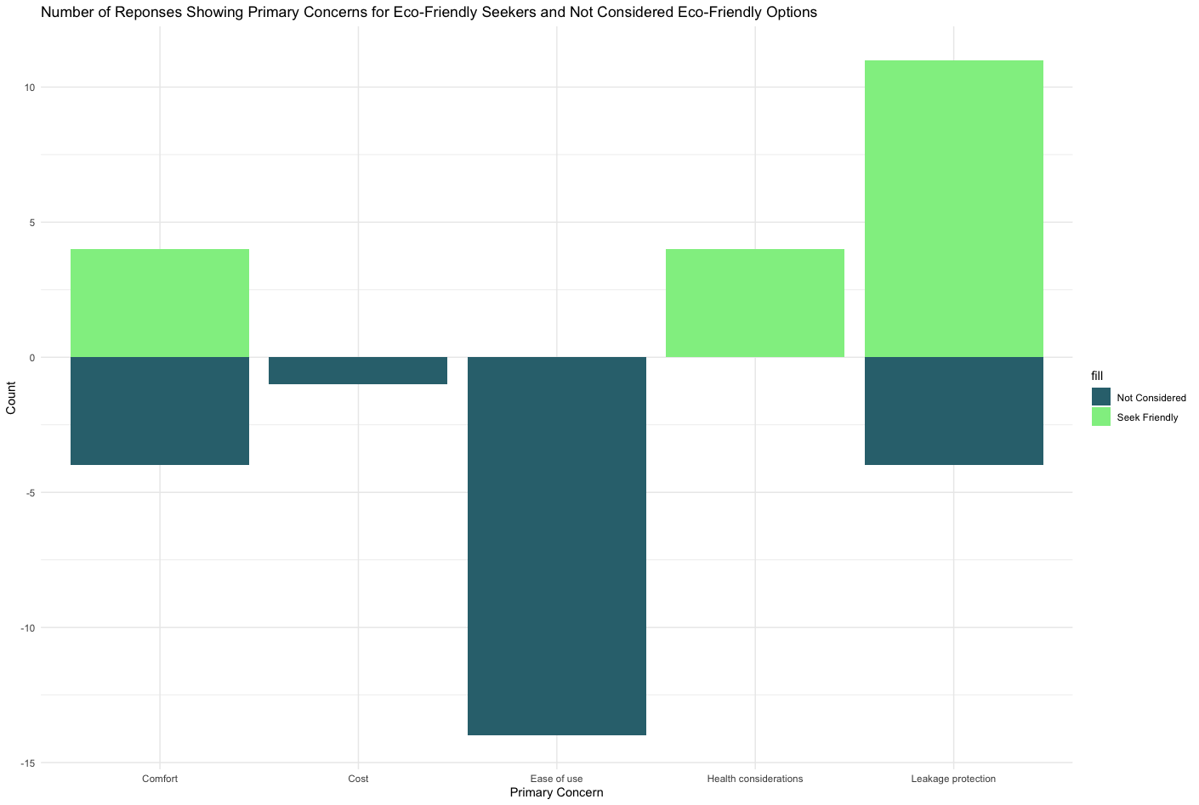

Figure : Number of Responses Showing Primary Concerns for Eco-Friendly Seekers and Not Considered Eco-Friendly Options

### Products Used Responses Count by Campus

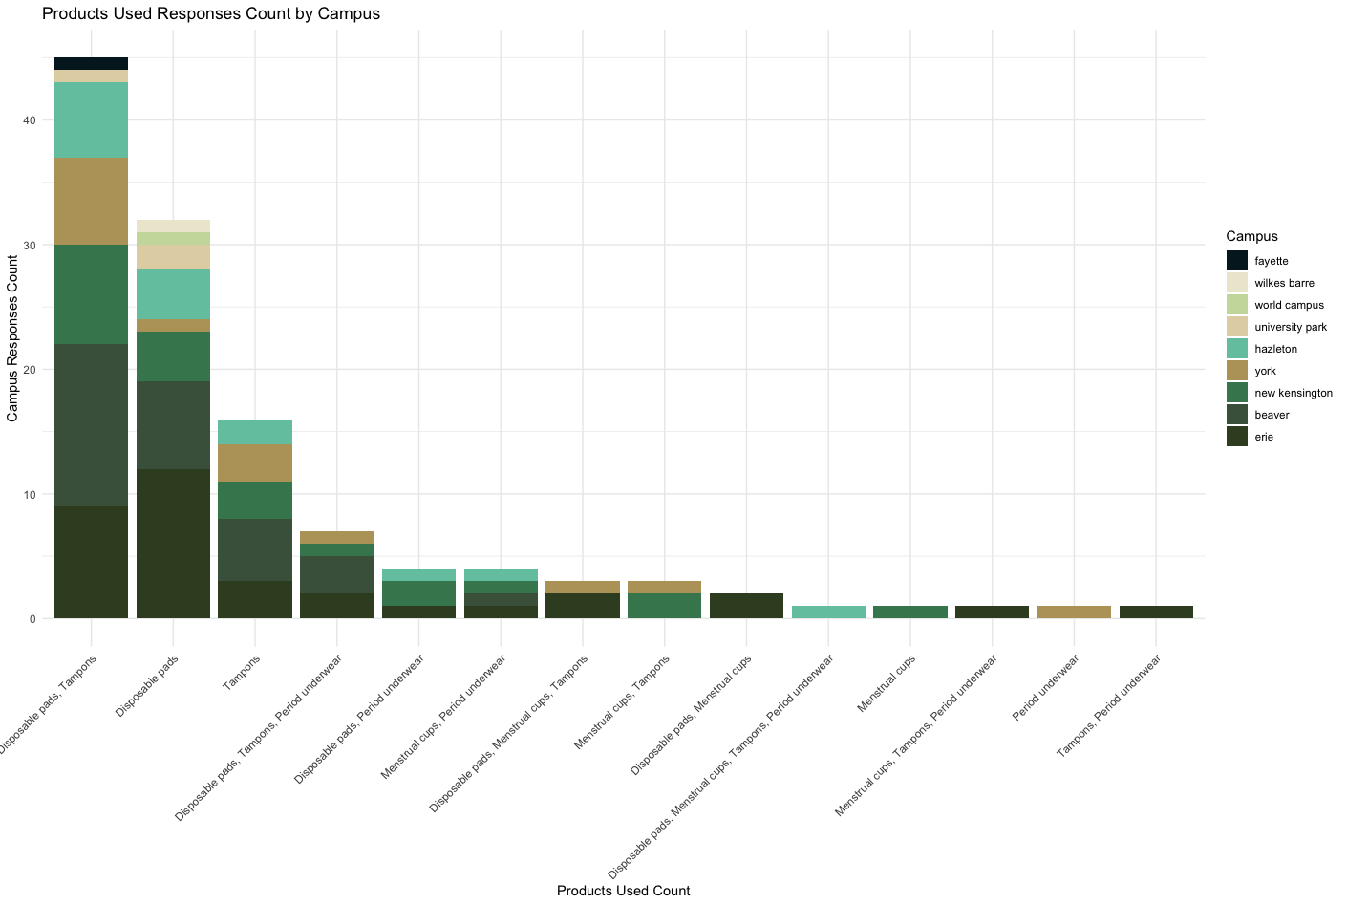

Figure : Products Used Responses Count by Campus

### Products Used Allergic Reactions Responses Count

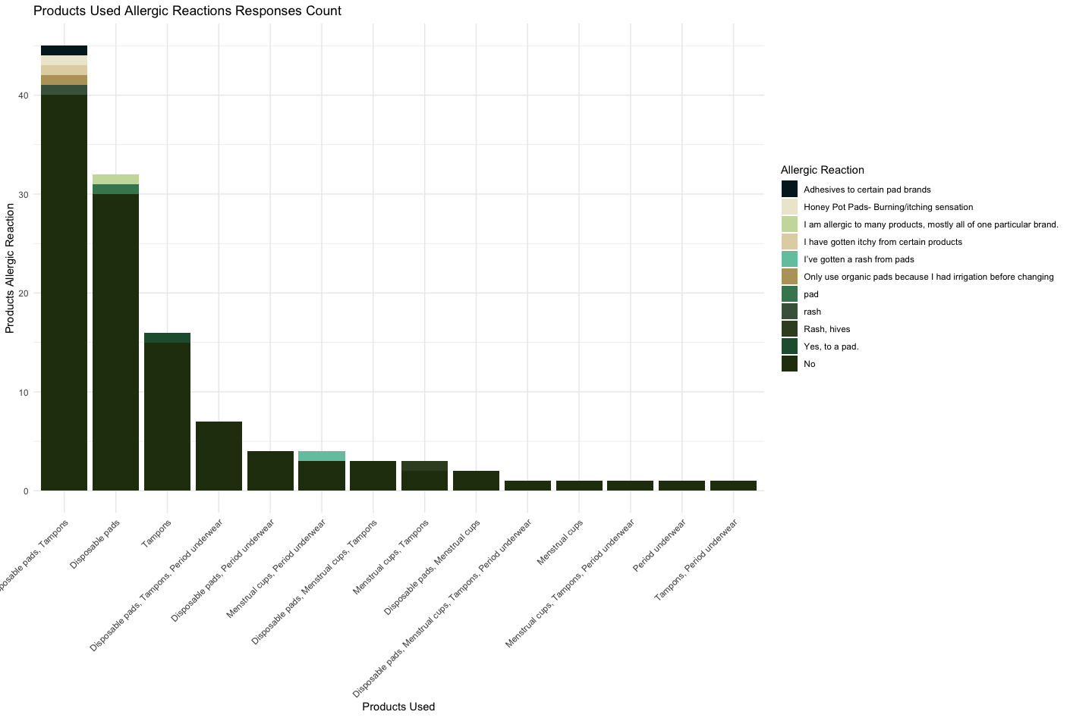

Figure : Products Used Allergic Reactions Responses Count

### For Individuals Who Experienced Menstrual Education Before Campus, Did They Experience Period Stigma?

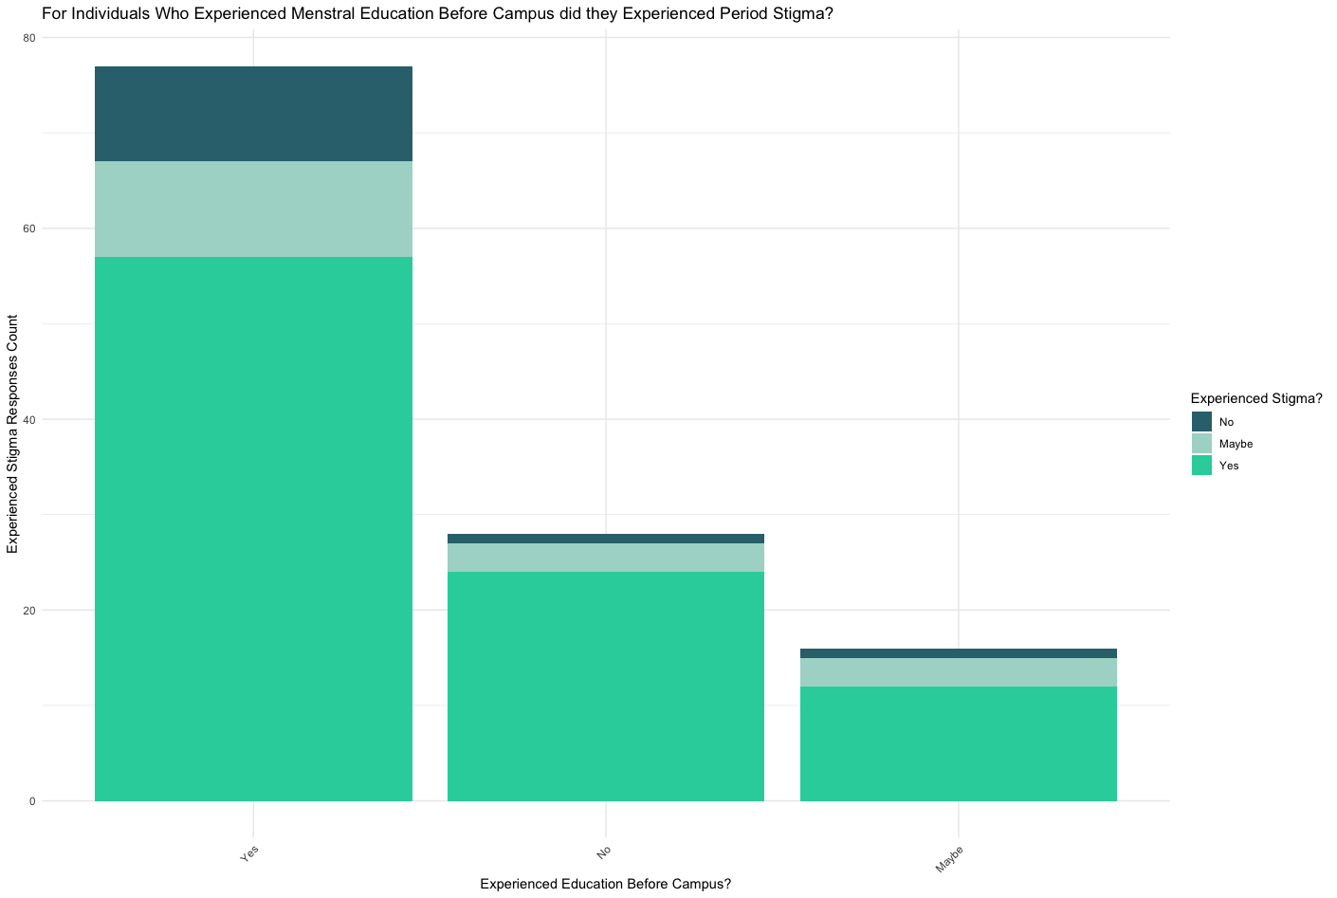

Figure : For Individuals Who Experienced Menstrual Education Before Campus, Did They Experience Period Stigma?

### Graph Comparing Perception of Eco-Friendly Period Products

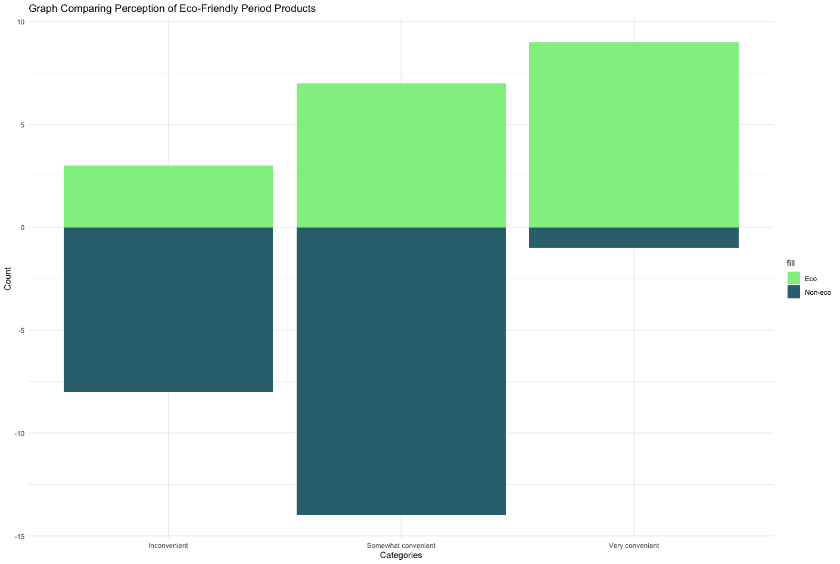

Figure : Graph Comparing Perception of Eco-Friendly Period Products

### Products Affordability Responses Count by Campus

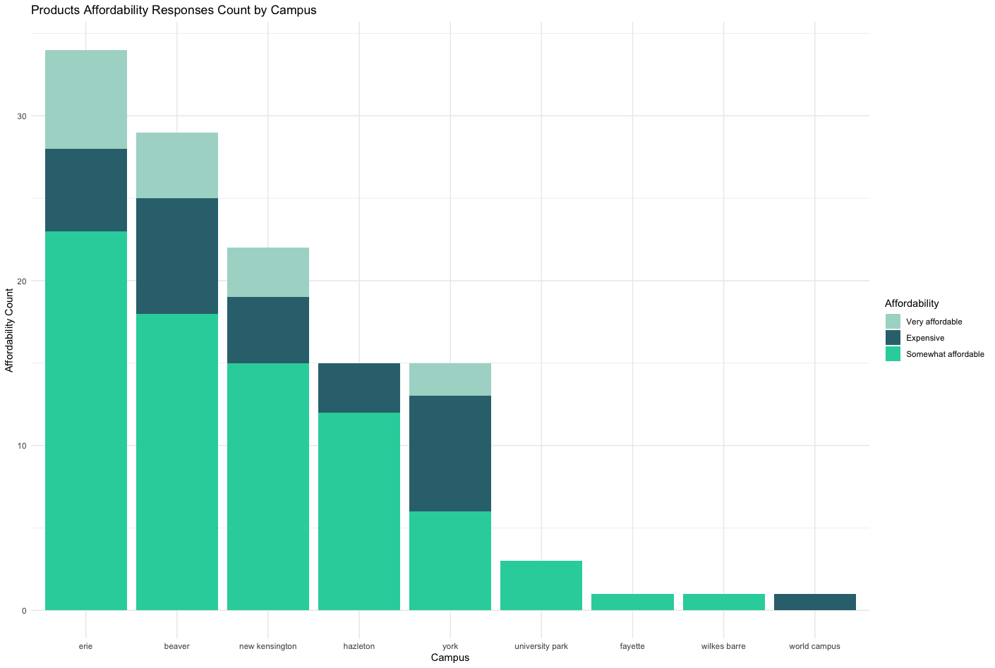

Figure : Products Affordability Responses Count by Campus

### Products Affordability Responses Count by Regions

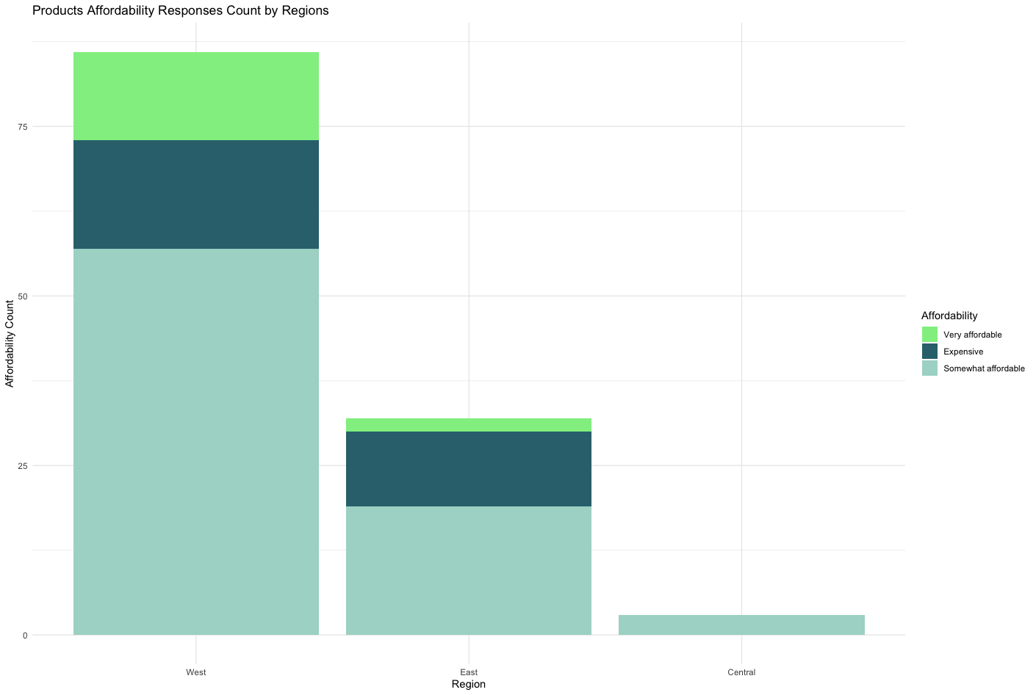

Figure : Products Affordability Responses Count by Regions

## Section 2: Period Stigma and Reusable Products

### How Are Individuals Interested in Learning About Reusable Products in Response to Period Stigma?

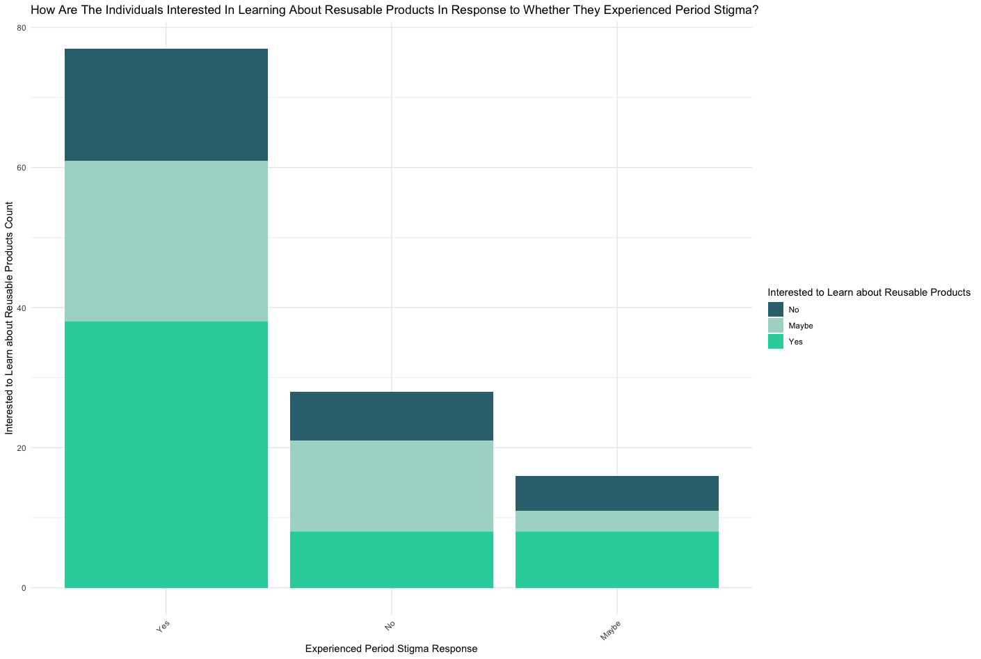

Figure : How Are Individuals Interested in Learning About Reusable Products in Response to Period Stigma?

### How Do People Who Respond to Having Experienced Period Stigma Respond to Being Allergic to Period Products?

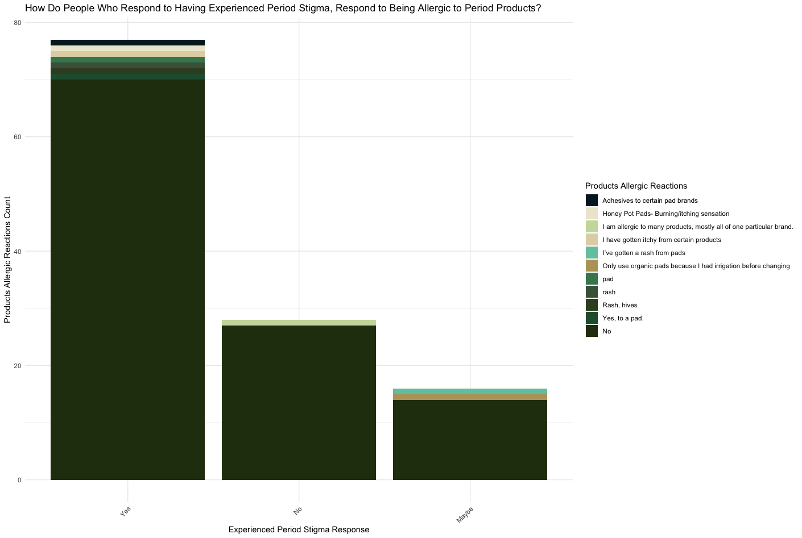

Figure : How Do People Who Respond to Having Experienced Period Stigma Respond to Being Allergic to Period Products?

### What Are the Perceptions of Reusable Products Taking Into Account Having Experienced Period Stigma?

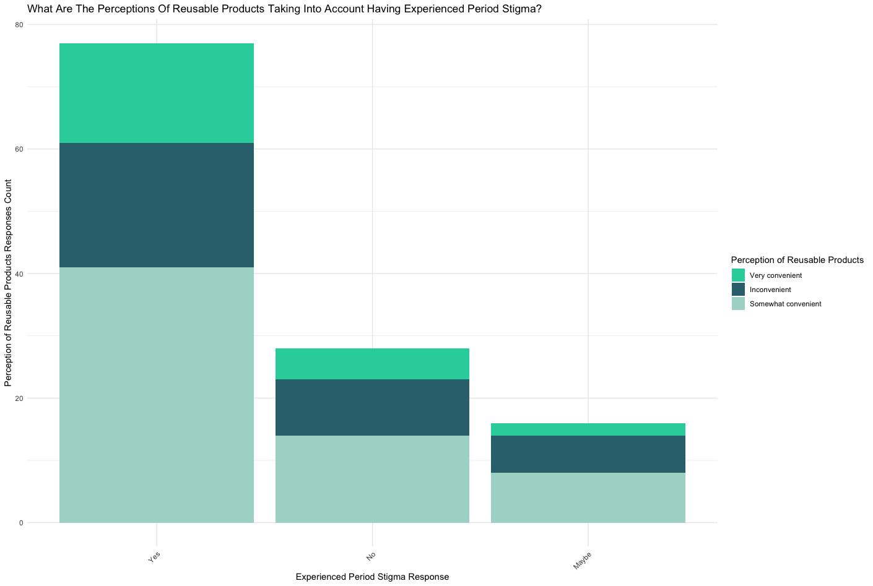

Figure : What Are the Perceptions of Reusable Products Taking Into Account Having Experienced Period Stigma?

### How Did Individuals Who Have Experienced Period Stigma Respond to the Importance of Having Period Products Variety on Campus?

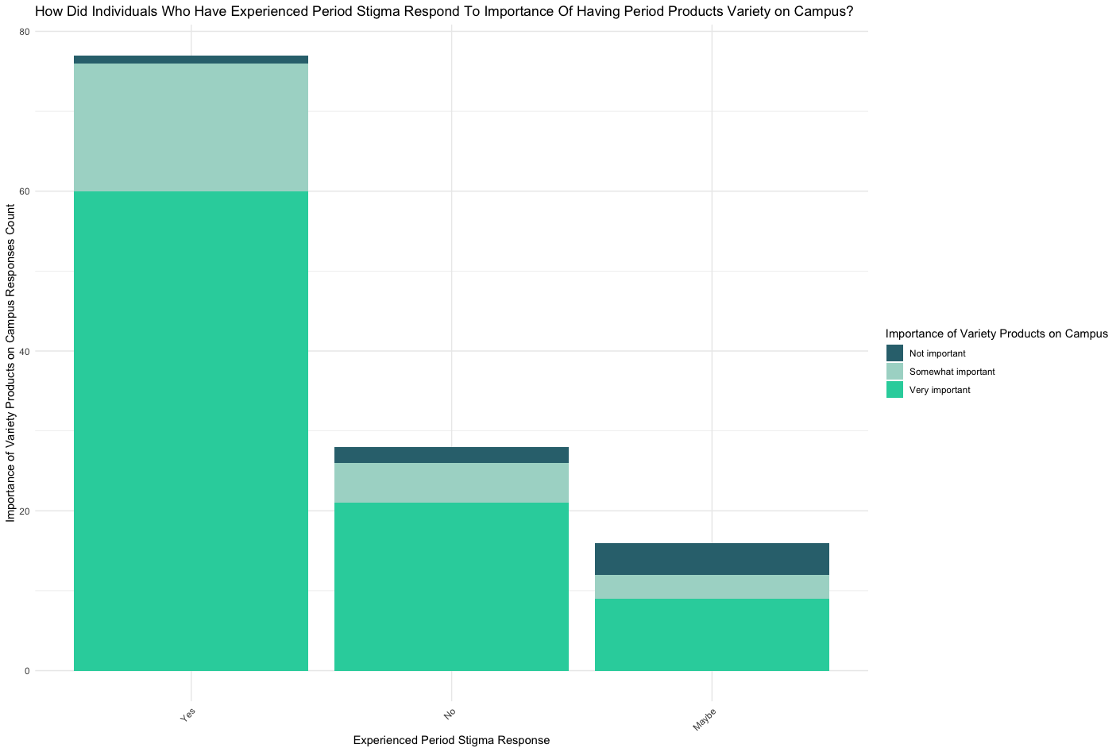

Figure : How Did Individuals Who Have Experienced Period Stigma Respond to the Importance of Having Period Products Variety on Campus?

### Experienced Period Stigma Responses by Campuses

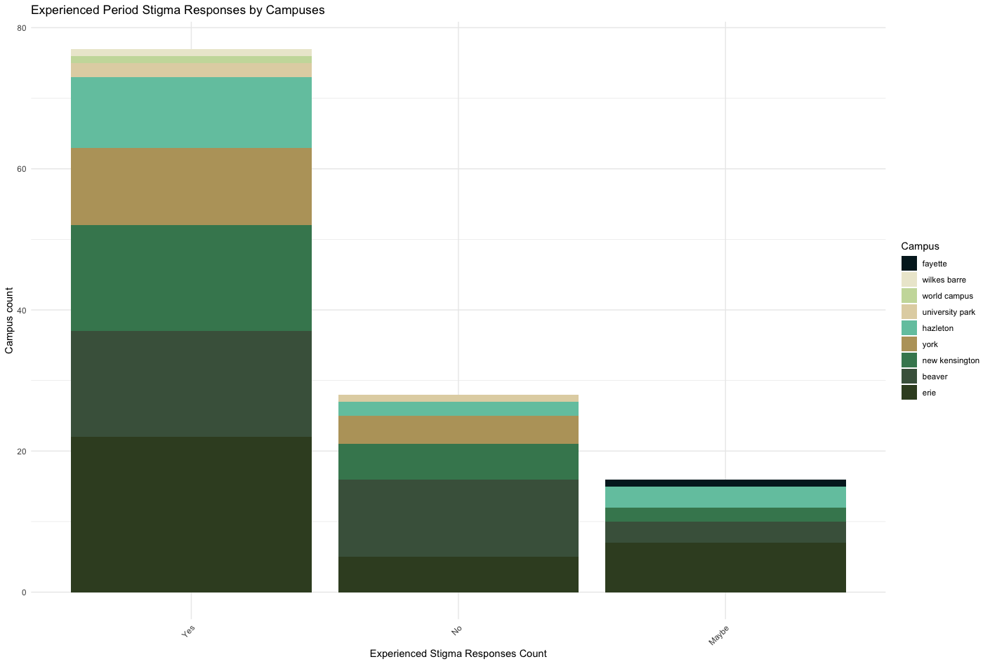

Figure : Experienced Period Stigma Responses by Campuses

### For Those Who Have Experienced Period Stigma, What Are Their Period Products' Affordability Perception?

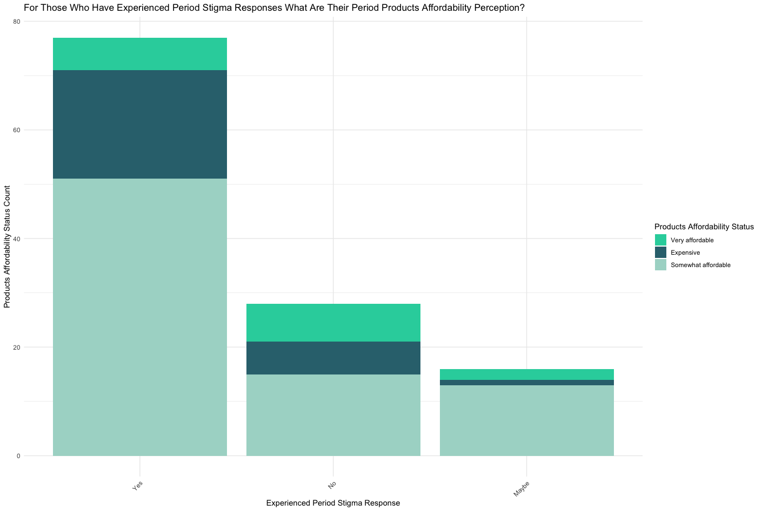

Figure : For Those Who Have Experienced Period Stigma, What Are Their Period Products' Affordability Perception?

## Section 3: Recommendations and Reactions

### For Those Who Have Experienced Period Stigma, How Likely Are They to Recommend Products?

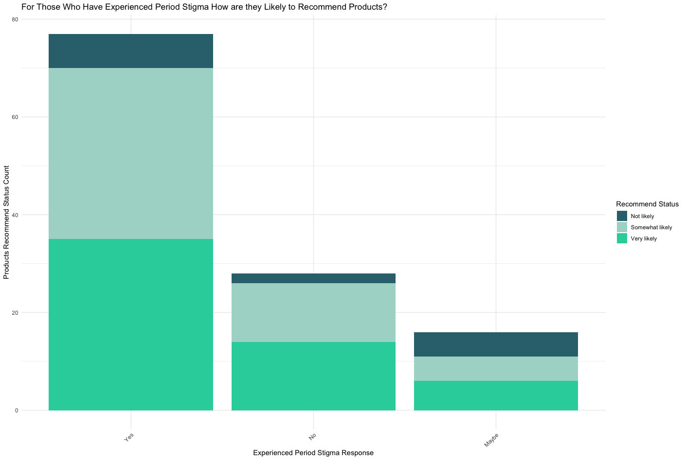

Figure : For Those Who Have Experienced Period Stigma, How Likely Are They to Recommend Products?

## Section 4: Environmental Concerns and Current Products

### Proportions of Campuses Concerned by Environmental Impact

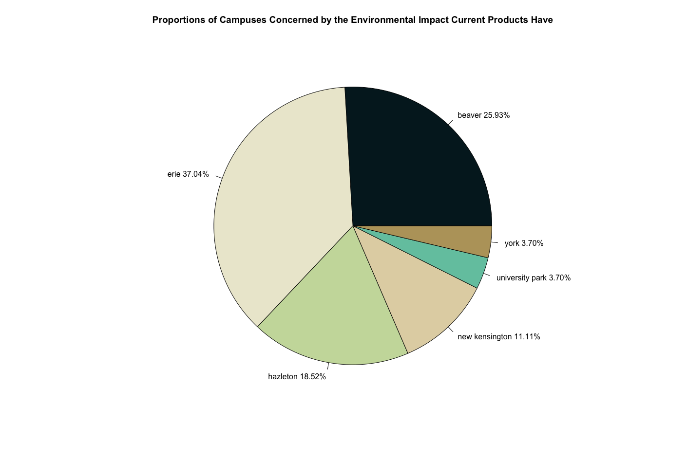

Figure : Proportions of Campuses Concerned by Environmental Impact

### Proportions of Responses by Campus Concerned by Environmental Impact

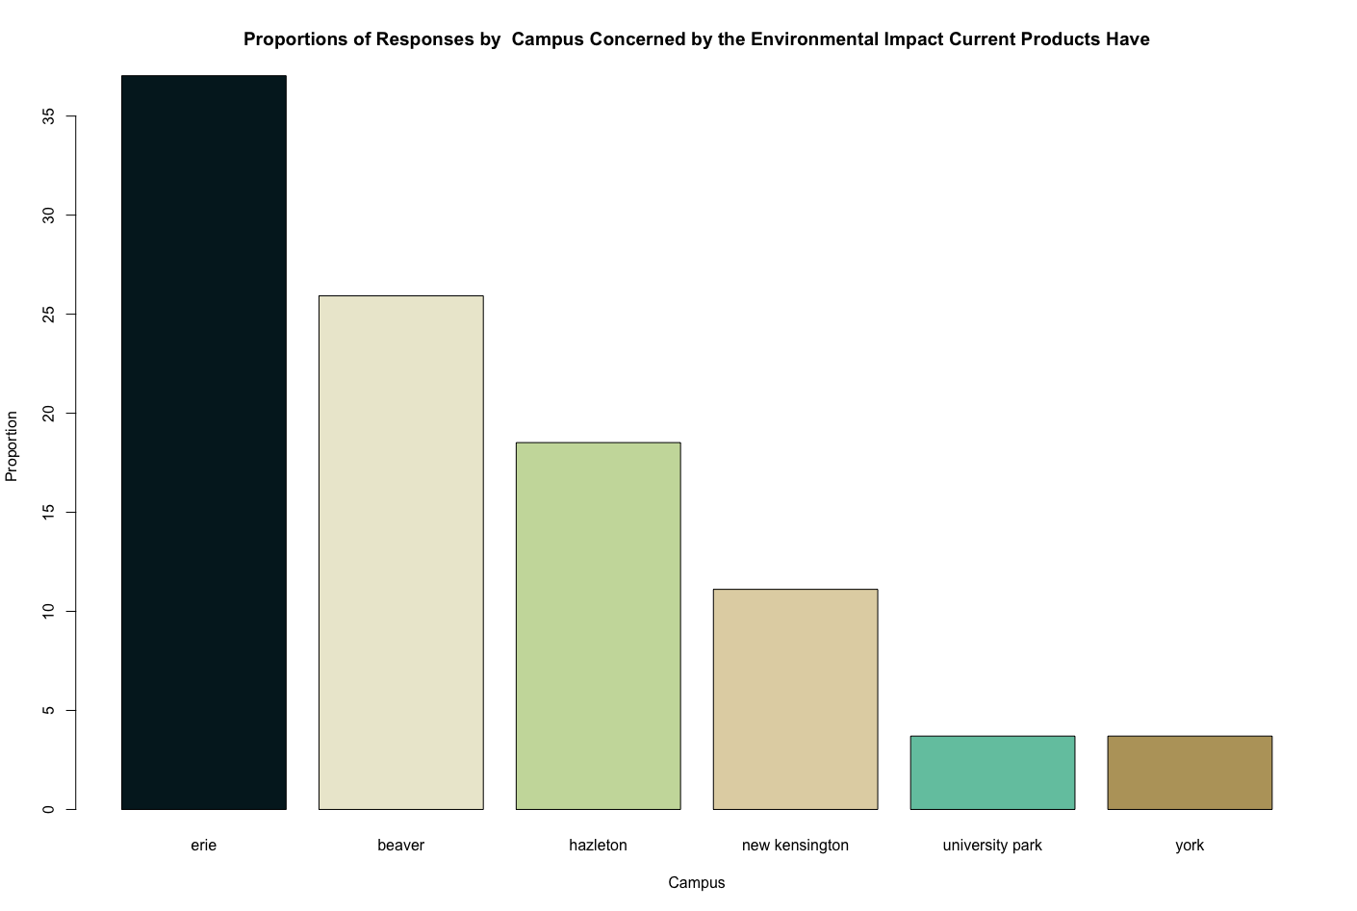

Figure : Proportions of Responses by Campus Concerned by Environmental Impact

### Proportions of Responses by Campus Not Concerned by Environmental Impact

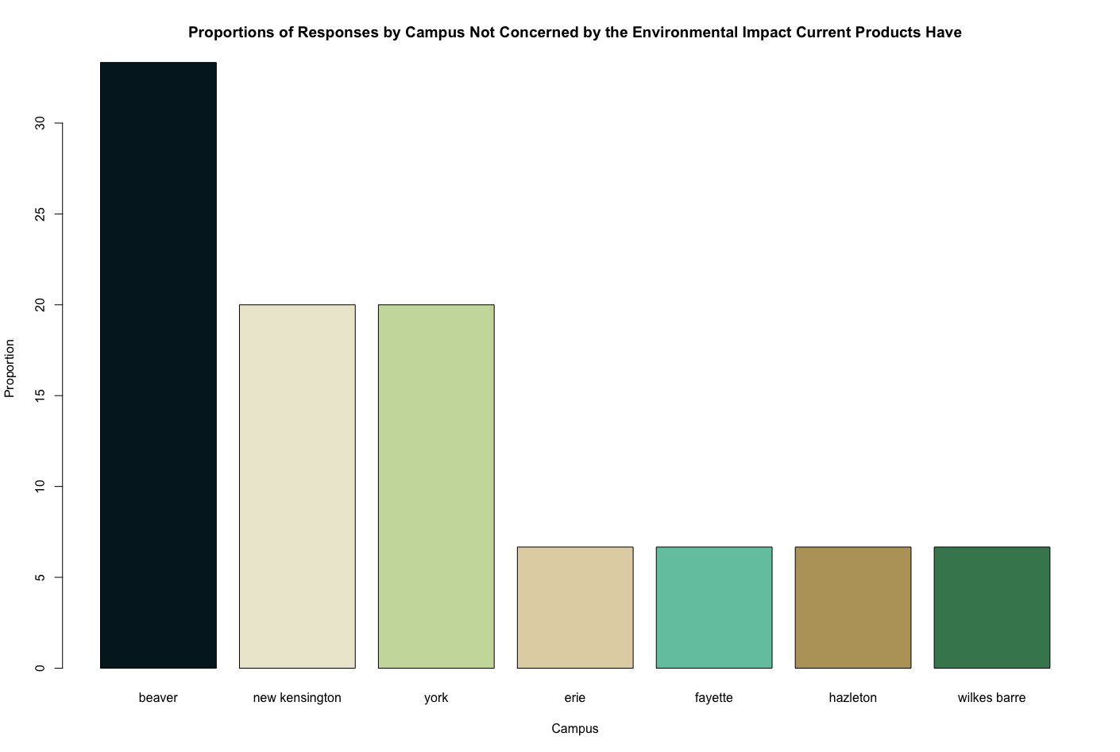

Figure : Proportions of Responses by Campus Not Concerned by Environmental Impact

### Proportions of Campuses Not Concerned of the Environmental Impact Current Products Have

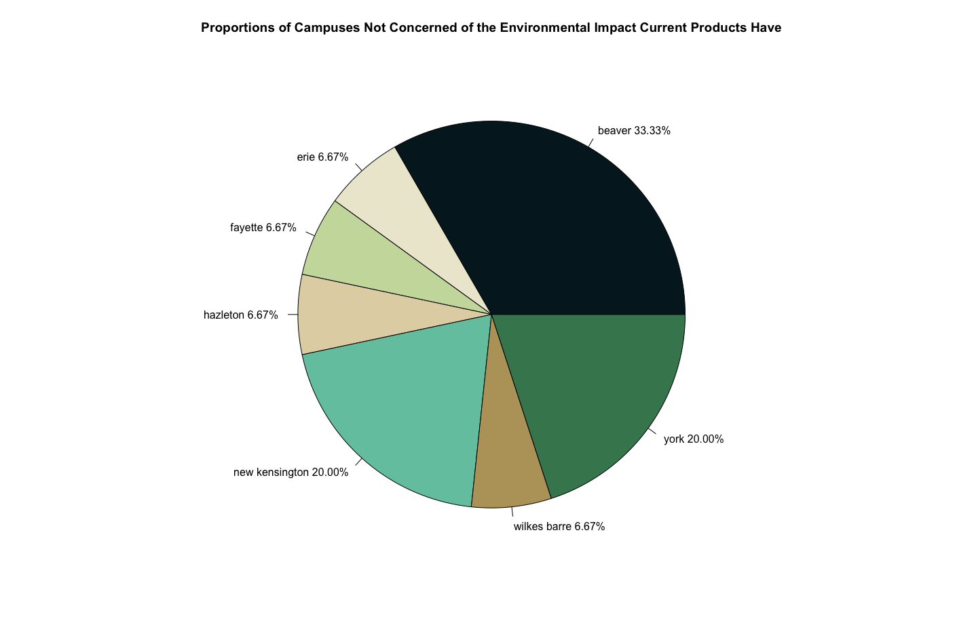

Figure : Proportions of Campuses Not Concerned of the Environmental Impact Current Products Have

### Comparing the Proportions of Responses by Campus in Concerned and Not Concerned Categories of Current Products' Environmental Impact

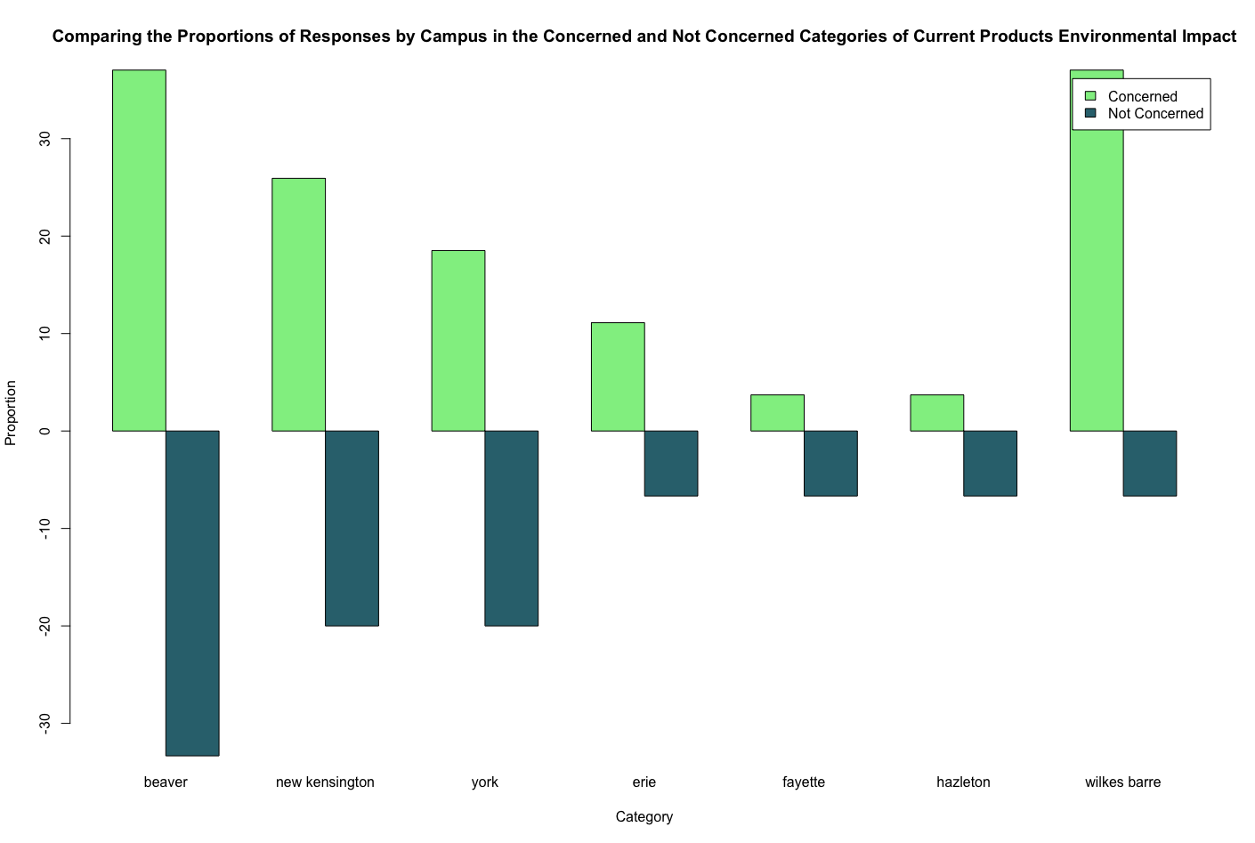

Figure : Comparing the Proportions of Responses by Campus in Concerned and Not Concerned Categories of Current Products Environmental Impact