COSC 364 Assignment: RIP

Test

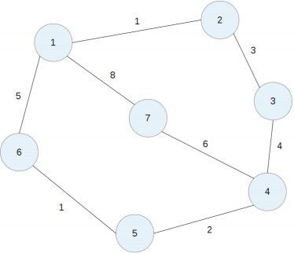

**Testcase 1**:

*Figure 1: network used in the testcase*

Aim of this testcase is to check routing table converge and the metric to the destination is minimum.

Expected routing table for router1:

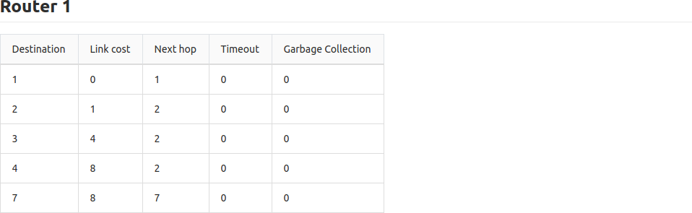

Actual routing table for router1:

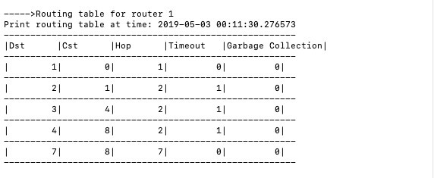

Expected routing table for router2:

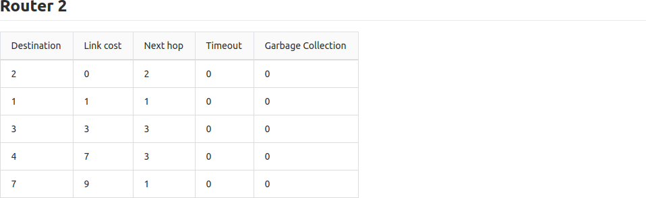

Actual routing table for router2:

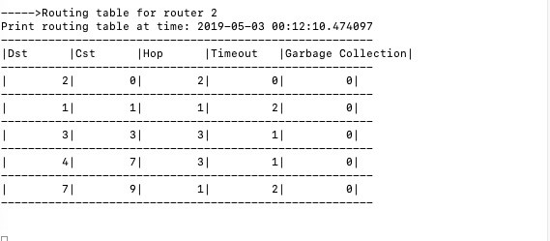

Expected routing table for router3:

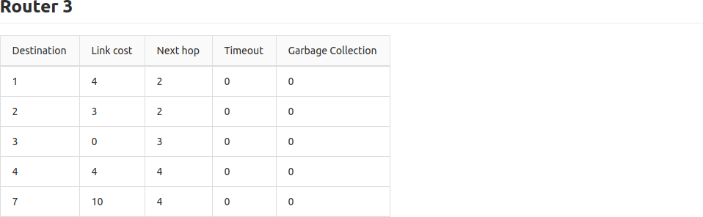

Actual routing table for router3:

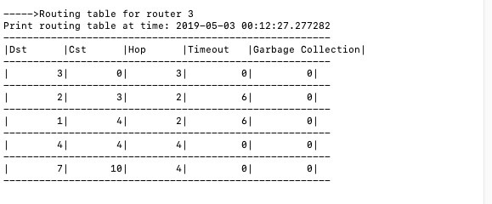

Expected routing table for router4:

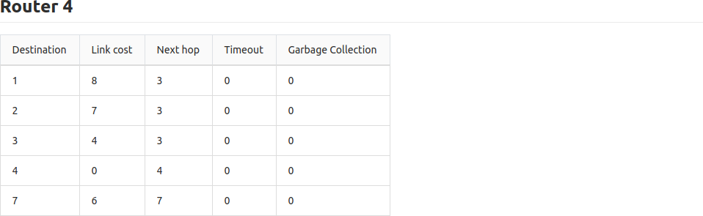

Actual routing table for router4:

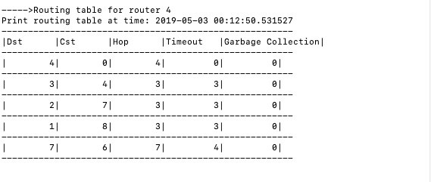

Expected routing table for router7:

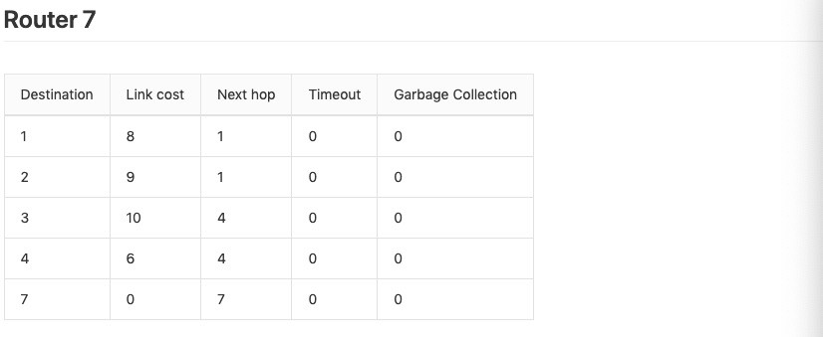

Actual routing table for router7:

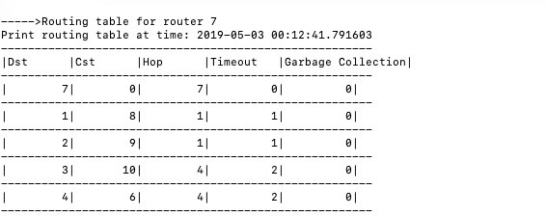

Conclusion: Our RIP protocol can achieve table convergence after every router is switched on. And the algorithm to find the minimal path is correct (the metric value to different detitanation is correct).

**Testcase 2:**

Aim of this testcase is to check any router is switched off, the Timeout of neighbored routers can reach to 60 (it can be set manually). After that

neighbored router will set the metric to this router to infinity and triggered update will start. Each router will start garbage-collection timer. After garbage-collection timer expired, router will be removed from every routing table.

**Before starting garbage-collection timer:**

Expected routing table for router1:

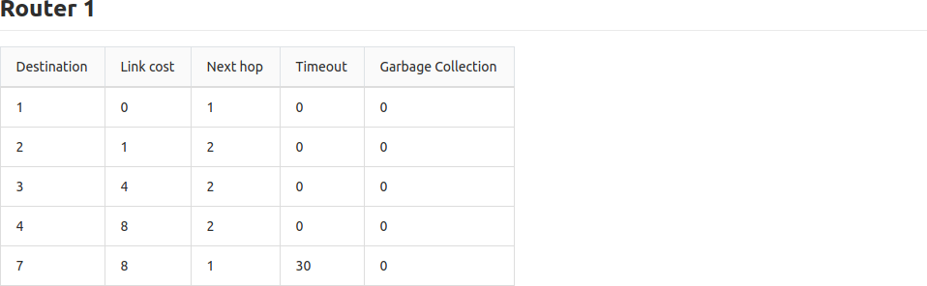

Actual routing table for router1:

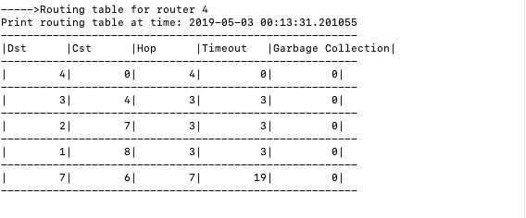

Expected routing table for router2:



Actual routing table for router2:

The picture below indicates that router2 get routing table from router1. But routing table for router2 will not start the Timeout timer to the

destination router7.

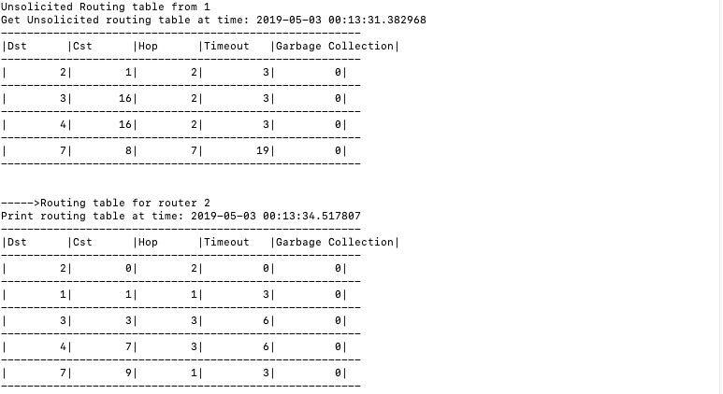

Expected routing table router3:

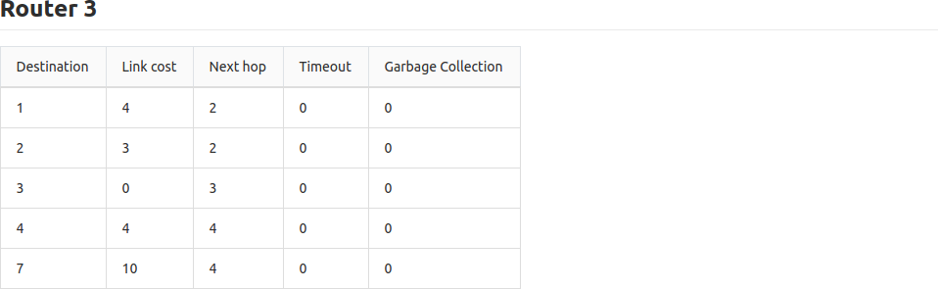

Actual routing table for router3:

The picture below indicates that router2 get routing table from router1. But routing table for router3will not start the Timeout timer to the destination router7.

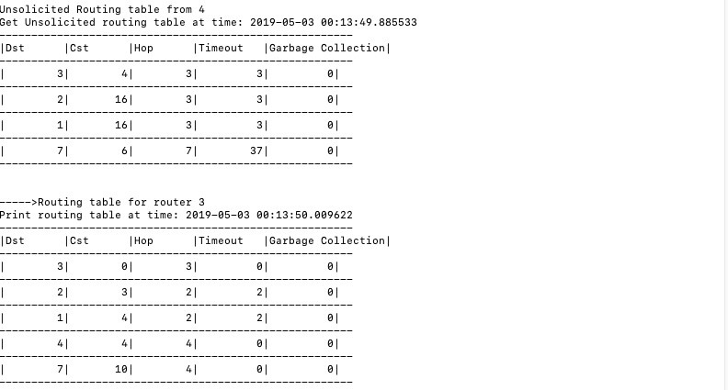

Expected routing table for router4:

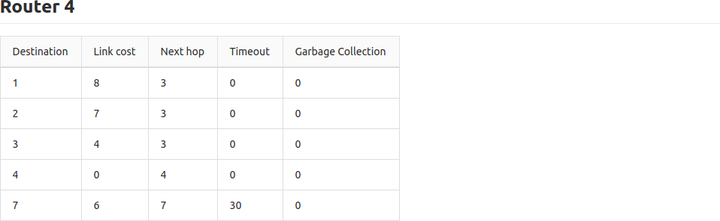

Actual routing table for router4:



**After starting garbage-collection timer:**

Expected routing table for router1:

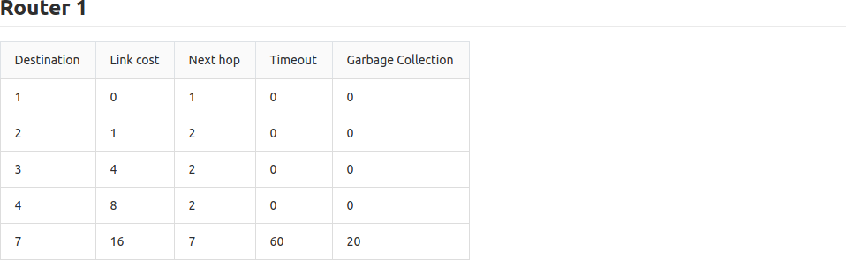

Actual routing table for router1:

The picture below indicates that router1 to router7 reaches timeout. Timer for garbage collection start increase.

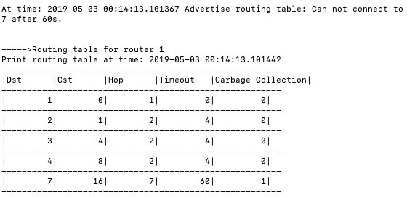

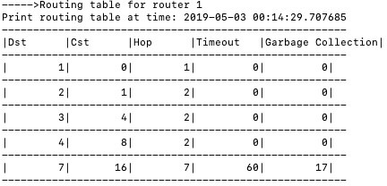

Expected routing table for router2:

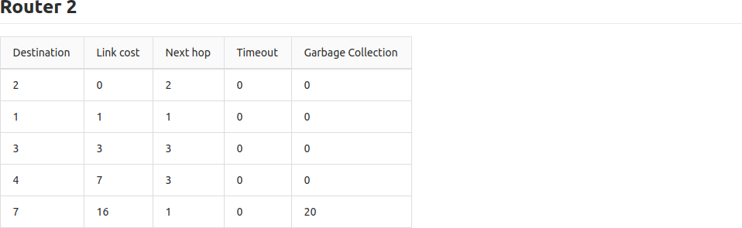

Actual routing table for router2:

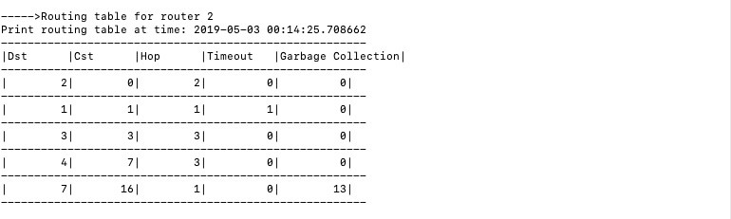

Expected routing table for router3:

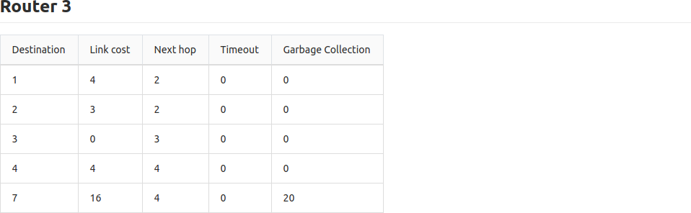

Actual routing table for router3:

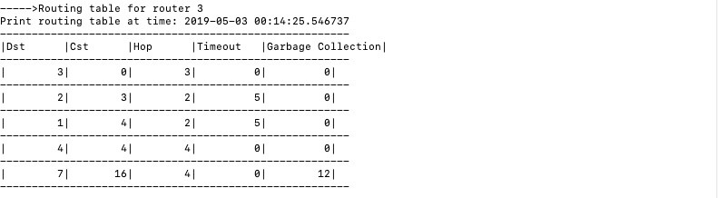

Expected routing table for router4:

The picture below indicates that router4 to router7 reaches timeout. Timer for garbage collection start increase.

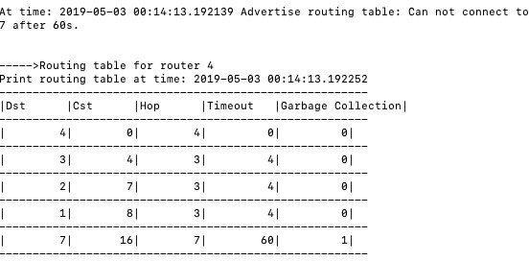

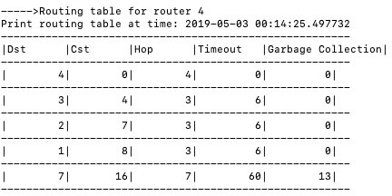

**After router7 removing from routing tables:**

Expected routing table for router1:

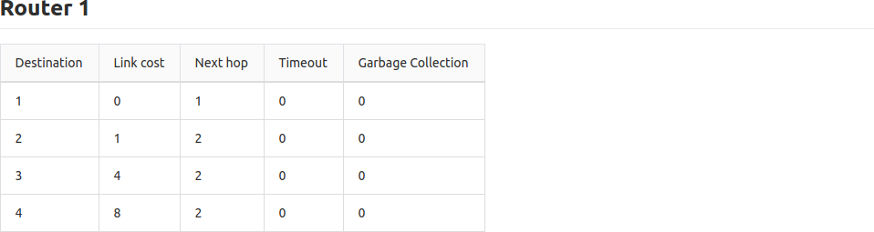

Actual routing table for router1:

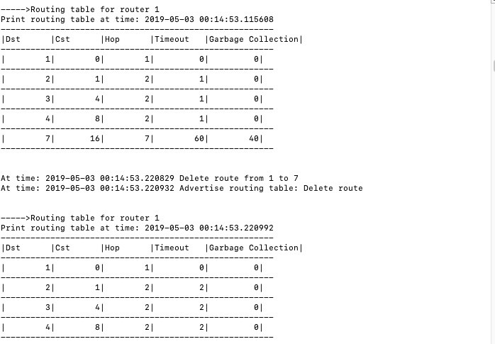

Expected routing table for router2:

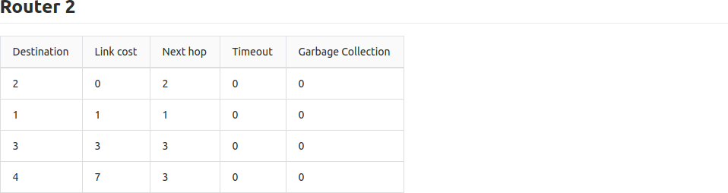

Actual routing table for router2:

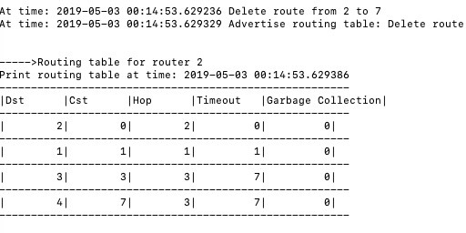

Expected routing table for router3:

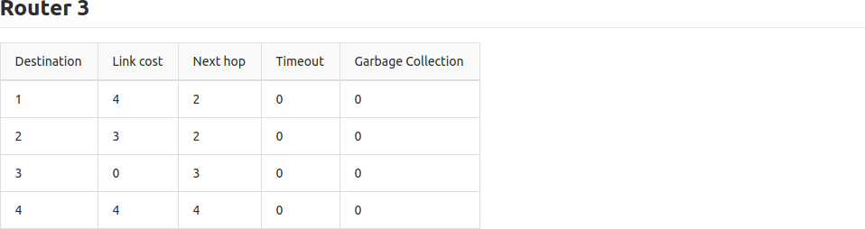

Actual routing table for router3:

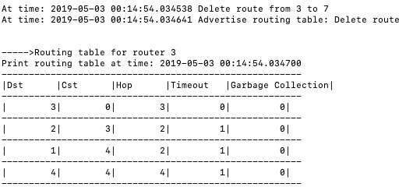

Expected routing table for router4:

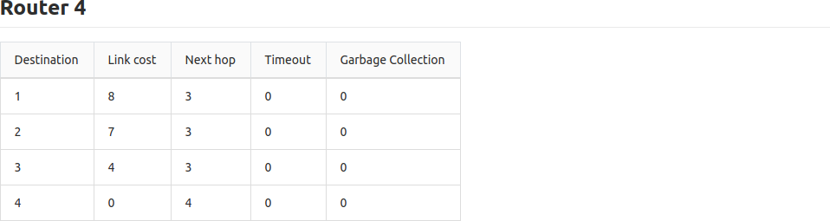

Actual routing table for router4:

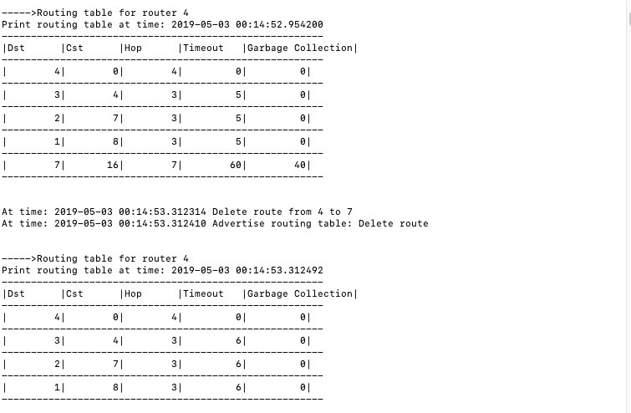

Conclusion: After router switched off, the Timeout of neighbored routers can reach to 60. And neighbored routers set the metric to this router to infinity and triggered update start. Each router starts garbage-collection timer. After garbage-collection timer expired, this router is removed from every routing table.

Testcase3:

The aim of this testcase is to switch the failed router and other routers on and expect to see that the network converges into the right state.

**Switch on router 7, router 5 and router 6:**

Expected routing table for router1:

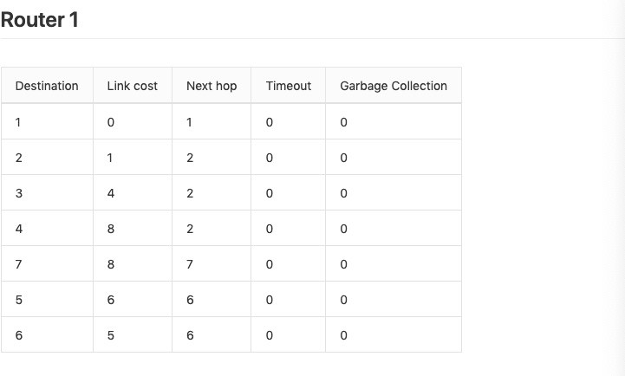

Actual routing table for router1:

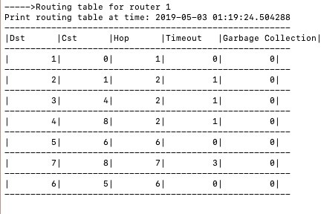

Expected routing table for router2:

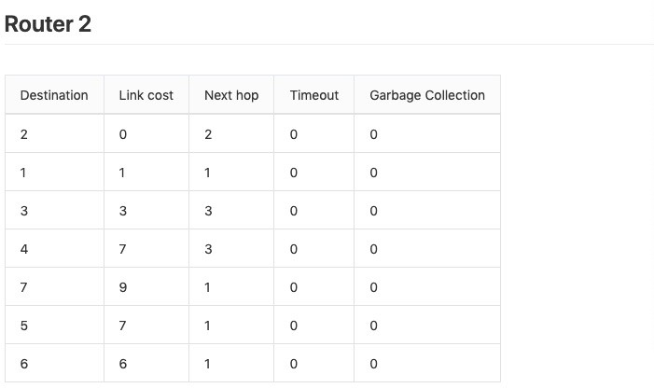

Actual routing table for router2:

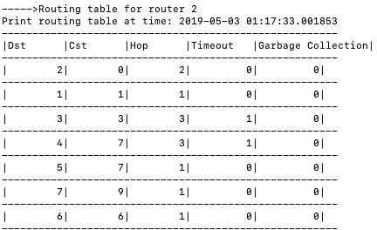

Expected routing table for router3:

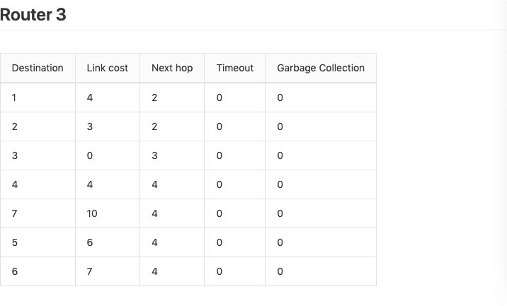

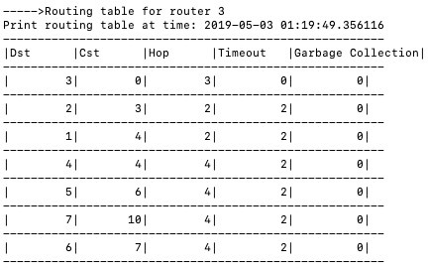Actual routing table for router3:

Expected routing table for router4:

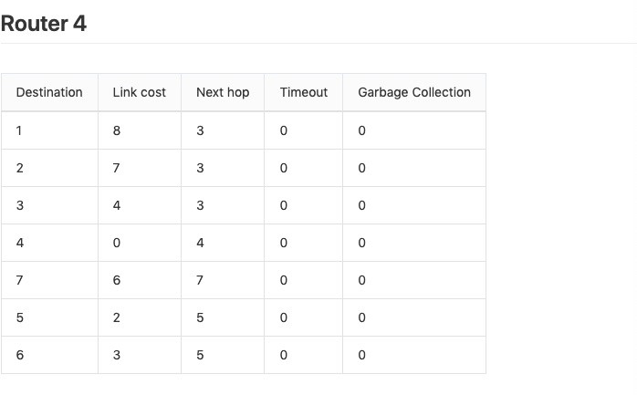

Actual routing table for router4:

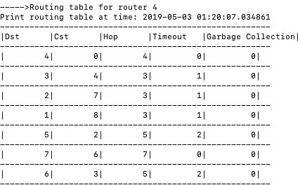

Expected routing table for router5:

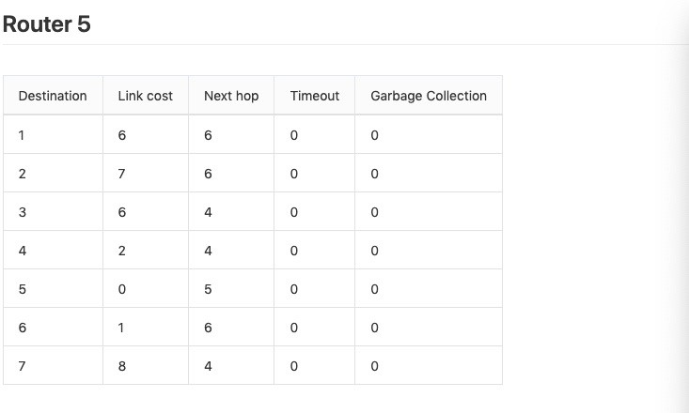

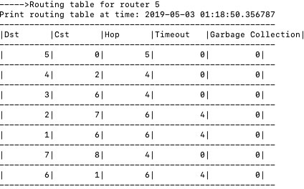Actual routing table for router5:

Expected routing table for router6:

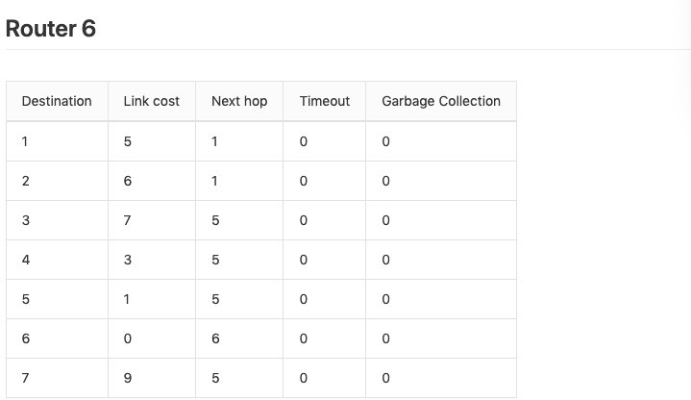

Actual routing table for router6:

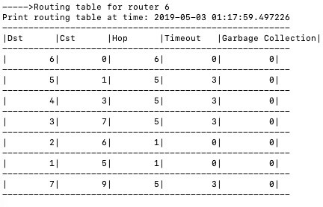

Expected routing table for router7:

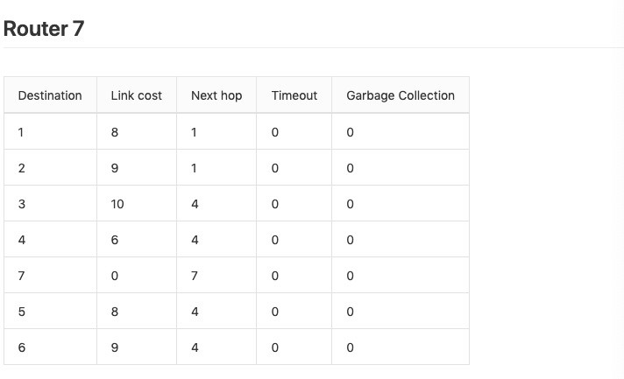

Actual routing table for router7:

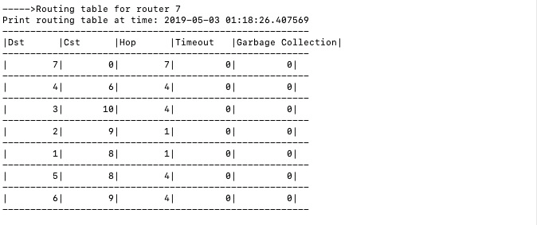

Conclusion: After switched the failed router and other routers on and the network can converge into the right state.