COURSE NAME: Software Project Management (SWE321)
Instructor: Dr. Fatma Helmy, Dr. Ahmed Taha, Dr. Mohamed Seif
TAs: Eng. Salma Osama, Eng. Bassant Kassem
Lab 4

PROJECT MANAGEMENT PLAN TEMPLATE
VERSION HISTORY
Version: 1.0
Approved by: [Dr.Ahmed Taha, Eng.Salma osama]
Revision Date: [13 March 2025]
Description of Change: Initial Version
Author: [Mariam Nasr, Sama Ahmed, Mina Adel, Mina Atef]

1. EXECUTIVE SUMMARY
The To-Do List Software project aims to develop a web-based application that helps users efficiently manage their tasks through an intuitive and user-friendly interface. The primary goal is to deliver a functional and reliable application with core features such as task creation, editing, deletion, and organization, as well as advanced features like reminders, due dates, and priority levels. The project also focuses on ensuring a seamless user experience and comprehensive documentation, including a Software Requirements Specification (SRS), Software Design Document (SDD), and technical documentation. By completing the project within the given timeline and meeting all academic requirements, the team aims to provide a practical tool for improving productivity and time management.

2. PROJECT MANAGEMENT APPROACH AND GOVERNANCE
2.1 PROJECT SCOPE
In scope:
- web-based application that allows users to create, edit, delete, and organize tasks
- The app has features such as due dates, reminders, and priority levels.
- The project will focus on delivering a functional and user-friendly application within the timeline and resources available.
Out scope:

The application will be developed as a web-based tool and will not include mobile app development.

Advanced features such as collaboration (e.g., shared tasks) and third-party integrations (e.g., Google Calendar) are out of scope unless explicitly approved.

The project will use free and open-source tools to avoid budget constraints.

2.2 DELIVERABLES
- Prototype 1 (Basic Functionality): A minimal viable product (MVP) with core features such as task creation, editing, and deletion.
- Prototype 2 (Advanced Features): An enhanced version with additional features like reminders, due dates, and priority levels.
- Final Application: A fully functional web-based to-do list application with all features implemented and tested.
- Documentation:
- Software Requirements Specification (SRS) document.
- User manual for end-users.
- Software Design Document (SDD).
- Testing Reports: Detailed reports on unit, integration, and system testing.
- Deployment: The application will be deployed to a web hosting platform for demonstration and evaluation.

2.3 WORK BREAKDOWN STRUCTURE (WBS)
The project tasks will be broken down into smaller, manageable units using a Work Breakdown Structure (WBS). The WBS is organized into phases and tasks as follows:
- Initiation Phase:
- Define the project objectives and purpose
- Identify key stakeholders and their roles
- Conduct a feasibility study to assess the viability of the project
- Draft the initial project charter outlining the scope, goals, and team structure
- Planning Phase:
- Create a detailed project timeline and schedule
- Create the Software Requirements Specification (SRS) document
- Assign roles and responsibilities to team members
- Identify risks and develop a risk management plan
- Design Phase:
- Design the user interface (UI) and user experience (UX)
- Create wireframes and mockups for the application
- Design the database schema for task management
- Create the Software Design Document(SDD)
- Review and finalize the design with the team and stakeholders
- Development Phase:
- Develop the core functionality of the application, including task creation, editing, and deletion.
- Implement advanced features such as reminders, due dates, and priority levels.
- Integrate the front-end (HTML, CSS, JavaScript) with the back-end (PHP, SQL).
- Conduct unit testing for individual components during development.
- Testing Phase:
- Perform integration testing to ensure all features work together.
- Conduct system testing to validate the application as a whole.
- Fix bugs and optimize performance.
- Deployment Phase:
- Deploy the application to a web hosting platform
- Configure the server and database for live use.
- Conduct final testing to ensure the application works in the production environment
- Monitoring and Controlling Phase
- Monitor the application’s performance and user feedback after deployment.
- Address any post-deployment issues or bugs.
- Track project progress against the schedule and budget.
- Ensure all deliverables meet the quality standards defined in the SRS.
- Closing Phase
- Prepare and submit final project documentation, including user manuals and technical documentation.
- Conduct a project review to evaluate successes, challenges, and lessons learned.
- Archive project files and code for future reference.
- Officially close the project and obtain sign-off from stakeholders.

2.4 STAKEHOLDER ANALYSIS

Project Team:
  - Project Manager (Mariam Nasr): Oversees the project timeline, coordinates tasks, and ensures deliverables are met.
  - UI/UX Designer (Mina Atef): Designs the user interface and ensures a user-friendly experience.
  - Software Developer (Sama Ahmad): Responsible for coding and implementing the application’s features.
  - Technical Writer (Mina Adel): Prepares project documentation and user manuals.
- Professor (Dr. Ahmed Taha):
  - Acts as the client and primary evaluator of the project.
  - Provides feedback and guidance throughout the development process.
- End-Users:
  - Students or individuals who will use the to-do list application to manage their tasks.
  - Their feedback will help improve the application’s usability.
- Teaching Assistants (Eng. Salma Osama):
  - Provide technical support and assist with project-related queries.

2.5 SCHEDULE BASELINE
The project is planned for a 2-month duration, with major milestones every week.
Week 1:
  - Project Planning: Define project objectives, scope, and goals.
  - Requirements Gathering: Collect and document functional and non-functional requirements.
  - SRS Document: Draft the Software Requirements Specification (SRS) document.
Week 2:
  - UI/UX Design: Create wireframes and mockups for the application.
  - Database Design: Design the database schema for task management.
  - Technical Planning: Define the system architecture and development tools.
Week 3-4:
  - Prototype 1 Development: Implement basic functionality, including task creation, editing, and deletion.
  - Unit Testing: Conduct unit testing for individual components.
  - Documentation: Prepare Software Design Document (SDD) and user manuals.
Week 5:
  - Prototype 1 Testing: Perform integration and system testing for Prototype 1.
  - Refinement: Fix bugs and optimize performance based on testing results.
Week 6-7:
  - Prototype 2 Development: Implement advanced features, including reminders, due dates, and priority levels.
  - Unit Testing: Conduct unit testing for new features.
Week 8:
  - Final Testing: Perform comprehensive testing of the entire application.
  - Deployment: Deploy the application to a web hosting platform.
  - Final Submission: Submit all deliverables and close the project.

This schedule will be tracked using project management tools like Jira and GitHub Projects, with regular updates provided during team meetings.

2.6 MILESTONE LIST
- Project Kickoff:.
  - Deliverables: Completion of project planning and SRS document
  - Target Date: End of Week 1
- UI/UX Design Completion:.
  - Deliverables: Finalization of wireframes, mockups, and database schema
  - Target Date: End of Week 2
- Prototype 1 Completion and SDD:
  - Deliverables: Development and testing of basic functionality (task creation, editing, and deletion), completion of Software Design Document SDD
  - Target Date: End of Week 4
- Prototype 2 Completion: .
  - Deliverables: Development and testing of advanced features (reminders, due dates, and priority levels)
  - Target Date: End of Week 7
- Project Delivery:
  - Deliverables: Deployment of the application and submission of final deliverables
  - Target Date: End of Week 8

2.7 CHANGE MANAGEMENT PLAN
Changes will be evaluated by the project manager and approved by the sponsor. All requests will be documented and tracked.

2.8 PROJECT SCOPE MANAGEMENT PLAN
Scope changes must be reviewed by the project manager and approved by key stakeholders.

3. COMMUNICATION MANAGEMENT PLAN
Communication will be through weekly status update meetings, Bi-weekly team meetings,Monthly progress reports , Risk & issue escalation meetings and client updates via Emails or virtual meetings.

4. RESOURCE MANAGEMENT PLAN
Resources required include development tools and human resources (project management , assistant project manager , developers) .

5. HUMAN RESOURCES MANAGEMENT PLAN
List project staff, roles, and responsibilities.

5.1 PROJECT STAFF LIST
Name | Title | Email | Phone
Mariam Nasr | Team Manager | mariam2209445@miuegypt.edu.eg
Sama Ahmed | Software Developer | sama2206518@miuegypt.edu.eg
Mina Adel | Technical Writer | mina2205319@miuegypt.edu.eg
Mina Atef | UI/UX Designer | mina2205542@miuegypt.edu.eg

5.2 RESOURCE REQUIREMENT CALENDAR
Define resource allocation per project phase.
Project Phase | Required resources | Team member involved
Prototype #1 Development (Homepage features) (3/6/25 - 3/8/25) | UI/U tools, Development tools | Mina Atef , Sama
Prototype #1 Development (Admin dashboard features) (3/9/25 - 3/11/25 | Development tools,UI/UX tools, Backend , Database | Mina Atef, Sama , Mariam nasr
Prototype #1 Development and Testing (Task & User Management) (3/13/25 - 3/14/25) | Development Tools,Testing | Sama,Mariam
Prototype #1 Final Testing  (3/15/25 - 3/18/25)  Delivery of Prototype #1 (3/19/25) | Testing environment,debugging  Documentation | All team members  All Team members but Mina Adel is the most important one
Prototype #2 Development (System Enhancements) (4/10/25 - 4/17/25) | Development and enhancement tools and UI/UX | Sama , Mina Atef
Prototype #2 Development (Due Dates Feature) (4/19/25 - 4/25/25) | Development and UI/UX | Sama , Mina Atef
Prototype #2 Development (Motivational Quotes Feature) (5/1/25 - 5/5/25) | Development and UI/UX | Sama , Mina Atef
Prototype #2 Development (Task Priority Levels) (5/5/25 - 5/10/25) | Development and UI/UX | Sama , Mina Atef
Prototype #2 Final Testing (10/5/25 - 16/5/25)  Delivery of Prototype #2, Exhibit Presentation (18/5/25 - 22/5/25) | Testing and debugging  Documentation | All team members  All Team members but Mina Adel is the most important one

6. SCHEDULE MANAGEMENT PLAN

3/1/25 | 3/5/25 | SRS documentation
3/6/25 | 3/8/25 | Prototype #1 Development (Homepage features and SDD documentation)
3/9/25 | 3/11/25 | Prototype #1 Development (Admin dashboard features and SDD documentation)
3/13/25 | 3/14/25 | Prototype #1 Development and testing (task management features,user management features and SDD documentation )
3/15/25 | 3/18/25 | Prototype #1 Final testing
3/19/25 |  | Delivery of Prototype #1
4/10/25 | 4/17/25 | Prototype #2 Development system(system enhancements)
4/19/25 | 4/25/25 | Prototype #2 Development (Due dates)
5/1/25 | 5/5/25 | Prototype #2 Development (Motivational quotes)
5/5/25 | 5/10/25 | Prototype #2 Development (task priority levels)
10/5/25 | 16/5/25 | Prototype #2 Final testing
18/5/25 | 22/5/25 | Delivery of Prototype #2, Exhibit Presentation

7. QUALITY MANAGEMENT PLAN

Section | Details
Project Name | To-Do List Application
Quality Goals | - the website should be fast and responsive  - users should be able to add,edit and delete tasks easily  - Users receive reminders on time.
team roles | - Project Manager: Ensures everything runs smoothly.  - Software Developers: Build and fix the app and check for bugs issues.  - UI/UX designer: build small prototypes to check user requirements and help developers to build the app  - Technical writers: responsible for project documentations
Testing methods | - Unit Testing: Checking small parts of the app (ex: task creation,reminder notification).  - System Testing: Making sure all features work together.  - User Testing: Letting real users test and report problems.
Bug handling | - Bugs are recorded in a tracking tool (ex: Jira).  - Bugs are fixed based on priority (High, Medium, Low).  - The fixed version is tested before release.
Improvements | - Ask users for feedback.  - Fix issues and make the app better.  - Update features based on user needs.
Final approval | The team and users will review and approve the final version.

8. RISK MANAGEMENT PLAN
The Risk Management Plan defines how risks will be discovered, assessed, and managed during the project. The goal is to reduce the impact of risks on the project’s timing, scope, and quality.

8.1 RISK LOG

ID | RISK | LIKELIHOOD | IMPACT | ACTION | Owner
R1 | delays in completing prototype 1 | High | High | break tasks into smaller parts,and set deadline and monitor the progress through jira | Mariam Nasr
R2 | Technical Challenges in development | Medium | High | asking the TAs for help to solve our bugs challenges | Sama Ahmed
R3 | Not enough testing leading to bugs | medium | medium | doing test using composer | Mina Adel
R4 | Adding Extra feature not in the plan | low | High | it will request update for the documentation (SRS ,SDD) | Mariam Nasr
R5 | Team member Unavailable | LOW | HIGH | working on shared platform like Github and wordDocs to keep all things backup | Sama Ahmed
R6 | Problem deployment | medium | medium | test on staging before going live | Mina Atef

9. COST BASELINE
The project will use free and open source tools to minimize costs,the cost will be defined in the table below

category | Estimated cost (EGP) | Description
development tools | 0 | free tools like visual studio code ,Github and mysql
web hosting | 500 | cost for deployment on web (if required)
other costs | 100 | documentation papers and other
Total Cost | 600

10. QUALITY BASELINE
10.1 Quality Standards
- Functional Requirements:
  - Core features (add, edit, delete tasks) must work, even if they have minor bugs.
  - Advanced features (reminders, due dates, priorities) should work but can have some issues.
- Non-Functional Requirements:
  - Usability: The app should be easy to use, even if the design is basic.
  - Performance: The app should load within 5 seconds.
  - Reliability: The app should work most of the time, but occasional crashes are acceptable.
  - Security:
    - Passwords must be hashed before storing in the database (no plain text passwords).
    - The app must prevent SQL injection attacks by using parameterized queries or prepared statements.
- Documentation Standards:
  - Documents (SRS, SDD, user manuals) should be clear but don’t need to be perfect.
  - Technical docs should include basic code comments and deployment steps.
- Testing Standards:
  - Unit testing should cover at least 70% of the code.
  - Integration and system testing should catch major bugs, but some minor issues are okay.
  - Critical bugs (e.g., app crashing, security vulnerabilities) must be fixed before submission.
10.2 Quality Assurance Processes
- Code Reviews: Team members will check each other’s code when possible, focusing on security practices like password hashing and SQL injection prevention.
- Testing: Test the app at every stage, but focus on fixing major bugs and security issues first.
- User Feedback: Get feedback from classmates or friends to improve usability.
- Documentation Review: Check documents for basic accuracy and completeness.
10.3 Quality Metrics
Metric | Target
Code Coverage (Unit Tests) | ≥ 70%
App Uptime | ≥ 90%
Bug Fix Rate | Fix all critical bugs before submission
Security Compliance | Passwords hashed, SQL injection prevented
User Satisfaction | ≥ 7/10 (based on user feedback)

11. APPENDICES
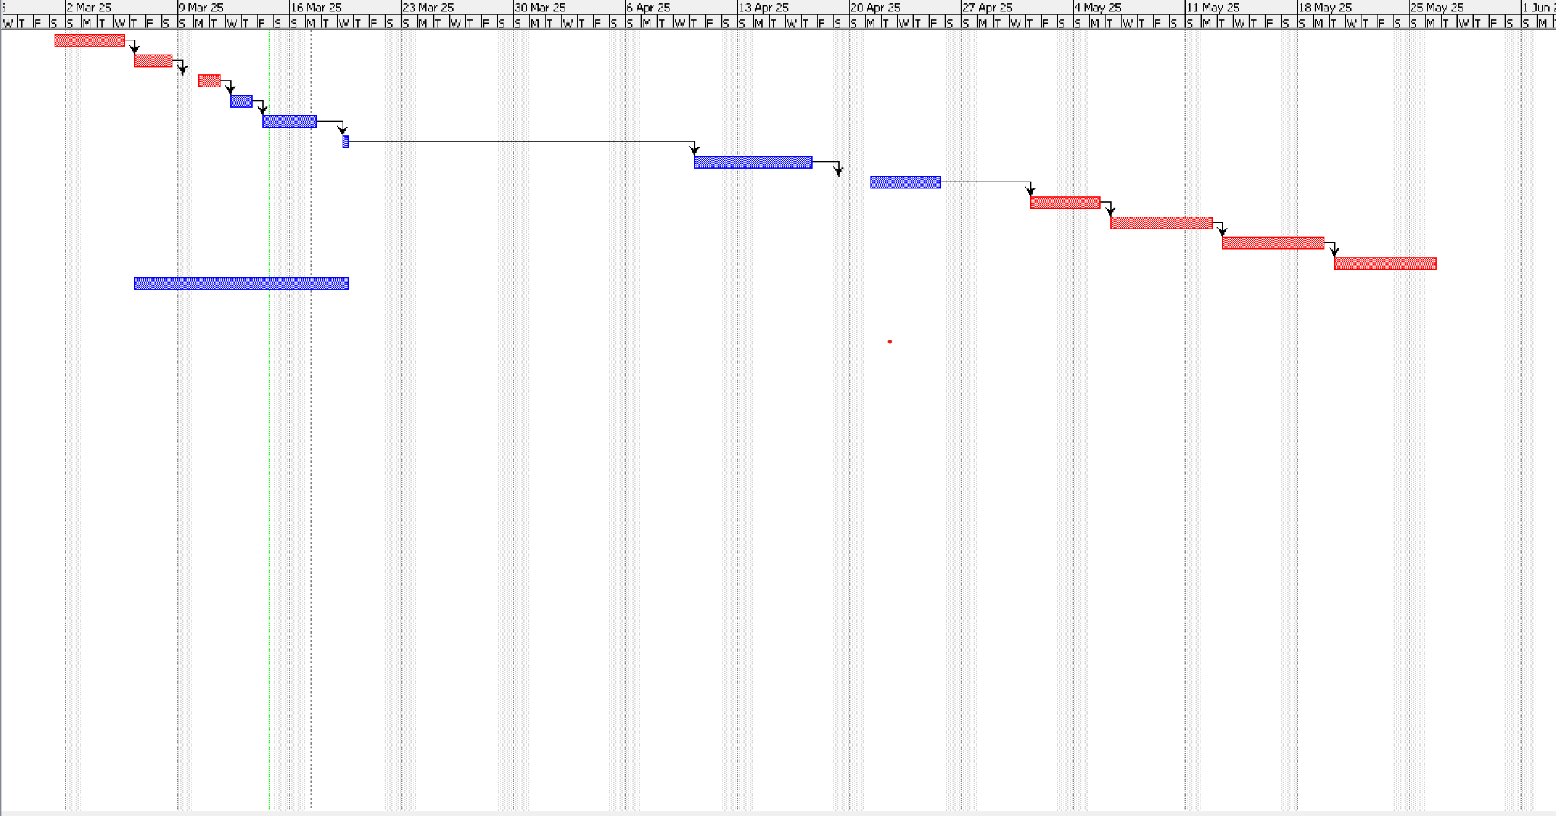

12. AUTHORIZATION SIGNATURES
Prepared by: [Mariam Nasr,Sama Ahmed,Mina Atef,Mina Adel]
Approved by: [Dr.Ahmed Taha, Eng.Salma Osama]
Date: [17 March 2025]

