Collison Avoidance Project

# Case Study: Collision Avoidance System

* Collision Avoidance System should check if the distance between itself and object doesn’t exceed 50 cm.
* If the distance between itself and object exceeded 50 cm the system should turn the DC Motor off

# Assumptions

* System setup and shutdown procedure are not modelled.
* System maintenance is not modelled.
* Ultrasonic sensor never fails.
* DC motors never fail.
* System never faces power cut.

# Activity diagram:

* 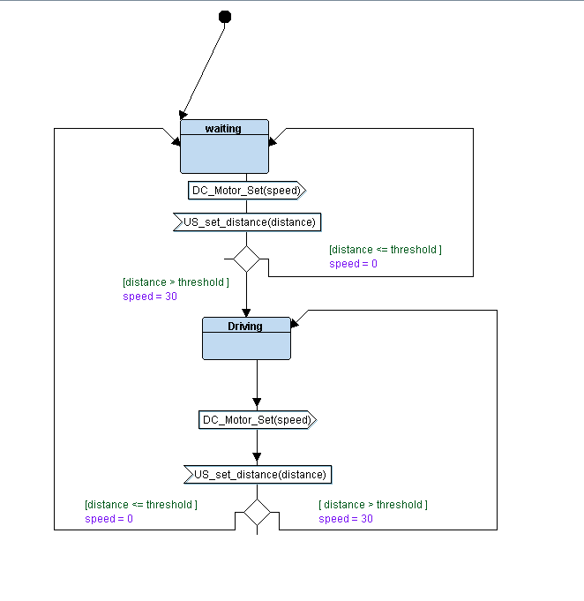CA :

* 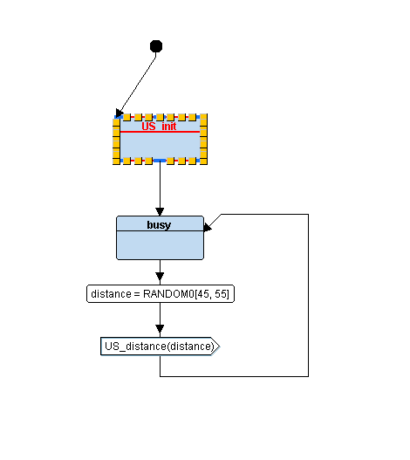US Sensor :
* 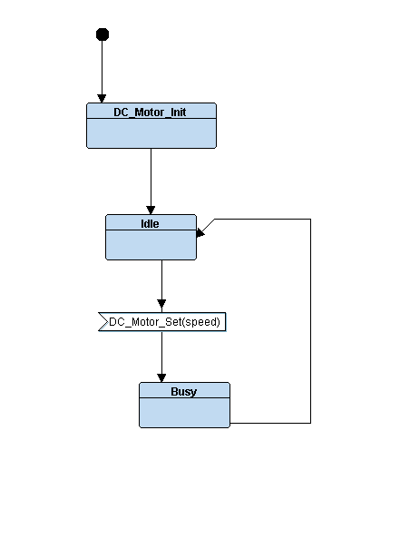DC Motor:

# Sequence diagram:

# Block diagram: