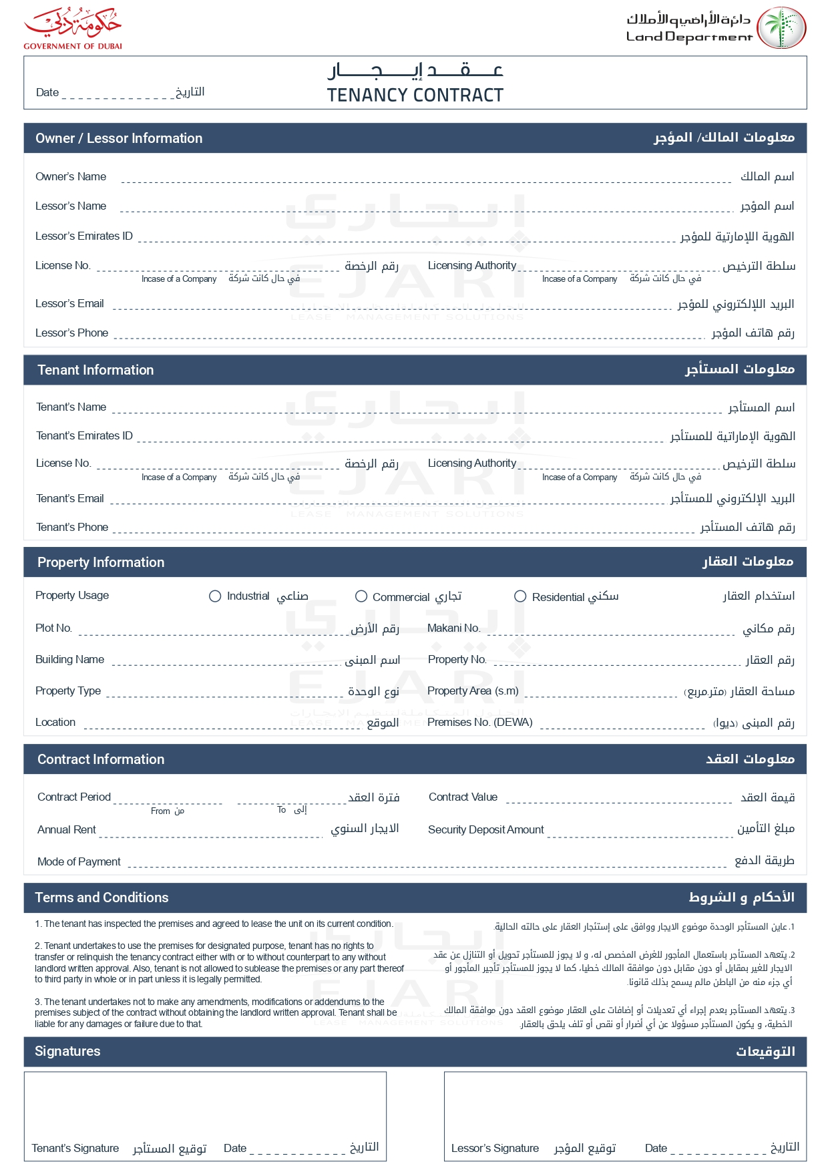

LeaseDate

LessorName

LandlordName

LessorIdNumber

LessorLicense

LessorEmail

LessorPhoneNumber

TenantName

TenantIdNumber

TenantEmail

TenantPhoneNumber

✓

PropertyPlotNumber

UnitNumber

PropertyName

UnitArea

UnitType

PropertyNumber

PropertyLocation

RentAmount Currency

EndDate

StartDate

SecurityDeposit Currency

RentAmount Currency

PaymentFrequency

TenantLicense

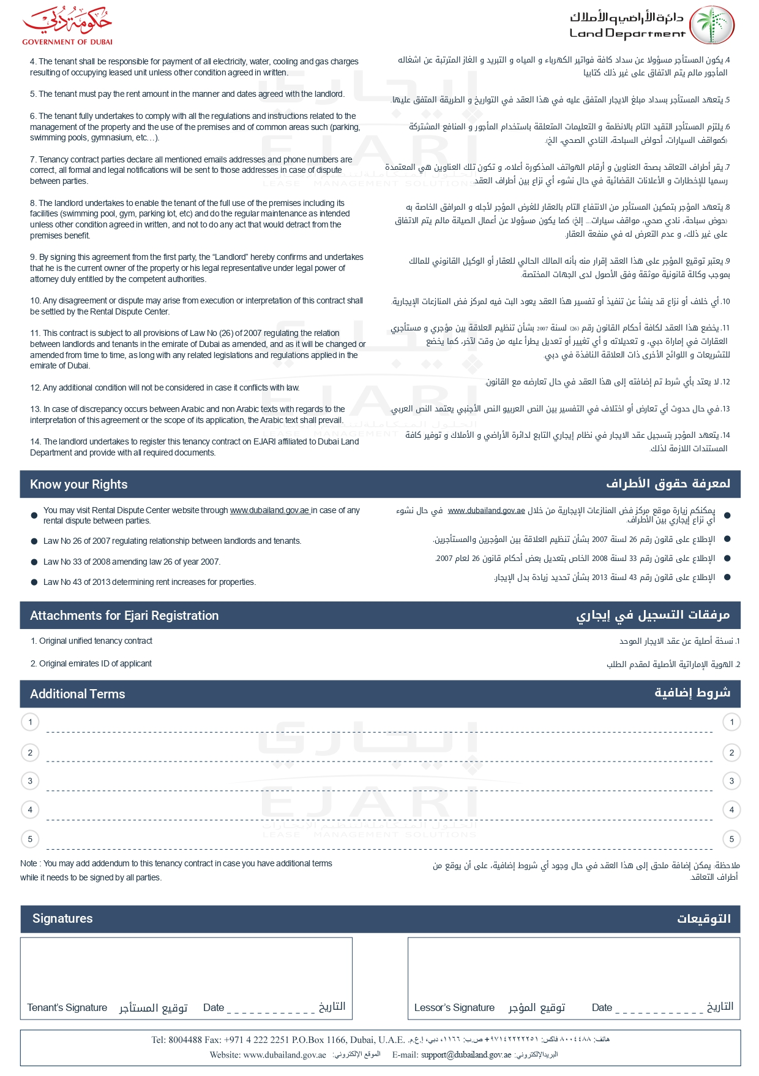

AdditionalTerms5

AdditionalTerms4

AdditionalTerms3

AdditionalTerms1

AdditionalTerms2