## Memory Management - Part I

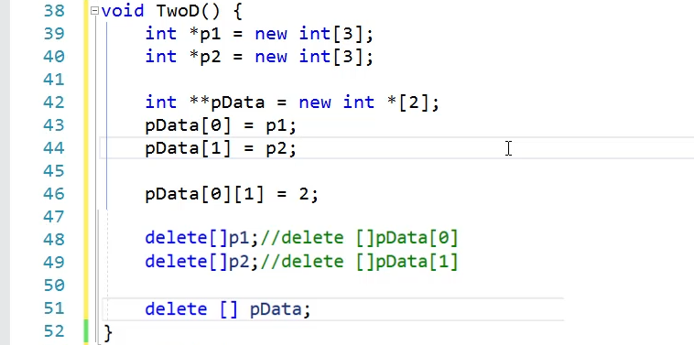

// Allocate the Cols

// Allocate the Rows

// Make Rows pointed to cols

