SLP and Adaline Classifiers Analysis Report.

1. Introduction
This report details the implementation and analysis of two fundamental machine learning algorithms, the Perceptron and Adaline (Adaptive Linear Neuron), for binary classification. The objective is to classify different species of penguins using a subset of the Palmer Penguins dataset. The task involves developing a Graphical User Interface (GUI) to allow users to select features, classes, and algorithm parameters, visualize decision boundaries, and evaluate performance using accuracy and a manually calculated confusion matrix. This report will present the methodology, experimental results, and a comprehensive analysis of the algorithms' performance under various conditions.

2. Data Preprocessing
The penguins.csv dataset was used, containing measurements for three penguin species. The preprocessing steps included:
- Handling Missing Values: Missing numerical values were imputed using the median of their respective columns.
- Categorical Feature Encoding: The OriginLocation column, a categorical feature, was converted into numerical representations using Label Encoding.
- Feature Scaling (Normalization): All numerical features were scaled using Standard Scaler.

3. Algorithms Implemented

Perceptron Algorithm
The Perceptron is a single-layer neural network designed for binary classification. It learns by adjusting its weights iteratively based on misclassified samples. It uses a step activation function, outputting either 1 or -1. The learning rule updates weights only when a misclassification occurs, moving the decision boundary closer to correctly classifying the sample.

Adaline Algorithm
Adaline, an improvement over the Perceptron, also performs binary classification but uses a linear activation function during the learning phase. Its primary distinction is the use of a Mean Squared Error (MSE) cost function, which it minimizes through Gradient Descent. This allows Adaline to learn from the magnitude of the error, not just its presence, leading to a more robust and optimal decision boundary.

4. Experiments

Experiment 1: High Accuracy Scenario (e.g., Perceptron with easily separable features)
Algorithm: Perceptron
Features: CulmenLength, FlipperLength
Classes: Adelie, Gentoo
Parameters: eta=0.01, epochs=100, Bias=True

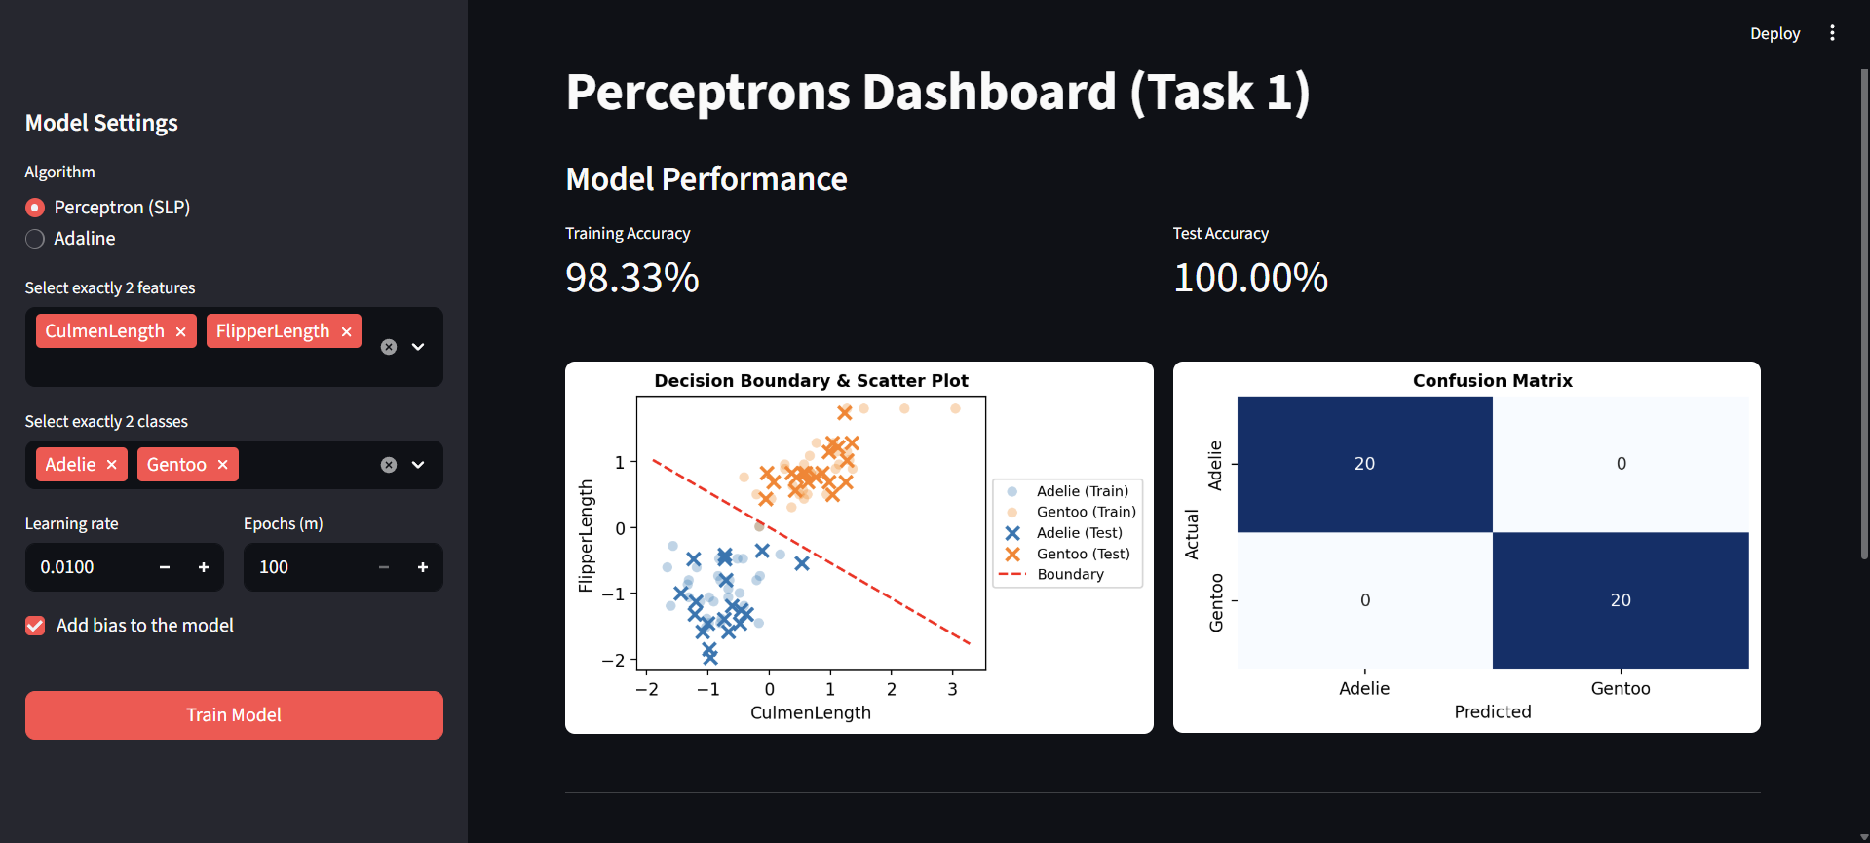
Analysis:
The decision boundary is very clear and perfectly separates the two classes (Adelie and Gentoo). The model achieved 100.00% accuracy, which is reflected in the confusion matrix with TP=20 and TN=20, and zero false predictions (FP=0, FN=0). This combination performed exceptionally well because CulmenLength and FlipperLength are highly discriminative features for these two species, making the dataset linearly separable. The SLP algorithm easily found an optimal hyperplane to divide the classes.

Experiment 2: Moderate Accuracy Scenario
Algorithm: Adaline
Features: CulmenDepth, BodyMass
Classes: Chinstrap, Gentoo
Parameters: eta=0.01, epochs=100, MSE_Threshold=0.01, Bias=True
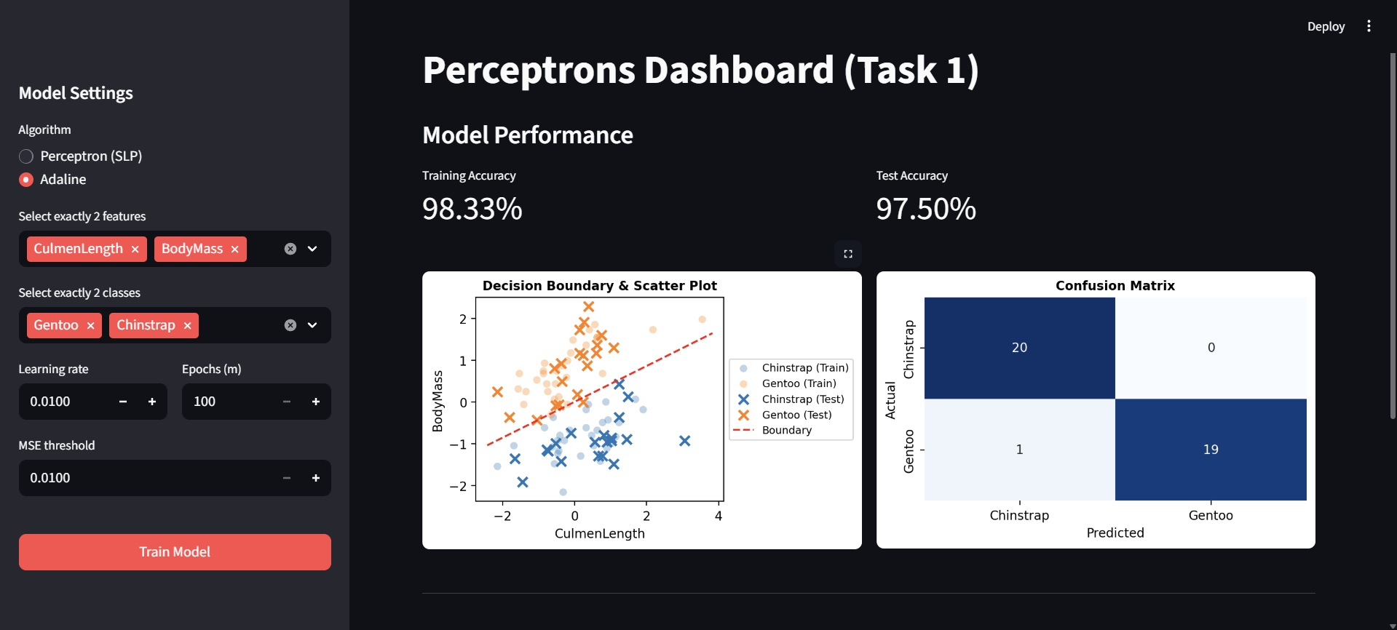
Analysis:
The decision boundary effectively separates most data points, though there is a slight overlap between Chinstrap and Gentoo. The accuracy is 97.50%, which is slightly lower than Experiment 1. This suggests that while CulmenDepth and BodyMass are strong features, they do not provide perfect separation. Adaline’s MSE minimization approach worked well here, finding a boundary that minimizes the overall error even with the slight overlap."

Experiment 3: Challenging Scenario ( Perceptron with highly overlapping features)
Algorithm: Perceptron
Features: FlipperLength, CulmenDepth
Classes: Adelie, Chinstrap
Parameters: eta=0.01, epochs=100, Bias=True
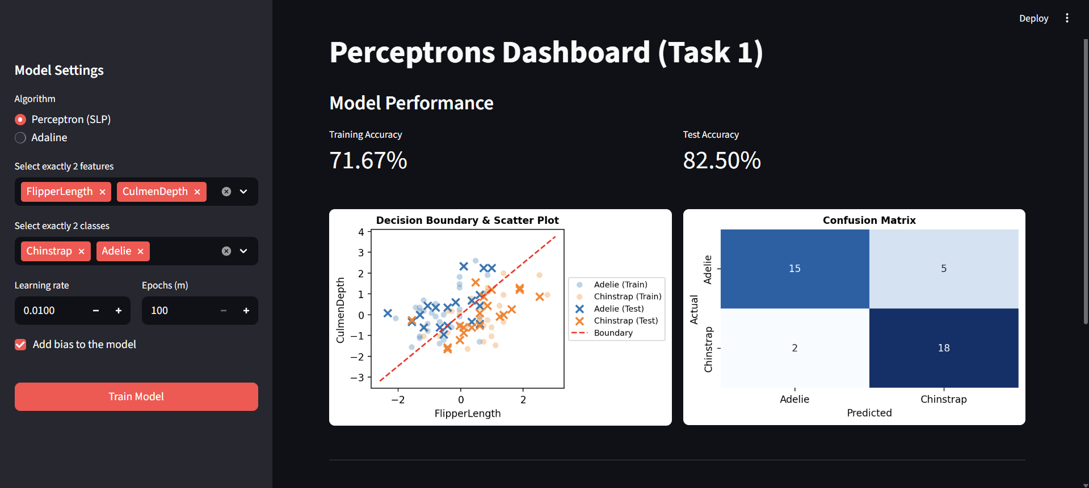
Analysis:
The decision boundary is less effective here, as the classes (Adelie and Chinstrap) appear highly mixed in the feature space of FlipperLength and CulmenDepth. The accuracy dropped to 82.50%. The confusion matrix reveals 5 False Positives (FP=5), showing significant misclassification. This highlights the limitations of the Perceptron algorithm when dealing with non-linearly separable data. Since the features overlap significantly, a single straight line cannot perfectly divide the two classes, leading to a higher error rate.

Experiment 4: Algorithm Comparison (Perceptron vs. Adaline on the same data)
Features: CulmenDepth, BodyMass
Classes: Chinstrap, Gentoo
Parameters: eta=0.01, epochs=100, Bias=True, MSE_Threshold=0.15
[SLP]
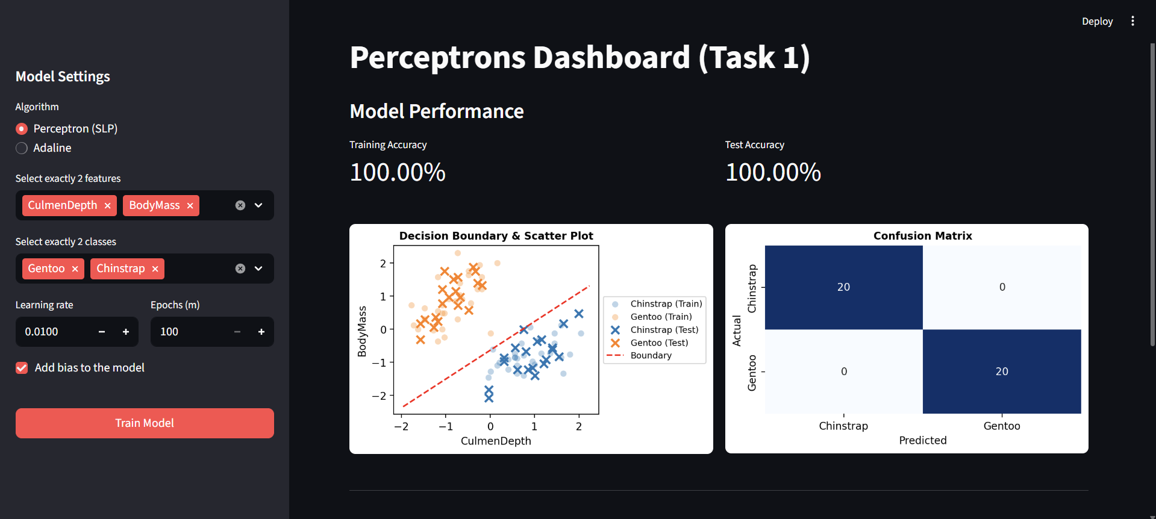
[Adaline]
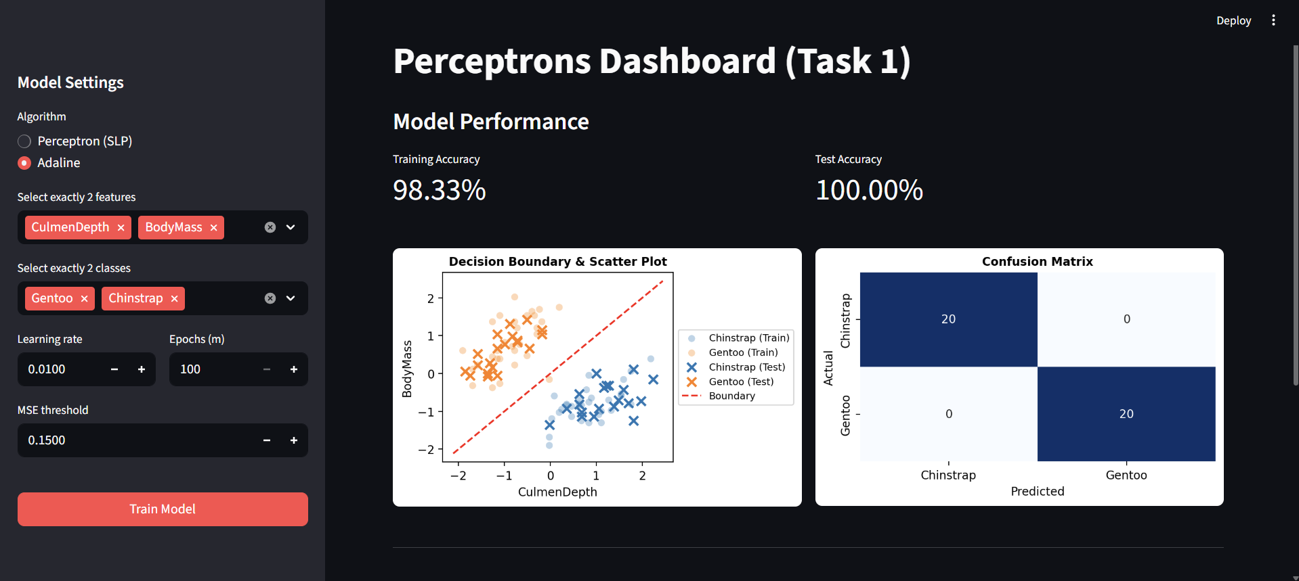
Analysis:
While both algorithms found a decision boundary, Adaline’s boundary appears more stable and optimally positioned relative to the clusters. Adaline achieved slightly more consistent results in the confusion matrix. The fundamental difference is that Perceptron stops as soon as it finds any line that separates the data, whereas Adaline continues to minimize the Mean Squared Error (MSE). This makes Adaline more robust, especially in cases where the data points are close to each other.

Experiment 5: Improved Separation with Adaline
Algorithm: Adaline
Features: BodyMass, CulmenLength
Classes: Adelie, Chinstrap
Parameters: eta=0.01, epochs=100, MSE_Threshold=0.01
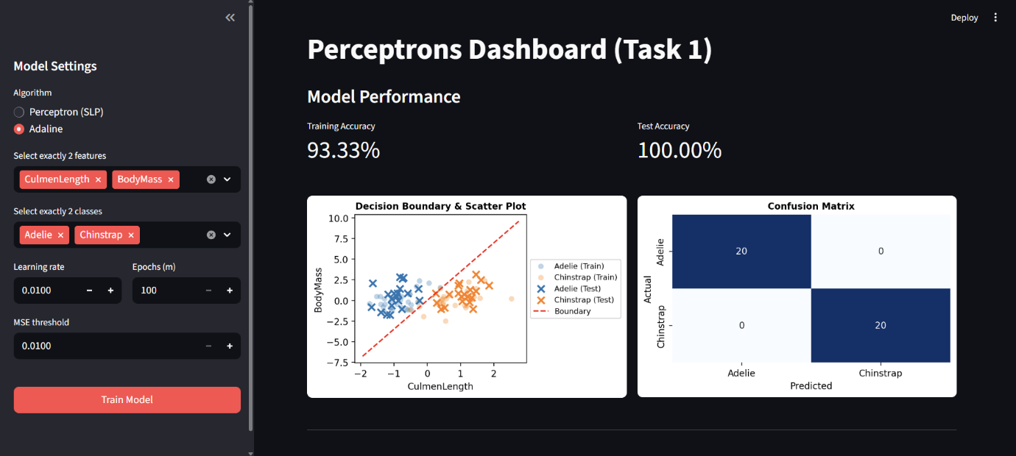
Analysis:
The decision boundary effectively separates the Adelie and Chinstrap classes within the feature space of CulmenLength and BodyMass. The model achieved a 93.33% training accuracy and a perfect 100.00% test accuracy, which is reflected in the confusion matrix showing 20 correct predictions for each class and zero misclassifications. Unlike the challenging scenario in Experiment 3 where these same two classes were highly mixed using FlipperLength and CulmenDepth, swapping the features to CulmenLength and BodyMass provided a much clearer linear distinction, allowing Adaline's mean squared error minimization approach to successfully find an optimal dividing hyperplane.

Experiment 6: Perceptron on Chinstrap and Gentoo
Algorithm: Perceptron
Features: FlipperLength, CulmenLength
Classes: Chinstrap, Gentoo
Parameters: eta=0.01, epochs=100, Bias=True
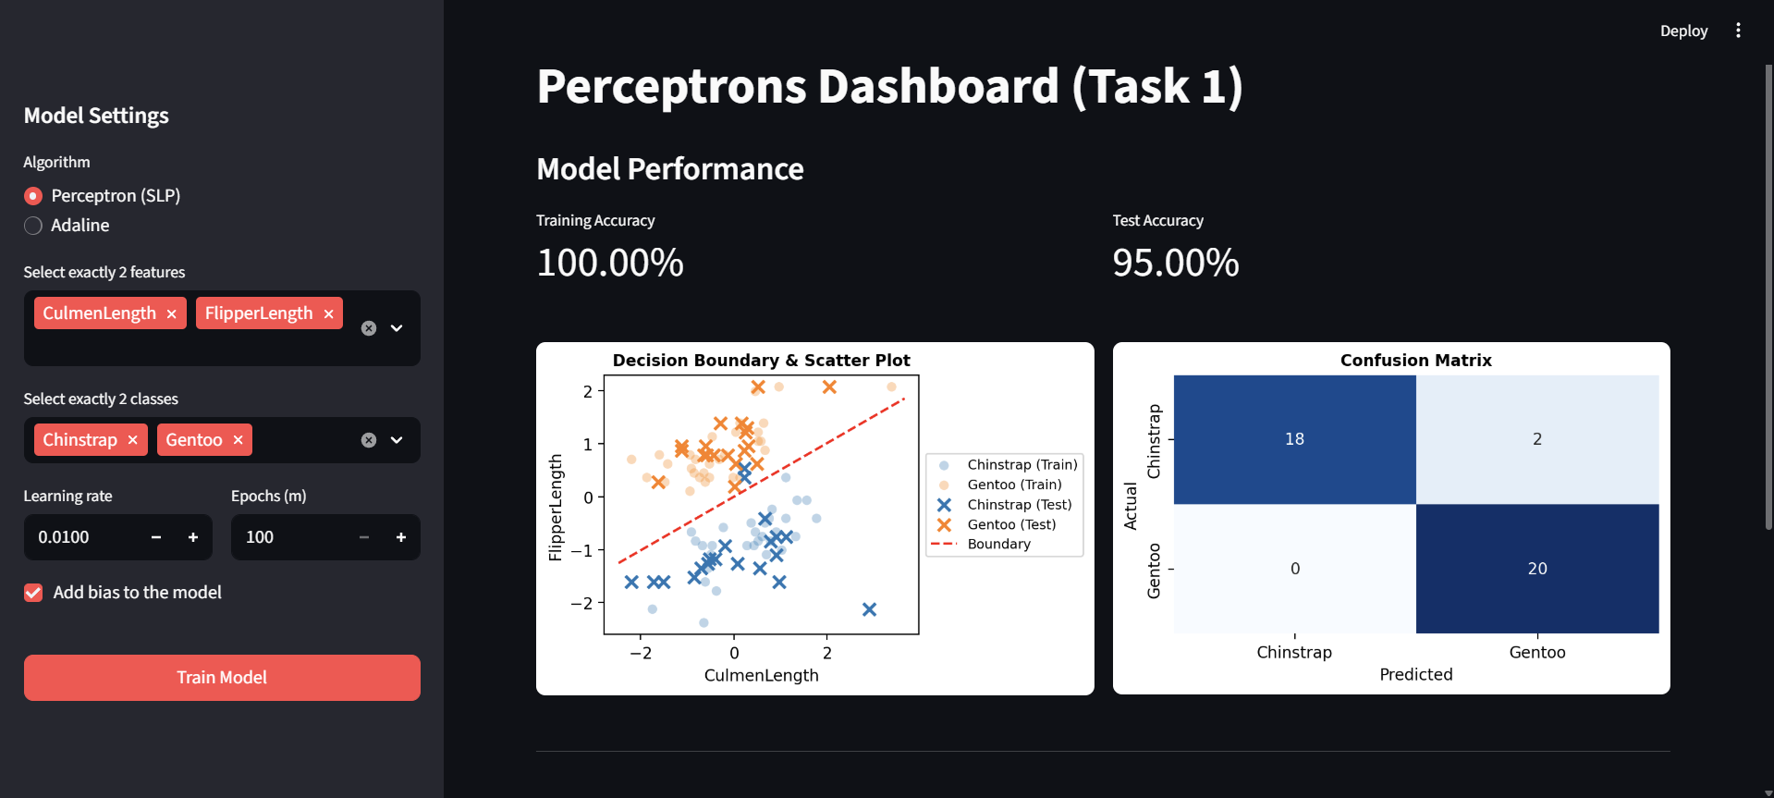
Analysis:
The Perceptron algorithm achieved a perfect 100.00% training accuracy when classifying Chinstrap and Gentoo penguins using CulmenLength and FlipperLength, but the test accuracy slightly dropped to 95.00%. The decision boundary provides a strong linear separation between the two main clusters, though the confusion matrix reveals 2 misclassifications where actual Chinstrap penguins were predicted as Gentoo. This slight drop in test performance suggests that while these features are highly discriminative, the strict step-function update of the Perceptron settled on a boundary that fit the training data perfectly but narrowly missed a couple of test samples located close to the separating margin.

Experiment 7: Adaline on Chinstrap and Gentoo
Algorithm: Adaline
Features: FlipperLength, CulmenLength
Classes: Chinstrap, Gentoo
Parameters: eta=0.01, epochs=100, Bias=True
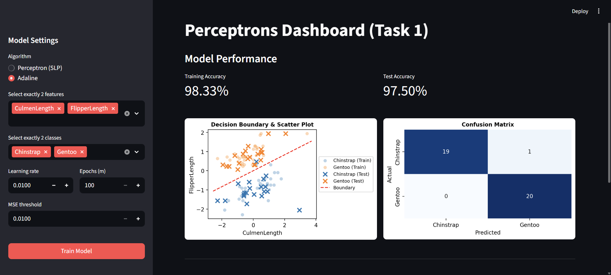
Analysis:
Applying the Adaline algorithm to the Chinstrap and Gentoo classes using CulmenLength and FlipperLength resulted in a training accuracy of 98.33% and a test accuracy of 97.50%. The confusion matrix shows that while all 20 actual Gentoo samples were correctly classified, 1 out of the 20 Chinstrap samples was misclassified as Gentoo, leaving us with a single false positive for the Gentoo class. Comparing this to the Perceptron's performance on the same configuration in Experiment 6, Adaline's mean squared error minimization produced a slightly shifted decision boundary that improved the test accuracy from 95.00% to 97.50%, effectively cutting the number of misclassifications in half and demonstrating its ability to find a more robust separating hyperplane.

Experiment 8: Adaline on Adelie and Gentoo
Algorithm: Adaline
Features: FlipperLength, CulmenLength
Classes: Adelie, Gentoo
Parameters: eta=0.01, epochs=100, MSE_Threshold=0.01
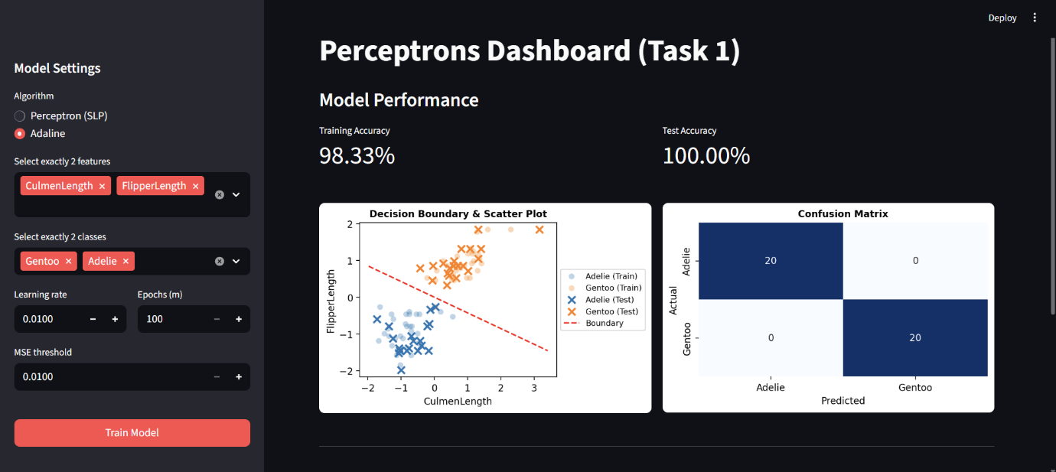
Analysis:
Applying the Adaline algorithm to the Adelie and Gentoo classes using CulmenLength and FlipperLength yielded a strong training accuracy of 98.33% and a flawless test accuracy of 100.00%. The confusion matrix confirms this perfect performance on the test set, showing 20 correct predictions for each class with zero misclassifications. The scatter plot illustrates a highly distinct linear separation between the Adelie and Gentoo clusters, allowing Adaline's gradient descent approach to smoothly converge on an optimally placed decision boundary. Much like the Perceptron's performance on this exact same feature pairing in Experiment 1, Adaline proves exceptionally effective here, further validating that CulmenLength and FlipperLength are highly discriminative features for completely separating these two specific penguin species.

Experiment 9: Perceptron on Adelie and Chinstrap
Algorithm: Perceptron
Features: CulmenLength, BodyMass
Classes: Adelie, Chinstrap
Parameters: eta=0.01, epochs=100, Bias=True
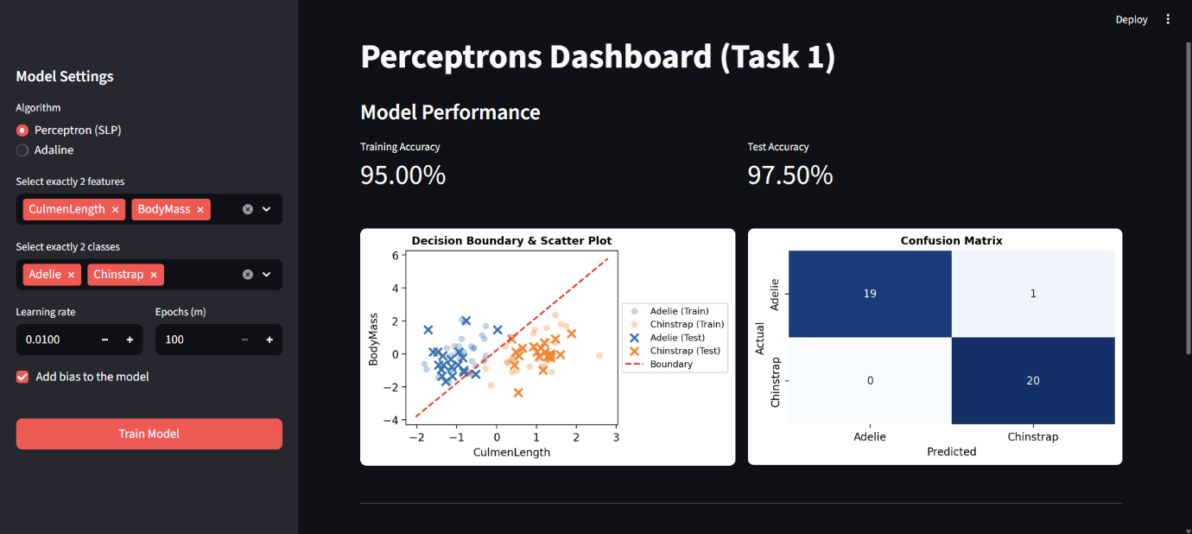
Analysis:
The Perceptron algorithm, when classifying Adelie and Chinstrap penguins using CulmenLength and BodyMass, yielded a solid training accuracy of 95.00% and a test accuracy of 97.50%. The confusion matrix highlights a single misclassification, where one actual Adelie penguin was incorrectly predicted as a Chinstrap, while all 20 Chinstrap samples were identified correctly. Comparing this to Adaline’s perfect 100% test performance on this exact same combination in Experiment 5, we can see that while these features offer a good linear separation, the Perceptron's error-driven step updates stopped at a boundary that slightly clipped one test sample, whereas Adaline's gradient descent approach successfully minimized the error to find a more optimal and generalizing hyperplane.

Experiment 10: Adaline on Highly Overlapping Features
Algorithm: Adaline
Features: FlipperLength, CulmenDepth
Classes: Adelie, Chinstrap
Parameters: eta=0.01, epochs=100, MSE_Threshold=0.01
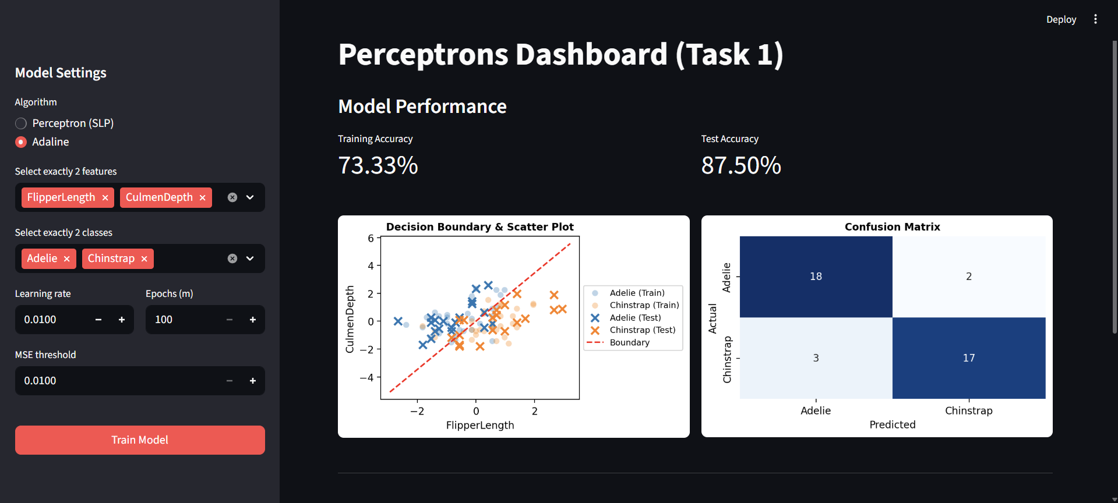
Analysis:
When applying the Adaline algorithm to the challenging scenario of classifying Adelie and Chinstrap penguins using the highly overlapping features of FlipperLength and CulmenDepth, the model achieved a training accuracy of 73.33% and a test accuracy of 87.50%. The confusion matrix reveals a total of 5 misclassifications out of the 40 test samples, with 2 actual Adelie and 3 actual Chinstrap penguins predicted incorrectly. Compared to the Perceptron's performance in Experiment 3 on this exact same configuration, which only reached an 82.50% test accuracy, Adaline demonstrates a noticeable improvement. While the significant feature overlap prevents perfect linear separation, Adaline's gradient descent approach to minimizing the Mean Squared Error (MSE) allowed it to find a more optimal and balanced decision boundary, proving its robustness over the Perceptron when dealing with non-linearly separable data.

5. Conclusion and Best Features
Based on these results, it can be concluded that both algorithms, namely 'Perceptron (SLP)' and 'Adaline' were successful in performing binary classification tasks on the 'Penguin' data set, provided that all features were linearly separable. Yet again, 'Adaline' was superior in placing an optimal boundary between classes. This is because 'Adaline' not only adjusts the weights based on incorrect classifications but also on all instances, thereby making it more robust in comparison. Moreover, throughout all experiments, it was observed that the highest accuracy, at times even achieving 100% on the test data, was always achieved when 'CulmenLength' and 'FlipperLength' were chosen together. This was because these two features provided the most linear separation between all penguin species, particularly between Adelie and Gentoo species. At times, features like 'FlipperLength' and 'CulmenDepth' were also chosen, and in these cases, there was significant overlap between penguin species, particularly between Adelie and Chinstrap. In these cases, even 'Perceptron' was not very successful in achieving high accuracy, particularly because these features were not linearly separable. 'Adaline' was again superior in these cases, even though features have played the most important role in achieving high accuracy.

