TECHNICAL DOCUMENTATION
Superstore Data Warehouse
Batch ELT pipeline with Apache Airflow, dbt and DuckDB

Author: Mina Milad Matta
Program: DataOps Engineering, NTI
Version: 1.0, October 2026
Repository: https://github.com/MinaMiladd/MinaMiladd-Superstore_Data_Warehouse_Airflow_dbt_DuckDB.git

Stack: Apache Airflow 3.1 · dbt-core 1.12 · DuckDB 1.5 · Python 3.11 · Docker

Contents
1. Overview 1
2. Source Data 1
3. Data Lineage 1
4. Layer Details 2
4.1 ODS — ods.superstore 2
4.2 Staging — main_stg.stg_superstore 2
4.3 Marts — main_dwh.* 2
5. Data Dictionary 3
fact_orders 3
dim_customer 3
dim_product 3
dim_location 4
dim_date 4
6. Orchestration 4
7. Data Quality & Testing 5
8. Infrastructure 6
Container 6
Volume mounts 6
Why a separate dbt virtualenv? 7
9. Configuration Reference 7
my_project/dbt_project.yml 7
my_project/profiles.yml 7
Airflow environment (docker-compose.yml) 7
10. Operations Runbook 8
11. Troubleshooting 8
12. Known Limitations 9

This document covers the internals of the project: data lineage, the data dictionary, transformation logic, orchestration, testing, operations and known limitations. For a quick overview and setup, see the README on GitHub.

1. Overview
Item | Value
Pattern | Batch ELT, full refresh
Orchestrator | Apache Airflow 3.1 (standalone mode, Python 3.11)
Transformation | dbt-core 1.12.5 with dbt-duckdb 1.11.0
Storage / compute | DuckDB 1.5.6, a single embedded file (my_project/dev.duckdb)
Modeling approach | Kimball dimensional model (star schema)
Schedule | Daily (@daily, UTC)
Runtime | One Docker container

Business questions it answers: sales and profit by product category, customer segment, region and time period; shipping lead time (order date to ship date); discount impact on profitability.

2. Source Data
Property | Value
File | data/raw/Superstore.xlsx
Sheet | Sample - Superstore
Rows | 9,994 order line items
Orders | 5,009 distinct Order IDs
Date range | Orders 2014-01-03 → 2017-12-30, shipments through 2018-01-05
Totals | ≈ 2.30 M sales, ≈ 286 K profit
Grain | One row per product per order

Known source quirk: a single Product ID can appear with more than one Product Name. The data model works around this (see dim_product).

3. Data Lineage
Superstore.xlsx
│ load_to_ods.py (DuckDB read_xlsx)
▼
ods.superstore ─────────────── source('ods', 'superstore')
│
▼
main_stg.stg_superstore (view)
│
├──► main_dwh.dim_customer ──┐
├──► main_dwh.dim_product ──┤
├──► main_dwh.dim_location ──┼──► main_dwh.fact_orders
└──► main_dwh.dim_date ──┘ (joined twice: order & ship date)
The same lineage, as rendered by dbt docs:
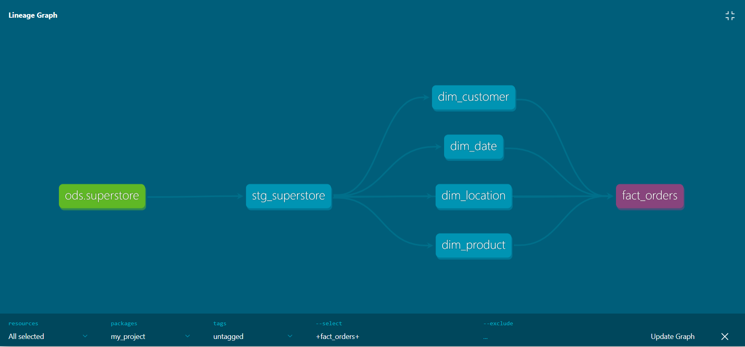
Figure 1: dbt lineage graph. The ods.superstore source (green) feeds the staging view, which feeds four dimensions and the fact table.
To explore it yourself, run dbt docs generate and then dbt docs serve --port 8081 from my_project/. Port 8081 avoids a clash with Airflow on 8080.

4. Layer Details

4.1 ODS — ods.superstore
- Built by: scripts/load_to_ods.py
- Method: CREATE OR REPLACE TABLE … AS SELECT * FROM read_xlsx(...) using DuckDB's excel extension
- Behavior: full reload on every run, so it is idempotent and safe to re-run
- Columns: kept exactly as in the spreadsheet, including spaces in names (e.g. "Order ID")

4.2 Staging — main_stg.stg_superstore
- Materialization: view
- Transformations:
- Renames every column to snake_case
- Casts Order Date / Ship Date to DATE
- No filtering or aggregation, so the grain matches the source (9,994 rows)
- Purpose: the single cleaned interface that every mart model reads from. No mart model reads the ODS directly.

4.3 Marts — main_dwh.*
- Materialization: table (rebuilt on every dbt run)
- Surrogate keys: md5() hashes of the natural or business key, so keys are deterministic across rebuilds

5. Data Dictionary

fact_orders
Grain: one row per order line item (9,994 rows).
Column | Type | Description
sales_key | double | Primary key (source Row ID)
order_id | varchar | Degenerate dimension: the order number
order_date_key | integer | FK → dim_date.date_key (order date)
ship_date_key | integer | FK → dim_date.date_key (ship date)
customer_key | varchar | FK → dim_customer.customer_key
product_key | varchar | FK → dim_product.product_key
geography_key | varchar | FK → dim_location.geography_key
ship_mode | varchar | First Class / Second Class / Standard Class / Same Day
sales | double | Line revenue
quantity | double | Units ordered
discount | double | Discount rate (0–1)
profit | double | Line profit (can be negative)

dim_customer
793 rows, one per customer.
Column | Type | Description
customer_key | varchar | PK, md5(customer_id)
customer_id | varchar | Business key
customer_name | varchar | Customer full name
segment | varchar | Consumer / Corporate / Home Office

dim_product
1,894 rows, one per distinct (product_id, product_name) pair.
Column | Type | Description
product_key | varchar | PK, md5(product_id | product_name)
product_id | varchar | Business key (not unique on its own)
product_name | varchar | Product description
category | varchar | Furniture / Office Supplies / Technology
sub_category | varchar | e.g. Chairs, Phones, Binders

Why a composite key? Some product_ids carry several names in the source. Keying on the ID alone would merge different products, or create duplicate dimension rows that fan out the fact join.

dim_location
632 rows, one per distinct location.
Column | Type | Description
geography_key | varchar | PK, md5(country | region | state | city | postal_code)
country | varchar | Country
region | varchar | Central / East / South / West
state | varchar | State
city | varchar | City
postal_code | double | Postal code

dim_date
1,464 rows: every calendar day from the first order date to the last ship date.
Column | Type | Description
date_key | integer | PK, YYYYMMDD (e.g. 20170315)
date_day | date | Calendar date
year | bigint | Year
quarter | bigint | Quarter (1–4)
month | bigint | Month number (1–12)
month_name | varchar | e.g. March
day_of_month | bigint | Day (1–31)
day_name | varchar | e.g. Wednesday
is_weekend | boolean | true on Saturday and Sunday

dim_date is a role-playing dimension: fact_orders joins to it twice, once as order date and once as ship date.

6. Orchestration
DAG: airflow/dags/superstore_dwh_dag.py
Setting | Value
dag_id | superstore_dwh
schedule | @daily
start_date | 2026-10-01 UTC
catchup | False
retries | 1, with a 2-minute delay
Paused on create | Yes (DAGS_ARE_PAUSED_AT_CREATION)

Task flow (strictly sequential):
dbt_debug → load_to_ods → dbt_test_sources → dbt_run → dbt_test
# | Task | Command (simplified) | Fails when
1 | dbt_debug | dbt debug | Profile, project or DB is unreachable
2 | load_to_ods | python scripts/load_to_ods.py | Excel file is missing or DB is locked
3 | dbt_test_sources | dbt test --select source:ods --indirect-selection cautious | Raw source tests fail
4 | dbt_run | dbt run | A model has a SQL error
5 | dbt_test | dbt test | Any data quality test fails

Every dbt command runs from /opt/airflow/project/my_project with --profiles-dir . --target dev, so the project uses its own committed profiles.yml.
--indirect-selection cautious on task 3 keeps the source check from also running tests on models that haven't been built yet.
--no-partial-parse makes dbt re-parse the project on every run. my_project/target/ is shared with the host through the volume mount, and a parse cache written by dbt on Windows contains Windows paths that crash dbt on Linux.
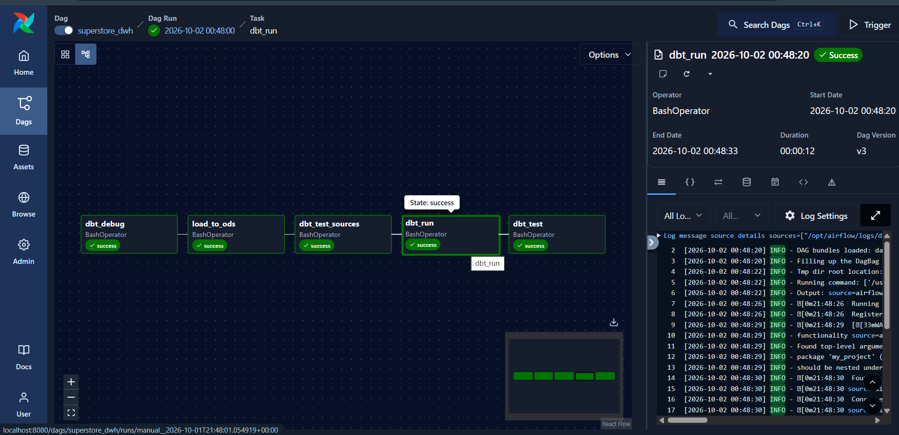
Figure 2: a successful superstore_dwh run in the Airflow 3 Graph view, with all five tasks green.

7. Data Quality & Testing
20 tests in total, run by the dbt_test task.
Model | Column | Tests
stg_superstore | row_id | unique, not_null
stg_superstore | order_id, order_date, customer_id, product_id, sales, quantity | not_null
fact_orders | sales_key | unique, not_null
fact_orders | customer_key, product_key, geography_key, order_date_key, ship_date_key | not_null, relationships

Together, the relationships and not_null tests on the fact table guarantee that every fact row joins to exactly one member of each dimension. This catches fan-out or orphaned rows caused by key logic changes.
Tests appear in dbt docs next to each column (U = unique, N = not_null, F = relationships / foreign key):
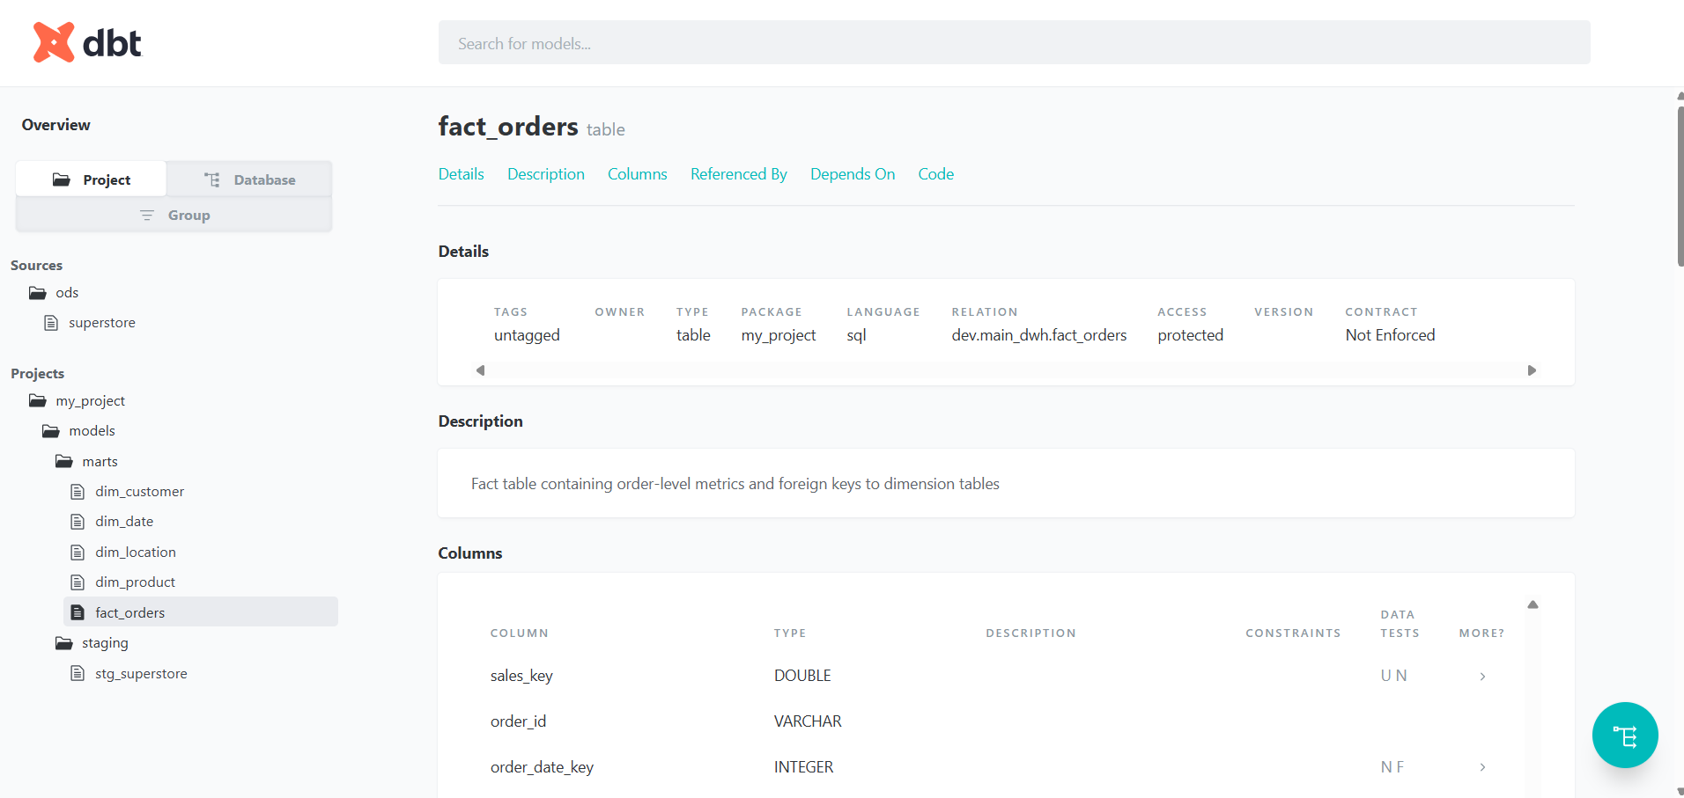
Figure 3: the dbt docs page for fact_orders, showing that it is built in dev.main_dwh and listing the tests on each column.
Run the tests manually:
cd my_project
dbt test --profiles-dir . --target dev # all tests
dbt test --profiles-dir . --target dev --select fact_orders # one model

8. Infrastructure

Container
Component | Detail
Base image | apache/airflow:3.1.0-python3.11
Airflow mode | standalone (API server, scheduler, DAG processor and triggerer in one process)
dbt runtime | Separate virtualenv at /opt/dbt_venv
DuckDB extension | excel, pre-installed at build time
Port | 8080 → Airflow UI

Volume mounts
Host path | Container path | Purpose
airflow/dags | /opt/airflow/dags | DAG files (picked up live)
airflow/logs | /opt/airflow/logs | Task logs, readable on the host
. (repo root) | /opt/airflow/project | dbt project, scripts and data

Because the repo root is mounted, changes to dbt models, scripts or the DAG take effect on the next run without rebuilding the image. Only changes to the Dockerfile or requirements-dbt.txt need docker compose up -d --build.

Why a separate dbt virtualenv?
Airflow pins a large dependency tree. Installing dbt into the same environment risks version conflicts (e.g. protobuf, jinja2). A dedicated venv, called by its absolute path (/opt/dbt_venv/bin/dbt), keeps the two isolated so each can be upgraded independently.

9. Configuration Reference

my_project/dbt_project.yml
models:
my_project:
staging:
+schema: stg
+materialized: view
marts:
+schema: dwh
+materialized: table
dbt's default generate_schema_name joins the target schema (main) and the custom schema, which gives main_stg and main_dwh.

my_project/profiles.yml
my_project:
target: dev
outputs:
dev:
type: duckdb
path: dev.duckdb # relative to my_project/
threads: 1
threads: 1 is deliberate, because DuckDB allows a single writer.

Airflow environment (docker-compose.yml)
Variable | Value | Effect
AIRFLOW__CORE__LOAD_EXAMPLES | False | Hides the example DAGs
AIRFLOW__CORE__SIMPLE_AUTH_MANAGER_ALL_ADMINS | True | No login (local dev only)
AIRFLOW__CORE__DAGS_ARE_PAUSED_AT_CREATION | True | New DAGs start paused
DO_NOT_TRACK | 1 | Turns off dbt anonymous usage stats

10. Operations Runbook
Task | Command / action
Start the stack | cd airflow && docker compose up -d --build
Stop the stack | cd airflow && docker compose down
Trigger a run | Airflow UI → superstore_dwh → Trigger
Re-run from a failed task | Airflow UI → failed task → Clear (downstream included)
Rebuild the warehouse from scratch | Delete my_project/dev.duckdb, then trigger the DAG
Run dbt in the container | docker exec -it superstore-airflow bash -c "cd /opt/airflow/project/my_project && /opt/dbt_venv/bin/dbt build --profiles-dir . --target dev"
View task logs on the host | airflow/logs/dag_id=superstore_dwh/…
Update the source data | Replace data/raw/Superstore.xlsx (same sheet name), then trigger the DAG

11. Troubleshooting
Symptom (in task log) | Cause | Fix
cd: /opt/airflow/project/...: No such file or directory | DBT_DIR in the DAG doesn't match the dbt folder name | Set DBT_DIR to {PROJECT_DIR}/my_project
Could not find profile named 'my_project' | Profile name in profiles.yml doesn't match dbt_project.yml (case-sensitive) | Make both exactly my_project
mapping values are not allowed in this context | YAML indentation error. dbt strips leading whitespace from the file, so a fully indented file breaks | Start top-level keys (version, models) at column 0
Configuration paths exist ... which do not apply to any resources | The key under models: isn't the project name | Use models: my_project:
IO Error: Could not set lock on file "dev.duckdb" | Another process (DBeaver, CLI, notebook) has the DB open | Close that connection, then clear the task
Nothing to do in dbt_test_sources | No tests are defined on the source | Expected until source tests are added (see Limitations)
'dbt_duckdb://macros/columns.sql' KeyError during parsing | target/partial_parse.msgpack was written by dbt on Windows (backslash paths) and reused by dbt in the container | Delete the file. The DAG passes --no-partial-parse to prevent this
dbt docs serve fails, or opens Airflow instead | Both default to port 8080 | dbt docs serve --port 8081
DAG doesn't appear in the UI | Python error in the DAG file | Check airflow/logs/dag_processor/…, or the import errors shown in the UI

12. Known Limitations
Limitation | Impact | Possible improvement
Full refresh on every run | Fine at 10 K rows, but doesn't scale | Incremental fact_orders (materialized='incremental')
No tests on the raw source | dbt_test_sources currently does nothing | Add not_null / unique on "Row ID" in sources.yml
Row ID / Postal Code typed as double | Inherited from Excel inference | Cast to integer / varchar in staging
Customer attributes use max() | No history of changes to segment or name | SCD Type 2 with dbt snapshots
Schemas named main_stg / main_dwh | Prefix comes from dbt's default naming | Custom generate_schema_name macro
Local, single-container setup | No auth, no high availability | CeleryExecutor or Kubernetes, with a managed warehouse
Deprecated generic test syntax | dbt shows warnings (5 occurrences) | Move test arguments under arguments:

