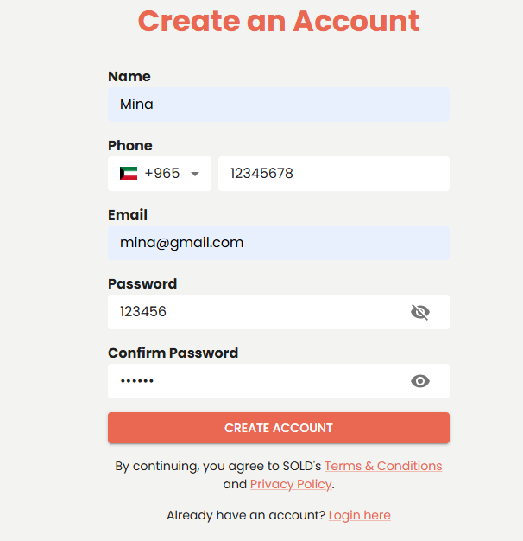

**On click eye button in create an account page show password not confirm password**

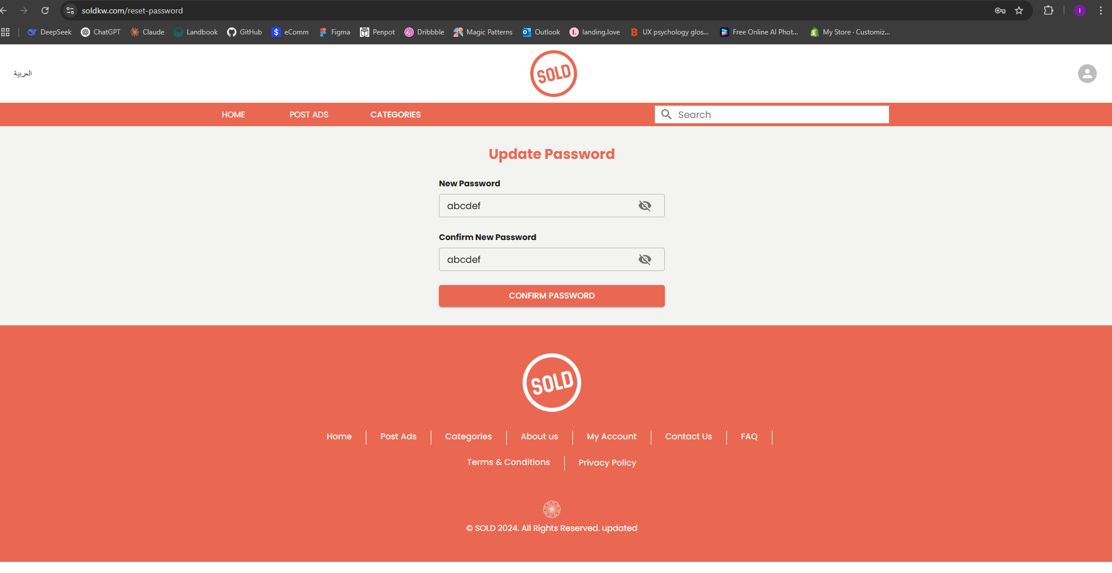

**reset password doesn’t work !important**

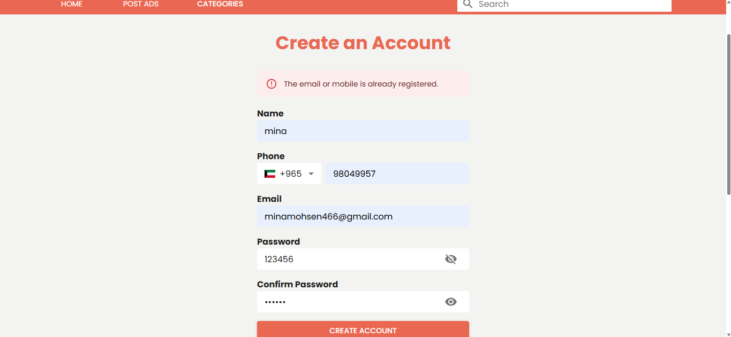

**In create an account page I created this account and then deleted it from the dashboard, but I can't create it again. A message appears in the email or mobile that is already registered !important**

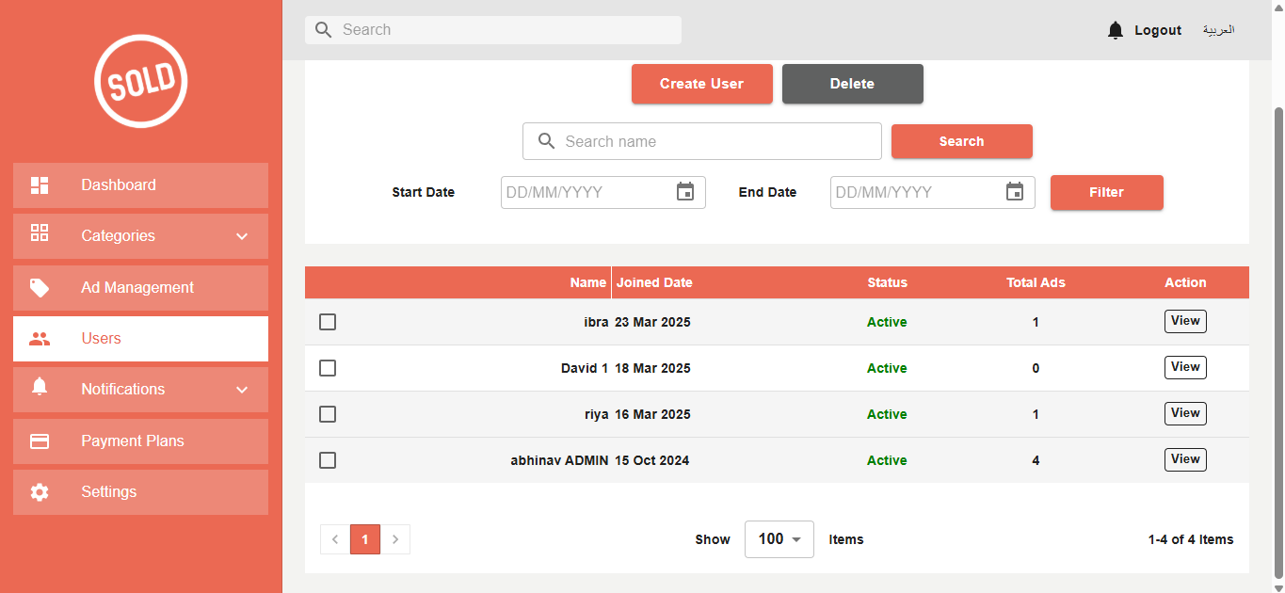

**1- Email and phone doesn’t exist in dashboard/users, why I can’t create a new account.**

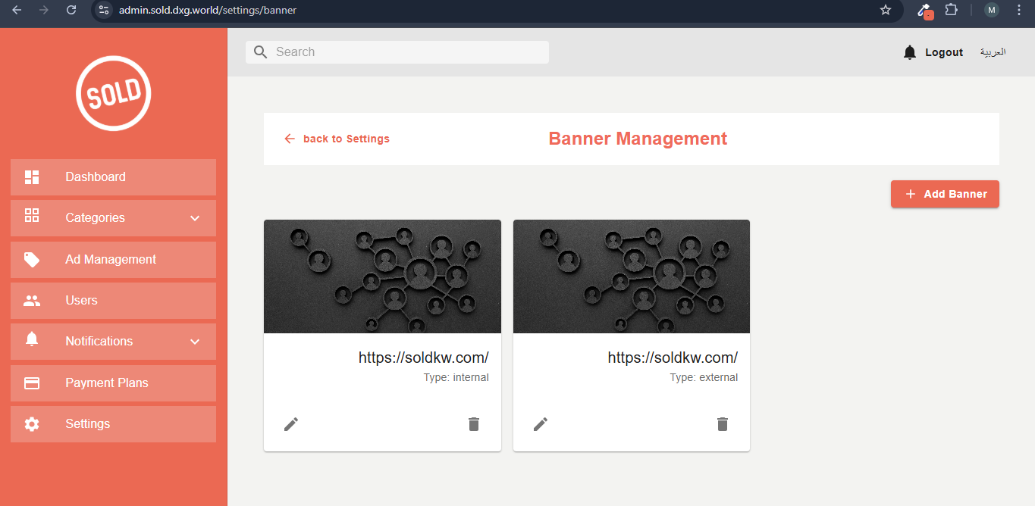

**I have added tow banners in Dashboard/Settings/Banner management but this banner is not showing on the site.**

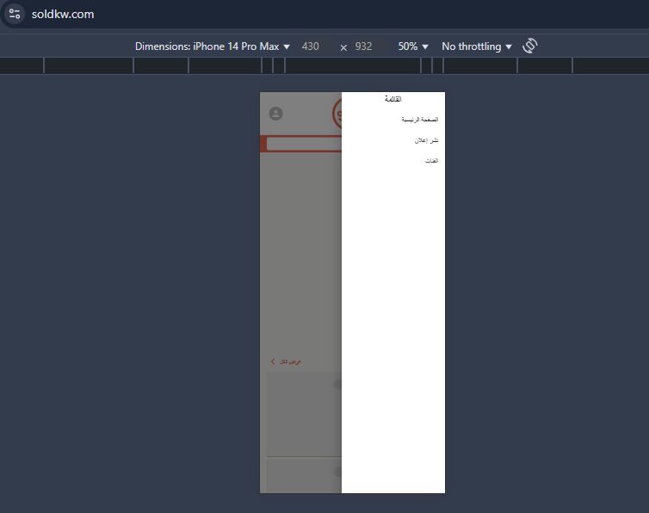

Logo

&

Social media icons

1. **In mobile design Specifically in Arabic language menu appeared from left to right but should appear from right to left**
2. **should add logo and social media icons in mobile menu**

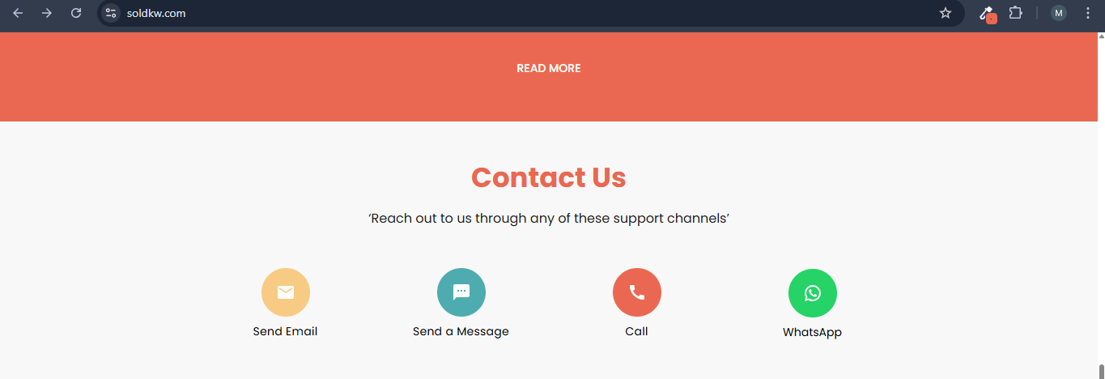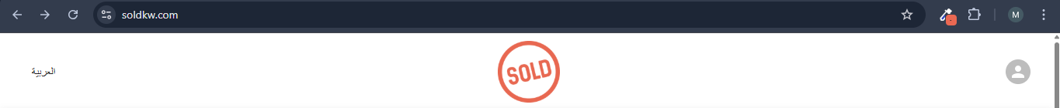

1. **Change user icon color to be like SOLD logo color : #E86851**
2. **Remove quotes from contact us section**