Attention please!!!
To ensure that rosserial over USB is working you must do the following:
1. go to Arduino folder Then libraries
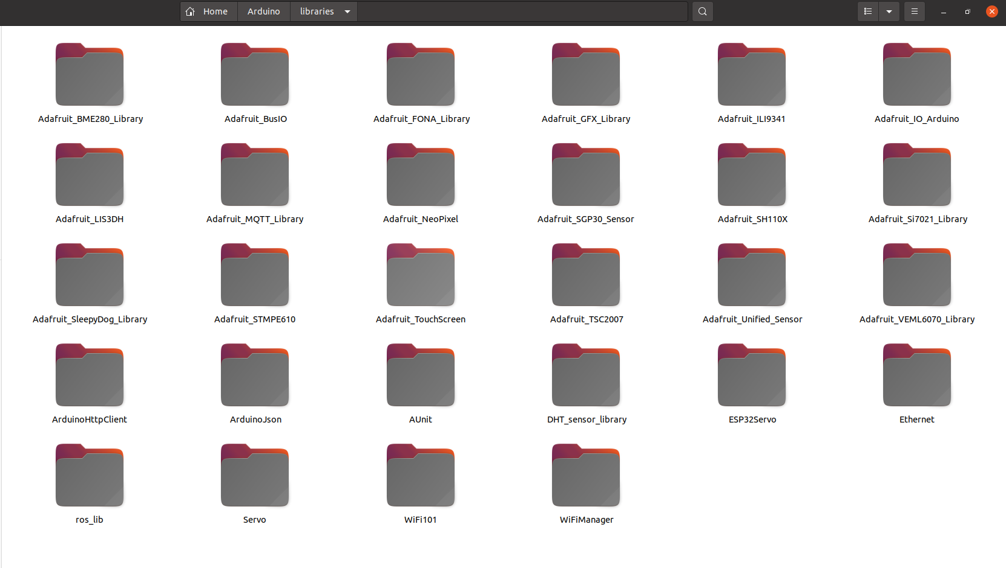
2. go to ros_lib folder to change ros.h file

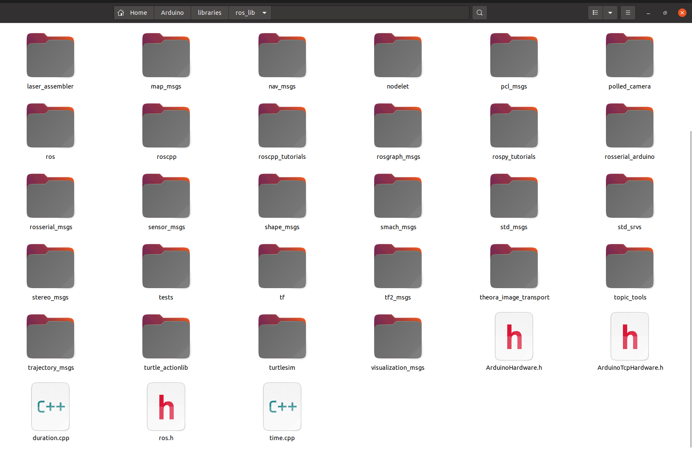

3. inside ros.h file you should change the following:

#if defined(ESP8266) or defined(ESP32) or defined(ROSSERIAL_ARDUINO_TCP)
#include "ArduinoTcpHardware.h"
#else
#include "ArduinoHardware.h"
#endif

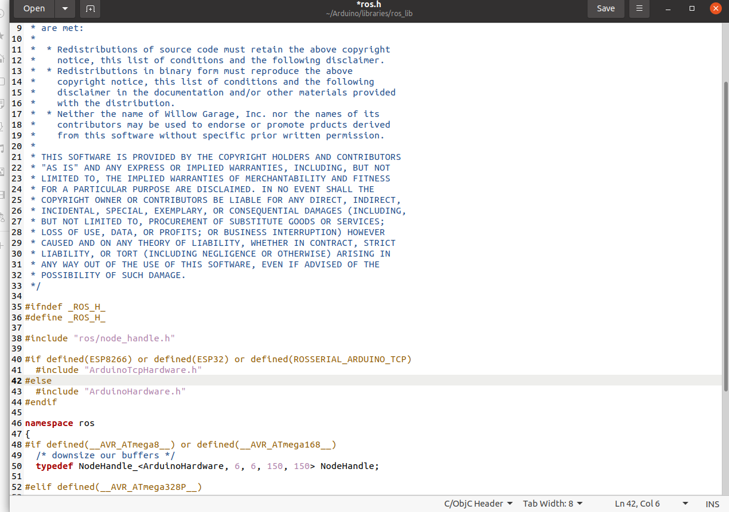
To:
#if defined(ESP8266) or defined(ESP32) or defined(ROSSERIAL_ARDUINO_TCP)
#include "ArduinoHardware.h"
#else
#include "ArduinoHardware.h"
#endif

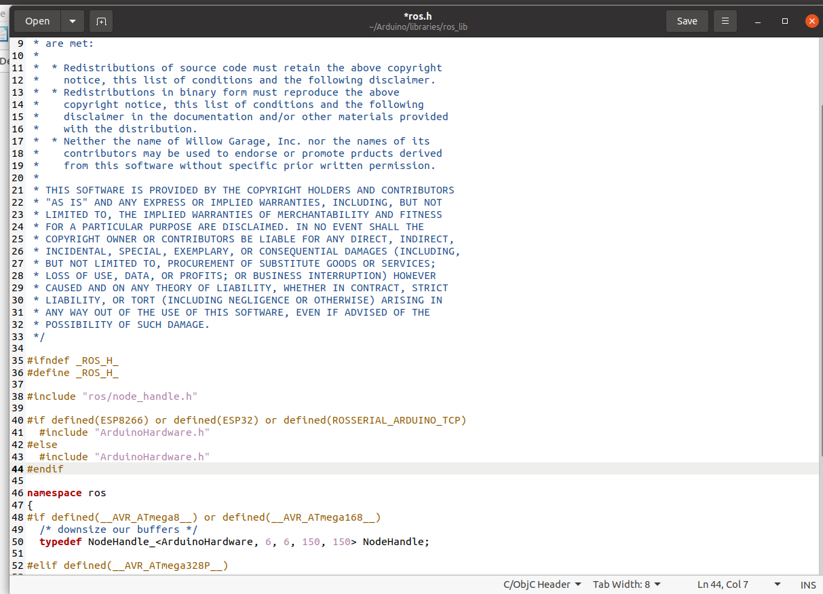

Second thing is very important
when connecting with rosserial serialnode.py you should make sure that serial monitor is closed.

Credits to
