**Lab 2**

1. Make your own interface to create tabs and display usernames by

requesting users from the link below using Ajax ES6 fetch function:

<https://jsonplaceholder.typicode.com/users>

Note: handle the response with promises using then and catch

methods.

b. When a user tab is clicked display its todo titles and show completed by requesting the todos from the link below using Ajax ES6 fetch function:

[https://jsonplaceholder.typicode.com/todos?userId=userId](https://jsonplaceholder.typicode.com/posts?userId=userId)

Note:

handle the response with promises using Async and await.

do not get the todos of all users on page load, the user tab must be clicked to request its todo.

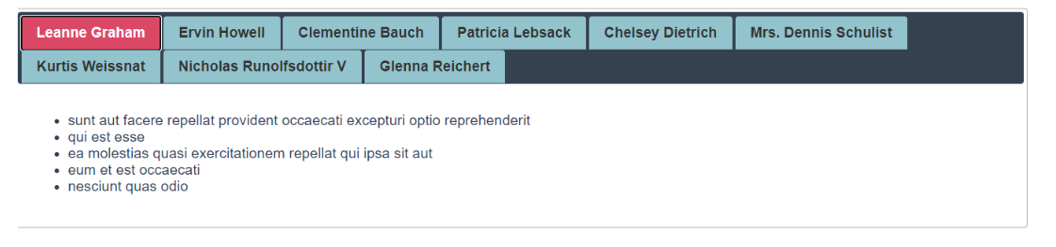

2-Create a function that using **fetch** and make an Ajax call to this URL (from demo get it), and after getting the users, display them in a dropdownlist (<select> item)in your page.

* + 1. Make button besides the list (Show image), and make it disabled.

After the user are retrieved from the server and filled in the drop-down list, enable the button, and when clicked, it should display the user details.

3) Create an iterable object by implementing @iterator method i.e. Symbol.iterator, so that you can use for..of and retrieve its properties. retrieving the object properties and its values

4) Create a generator that returns Fibonacci

[1,1,2,3,5,8,13,….]

series that takes only one parameter:

A. the parameter passed determines the number of elements displayed from the series.

Ex insert 6 print 1,1,2,3,5,8