Ephaptic Aβ-to-C-Fiber Crosstalk in Pathologically Restricted Nerve Clefts: A Closed-Loop Core-Conductor Study of Spatial and Temporal Summation
Mina Saied Attia Rizk
New Cairo STEM School, Cairo, Egypt
Corresponding author. Email: Mina.3024031@stemnewcairo.moe.edu.eg
Abstract: Dynamic mechanical allodynia is hypothesized to involve non-synaptic (“ephaptic”) cross-excitation between myelinated Aβ mechanoreceptive afferents and unmyelinated C-fiber nociceptors at sites of focal demyelination or nerve compression. We present a closed-loop, one-dimensional core-conductor model coupling a Chiu-Ritchie-Rogart-Stagg-Sweeney (CRRSS) Aβ axon to a C-fiber through a shared, restricted extracellular cleft, using algebraic elimination of capacitive currents. C-fibers used classical Hodgkin-Huxley kinetics (Phase 1) or literature-derived Nav1.8/Nav1.9 kinetics (Phase 2, robustness check). Single-fiber-pair crosstalk remained subthreshold under single-pulse stimulation in both models (≤1.325 mV, Phase 1; ≤1.76 mV, Phase 2) across cleft widths of 20 nm to 5 μm. In a bundle of n ∈ [1,50] synchronized Aβ fibers, return currents produced saturating subthreshold depolarization within 5 ms (+6.2 mV, Phase 1; +10.4 mV, Phase 2, at n=50), limited by axoplasmic shunting; a 1.5-ms onset-dispersion window attenuated it by 92.9–93.8%. In the ungrounded full-length model, a 100-Hz train produced a propagated C-fiber action potential (≈ 0.41 m/s) during the second pulse interval, but it was initiated by the first pulse at the sealed stimulation boundary and delayed by slow conduction; a single pulse yields the same spike, so it does not demonstrate temporal summation. In a grounded interior-lesion control, endogenous crosstalk evoked no action potentials in either phase, including under 800-Hz trains. Isolated Aβ conduction velocity (41.03 m/s) and event classifications were robust to spatial refinement, though the single-pulse n=25 peak amplitude was not fully timestep-converged. Here, ephaptic coupling produced subthreshold depolarization but no threshold crossing without a boundary-initiated spike.
Keywords: ephaptic coupling, dynamic mechanical allodynia, core-conductor model, Nav1.8/Nav1.9 kinetics, spatial summation, temporal summation

1 Introduction
Dynamic mechanical allodynia—pain evoked by light, moving tactile stimuli such as light brushing or the contact of clothing—is a debilitating hallmark of peripheral neuropathic pain conditions, including painful diabetic neuropathy (Asmedi et al., 2018), post-herpetic neuralgia, and nerve entrapment syndromes such as trigeminal neuralgia (Rappaport & Devor, 1994). A prominent biophysical hypothesis holds that at sites of focal demyelination, chronic mechanical compression, or traumatic nerve injury, the normally independent electrical activity of large myelinated Aβ mechanoreceptive afferents and small unmyelinated C-fiber nociceptors can become directly coupled through their shared, pathologically restricted extracellular space. This non-synaptic electrical interaction, termed “ephaptic” coupling, was first characterized biophysically by Arvanitaki (1942) and by Katz and Schmitt (1940). Experimental evidence for cross-excitation between afferent classes has since been documented in mammalian dorsal root ganglia (Amir & Devor, 2000; Devor & Wall, 1990) and in chronically injured peripheral nerve trunks (Rasminsky, 1980; Seltzer & Devor, 1979). Under this hypothesis, low-threshold tactile activity conducted by Aβ fibers could directly evoke ectopic action potentials in neighboring nociceptive axons, providing a peripheral mechanism for tactile allodynia that operates upstream of, or in concert with, central sensitization.
Computational investigations of ephaptic coupling in nervous tissue have traditionally followed two distinct approaches: open-loop forward models, in which the extracellular field generated by an active fiber is imposed as an external driving potential on an adjacent passive or excitable cable without reciprocal feedback (Goldwyn & Rinzel, 2016; Lindén et al., 2014), and closed-loop formulations restricted to homogeneous fiber populations, such as bundles of myelinated axons or central white-matter tracts (Reutskiy et al., 2003; Schmidt et al., 2021; Schmidt & Knösche, 2022). Foundational analytical and numerical work by Reutskiy, Rossoni, and Tirozzi (2003) demonstrated that bundle geometry and inter-fiber packing profoundly modulate conduction velocity and recruitment thresholds in demyelinated nerve. More recently, generalized higher-dimensional formulations of interacting parallel axon networks have elucidated the complex dynamical dependencies of ephaptic crosstalk on spatial packing, boundary conditions, and coupling topologies (Chawla & Morgera, 2024; Chawla et al., 2021). Fully coupled Extracellular–Membrane–Intracellular (EMI) finite-element formulations have further advanced the field by resolving three-dimensional micro-domains around excitable cells (Jæger & Tveito, 2022, 2026). Nevertheless, closed-loop bidirectional coupling between physiologically distinct fiber classes—specifically a fast myelinated Aβ mechanoreceptor and an unmyelinated C-fiber nociceptor—remains incompletely characterized, particularly concerning whether multi-fiber spatial convergence or repetitive temporal trains can bridge the threshold gap where single-pair coupling fails.
This paper reports a closed-loop core-conductor model developed to evaluate this interaction systematically across two complementary modeling phases. Phase 1 establishes a baseline system coupling a Chiu-Ritchie-Rogart-Stagg-Sweeney (CRRSS) myelinated Aβ axon to a classical Hodgkin-Huxley (HH) C-fiber through a shared extracellular cleft. Using this baseline, we test whether single-pair crosstalk can trigger ectopic nociceptor spikes under single-pulse stimulation, tonic peripheral sensitization, or high-frequency temporal summation. Recognizing that classical HH kinetics lack the tetrodotoxin-resistant (TTX-R) conductances characteristic of mammalian nociceptors, Phase 2 replaces the classical Na⁺ current with literature-derived Nav1.8 and Nav1.9 kinetics (Akopian et al., 1996; Cummins et al., 1999; Klein et al., 2017). Phase 2 is designed not as an independent biological validation of Phase 1, but as a biological sensitivity and robustness check within the same one-dimensional core-conductor framework. We then extend Phase 2 to a multi-fiber bundle configuration in which an ensemble of synchronized or temporally dispersed Aβ fibers converges upon a shared extracellular compartment with one C-fiber.
We report that single-fiber-pair crosstalk remains strictly subthreshold under single-pulse stimulation across both channel models. In contrast, multi-fiber spatial summation produces substantial subthreshold depolarizations that asymptotically saturate due to parallel axoplasmic conductance shunting. Furthermore, in the ungrounded full-length model a 100-Hz train yields a propagated C-fiber action potential during the second pulse interval; because a single pulse produces the same spike when observed for long enough, we attribute it to boundary initiation and slow conduction rather than to demonstrated temporal summation, and a grounded interior-lesion control evoked no action potentials.

2 Methods

2.1 Coupled Core-Conductor Cable Equations
We consider two parallel axons of length L = 10 mm embedded in a shared, longitudinally restricted extracellular cleft with resistance per unit length r_{e} (Ω/m). Axon 1 (k=1) represents the myelinated Aβ fiber, and axon 2 (k=2) represents the unmyelinated C-fiber. For each axon, the transmembrane potential is defined as v_{m,k}(z,t) = u_{i,k}(z,t) - u_{e}(z,t), where u_{i,k} is the intracellular potential and u_{e} is the shared extracellular cleft potential. The coupled core-conductor cable equations are given by:
$$\frac{∂v_{m,k}}{∂t}=\frac{1}{C_{m,k}}\left[\frac{d_{\text{axon},k}}{4ρ_{i}}\left(\frac{∂^{2}v_{m,k}}{∂z^{2}}+\frac{∂^{2}u_{e}}{∂z^{2}}\right)−I_{\text{ion},k}+I_{\text{stim},k}\right]$$
where d_{axon,k} is the inner axonal core diameter (d_{axon,1} = 0.7 D₁ = 7.0 μm for the myelinated Aβ fiber with outer diameter D₁ = 10 μm, representing an established g-ratio of 0.7; and d_{axon,2} = d₂ = 1.0 μm for the unmyelinated C-fiber). The parameter ρ_{i} = 54.7 Ω⋅cm = 0.547 Ω⋅m is the axoplasmic resistivity (Sweeney et al., 1987), C_{m,k} is the specific membrane capacitance (F/m²), I_{ion,k} is the total transmembrane ionic current density (A/m²), and I_{stim,k} is the applied intracellular stimulation current density (A/m²). All current densities and capacitances are defined per unit inner-axonal membrane area (π d_{axon,k}), ensuring mathematical consistency with the core-conductor derivation of the axial diffusion term. Symbols, parameters, and SI units are defined in Table 3. Sealed-end (Neumann) boundary conditions are enforced at both cable ends (z = 0 and z = L):
$${\left.\frac{∂v_{m,k}}{∂z}\right|}_{z=0,L}=0, {\left.\frac{∂u_{e}}{∂z}\right|}_{z=0,L}=0$$
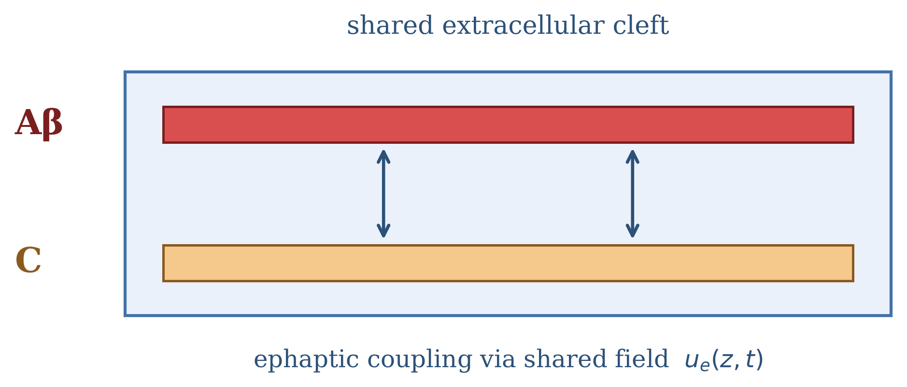
Fig. 1 Model architecture (schematic). A myelinated Aβ axon (CRRSS kinetics, discrete nodes of Ranvier) and an unmyelinated C-fiber (classical HH or Nav1.8/Nav1.9 kinetics) are embedded in a pathologically restricted extracellular cleft of width w_{cleft}. Both fibers’ transmembrane currents drive a regularized Poisson equation for the shared extracellular potential u_{e}(z,t), which is solved at each time step and fed back into both cable equations as an ephaptic driving term (double-headed arrows), closing the loop

2.2 Membrane Kinetics and Conduction Properties

2.2.1 Myelinated Aβ Fiber (CRRSS Kinetics)
The Aβ axon employs the Chiu-Ritchie-Rogart-Stagg-Sweeney (CRRSS) nodal kinetics (Chiu et al., 1979; Sweeney et al., 1987). Active ionic currents are localized to discrete physical nodes of Ranvier of fixed physical length l_{node} = 1.0 μm, spaced at internodal intervals of Δ L = 1.0 mm along the 10 mm cable (10 nodes total, at z = 0, 1, …, 9 mm). To ensure that spatial grid refinement (Δ z) does not alter the physical membrane area of the node, we apply a consistent homogenization scheme: for any computational compartment of width Δ z, the fraction occupied by an active node is f_{node} = l_{node} / Δ z (f_{node} ≤ 1). The effective compartment capacitance and leak conductance are weighted accordingly:
$$C_{m,1}=f_{\text{node}}C_{m,\text{node}}+\left(1−f_{\text{node}}\right)C_{m,\text{internode}}$$
$$g_{\text{leak},1}=f_{\text{node}}g_{\text{leak},\text{node}}+\left(1−f_{\text{node}}\right)g_{\text{leak},\text{internode}}$$
Physical nodal parameters are: ḡ_{Na} = 1445 mS/cm² = 14450 S/m², g_{leak,node} = 128 mS/cm² = 1280 S/m², C_{m,node} = 2.0 μF/cm², E_{Na} = +35.64 mV, and E_{leak,1} = -80.0 mV (Sweeney et al., 1987). Internodal compact myelin is parameterized with C_{m,internode} = 0.005 μF/cm² and g_{leak,internode} = 0.006 mS/cm², with active Na⁺ channels absent.
The gating rate equations follow the mammalian CRRSS formulation (Chiu et al., 1979; Sweeney et al., 1987) with corrected monotonic h-gate inactivation designations:
$$α_{m}\left(v\right)=\frac{\left(97.0+0.363\left(v_{\text{mV}}+80.0\right)\right)×{10}^{3}}{1.0+exp\left(−\left(v_{\text{mV}}+49.0\right)/5.3\right)} {\text{s}}^{−1}$$
$$β_{m}\left(v\right)=α_{m}\left(v\right)exp\left(−\left(v_{\text{mV}}+56.2\right)/4.17\right)$$
$$β_{h}\left(v\right)=\frac{15.6×{10}^{3}}{1.0+exp\left(−\left(v_{\text{mV}}+56.0\right)/10.0\right)} {\text{s}}^{−1}$$
$$α_{h}\left(v\right)=β_{h}\left(v\right)exp\left(−\left(v_{\text{mV}}+74.5\right)/5.0\right)$$
where v_{mV} = v_{m,1} × 10³, corresponding to the classic deviation from resting potential V = v_{mV} + 80.0 mV in Chiu et al. (1979). The inactivation curve h_∞(v) = α_{h} / (α_{h} + β_{h}) decreases monotonically from ≈ 1.0 at hyperpolarized potentials to 0.0 upon depolarization, with half-inactivation at V_{1/2} ≈ -74.5 mV. Rates are scaled to 37 °C using Q₁₀ = 3.0 (Sweeney et al., 1987). Under this parameterization, an isolated Aβ fiber stimulated at node 0 (2 nA, 0.2 ms) generates a brief, physiological saltatory action potential, reaching an absolute peak of approximately +0.44 mV at z = 4 mm from a resting potential of -80.0 mV, corresponding to an action-potential excursion of 80.44 mV, conducting at 41.03 m/s (measured via maximum upstroke dV/dt between 4.0 mm and 8.0 mm), well within the established mammalian range (30–60 m/s). The coupled simulations of Section 3.2 onward use a stronger 100 nA stimulus, which produces a large local transient at the stimulated end (Section 3.5.1); the 2 nA drive is used for all uncoupled Aβ validation. Steady-state gating curves and time constants are shown in Fig. 2.
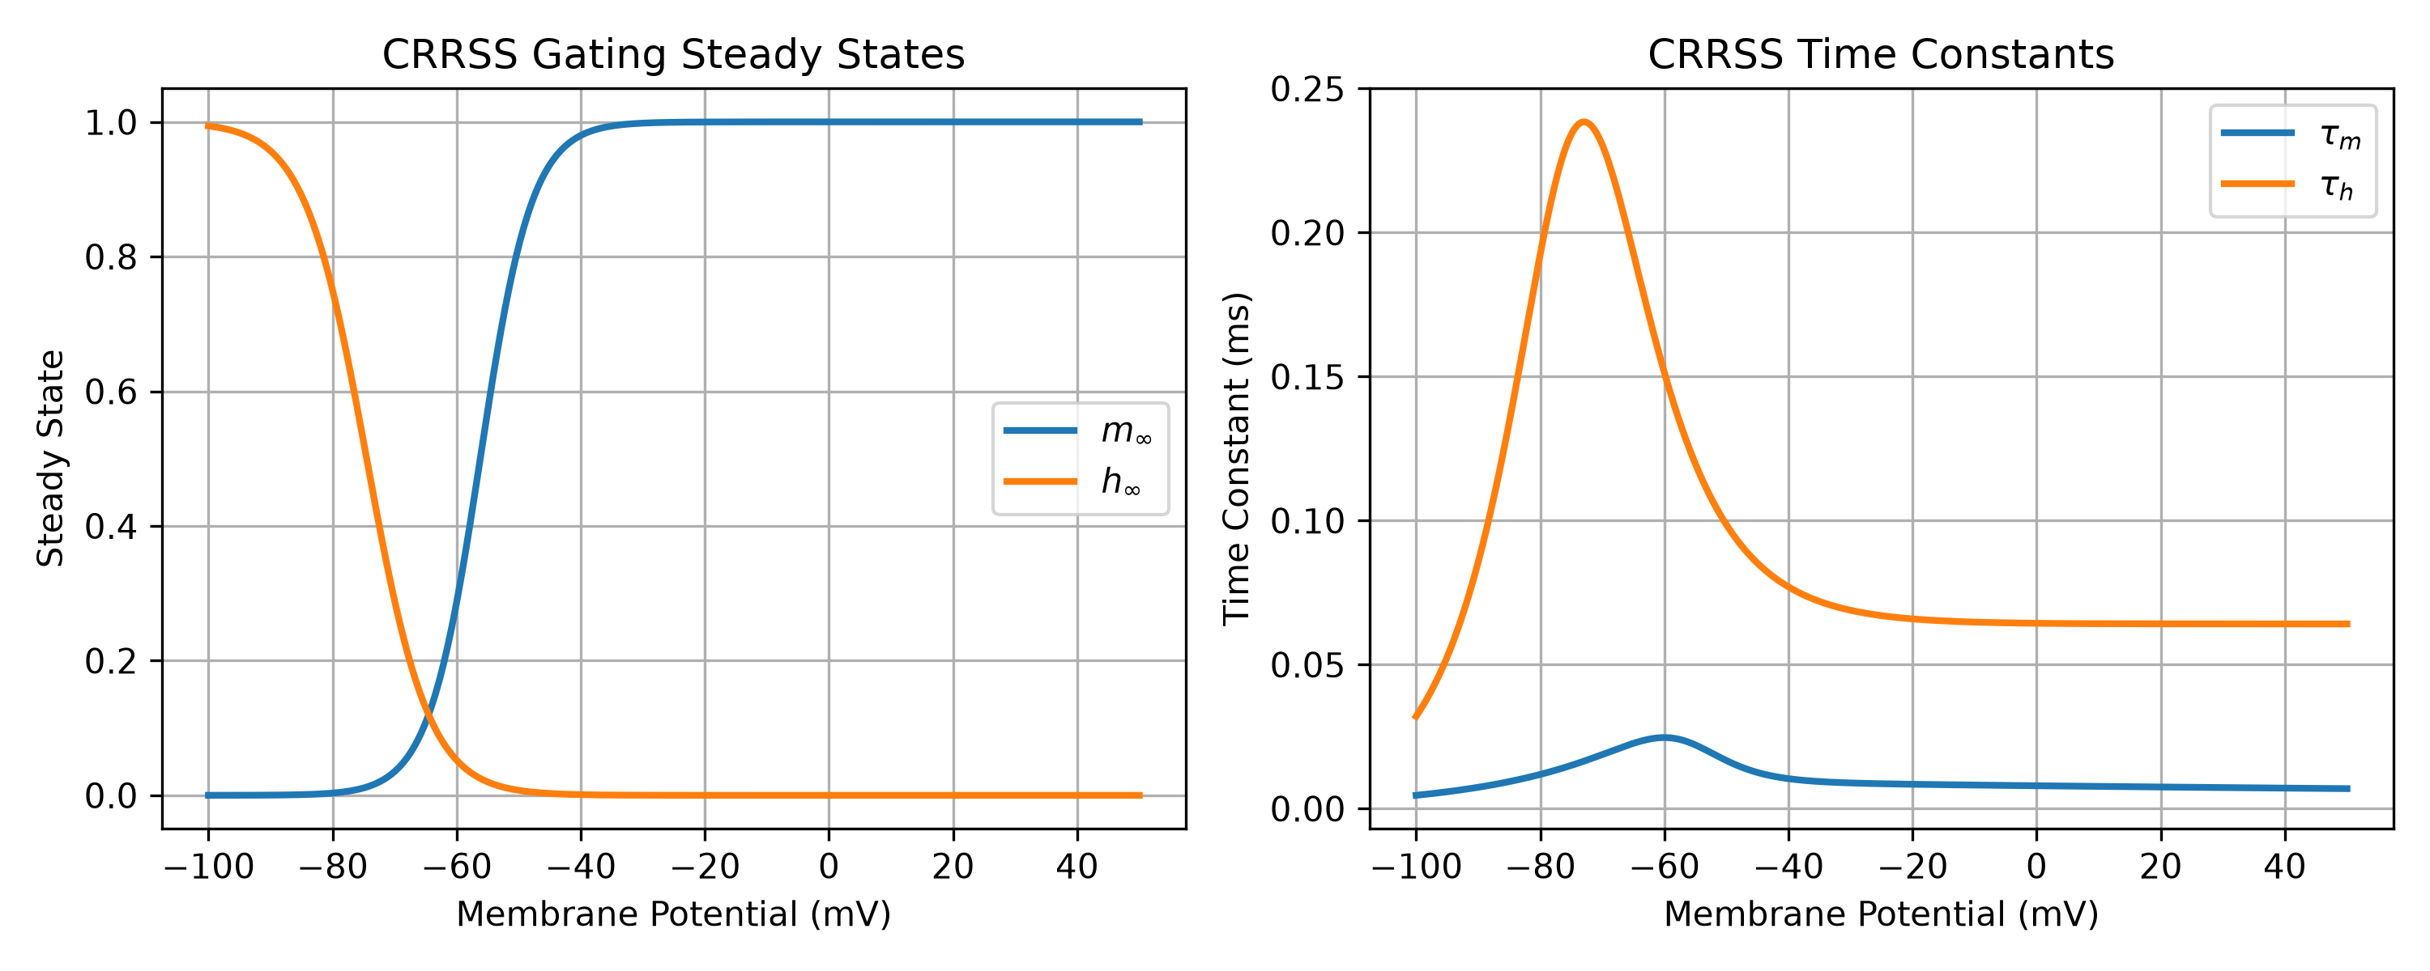
Fig. 2 CRRSS nodal gating kinetics used for the myelinated Aβ fiber. Left, steady-state activation (m∞) and inactivation (h∞) as functions of membrane potential; right, corresponding time constants τ_{m} and τ_{h}. The inactivation curve decreases monotonically with depolarization, confirming the corrected h-gate rate equations

2.2.2 C-Fiber Membrane Models
The unmyelinated C-fiber (d₂ = 1.0 μm, C_{m,2} = 1.0 μF/cm²) is modeled continuously along its length. In Phase 1, it follows classical Hodgkin-Huxley kinetics (Hodgkin & Huxley, 1952): ḡ_{Na} = 120 mS/cm², ḡ_{K} = 36 mS/cm², g_{leak} = 0.3 mS/cm², E_{Na} = +50.0 mV, E_{K} = -77.0 mV, and E_{leak,2} = -54.4 mV, resting stably at -65.0 mV. The delayed-rectifier K⁺ conductance obeys I_{K} = ḡ_{K} n⁴ (v₂ - E_{K}) with gating kinetics:
$$\frac{dn}{dt}=α_{n}\left(v\right)\left(1−n\right)−β_{n}\left(v\right)n$$
$$α_{n}\left(v\right)=\frac{0.01\left(v_{\text{mV}}+55.0\right)}{1.0−exp\left(−\left(v_{\text{mV}}+55.0\right)/10.0\right)}×{10}^{3} {\text{s}}^{−1}$$
$$β_{n}\left(v\right)=0.125exp\left(−\left(v_{\text{mV}}+65.0\right)/80.0\right)×{10}^{3} {\text{s}}^{−1}$$
where v_{mV} = v_{m,2} × 10³. Under direct stimulation, the isolated classical C-fiber conducts at 0.41 m/s.
In Phase 2, the generic Na⁺ current is replaced with literature-derived TTX-R Nav1.8 and Nav1.9 nociceptor kinetics (Section 2.5).

2.3 Extracellular Coupling, Regularization, and Exact Algebraic Elimination
The longitudinal extracellular cleft resistance per unit length r_{e} = ρ_{e} / A_{eff} (Ω/m) is determined by extracellular resistivity (ρ_{e} = 100 Ω⋅cm = 1.0 Ω⋅m) and the annular cleft area A_{eff}:
$$A_{\text{eff}}=π\left[{\left(\frac{d_{1}+d_{2}}{2}+w_{\text{cleft}}\right)}^{2}−{\left(\frac{d_{1}}{2}\right)}^{2}−{\left(\frac{d_{2}}{2}\right)}^{2}\right]$$
In the zero-cleft limit (w_{cleft} → 0), A_{eff} approaches A_{eff,min} = π d₁ d₂ / 2 ≈ 15.7 μm² = 1.57 × 10⁻¹¹ m², bounding r_{e} at an upper ceiling r_{e,max} = ρ_{e} / A_{eff,min} ≈ 6.37 × 10¹⁰ Ω/m. For the nominal restricted cleft width w_{cleft} = 20 nm, A_{eff} ≈ 16.4 μm² (1.64 × 10⁻¹¹ m²) and r_{e} ≈ 6.10 × 10¹⁰ Ω/m.
To avoid numerical stiffness associated with the explicit evaluation of membrane capacitive displacement currents, we implement an algebraic elimination that incorporates the capacitive, ionic, and applied-current terms through the membrane equations while removing their explicit appearance from the extracellular solve. From core-conductor theory, total transmembrane current per unit length exiting axon k equals the axial current divergence:
$$i_{m,k}\left(z,t\right)=\frac{1}{r_{i,k}}\frac{∂^{2}u_{i,k}}{∂z^{2}}=\frac{1}{r_{i,k}}\left(\frac{∂^{2}v_{m,k}}{∂z^{2}}+\frac{∂^{2}u_{e}}{∂z^{2}}\right)$$
where r_{i,k} = 4 ρ_{i} / (π d_{axon,k}²) is the intracellular longitudinal core resistance per unit length (Ω/m). Extracellular current conservation per unit length requires:
1re∂2ue∂z2−Geue+k​im,k=0
where G_{e} = κ / r_{e} (S/m) represents weak ohmic leakage from the restricted cleft to the surrounding bulk interstitial tissue, and κ (m⁻²) is a phenomenological regularization parameter. Substituting i_{m,k} yields:
1re+k​1ri,k∂2ue∂z2−κreue=−k​1ri,k∂2vm,k∂z2
Dividing by the total core conductance Σ_{G} = (1)/(r_{e}) + Σ_{k} (1)/(r_{i,k}) produces a regularized Poisson/Helmholtz equation:
∂2ue∂z2−κeffue=−1ΣGk​1ri,k∂2vm,k∂z2
The algebraic elimination removes the explicit capacitive-current feedback from the extracellular solve, avoiding that particular stiffness pathway; numerical stability was assessed empirically through the reported timestep/convergence tests.
where the effective regularization parameter κ_{eff} (m⁻²) is:
$$κ_{\text{eff}}=\frac{κ/r_{e}}{Σ_{G}}$$
We treat κ = 1.0 × 10⁹ m⁻² as a fixed phenomenological model parameter throughout all comparative analyses, defining a nominal pre-elimination spatial decay scale λ_κ = 1/√(κ) ≈ 31.62 μm. It is not an experimentally measured constant. Importantly, the effective spatial decay scale of the reduced Helmholtz operator is governed by λ_{eff} = 1/√(κ_{eff}), where κ_{eff} = (κ / r_{e}) / Σ_{G}. Because total core conductance Σ_{G}(n) expands with fiber count n, κ_{eff} decreases and λ_{eff} correspondingly lengthens: λ_{eff} = 73.3 μm for n=1, 209.7 μm for n=10, 329.1 μm for n=25, and 464.3 μm for n=50 (Table 4).

Discrete Current Conservation and Operator-Splitting Residual Analysis
To evaluate current conservation rigorously, we explicitly distinguish between two separate conservation metrics:
- Discrete Algebraic Operator Identity Residual (R_{alg}): Evaluates whether the banded matrix solve numerically satisfies the discretized Helmholtz operator:
Ralgzj,tn+1=1re+k​1ri,k∇2uen+1zj−κreuen+1zj+k​1ri,k∇2vknzj
Across all spatial compartments and timesteps, the discrete operator identity is satisfied to machine precision: max |R_{alg}| ≈ 1.95 × 10⁻¹⁷ A/m (1.3 × 10⁻¹²% of peak transmembrane source current, ≈ 1.49 × 10⁻³ A/m). Both residuals are shown in Fig. 3.
- Physical Dynamic Current-Balance Residual (R_{phys}): Evaluates the physical Kirchhoff current balance using the actual updated transmembrane currents i_{m,k}^{phys}(z_{j}, t^{n+1}) = π d_{axon,k} [ C_{m,k} (v_{k}^{n+1} - v_{k}^{n})/(Δ t) + I_{ion,k}(v_{k}^{n}, w_{k}^{n+1}) - I_{stim,k}^{n+1} ]:
Rphyszj,tn+1=1re∇2uen+1zj−κreuen+1zj+k​im,kphyszj,tn+1
Because linear axial diffusion is stepped implicitly while u_{e}^{n+1} is computed from the explicit state v_{k}^{n}, the physical current balance exhibits an implicit–explicit operator-splitting lag:
Lsplitzj,tn+1=k​1ri,k∇2vkn+1−vkn=OΔt
Under systematic temporal refinement across Δ t ∈ [5.0, 2.5, 1.25, 0.625, 0.3125, 0.15625] μs at fixed Δ z = 10 μm, and the benchmark-default cleft width of 100 nm, the peak physical residual converges monotonically toward zero:
- Δ t = 5.0 μs: max |R_{phys}| = 3.88 × 10⁻⁴ A/m (26.20% of peak source)
- Δ t = 2.5 μs (nominal production step): max |R_{phys}| = 3.24 × 10⁻⁴ A/m (21.78%)
- Δ t = 1.25 μs: max |R_{phys}| = 2.59 × 10⁻⁴ A/m (17.35%)
- Δ t = 0.625 μs: max |R_{phys}| = 1.82 × 10⁻⁴ A/m (12.19%)
- Δ t = 0.3125 μs: max |R_{phys}| = 1.15 × 10⁻⁴ A/m (7.70%)
- Δ t = 0.15625 μs: max |R_{phys}| = 6.65 × 10⁻⁵ A/m (4.44%)
The apparent local convergence order rises from p = 0.26 at coarse steps to p = 0.79 at the finest step pair (results/convergence/kcl_refinement_study.csv), and is still increasing at the smallest step; the data are consistent with, but do not by themselves demonstrate, first-order asymptotic convergence of the IMEX splitting lag.
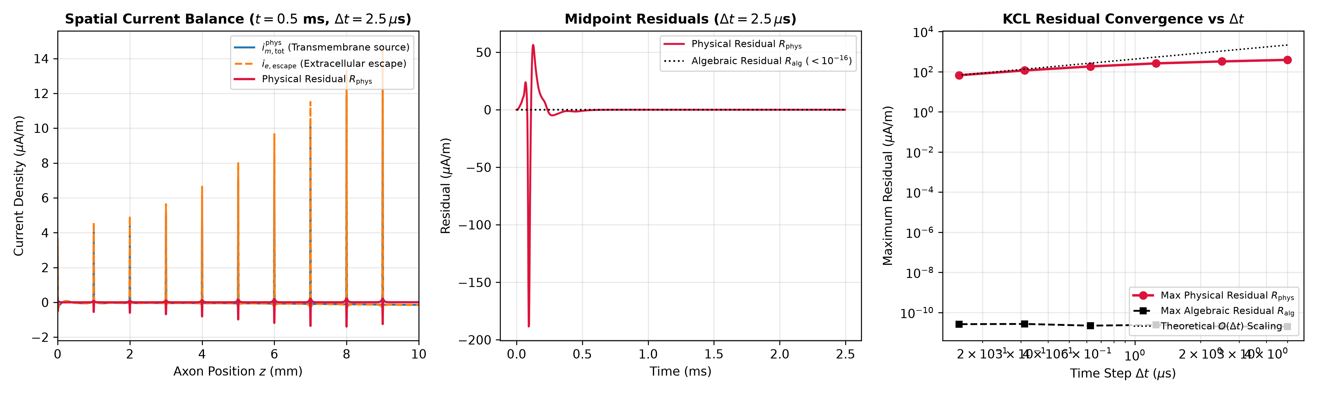
Fig. 3 Discrete Kirchhoff’s current law conservation and temporal refinement. (a) Spatial profiles of dynamic transmembrane source currents and extracellular return current at peak action-potential propagation (t = 0.25 ms). (b) Discrete algebraic operator identity residual R_{alg}, verified to machine precision (< 10⁻¹⁶ A/m). (c) Physical current-balance residual R_{phys} convergence under temporal refinement (Δ t ∈ [5.0, 0.156] μs), demonstrating monotonic reduction of the IMEX operator-splitting lag from 26.2% to 4.44% (apparent order rising from 0.26 to 0.79). Benchmark cleft width: 100 nm.

2.4 Numerical Scheme and Convergence Methodology
The system is integrated using an implicit–explicit (IMEX) operator-splitting scheme on a spatial grid of nominal Δ z = 10 μm (N = 1000 compartments) with time step Δ t = 2.5 μs. Linear axial diffusion terms are stepped implicitly via backward Euler using tridiagonal LAPACK solvers (solve_banded), while nonlinear ionic currents are updated explicitly. Extracellular potential u_{e} is obtained at each step by solving the banded Helmholtz operator.

2.4.1 Spatial Refinement Study
To verify spatial convergence, Δ z was refined across [20, 10, 5, 2.5, 1.25, 1.0] μm holding all physical dimensions, including l_{node} = 1.0 μm, strictly fixed, with the temporal step held constant at Δ t = 2.5 μs and the cleft width at w_{cleft} = 20 nm (src/run_convergence_battery.py). As detailed in Section 3.1 and Table 5, the isolated Aβ conduction velocity (41.03 m/s) and the action-potential excursion at z = 4 mm (80.44 mV, an absolute peak of +0.44 mV from rest -80.0 mV) were identical at every grid step. The coupled responses converged monotonically: the single-pair Δ V (n=1) rose from 1.237 mV at 20 μm to 1.354 mV at 1.0 μm, and the multi-fiber Δ V (n=25) from 5.919 mV to 6.050 mV, with successive changes below 0.5% for Δ z ≤ 2.5 μm. The nominal grid (Δ z = 10 μm) underestimates the finest-grid values by 2.1% (n=1) and 0.6% (n=25).

2.4.2 Temporal Refinement Study
Temporal convergence was evaluated independently across Δ t ∈ [5.0, 2.5, 1.25, 0.625, 0.5, 0.25, 0.125] μs (holding Δ z = 10.0 μm and w_{cleft} = 20 nm fixed). Single-pair and multi-fiber event classifications (Local Stimulus Transient) remain unchanged across all time steps. Aβ conduction velocity depends weakly on the time step: it decreases from 42.11 m/s at 5.0 μs to 41.03 m/s at the nominal 2.5 μs and 40.00 m/s at 1.25 μs, then changes by less than 0.3% per halving (39.80 m/s at 0.125 μs). However, as documented in Section 4.6, the absolute peak amplitude of the single-pulse multi-fiber (n=25) response exhibits notable timestep dependence: 6.015 mV at Δ t = 2.5 μs, 8.673 mV at 1.25 μs, 11.557 mV at 0.625 μs, 12.424 mV at 0.5 μs, 14.470 mV at 0.25 μs, and 15.313 mV at 0.125 μs (results/convergence/temporal_convergence_final.csv). Richardson extrapolation across the finest dyadic steps (Δ t ∈ [0.5, 0.25, 0.125] μs, apparent order p ≈ 1.28) yields an asymptotic estimate of ≈ 15.90 mV (or ≈ 16.16 mV under first-order extrapolation, p = 1.0). We explicitly emphasize that these extrapolated values are mathematical estimates rather than directly simulated converged points; thus, while event classification remains robust and invariant across all tested timesteps, single-pulse potential magnitude is not quantitatively converged.

2.4.3 Independent Reference Solver Validation for Aβ Fiber
To verify the numerical implementation of the saltatory Aβ axon model against an independent integration scheme, a standalone reference solver was implemented (audit_reference_solver.py). It integrates the axial diffusion term with Crank-Nicolson and updates the CRRSS gates with a Rush-Larsen step at the midpoint voltage, treating ionic and stimulus currents explicitly as in the production solver. Evaluated at Δ t = 0.625 μs and nominal Δ z = 10 μm, with a 2-nA, 0.2-ms stimulus at node 0, the production IMEX solver yielded an Aβ conduction velocity of 40.00 m/s compared to 39.51 m/s for the Crank-Nicolson reference solver (a 1.2% difference; the action potential excursion at z = 4 mm differed by 0.24%, 79.98 mV vs 79.78 mV). This agreement supports the numerical integration of the Aβ cable dynamics specifically; the two solvers share the membrane model, geometry, and explicit ionic-current treatment, so the comparison does not constitute a full reference solver for the coupled multi-fiber system.
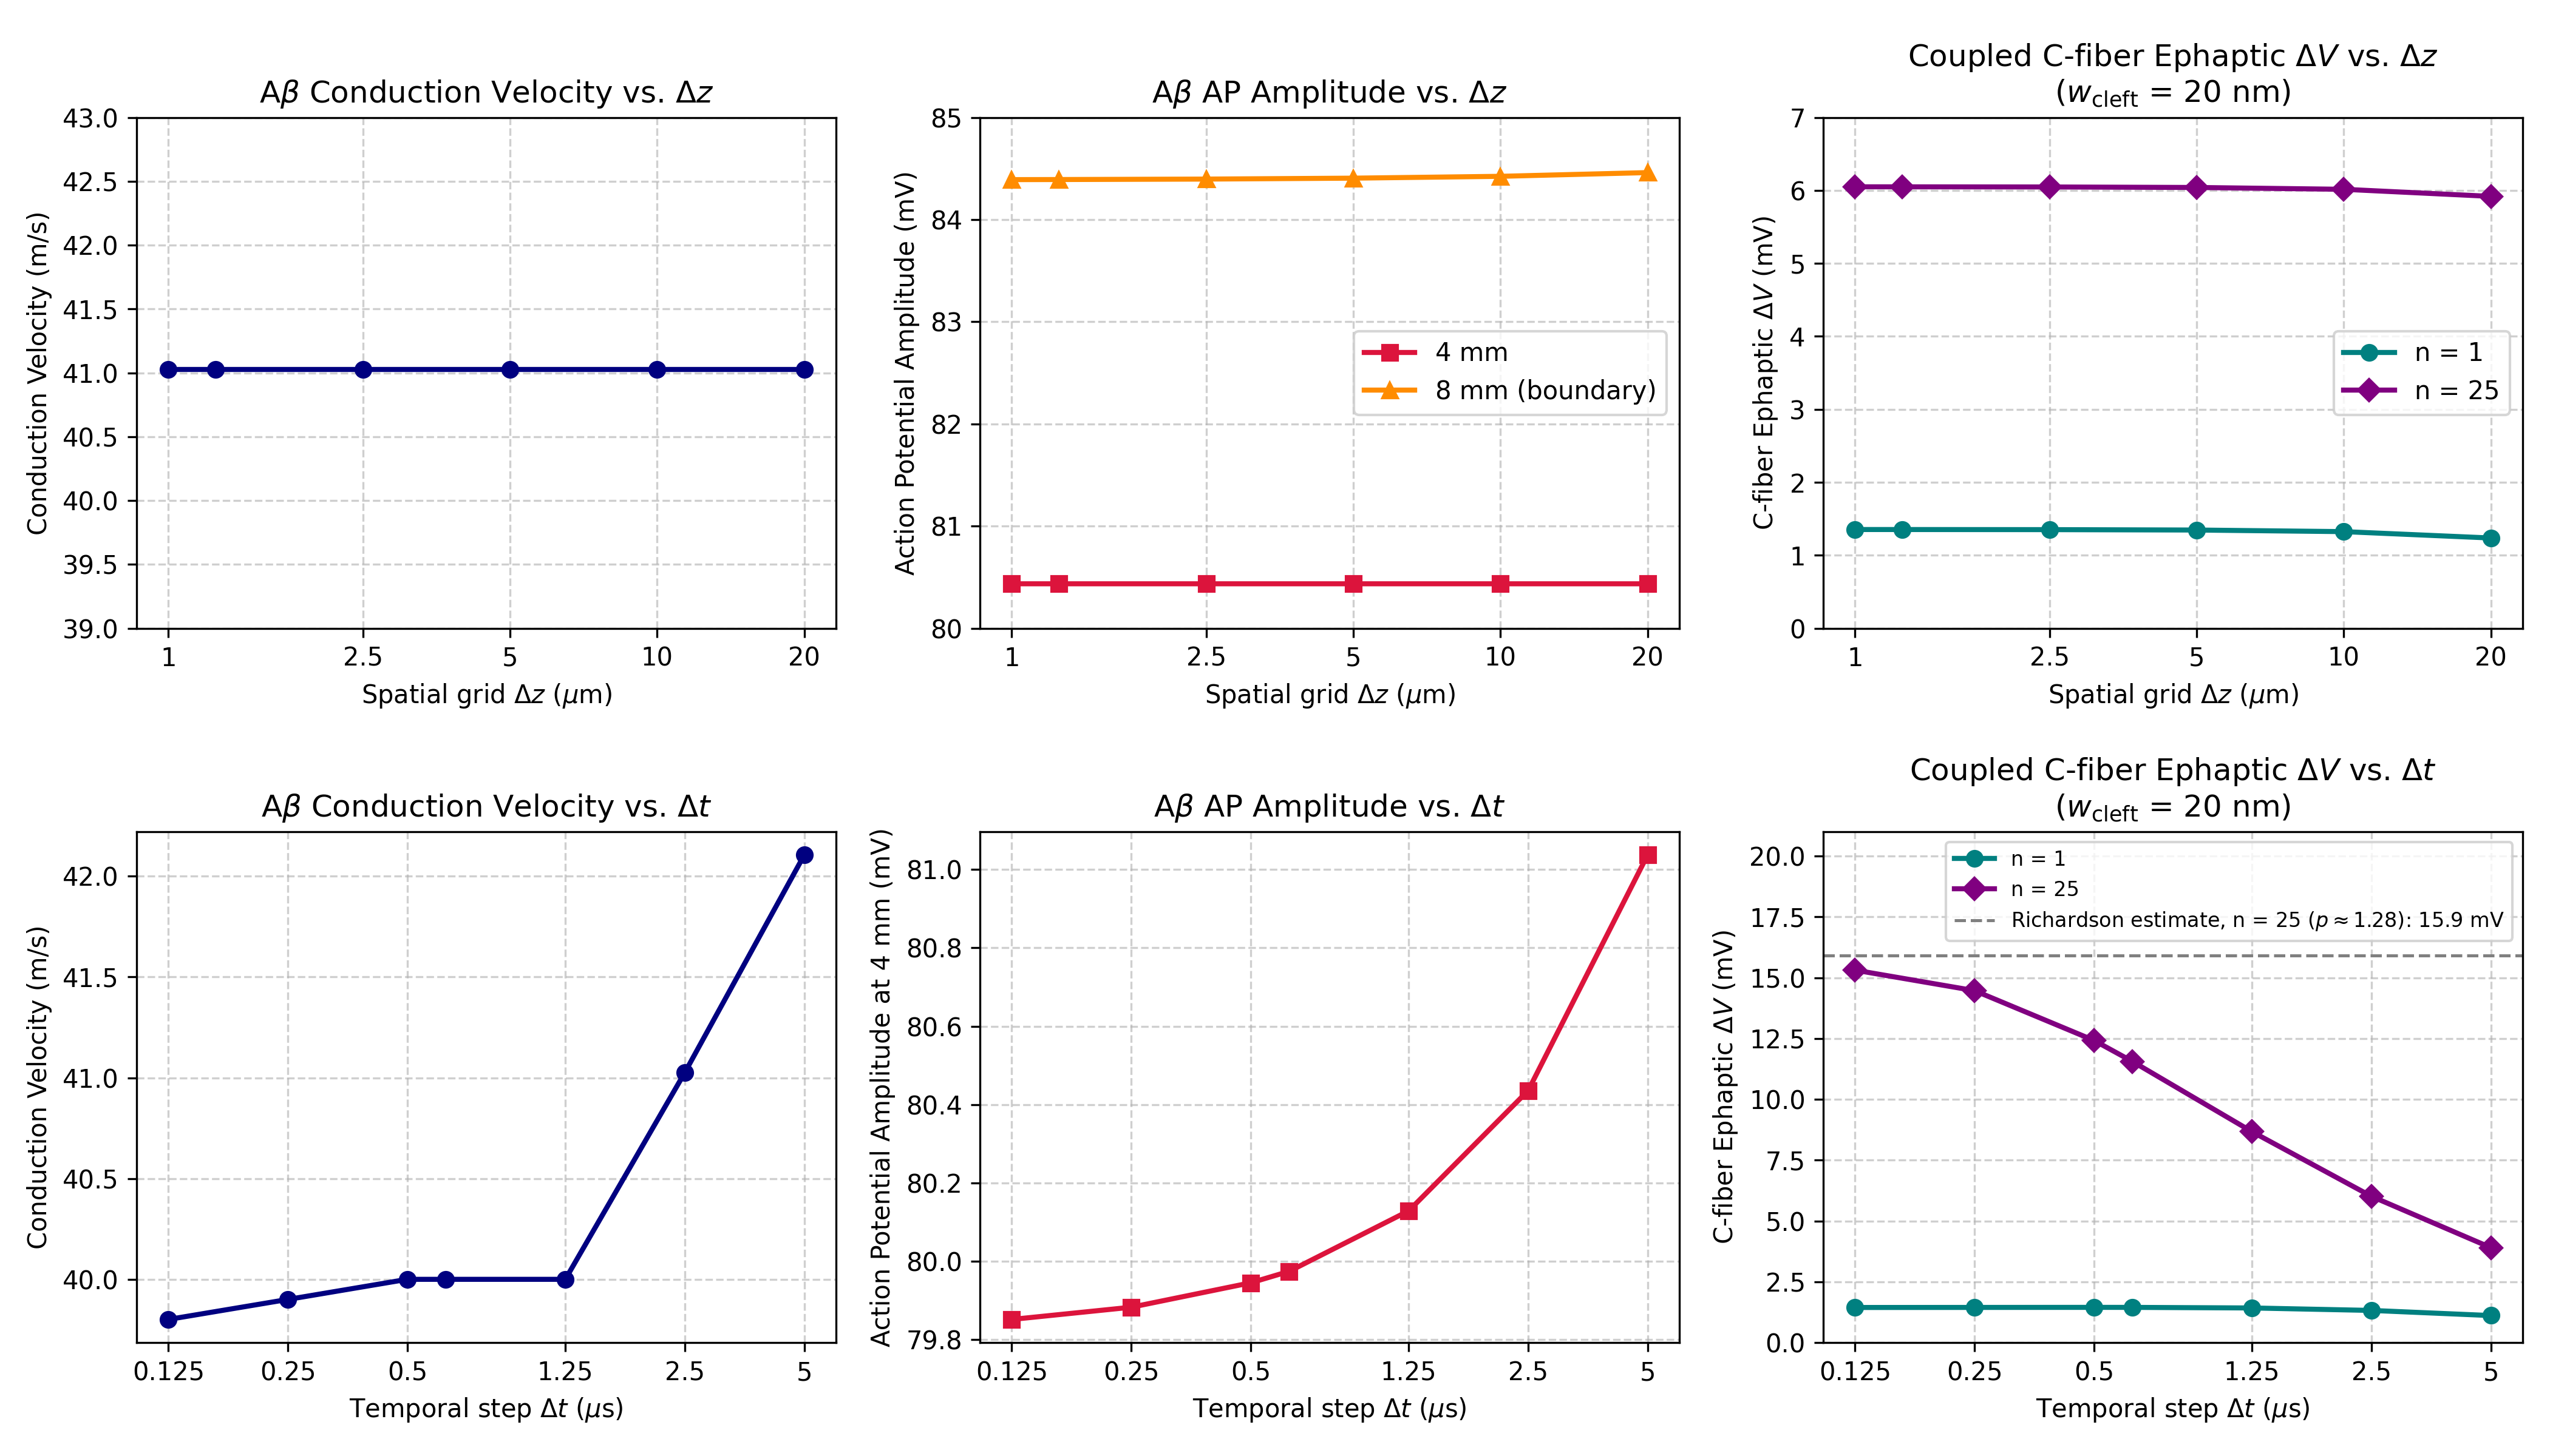
Fig. 4 Spatial and temporal convergence of the Aβ conduction and the coupled n=25 ephaptic response. Top row: spatial refinement at fixed Δ t = 2.5 μs (physical node width held fixed) for Aβ conduction velocity, Aβ action-potential amplitude, and coupled C-fiber ephaptic Δ V for n = 1 and n = 25 (w_{cleft} = 20 nm); conduction velocity and the amplitude at 4 mm are independent of Δ z, and both Δ V curves converge. Bottom row: temporal refinement at fixed Δ z = 10 μm. Conduction velocity and amplitude decrease slightly with the time step (-5.5% and -1.5% from 5.0 to 0.125 μs) and event classification is unchanged, whereas the single-pulse n = 25 amplitude depends strongly on the timestep and is not converged; the dashed line marks the Richardson estimate (15.9 mV, p ≈ 1.28).

2.5 Nav1.8/Nav1.9 Nociceptor Kinetics (Phase 2)
Phase 2 replaces the classical HH Na⁺ current with TTX-R Nav1.8 and Nav1.9 currents (Akopian et al., 1996; Cummins et al., 1999; Klein et al., 2017):
$$I_{\text{ion},2}={\overset{‾}{g}}_{18}m_{8}^{3}h_{8}\left(v_{2}−E_{\text{Na}}\right)+{\overset{‾}{g}}_{19}m_{9}\left(v_{2}−E_{\text{Na}}\right)+{\overset{‾}{g}}_{\text{K}}n^{4}\left(v_{2}−E_{\text{K}}\right)+g_{\text{leak}}\left(v_{2}−E_{\text{leak},2}\right)$$
$$m_{8,∞}\left(v\right)=\frac{1}{1+exp\left(−\left(v+25.0\right)/6.0\right)}, τ_{m8}=1.5 \text{ms}$$
$$h_{8,∞}\left(v\right)=\frac{1}{1+exp\left(\left(v+42.0\right)/6.0\right)}, τ_{h8}=2.0 \text{ms}$$
$$m_{9,∞}\left(v\right)=\frac{1}{1+exp\left(−\left(v+50.0\right)/5.0\right)}, τ_{m9}=10.0 \text{ms}$$
The delayed-rectifier K⁺ gating variable n and its voltage-dependent kinetics are retained directly from the classical Hodgkin-Huxley formulation described in Section 2.2.2 (with delayed-rectifier conductance calibrated to ḡ_{K} = 60.0 mS/cm² and E_{K} = -77.0 mV). Nav1.8 inactivation kinetics were calibrated (V_{1/2} = -42.0 mV, k = 6.0 mV, τ_{h8} = 2.0 ms) to eliminate a non-repolarizing attractor and ensure physiological action potential duration (5–10 ms). Membrane parameters are ḡ₁₈ = 2000 mS/cm², ḡ₁₉ = 0.2 mS/cm², E_{Na} = +50.0 mV, and E_{leak,2} = -55.0 mV. To eliminate initialization transients, a 20-ms pre-stimulus settling simulation is performed prior to stimulus onset (get_settled_c_fiber), establishing a stable resting baseline at -66.82 mV (drift < 10 μV over 20 ms; steady-state gating variables m₈ = 0.0009, h₈ = 0.9843, m₉ = 0.0334, n = 0.2902).

2.6 Multi-Fiber Bundle Formulation and Temporal Jitter
In intact peripheral nerves, unmyelinated axons are enclosed within Schwann cell cytoplasm inside Remak bundles (Murinson & Griffin, 2004), isolated from myelinated Aβ fibers. The present geometry models a pathologically altered or confined lesion space (e.g., focal compression or demyelination) where denuded axolemmas share a restricted interstitial cleft (w_{cleft} = 20 nm).
To evaluate spatial summation, we extend the system to n synchronized Aβ fibers sharing the cleft with one C-fiber. Under synchronous stimulation, identical fibers contribute symmetrically. We model a single representative Aβ cable and scale its current source by n. Total core conductance scales as:
$$Σ_{G}\left(n\right)=\frac{1}{r_{e}}+\frac{n}{r_{i,1}}+\frac{1}{r_{i,2}}$$
To assess the impact of desynchronization, we implement an asynchronous recruitment protocol where Aβ activation times are distributed across a uniform jitter window of 1.5 ms (± 0.75 ms) discretized into K = 21 temporal phases:
$$t_{\text{stim},k}=t_{\text{pulse}}+δt_{k}, δt_{k}∈\left[−0.75,+0.75\right] \text{ms}$$
The ensemble source term is averaged across all K phases before driving the extracellular Helmholtz solve.

2.7 Operational Detection Endpoints
To maintain strict objectivity, every simulation is classified automatically by an integrated spatiotemporal waveform analyzer (classify_waveform in src/phase1_classical_hh/spike_detector.py):
- No Response (code: NO_RESPONSE): Peak downstream depolarization Δ V < 0.5 mV.
- Passive Depolarization (code: PASSIVE_DEPOLARIZATION): Downstream Δ V < 45 mV or maximum rate of rise max(dV/dt) < 30 V/s.
- Local Stimulus Transient (code: LOCAL_STIMULUS_TRANSIENT): Depolarization exceeds threshold proximal to the electrode (z < 2.0 mm) but decays below threshold in the downstream cable window (z ∈ [3.0, 8.0] mm).
- Local Aborted Spike (code: LOCAL_ABORTED_SPIKE): Threshold (-20 mV) crossed at z = 4.0 mm but fails to propagate past z = 8.0 mm.
- Propagated Action Potential (code: PROPAGATED_ACTION_POTENTIAL): Threshold crossed sequentially at both z = 4.0 mm and z = 8.0 mm with conduction velocity within physiological bounds (0.2 ≤ CV ≤ 3.0 m/s for C-fibers).

2.8 Uniform Hodgkin-Huxley Kinetics Shift (Phase 1 Sensitivity Protocol)
To explore whether classical Hodgkin-Huxley dynamics could support a quiescent yet excitable sensitized state near threshold, an artificial parameter sensitivity perturbation was applied to the Phase 1 C-fiber model. The voltage-dependent rate functions α(v) and β(v) for sodium and potassium gating were subjected to a uniform hyperpolarizing shift Δ V_{shift}:
$${\tilde{α}}_{x}\left(v\right)=α_{x}\left(v+ΔV_{\text{shift}}\right), {\tilde{β}}_{x}\left(v\right)=β_{x}\left(v+ΔV_{\text{shift}}\right) \left(x∈\{m,h,n\}\right)$$
This protocol served strictly as a parameter sensitivity exploration rather than a physiological representation of inflammatory sensitization. It evaluated whether shifting the activation window closer to the unperturbed resting potential could enable single-pulse Aβ ephaptic inputs to cross threshold without precipitating runaway spontaneous pacemaking. A positive Δ V_{shift} displaces every rate function toward more negative membrane potentials. For both sensitization protocols (Sections 3.3 and 3.4) the C-fiber was started at the exact equilibrium of the unperturbed membrane (-65.13 mV), the perturbation was switched on at t = 0, and the membrane was followed for 1 s. Because a uniform perturbation with a quiescent Aβ fiber leaves the cable spatially uniform, the analysis was carried out on the space-clamped membrane equations (identical rate functions and conductances) and verified on the full coupled cable at selected points (run_sensitization_phase1.py).

3 Results

3.1 Single-Fiber Validation and Positive Controls
The isolated Aβ fiber conducted saltatorily across all 10 nodes, reaching an absolute peak of approximately +0.44 mV from a resting potential of -80.0 mV, corresponding to an action-potential excursion of 80.44 mV, with an isolated conduction velocity of 41.03 m/s (Table 5). The isolated Phase 1 C-fiber conducted continuously at 0.41 m/s with a peak amplitude of +24.7 mV (Fig. 5b). Both models confirmed independent excitability and stable resting baselines, providing a rigorous positive control.
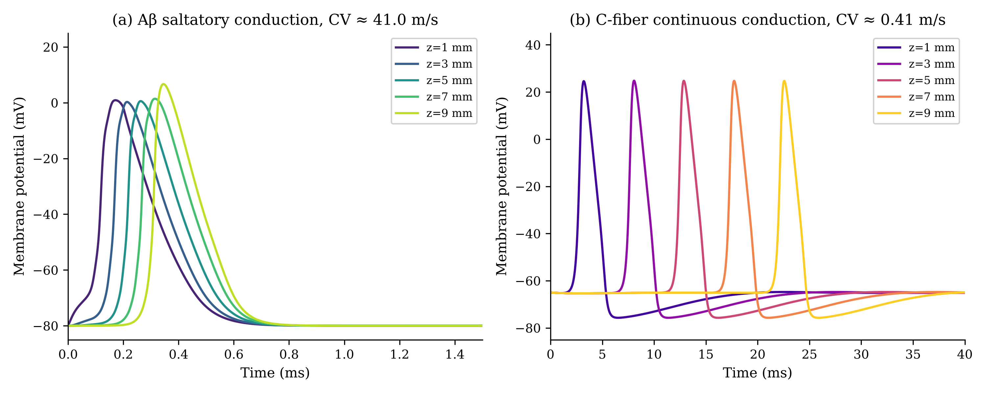
Fig. 5 Positive controls (uncoupled). (a) Isolated Aβ fiber: saltatory action potential (excursion 80.44 mV at z = 4 mm, resting at -80.0 mV and peaking at +0.44 mV) propagating at 41.03 m/s across nodes z = 1–9 mm (2 nA, 0.2 ms stimulus at z = 0). (b) Isolated classical HH C-fiber: regenerative action potential conducting continuously at 0.41 m/s (1 nA, 1 ms stimulus at z = 0)

3.2 Experiment 1: Single-Pulse Crosstalk (Phase 1)
Across the tested cleft-width range of w_{cleft} = 20 nm to 5 μm, a single Aβ action potential failed to trigger an ectopic C-fiber action potential. At the tightest cleft (20 nm), peak C-fiber depolarization was only Δ V = 1.325 mV (membrane potential rising from -65.0 mV to -63.68 mV at z = 6.0 mm; Table 1). The event was classified as Local Stimulus Transient.

3.3 Sensitization via Persistent Depolarizing Bias (Phase 1)
Applying a uniform depolarizing bias current to the C-fiber (starting from its exact resting equilibrium, -65.13 mV, with the bias switched on at t = 0; Section 2.8) produced a stable, quiescent sensitized state only up to a bias of ≈ 0.10 A/m², where the baseline rises to -61.9 mV (0.05 A/m²) and -59.8 mV (0.10 A/m²). In this window the marginal ephaptic perturbation evoked by a passing Aβ action potential was unchanged by the bias (Δ V = 1.33 mV for n = 1 at every bias tested) and failed to reach firing threshold. Above ≈ 0.108 A/m² the C-fiber fired repetitively with no Aβ input (60–96 Hz at 0.11–0.30 A/m²); between 0.4 and ≈ 1.2 A/m² it showed large oscillations (peak-to-peak 69 mV falling to 6 mV) that stayed below 0 mV, and above ≈ 1.23 A/m² it settled on a stable depolarized silent state (-45.0 mV at 1.3 A/m²; depolarization block) (Table 1; sensitization_phase1_bias.csv). Classical HH kinetics therefore offer only a narrow window of stable sensitization (≲ 5.3 mV of depolarization) before intrinsic pacemaking, indicating the absence of a broad stable sensitized intermediate.

3.4 Sensitization via Uniform HH Kinetics Shift (Phase 1 Sensitivity Test)
Applying a uniform shift Δ V_{shift} to all HH rate functions served as a mathematical sensitivity exploration (Section 2.8). Shifts up to 8.5 mV (and negative shifts down to -20 mV) left the fiber quiescent, with the resting potential moving slightly hyperpolarized (-66.35 mV at Δ V_{shift} = 3 mV; -67.83 mV at 8.5 mV) and the Aβ-evoked midpoint perturbation unchanged (Δ V = 1.33 mV for n = 1; 5.07–5.10 mV for n = 25). At Δ V_{shift} ≈ 8.56 mV the fiber switched abruptly into spontaneous pacemaking without external stimulation (≈ 52–58 Hz at 8.6–10 mV; sensitization_phase1_kinetics_shift.csv). The shift therefore did not create a stable, quiescent yet near-threshold sensitized state: the transition from quiescence to pacemaking is abrupt, which motivated Phase 2.

3.5 High-Frequency Stimulation, Propagation Timing, and Lesion Boundary Controls
Delivering pulse trains at 100 Hz (n=25, w_{cleft}=20 nm) reveals critical spatiotemporal propagation dynamics that distinguish stimulation-boundary artifacts from pure endogenous ephaptic crosstalk:

3.5.1 Full-Length Cable Dynamics and Propagation Latency
In the full-length coupled model (w_{cleft} = 20 nm across the entire 10-mm cable), injecting a 100-nA stimulus into 25 Aβ fibers at the sealed boundary (z = 0) generates a large local extracellular voltage transient at the boundary (u_{e} ≈ +265 mV). In the Phase 1 classical Hodgkin-Huxley model, this transient initiates a slow C-fiber action potential at t = 0.02 ms. Because unmyelinated C-fiber conduction velocity is 0.41 mm/ms, this action potential requires:
- 12.90 ms to propagate from z = 0 to the cable midpoint (z = 5.0 mm), and
- 20.16 ms to reach the downstream recording electrode (z = 8.0 mm).
This propagation latency explains key reporting differences across historical simulation runs:
- Short Observation Windows (T ≤ 5.2 ms): In single-pulse simulations evaluated over 5.2 ms (e.g., EXP_E02_E03_reconciliation.csv and phase2_temporal_summation.csv), the traveling wave has only propagated to z ≈ 1.8 mm. Downstream recording sites (z ≥ 3.0 mm) record only the rapid passing Aβ wave at t ≈ 0.25 ms (+5.039 mV at midpoint, +6.015 mV downstream maximum at z = 7.0 mm). Consequently, the spike classifier correctly classifies the downstream trace as Local Stimulus Transient with c_propagated_ap = False.
- Extended Observation Windows (T ≥ 30 ms): When the single-pulse simulation is extended to T = 30 ms (final_100Hz_reconciliation.csv, row 0), the slow wave initiated at t=0 completes its traverse, reaching the downstream electrode at t = 20.16 ms (V₂ = +24.74 mV, spiked = True).
- 100-Hz Pulse Train Progression: In a 100-Hz train (inter-pulse interval 10 ms), Pulse 2 is delivered at t = 10 ms. The traveling spike initiated at t=0 reaches the midpoint at t = 12.90 ms—within the Pulse 2 observation window ([10, 20] ms)—producing a midpoint peak of +24.83 mV. In historical exploratory runs truncated at T = 15.2 ms, the wave was captured in flight at z ≈ 2.1 mm before reaching the downstream electrode (z = 8.0 mm), producing an artificial Local Aborted Spike classification. With adequate observation time (T ≥ 35 ms), fully propagated action potentials are recorded downstream (midpoint peak +24.83 mV, downstream peak +24.70 mV at 8.0 mm, CV = 0.41 m/s; Propagated Action Potential, spiked = True; Table 1).
- State-Reset Mechanism Control: Resetting the C-fiber membrane potential and gating variables to rest immediately prior to Pulse 2 (t = 10 ms; run_test3_mechanism.py) physically extinguishes the traveling wave in flight at z ≈ 4.0 mm, completely preventing downstream spike arrival. This confirms that downstream threshold crossing in repetitive trains requires uninterrupted continuous membrane-state propagation along the unmyelinated cable.

3.5.2 Grounded Stimulation Site and Interior Lesion Control
To determine whether ephaptic threshold crossing can occur purely from endogenous Aβ action potentials traveling through a pathological lesion without any boundary stimulus coupling, an interior lesion control experiment was implemented (src/interior_lesion_test.py and src/run_lesion_audit.py). In this control:
- The stimulation site (z ∈ [0, 2.0] mm) is grounded in bulk interstitial fluid (r_{e} = 0, u_{e} = 0).
- The restricted pathological cleft (w_{cleft} = 20–50 nm) is strictly confined to an interior lesion zone (z ∈ [3.0, 7.0] mm).
- Aβ action potentials are initiated in the grounded zone and propagate endogenously into the lesion.
Under these conditions, pure endogenous ephaptic crosstalk produced peak C-fiber depolarizations of only 1.33 mV in Phase 1 (single Aβ fiber, 20-nm cleft; peak -63.67 mV against a -65.0 mV rest) and 9.48 mV in Phase 2 (n=25, 20-nm cleft; peak -57.41 mV) inside the lesion. No action potential was evoked in the C-fiber in either phase. In Phase 1 the lesion peak was identical for 5, 10 and 20 pulses at 800 Hz, and in Phase 2 a 10-pulse 800-Hz train gave the same -57.41 mV peak as a single pulse, so no pulse-to-pulse build-up was observed (run_lesion_audit.py); 20-nm and 50-nm clefts differed by about 0.1 mV or less. Peak depolarization therefore remained strictly subthreshold in this grounded configuration. The control covers one geometry (grounded stimulation site, lesion at 3–7 mm, 20–50 nm clefts, 800-Hz trains) and does not exclude threshold crossing under other conditions.

3.5.3 Threshold Resistance of Nav1.8/Nav1.9 Nociceptors (Phase 2)
Furthermore, in the Phase 2 nociceptor model incorporating realistic TTX-resistant Nav1.8 and Nav1.9 kinetics, the higher activation threshold of Nav1.8 (-35.0 mV vs -55.0 mV for classical HH Na⁺) renders the C-fiber resistant to threshold crossing at moderate recruitment (n ≤ 28; at n ≥ 29 the ungrounded boundary transient can launch a spike, Section 3.9.1):
- Even in the ungrounded full-length cleft with n = 25 synchronized Aβ fibers and extended 40-ms simulation time, the Phase 2 C-fiber reaches a midpoint peak of only -56.66 mV (Δ V = 10.16 mV above resting baseline -66.82 mV; phase2_navc_multifiber.csv).
- The peak remains 21.66 mV below the Nav1.8 threshold (-35.0 mV), and in the single-pulse and n ≤ 28 conditions of Fig. 7 the C-fiber produces c_propagated_ap = False and spiked = False. A 40-ms run at n = 28 gives the same result (midpoint peak -56.51 mV; no C-fiber voltage above -58.8 mV at z ≥ 0.3 mm after 1.5 ms).

3.6 Regularization Sensitivity Analysis (κ)
A lower-κ sensitivity exploration (κ = 3 × 10⁷ m⁻², λ_{e} ≈ 183 μm) produced nonphysical delayed threshold crossings under the tested numerical implementation. Because this behavior was diagnosed as numerical instability under the tested lower-κ implementation rather than an independently motivated physiological parameter choice or physical stability boundary, it is not used to support biological conclusions; all comparative analyses across the paper therefore retain the prespecified phenomenological baseline κ = 1.0 × 10⁹ m⁻².

3.7 Nav1.8/Nav1.9 C-Fiber Positive Controls and Baseline (Phase 2)
Following 20 ms settling, the uncoupled Nav1.8/Nav1.9 C-fiber rested stably at -66.82 mV with baseline drift < 10 μV (steady-state gating variables m₈ = 0.0009, h₈ = 0.9843, m₉ = 0.0334, n = 0.2902). Direct current injection (2 nA, 1 ms) evoked full-amplitude continuous action potentials propagating at 0.26 m/s (Fig. 6a), providing a positive-control demonstration of excitability and propagation within the Phase 2 model.
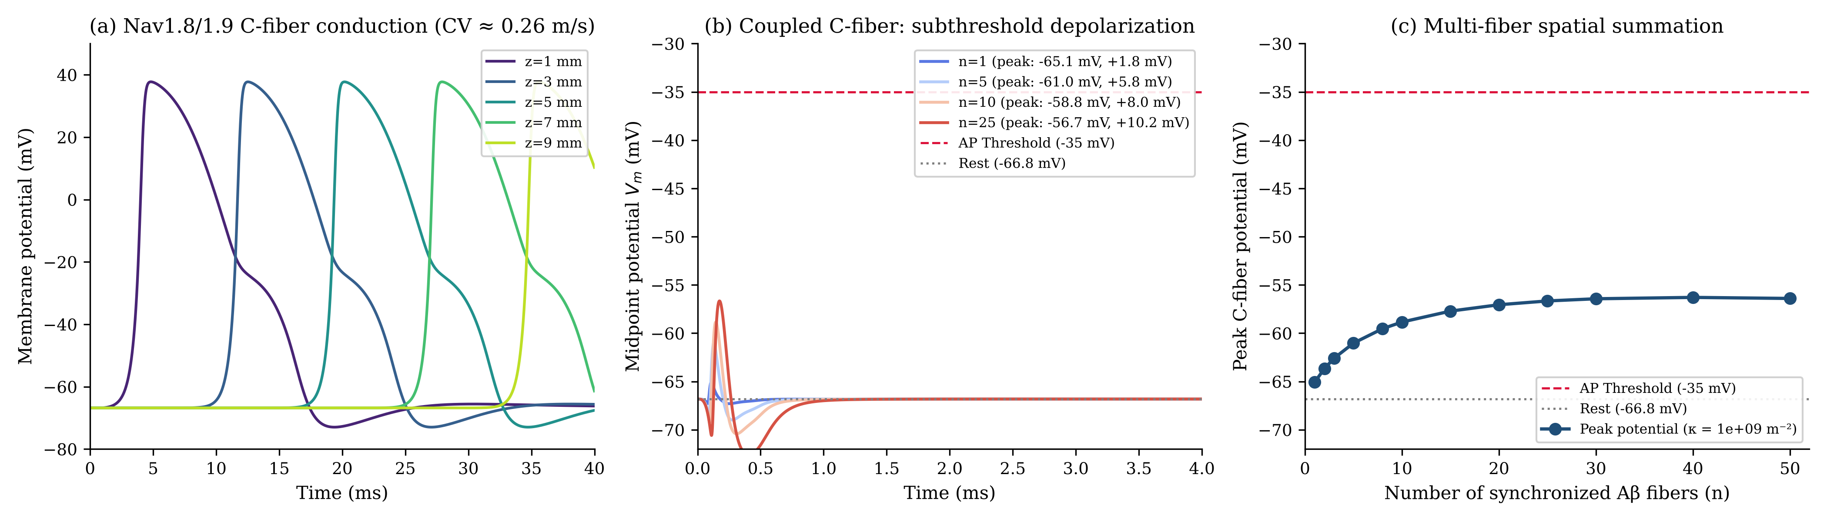
Fig. 6 Phase 2 positive control and multi-fiber summation. (a) Isolated Nav1.8/Nav1.9 C-fiber action potential conducting continuously at 0.26 m/s (z = 1–9 mm). (b) Subthreshold C-fiber midpoint membrane potential traces for n ∈ [1, 5, 10, 25] synchronized Aβ fibers (w_{cleft} = 20 nm). (c) Multi-fiber spatial summation trend: peak C-fiber midpoint potential as a function of synchronized Aβ fiber count n ∈ [1, 50], rising from -65.1 mV at n = 1 to -56.7 mV at n = 25, showing an overall increase with a small fluctuation at the largest n (-56.29 mV at n = 40; -56.40 mV at n = 50) and saturating near -56.4 mV due to core conductance shunting (Σ_{G})

3.8 Phase 2 Single-Pair Crosstalk
Single-pulse stimulation across w_{cleft} ∈ [20 nm, 5 μm] in the Nav1.8/Nav1.9 model confirmed the Phase 1 negative finding: no action potentials were evoked, with peak depolarization of 1.76 mV at 20 nm, falling monotonically to 0.12 mV at 5 μm. Graded depolarizing bias currents (0–2 A/m²) shifted the C-fiber baseline smoothly from -66.82 mV to -59.30 mV at 0.25 A/m² and -47.39 mV at 2 A/m², with the membrane remaining on a stable quiescent equilibrium at every bias up to ≈ 3.2 A/m² (Nav1.8 availability h₈ falling from 0.98 to 0.71 over 0–2 A/m²). The Aβ-evoked perturbation barely changed (Δ V = 1.71–1.76 mV for n = 1 and 9.5–10.2 mV for n = 25 at the midpoint) and remained well below the Nav1.8 activation threshold (Table 2; run_sensitization_phase2.py). Depolarization block, a jump to a silent, Nav1.8-inactivated state near -21 mV (h₈ ≈ 0.03), occurred only above ≈ 3.2 A/m².

3.9 Multi-Fiber Bundle Spatial Summation, Temporal Jitter, and Mechanism Control

3.9.1 Multi-Fiber Spatial Summation
In the Phase 1 classical HH model, sweeping synchronized Aβ fiber count n ∈ [1, 50] in a 20 nm cleft (V_{rest} = -65.000 mV) produced a progressive increase in subthreshold depolarization: from Δ V = 1.325 mV at n = 1 to Δ V = 5.039 mV at midpoint (and 6.015 mV downstream maximum) at n = 25 (Table 4). As n increased further across the tested range up to 50, depolarization exhibited saturation-like behavior, leveling off at Δ V = 6.184 mV. This plateau is directly attributable to the expanding parallel intracellular core conductance Σ_{G}(n), which shunts the extracellular cleft. Concurrently, collective cleft loading decelerates Aβ conduction velocity from 40.0 m/s (n = 1) to 32.00 m/s (n = 25) and 27.1 m/s (n = 50). Across the entire tested range of n ≤ 50, single-pulse multi-fiber spatial summation remains strictly subthreshold.
In the Phase 2 Nav1.8/Nav1.9 nociceptor model (V_{rest} = -66.82 mV; Fig. 7), synchronous multi-fiber activation similarly produces an asymptotic subthreshold depolarization trend, rising from a midpoint peak of -65.07 mV (Δ V = 1.76 mV) at n = 1 to -56.66 mV (Δ V = 10.16 mV) at n = 25, and saturating near -56.40 mV (Δ V = 10.42 mV) at n = 50, remaining well below the nociceptor threshold (-35.0 mV).
The midpoint values above are read within the first 3–5 ms after the pulse. In the ungrounded full-length model, the same boundary transient that produces the 100-Hz result (Section 3.5.1) can also launch a slow C-fiber action potential at the sealed boundary z = 0 once enough Aβ fibers are summed: this occurs for n ≥ 2 in Phase 1 (n = 1 does not fire) and for n ≥ 29 in Phase 2 (threshold n* ≈ 28.5; boundary_spike_phase1.csv, boundary_spike_phase2.csv). The spike conducts at 0.41 m/s (Phase 1) or 0.26 m/s (Phase 2) and reaches the midpoint only after roughly 13 ms (Phase 1) or 20 ms (Phase 2), so it lies outside the midpoint window and is not part of the saturation trend. In the grounded interior-lesion control no action potential occurred for any n up to 200 (Phase 2, 20 nm cleft: lesion-zone peak -56.68 mV at n = 50 and -58.49 mV at n = 200; lesion_control_high_n.csv).

3.9.2 Temporal Dispersion / Jitter Attenuation
Introducing a modeled 1.5 ms temporal onset-dispersion window across the Aβ population desynchronized the source currents, reducing temporal overlap and sharply attenuating depolarization. In the Phase 1 model at n = 25, peak downstream depolarization is suppressed from 6.015 mV to 0.426 mV—a 92.9% attenuation. In the Phase 2 model at n = 25 (Fig. 7), peak midpoint potential is suppressed from -56.66 mV (Δ V = 10.16 mV) to -66.20 mV (Δ V = 0.63 mV above rest -66.82 mV)—a 93.8% attenuation. This establishes that multi-fiber spatial summation is highly sensitive to input synchrony under tested conditions across both channel models.
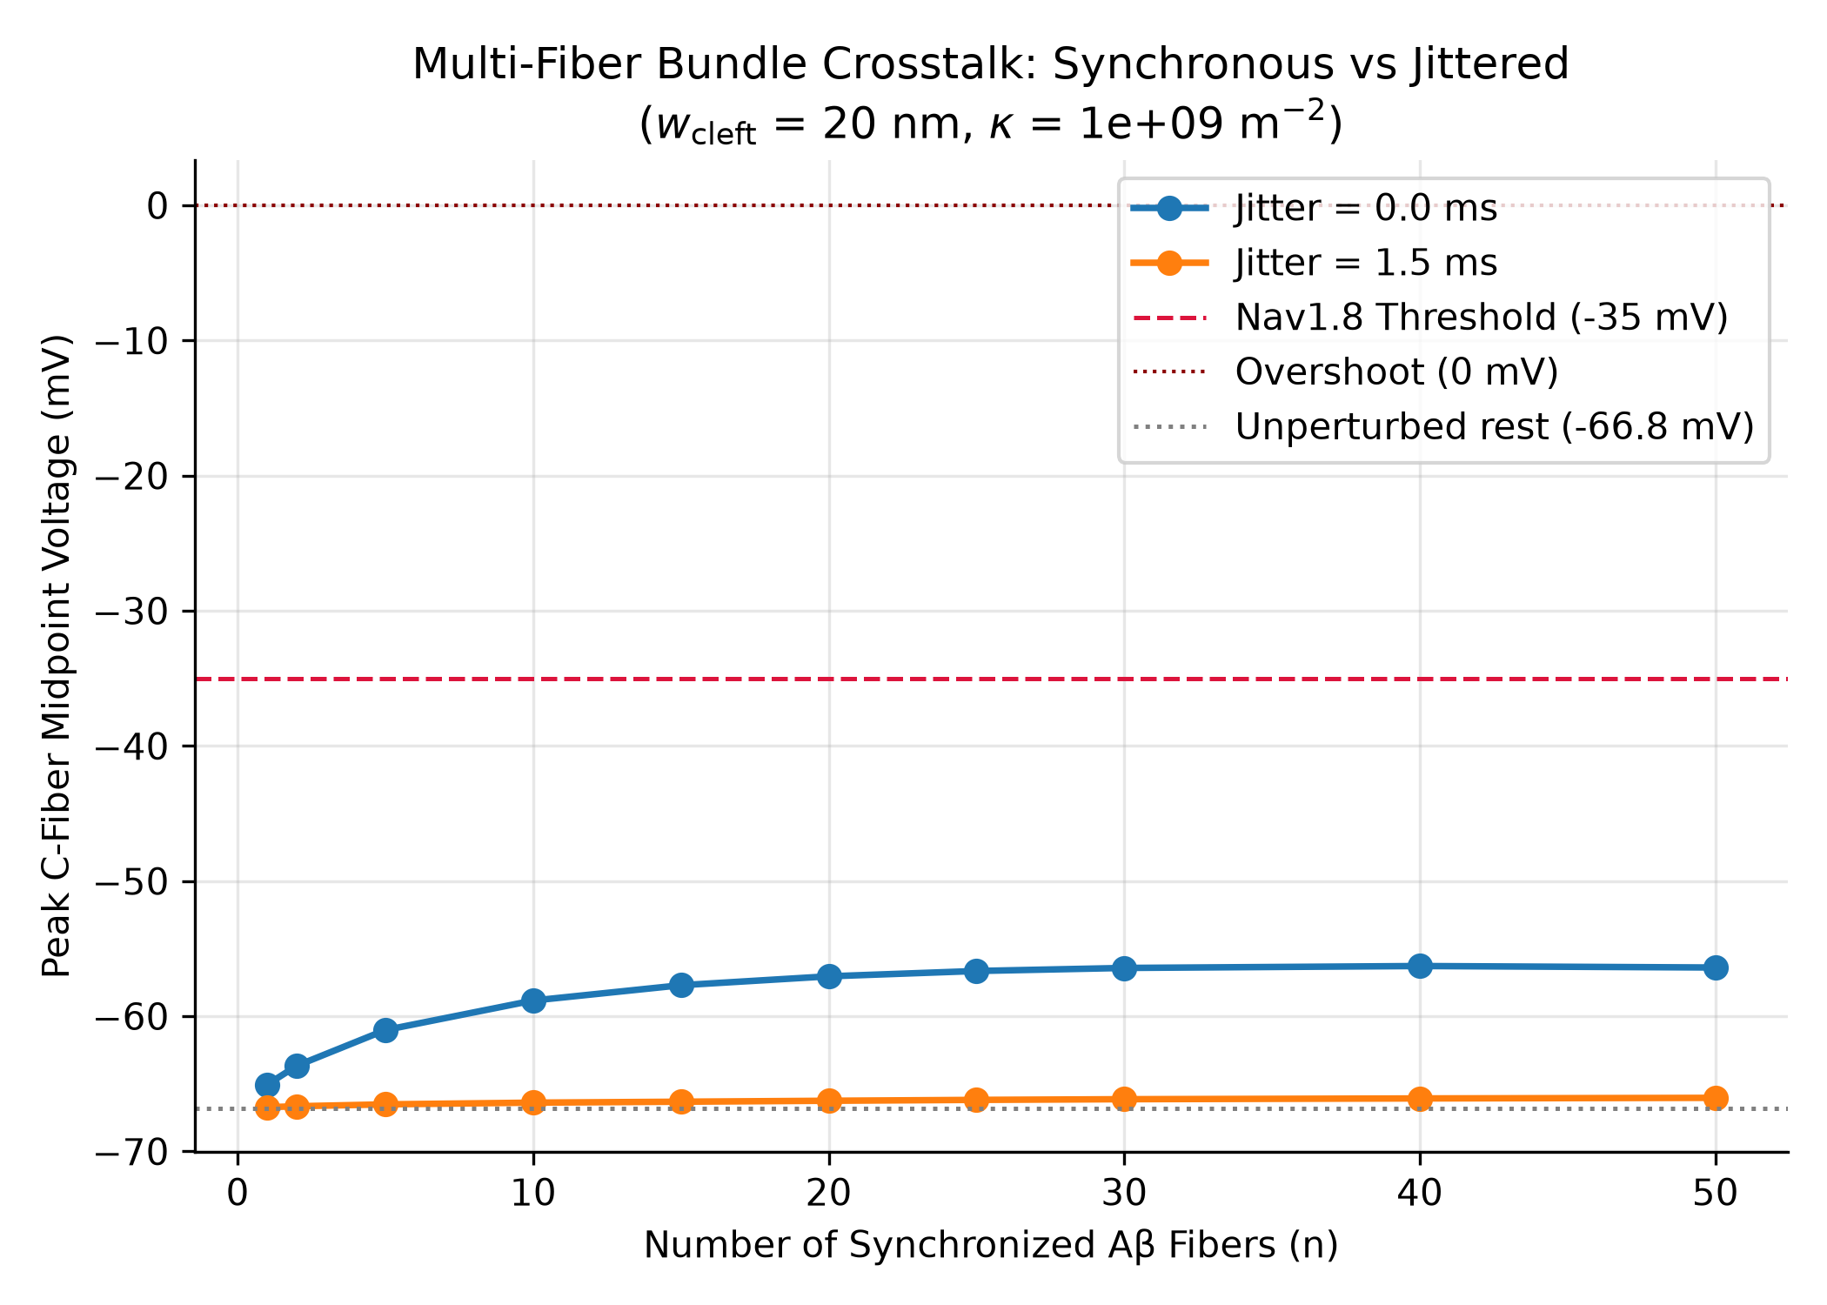
Fig. 7 Multi-fiber spatial summation and temporal dispersion in the Phase 2 Nav1.8/Nav1.9 nociceptor model. Parameters: w_{cleft} = 20 nm, fixed baseline κ = 1.0 × 10⁹ m⁻². Peak absolute C-fiber midpoint membrane potential (V₂ at z = 5.0 mm) is plotted across synchronized Aβ fiber count n ∈ [1, 50] under synchronous recruitment (jitter 0.0 ms; peaking at -65.07 mV for n=1, -58.84 mV for n=10, -56.66 mV for n=25, and -56.40 mV for n=50, demonstrating an asymptotic subthreshold trend) and under a modeled 1.5-ms onset-dispersion window (jitter 1.5 ms across K=21 phases; peaking at -66.20 mV for n=25, representing Δ V = 0.63 mV above rest and a 93.8% attenuation of ephaptic depolarization). Both curves originate from the settled resting baseline of -66.82 mV (dotted gray line) and remain well below the Nav1.8 regenerative threshold (-35.0 mV, dashed crimson line)

3.9.3 Mechanism Control: Membrane State vs Extracellular Potential Accumulation
To determine whether repeated 100-Hz events are driven by extracellular potential buildup or by C-fiber membrane-state accumulation, we executed a controlled state-reset experiment (run_test3_mechanism.py). In the control simulation, extracellular potential pulses u_{e} returned to baseline between pulses, with no progressive accumulation. Resetting the C-fiber membrane potential and gating variables to rest immediately before Pulse 2 (t = 10 ms) extinguished the traveling wave in flight, so no downstream spike was recorded. This shows that the downstream spike depends on uninterrupted propagation of a wave already underway; because a reset removes a wave in flight by construction, it does not by itself separate membrane-state accumulation from conduction delay. The stronger evidence is the single-pulse run, which reproduces the same downstream spike when observed for T ≥ 30 ms (Table 1). Together, these results indicate that the events recorded in the Pulse 2 window are delayed propagation of a spike initiated by Pulse 1 at the sealed boundary, not demonstrated pulse-to-pulse recruitment.

4 Discussion

4.1 Principal Findings
This study provides a rigorous, closed-loop computational evaluation of bidirectional ephaptic crosstalk between myelinated Aβ afferents and unmyelinated C-fibers. Across both classical HH and nociceptor-realistic Nav1.8/Nav1.9 channel kinetics, our simulations demonstrate:
- Single-pair coupling under single-pulse stimulation is insufficient under tested conditions to evoke an action potential across the tested cleft-width range of 20 nm to 5 μm.
- In the Phase 1 classical-HH model, synchronized multi-fiber spatial summation produces substantial subthreshold depolarization (+5.04 to +6.01 mV for n=25), but plateaus asymptotically near +6.2 mV due to parallel axoplasmic core conductance shunting. The Phase 2 Nav1.8/Nav1.9 model shows the same qualitative saturation, reaching +10.16 mV at n=25 and +10.42 mV at n=50.
- Temporal dispersion strongly attenuates spatial summation, reducing peak ephaptic drive by 92.9% in Phase 1 (93.8% in Phase 2) under the modeled 1.5-ms onset-dispersion window.
- Repetitive 100-Hz stimulation did not demonstrate temporal summation to threshold. In the ungrounded model, the propagated spike recorded in the Pulse 2 window is initiated by Pulse 1 at the sealed stimulation boundary and delayed by slow conduction (0.41 m/s); in the grounded interior-lesion control, crosstalk remained subthreshold in every configuration tested.

4.2 Single-Pair Coupling Insufficiency
Single-pair ephaptic drive generates peak membrane perturbations of only ≈ 1.3 mV in a 20-nm cleft, substantially below the depolarization required to initiate regenerative firing under the tested Phase 1 model. Within the present core-conductor formulation, the single-fiber source produces only limited current transfer into the shared extracellular pathway. This finding holds across generic and nociceptor-specific kinetics.

4.3 Multi-Fiber Spatial Summation and Asymptotic Saturation
In the Phase 1 classical-HH model, extending the system to 25 synchronized Aβ fibers generates an approximately 6.0-mV depolarization (5.039 mV midpoint, 6.015 mV downstream maximum). However, the response saturates asymptotically near +6.2 mV. The Phase 2 Nav1.8/Nav1.9 model reproduces the same saturation mechanism qualitatively, reaching a midpoint depolarization of 10.16 mV at n=25 and 10.42 mV at n=50. The core-conductor derivation reveals the mathematical mechanism underlying this plateau, which involves three interacting factors: (1) as synchronized fiber count n increases, the total axial core conductance Σ_{G}(n) = 1/r_{e} + n/r_{i,1} + 1/r_{i,2} expands linearly with each added intracellular channel; (2) this expansion of Σ_{G} directly reduces the effective regularization parameter κ_{eff}(n) = (κ/r_{e})/Σ_{G}(n), systematically lengthening the effective electrotonic spatial decay scale of the reduced 1-D Helmholtz operator, λ_{eff} = 1/√(κ_{eff}) (from 73.3 μm at n=1 to 464.3 μm at n=50; Table 4); and (3) in the reduced extracellular operator, the expanding parallel intracellular conductances act as an intrinsic low-resistance resistive shunt that dissipates return currents longitudinally rather than confining them to the cleft, causing the induced extracellular and transmembrane potentials to plateau asymptotically. Thus, multi-fiber spatial summation alone cannot drive single-pulse suprathreshold activation under the tested geometry.

4.4 High-Frequency Stimulation, Propagation Timing, and Lesion Boundary Controls
In the ungrounded, full-length coupled model (w_{cleft} = 20 nm from z = 0 to 10 mm), the propagated C-fiber action potential recorded in the Pulse 2 window is initiated by Pulse 1 at the sealed boundary. Spatiotemporal analysis reveals that injecting 100 nA into 25 Aβ fibers at the sealed boundary z = 0 generates a large initial extracellular transient (u_{e} ≈ +265 mV) that initiates a slow C-fiber action potential at t = 0.02 ms. Because C-fiber conduction velocity is 0.41 mm/ms, this action potential requires 12.90 ms to reach the midpoint (z = 5.0 mm)—falling squarely within the Pulse 2 observation window ([10, 20] ms). A single pulse observed for T ≥ 30 ms yields the same spike, and the state-reset control shows that it depends on continuous membrane-state propagation along the unmyelinated cable, as resetting the cable at t = 10 ms extinguishes the traveling wave in flight at z ≈ 4.0 mm. These results do not show that Pulse 2 or subthreshold accumulation is required for the spike.
Crucially, when the stimulation site (z ∈ [0, 2.0] mm) is grounded in bulk fluid (r_{e} = 0, u_{e} = 0) and cleft restriction is confined to an interior lesion (z ∈ [3.0, 7.0] mm), no action potential is ever triggered across Phase 1, Phase 2, or 800-Hz trains up to 20 pulses (run_lesion_audit.py). Furthermore, in Phase 2 with realistic TTX-resistant Nav1.8 and Nav1.9 kinetics, the high threshold of Nav1.8 (-35.0 mV) keeps the midpoint response subthreshold at n = 25 even in the ungrounded full-length setup (midpoint peak -56.66 mV; Δ V = 10.16 mV; 21.66 mV subthreshold), and the boundary-initiated spike appears only for n ≥ 29 (versus n ≥ 2 in Phase 1; Section 3.9.1). Pure endogenous ephaptic crosstalk in an interior lesion is therefore strictly subthreshold across both classical and nociceptor-realistic kinetics.

4.5 Synchrony Dependence
The strong attenuation observed under the modeled 1.5 ms onset-dispersion window (92.9% in Phase 1; 93.8% in Phase 2) highlights that multi-fiber spatial summation is highly sensitive to the degree of temporal alignment across fibers. While highly synchronous activation may occur during rapid electrical stimulation or sharp mechanical transients, naturalistic tactile stimuli recruiting dispersed afferent populations would exhibit reduced temporal overlap of source currents, substantially attenuating the ephaptic potential.

4.6 Numerical and Modeling Limitations
- One-Dimensional Approximation: The 1D core-conductor model longitudinally averages extracellular potential, omitting three-dimensional cleft tortuosity, micro-domains, and non-uniform axon packing. Fully coupled 3D EMI formulations (Jæger & Tveito, 2026) are required to resolve localized field hotspots.
- Phenomenological Regularization (κ): The parameter κ = 1.0× 10⁹ m⁻² represents cleft leakage but is not directly measured experimentally. Furthermore, κ_{eff} inherently depends on fiber count n through Σ_{G}.
- Temporal Non-Convergence of Single-Pulse n=25 Peak: While event classifications are strictly stable under temporal refinement down to Δ t = 0.125 μs (Local Stimulus Transient throughout), the single-pulse n=25 peak Δ V magnitude exhibits notable timestep dependence (6.015 mV at Δ t = 2.5 μs to 15.313 mV at 0.125 μs, w_{cleft} = 20 nm). Richardson extrapolation across the finest steps yields an asymptotic estimate of ≈ 15.90 mV (first-order ≈ 16.16 mV), but these are extrapolated estimates rather than directly simulated converged points. Absolute potential magnitudes must therefore be interpreted with caution, whereas threshold-crossing and propagation classifications remain robust.
- Boundary Stimulation vs. Interior Lesion Coupling: In the full-length coupled model, current injection at the sealed boundary z = 0 creates a localized extracellular potential transient that can initiate a boundary spike (Phase 1: n ≥ 2; Phase 2: n ≥ 29; Section 3.9.1). When the stimulation site is grounded and cleft restriction is confined to an interior lesion (z ∈ [3, 7] mm), pure endogenous ephaptic crosstalk remained subthreshold (peak depolarization 1.33 mV in Phase 1 and 9.48 mV in Phase 2; no action potentials, including under 800-Hz trains). This control covers one geometry and a 20–50 nm cleft range, so it does not establish that threshold crossing is impossible in other configurations.
- Reduced Multi-Fiber Scaling: The multi-fiber model uses a 1D synchronized source-scaling approximation rather than an explicit 3D anatomical bundle reconstruction.

4.7 Biological and Clinical Implications
These computational findings generate testable biophysical hypotheses, reframing peripheral ephaptic interaction as a subthreshold depolarizing influence rather than an autonomous single-pulse spark generator under the modeled conditions. In pathological scenarios where nociceptors may already be depolarized by inflammatory mediators, subthreshold ephaptic depolarization from synchronized Aβ input could plausibly bring a nociceptor closer to threshold; the present simulations do not show threshold crossing by this route, and the direct etiology of clinical dynamic mechanical allodynia in vivo remains to be established experimentally.

4.8 Future Work
Key future directions include: (1) extending the model to higher-dimensional parallel axon networks (Chawla & Morgera, 2024; Reutskiy et al., 2003) and 3D EMI finite-element models (Jæger & Tveito, 2026); (2) driving the bundle with naturalistic human microneurography spike trains; and (3) incorporating detailed kinetic models of Nav1.7 and subthreshold potassium channels (Pelot et al., 2021; Sundt et al., 2015; Tigerholm et al., 2014).

5 Conclusion
A closed-loop core-conductor model demonstrates that single-pair ephaptic crosstalk under single-pulse stimulation is insufficient to trigger ectopic nociceptor action potentials across both classical HH and nociceptor-realistic Nav1.8/Nav1.9 kinetics. Synchronized multi-fiber spatial summation produces substantial subthreshold depolarization (in Phase 1: +5.04 mV midpoint, +6.01 mV downstream maximum for n=25 at the nominal production timestep; in Phase 2: +10.16 mV midpoint depolarization to -56.66 mV) that asymptotically saturates due to core conductance shunting, and is strongly attenuated by temporal dispersion (92.9% attenuation in Phase 1, 93.8% in Phase 2). In the ungrounded full-length model, a 100-Hz train yields a propagated C-fiber action potential during the second pulse interval, but this spike is initiated by the first pulse at the sealed stimulation boundary and delayed by slow conduction (≈ 0.41 m/s); a single pulse reproduces it, and the state-reset control shows that it requires uninterrupted propagation. In a grounded interior-lesion control, crosstalk remained subthreshold in every configuration tested. Within the parameter space explored, ephaptic coupling in restricted nerve clefts therefore produced subthreshold depolarization but did not by itself cross threshold; whether other conditions could do so remains untested.

Nomenclature
Table 3 Definition of symbols, parameters, and SI units used in the core-conductor formulation.
Symbol | Definition | Physical Units
v_{m,k} | Transmembrane potential of fiber k (k=1: Aβ, k=2: C-fiber) | V or mV
u_{i,k} | Intracellular potential of fiber k | V or mV
u_{e} | Shared extracellular cleft potential | V or mV
r_{i,k} | Longitudinal intracellular core resistance per unit length | Ω/m
r_{e} | Longitudinal extracellular cleft resistance per unit length | Ω/m
Σ_{G} | Total longitudinal core conductance per unit length (1/r_{e} + Σ 1/r_{i,k}) | S⋅m or m/Ω
κ | Phenomenological extracellular leakage regularization parameter | m⁻²
κ_{eff} | Effective regularization parameter ((κ/r_{e})/Σ_{G}) | m⁻²
w_{cleft} | Extracellular cleft width | nm or m
D₁ | Outer fiber diameter of myelinated Aβ axon (10.0 μm) | m
d_{axon,k} | Inner axonal core diameter (d_{axon,1}=7.0 μm, d_{axon,2}=1.0 μm) | m
l_{node} | Fixed physical length of node of Ranvier (1.0 μm) | m
ρ_{i}, ρ_{e} | Axoplasmic (0.547 Ω⋅m) and extracellular (1.0 Ω⋅m) bulk resistivity | Ω⋅m
C_{m,k} | Specific membrane capacitance per unit inner area | F/m²
I_{ion,k}, I_{stim,k} | Transmembrane ionic and injected stimulation current density | A/m²
ḡ_{Na}, ḡ_{K}, g_{leak} | Maximum ionic conductance densities (CRRSS / classical HH) | S/m² or mS/cm²
ḡ₁₈, ḡ₁₉ | Maximum Nav1.8 / Nav1.9 conductance densities | S/m² or mS/cm²
n | Number of synchronously active Aβ fibers in multi-fiber bundle | dimensionless
Δ z, Δ t | Spatial and temporal discretization steps | m, s (μm, μs)

Experimental Summary Tables
Table 1 Phase 1 (classical HH C-fiber): summary of experimental conditions and outcomes.
Condition | Maximum Δ V (mV) | Propagated AP? | Event Classification | Notes
Single pulse (w_{cleft} = 20 nm to 5 μm) | 1.325 | False | Local Stimulus Transient | Subthreshold perturbation; decays passively downstream.
Mild tonic bias (≤ 0.10 A/m²) + pulse | 1.33 | False | Local Stimulus Transient | Stable quiescent baseline (-61.9 mV at 0.05, -59.8 mV at 0.10 A/m²); evoked response independent of bias (n = 1).
Aggressive tonic bias (≥ 0.11 A/m²) | N/A | Spontaneous | Intrinsic Pacemaking | Repetitive firing from ≈ 0.108 A/m² (60–96 Hz at 0.11–0.30); large sub-0 mV oscillations at 0.4–1.2; stable depolarization block (≈ -45 mV) above ≈ 1.23 A/m².
Gating kinetics shift (Δ V_{shift} ≥ 8.6 mV) | N/A | Spontaneous | Intrinsic Pacemaking | Quiescent for all smaller shifts (rest moves to -66 to -68 mV); abrupt onset of pacemaking at ≈ 8.56 mV (sensitivity test).
100 Hz train (1 pulse, n=25) | 5.039 (mid), 6.015 (max) | False (T ≤ 5.2 ms) / True (T ≥ 30 ms) | Local Stimulus Transient (T ≤ 5.2 ms) | In short windows (T ≤ 5.2 ms), downstream electrodes record only subthreshold passing Aβ wave. In extended windows (T ≥ 30 ms), sealed-boundary spike initiated at z=0 arrives downstream at t = 20.16 ms (+24.74 mV).
100 Hz train (2 pulses, n=25) | +24.83 (mid), +24.70 (8 mm) | True | Propagated Action Potential | AP initiated by Pulse 1 arrives during the Pulse 2 window (conduction delay; a single pulse yields the same spike); requires T ≥ 35 ms.
100 Hz train (3, 5, 10 pulses, n=25) | +24.83 (mid), +24.70 (8 mm) | True | Propagated Action Potential | Successive spikes consistent with boundary initiation by each pulse plus conduction delay (CV=0.41 m/s); pulse-to-pulse dependence not separately tested.
Interior lesion control (grounded z ∈ [0, 2] mm, lesion z ∈ [3, 7] mm; Phase 1: single Aβ fiber, 5–20 pulses at 800 Hz; Phase 2: n=25, 10 pulses) | 1.33 (Phase 1); 9.48 (Phase 2) | False | Local Stimulus Transient | Stimulation site grounded in bulk fluid. Pure endogenous ephaptic crosstalk in the focal lesion remained subthreshold in every case tested; no spike was triggered, and the lesion peak did not grow with pulse count.
Lower-κ sensitivity check (κ = 3× 10⁷ m⁻²) | N/A | False | Numerical Artifact | Numerical instability under lower-κ regularization; delayed and geometry-independent.

Table 2 Phase 2 (Nav1.8/Nav1.9 C-fiber): summary of experimental conditions and outcomes.
Condition | Maximum Δ V (mV) | Propagated AP? | Event Classification | Notes
Single pulse (w_{cleft} = 20 nm to 5 μm) | 1.76 | False | Local Stimulus Transient | Strictly subthreshold across the tested cleft-width range (20 nm to 5 μm).
Graded bias (≤ 2 A/m²) | Stable baseline | False | Quiescent Sensitized | Stable sensitized resting window (-59.30 mV at 0.25 A/m²; -47.39 mV at 2 A/m²).
Bias + pulse (0.25–2 A/m²) | 1.71–1.75 | False | Local Stimulus Transient | Marginal ephaptic perturbation remains subthreshold; barely changed by bias (n = 1).
Depolarizing block (≳ 3.2 A/m²) | N/A | False | Depolarizing Block | Sustained silent state (≈ -21 mV; Nav1.8 availability h₈ ≈ 0.03) reached from rest only above ≈ 3.2 A/m².
Multi-fiber bundle (n = 25, synchronous) | 10.16 (mid peak -56.66 mV) | False | Local Stimulus Transient | Subthreshold spatial summation; plateaus near -56.4 mV at n = 50 (Δ V ≈ 10.4 mV; rest -66.82 mV). A boundary-initiated spike for n ≥ 29 arrives after the 5-ms window (Sec. 3.9.1).
Multi-fiber bundle (n = 25, 1.5 ms jitter) | 0.63 (mid peak -66.20 mV) | False | Local Stimulus Transient | 93.8% attenuation due to reduced temporal overlap of source currents (rest -66.82 mV).

Table 4 Multi-fiber spatial summation sweep in the Phase 1 classical Hodgkin-Huxley model across synchronized Aβ fiber count n ∈ [1, 50] (w_{cleft} = 20 nm, fixed baseline κ = 1.0 × 10⁹ m⁻², V_{rest} = -65.000 mV). Values are read within the first 5 ms; in the ungrounded model a boundary-initiated C-fiber spike appears later for n ≥ 2 (Section 3.9.1).
Fiber Count (n) | Downstream Peak Δ V (mV) | Downstream Peak V₂ (mV) | Midpoint Peak V₂ (mV) | Aβ CV (m/s) | Effective κ_{eff} (m⁻²) | Effective Length Scale λ_{eff} (μm) | Classification
1 | 1.325 | -63.675 | -63.712 | 40.00 | 1.86 × 10⁸ | 73.3 | Local Stimulus Transient
2 | 2.240 | -62.760 | -62.857 | 40.00 | 1.03 × 10⁸ | 98.3 | Local Stimulus Transient
5 | 3.763 | -61.237 | -61.524 | 37.21 | 4.44 × 10⁷ | 150.1 | Local Stimulus Transient
10 | 4.929 | -60.071 | -60.612 | 34.78 | 2.27 × 10⁷ | 209.7 | Local Stimulus Transient
15 | 5.507 | -59.493 | -60.216 | 34.04 | 1.53 × 10⁷ | 255.8 | Local Stimulus Transient
20 | 5.829 | -59.171 | -60.036 | 32.65 | 1.15 × 10⁷ | 294.8 | Local Stimulus Transient
25 | 6.015 | -58.985 | -59.962 | 32.00 | 9.23 × 10⁶ | 329.1 | Local Stimulus Transient
30 | 6.121 | -58.879 | -59.950 | 30.19 | 7.71 × 10⁶ | 360.3 | Local Stimulus Transient
40 | 6.197 | -58.803 | -60.032 | 28.57 | 5.79 × 10⁶ | 415.6 | Local Stimulus Transient
50 | 6.184 | -58.816 | -60.186 | 27.12 | 4.64 × 10⁶ | 464.3 | Local Stimulus Transient

Table 5 Spatial grid refinement and convergence verification holding physical node width fixed (l_{node} = 1.0 μm, Δ t = 2.5 μs, w_{cleft} = 20 nm). Aβ excursion is measured at z = 4 mm; “Converged” denotes a successive change below 0.5% in both Δ V columns.
Spatial Step Δ z | Isolated Aβ CV (m/s) | Isolated Aβ Excursion (mV) | Single-Pair Δ V (n=1, mV) | Multi-Fiber Δ V (n=25, mV) | Classification | Status
20.0 μm | 41.03 | 80.44 | 1.237 | 5.919 | Local Stimulus Transient | Coarse reference
10.0 μm (Nominal) | 41.03 | 80.44 | 1.325 | 6.015 | Local Stimulus Transient | Nominal study grid
5.0 μm | 41.03 | 80.44 | 1.347 | 6.041 | Local Stimulus Transient | Converging
2.5 μm | 41.03 | 80.44 | 1.352 | 6.047 | Local Stimulus Transient | Converged (<0.5%)
1.25 μm | 41.03 | 80.44 | 1.353 | 6.049 | Local Stimulus Transient | Converged (<0.5%)
1.0 μm | 41.03 | 80.44 | 1.354 | 6.050 | Local Stimulus Transient | Converged (<0.5%)

Declarations

Funding
No funding was received for conducting this study.

Competing Interests
The author declares that he has no competing interests or financial disclosures relevant to the content of this article.

Ethics Approval
Not applicable. This study involves only mathematical and computational modeling; no human participants, clinical records, biological material, or live animals were involved.

Consent to Participate
Not applicable. No human participants were involved in this study.

Consent for Publication
Not applicable. This manuscript contains no individual person’s data in any form.

Data Availability
All numerical data supporting the findings of this study (raw simulation outputs, convergence studies, and reconciliation tables underlying every figure and table) are provided as Supplementary Information accompanying this article and are additionally archived at the code repository cited below. No restrictions apply to their reuse.

Code Availability
The simulation code implementing the closed-loop core-conductor model, CRRSS kinetics, Nav1.8/Nav1.9 nociceptor kinetics, the multi-fiber bundle formulation, and all verification suites is freely available for academic use at: https://github.com/MinaSaied23/ephaptic-crosstalk.
Simulations were implemented in Python (v3.11/v3.12, RRID:SCR_008394) using NumPy (v1.26.4, RRID:SCR_008633), SciPy (v1.13.0, RRID:SCR_008058), Matplotlib (v3.8.4, RRID:SCR_008624), and Pillow (v10.3.0, RRID:SCR_023337).

Author Contributions
Mina Saied Attia Rizk: Conceptualization, Methodology, Software, Validation, Formal Analysis, Investigation, Data Curation, Writing - Original Draft, Writing - Review & Editing, Visualization.

References
Akopian, A. N., Sivilotti, L., & Wood, J. N. (1996). A tetrodotoxin-resistant voltage-gated sodium channel expressed by sensory neurons. Nature, 379(6562), 257–262. https://doi.org/10.1038/379257a0
Amir, R., & Devor, M. (2000). Functional cross-excitation between afferent A- and C-neurons in dorsal root ganglia. Neuroscience, 95(1), 189–195. https://doi.org/10.1016/s0306-4522(99)00418-4
Arvanitaki, A. (1942). Effects evoked in an axon by the activity of a contiguous one. Journal of Neurophysiology, 5(2), 89–108. https://doi.org/10.1152/jn.1942.5.2.89
Asmedi, A., Wibowo, S., & Meliala, L. (2018). Ephaptic crosstalk in painful diabetic neuropathy: An electrodiagnostic study. Journal of the Medical Sciences (Berkala Ilmu Kedokteran), 50(2), 173–179. https://doi.org/10.19106/JMedSci005002201806
Chawla, A., & Morgera, S. D. (2024). On the geometry of interacting axon tracts in relation to their functional properties. Communications in Mathematical Biology and Neuroscience, 2024, Article 57. https://doi.org/10.28919/cmbn/8509
Chawla, A., Morgera, S. D., & Snider, A. D. (2021). On axon interaction and its role in neurological networks. IEEE/ACM Transactions on Computational Biology and Bioinformatics, 18(2), 790–796. https://doi.org/10.1109/TCBB.2019.2941689
Chiu, S. Y., Ritchie, J. M., Rogart, R. B., & Stagg, D. (1979). A quantitative description of membrane currents in rabbit myelinated nerve. The Journal of Physiology, 292, 149–166. https://doi.org/10.1113/jphysiol.1979.sp012843
Cummins, T. R., Dib-Hajj, S. D., Black, J. A., Akopian, A. N., Wood, J. N., & Waxman, S. G. (1999). A novel persistent tetrodotoxin-resistant sodium current in SNS-null and wild-type small primary sensory neurons. Journal of Neuroscience, 19(24), RC43. https://doi.org/10.1523/JNEUROSCI.19-24-j0001.1999
Devor, M., & Wall, P. D. (1990). Cross-excitation in dorsal root ganglia of nerve-injured and intact rats. Journal of Neurophysiology, 64(6), 1733–1744. https://doi.org/10.1152/jn.1990.64.6.1733
Goldwyn, J. H., & Rinzel, J. (2016). Neuronal coupling by endogenous electric fields: Cable theory and applications to coincidence detector neurons in the auditory brain stem. Journal of Neurophysiology, 115(4), 2033–2051. https://doi.org/10.1152/jn.00780.2015
Hodgkin, A. L., & Huxley, A. F. (1952). A quantitative description of membrane current and its application to conduction and excitation in nerve. The Journal of Physiology, 117(4), 500–544. https://doi.org/10.1113/jphysiol.1952.sp004764
Jæger, K. H., & Tveito, A. (2022). Deriving the bidomain model of cardiac electrophysiology from a cell-based model; properties and comparisons. Frontiers in Physiology, 12, 811029. https://doi.org/10.3389/fphys.2021.811029
Jæger, K. H., & Tveito, A. (2026). Extracellular stimulation and ephaptic coupling of neurons in a fully coupled finite element-based Extracellular-Membrane-Intracellular (EMI) model. Frontiers in Computational Neuroscience, 20, 1755548. https://doi.org/10.3389/fncom.2026.1755548
Katz, B., & Schmitt, O. H. (1940). Electric interaction between two adjacent nerve fibres. The Journal of Physiology, 97(4), 471–488. https://doi.org/10.1113/jphysiol.1940.sp003823
Klein, A. H., Vyshnevska, A., Hartke, T. V., De Col, R., Mankowski, J. L., Turnquist, B., Bosmans, F., Reeh, P. W., Schmelz, M., Carr, R. W., & Ringkamp, M. (2017). Sodium channel Nav1.8 underlies TTX-resistant axonal action potential conduction in somatosensory C-fibers of distal cutaneous nerves. Journal of Neuroscience, 37(20), 5204–5214. https://doi.org/10.1523/JNEUROSCI.3799-16.2017
Lindén, H., Hagen, T., Łęski, S., Norheim, E. S., Pettersen, K. H., & Einevoll, G. T. (2014). LFPy: A tool for biophysical simulation of extracellular potentials generated by detailed model neurons. Frontiers in Neuroinformatics, 7, 41. https://doi.org/10.3389/fninf.2013.00041
Murinson, B. B., & Griffin, J. W. (2004). C-fiber structure varies with location in peripheral nerve. Journal of Neuropathology and Experimental Neurology, 63(3), 246–254. https://doi.org/10.1093/jnen/63.3.246
Pelot, N. A., Catherall, D. C., Thio, B. J., Titus, N. D., Liang, E. D., Henriquez, C. S., & Grill, W. M. (2021). Excitation properties of computational models of unmyelinated peripheral axons. Journal of Neurophysiology, 125(1), 86–104. https://doi.org/10.1152/jn.00315.2020
Rappaport, Z. H., & Devor, M. (1994). Trigeminal neuralgia: The role of self-sustaining discharge (ignition) in the medicine and surgery of paroxysmal pain. Pain, 56(2), 127–138. https://doi.org/10.1016/0304-3959(94)90086-6
Rasminsky, M. (1980). Ephaptic transmission between single nerve fibres in the spinal nerve roots of dystrophic mice. The Journal of Physiology, 305(1), 151–169. https://doi.org/10.1113/jphysiol.1980.sp013356
Reutskiy, S., Rossoni, E., & Tirozzi, B. (2003). Conduction in bundles of demyelinated nerve fibers: Computer simulation. Biological Cybernetics, 89(6), 439–448. https://doi.org/10.1007/s00422-003-0430-x
Schmidt, H., Hahn, G., Deco, G., & Knösche, T. R. (2021). Ephaptic coupling in white matter fibre bundles modulates axonal transmission delays. PLOS Computational Biology, 17(2), e1007858. https://doi.org/10.1371/journal.pcbi.1007858
Schmidt, H., & Knösche, T. R. (2022). Modelling the effect of ephaptic coupling on spike propagation in peripheral nerve fibres. Biological Cybernetics, 116(4), 461–473. https://doi.org/10.1007/s00422-022-00934-9
Seltzer, Z., & Devor, M. (1979). Ephaptic transmission in chronically damaged peripheral nerves. Neurology, 29(7), 1061–1064. https://doi.org/10.1212/wnl.29.7.1061
Sundt, D., Gamper, N., & Jaffe, D. B. (2015). Spike propagation through the dorsal root ganglia in an unmyelinated sensory neuron: A modeling study. Journal of Neurophysiology, 114(6), 3140–3153. https://doi.org/10.1152/jn.00226.2015
Sweeney, J. D., Mortimer, J. T., & Durand, D. M. (1987). Modeling of mammalian myelinated nerve for functional neuromuscular stimulation. In Proceedings of the 9th Annual Conference of the IEEE Engineering in Medicine and Biology Society (pp. 1577–1578).
Tigerholm, J., Petersson, M. E., Obreja, O., Lampert, A., Carr, R., Schmelz, M., & Fransén, E. (2014). Modeling activity-dependent changes of axonal spike conduction in primary afferent C-nociceptors. Journal of Neurophysiology, 111(9), 1721–1735. https://doi.org/10.1152/jn.00777.2012

