Supplementary Information: Ephaptic Aβ-to-C-Fiber Crosstalk and Multi-Fiber Spatial Summation
Mina Saied Attia Rizk

S1 Numerical verification
n | lagged, Δt = 2.5 µs | lagged, Δt = 0.125 µs | monolithic, Δt = 5 µs | monolithic, Δt = 0.125 µs
1 | 1.39 | 1.51 | 1.54 | 1.51
10 | 5.01 | 10.00 | 10.03 | 9.94
25 | 6.10 | 15.41 | 15.39 | 15.47
50 | 6.28 | 20.88 | 21.22 | 21.72
Table S1. The lagged coupling scheme vs the monolithic scheme, in the extended-compartment configuration (HH E_{Na} = +35.64 mV, 100-nA stimulus inside the compartment, Δz = 10 µm). Entries are the peak C-fiber depolarization between z = 3 and 8 mm (mV). The lagged error grows with n; the monolithic values are Δt-independent to within 2.4 %.
model | n | Δz 20 µm | Δz 10 µm | production (5 µm, 1 µs) | Δz 1.25 µm | Δt 0.125 µs | conductance-implicit
HH | 1 | 1.43 | 1.53 | 1.56 | 1.57 | 1.55 | 1.54
HH | 10 | 10.25 | 10.79 | 10.93 | 10.97 | 10.93 | 10.89
HH | 25 | 18.88 | 19.12 | 19.34 | 19.40 | 19.39 | 19.41
HH | 50 | 22.35 | 23.26 | 23.51 | 23.59 | 23.62 | 23.76
NavC | 1 | 1.43 | 1.53 | 1.56 | 1.57 | 1.55 | 1.54
NavC | 10 | 10.25 | 10.79 | 10.93 | 10.97 | 10.93 | 10.89
NavC | 25 | 18.90 | 19.13 | 19.35 | 19.41 | 19.40 | 19.42
NavC | 50 | 22.36 | 23.28 | 23.53 | 23.61 | 23.63 | 23.78
Table S2. Grid and time-step refinement of the peak C-fiber depolarization in the lesion (mV) in the production configuration. Unless stated, Δz = 5 µm, Δt = 1 µs, explicit ionic currents. “Conductance-implicit”: ionic conductances in the system matrix.

S2 Membrane verification
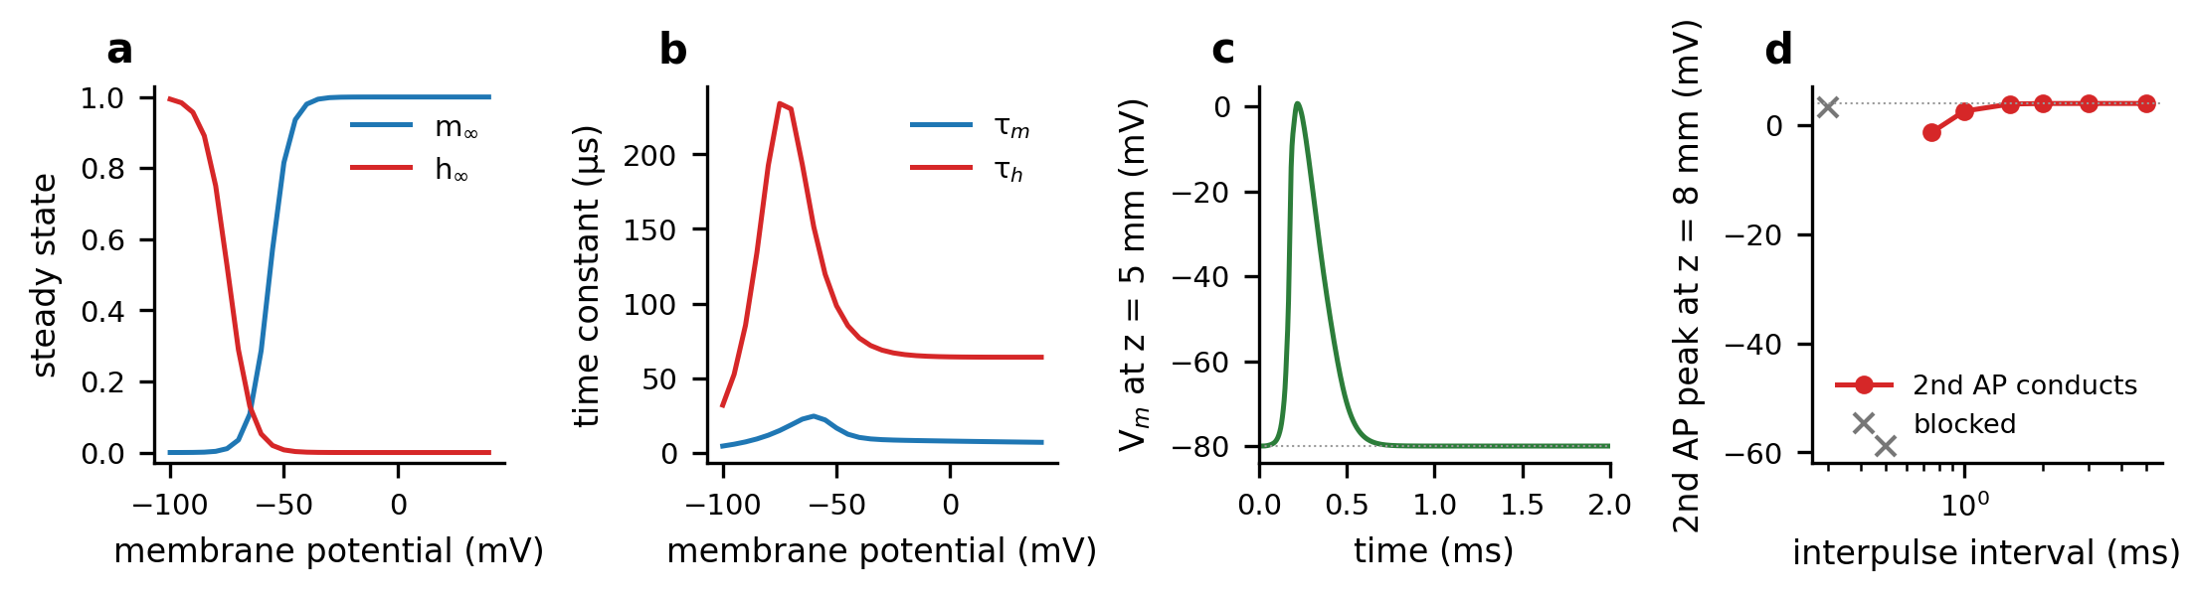
Fig. S1 Verification of the Aβ source. (a) CRRSS steady-state activation and inactivation and (b) their time constants over the modelled range, at 37 °C. (c) Action potential at a node (z = 5 mm) followed through repolarization to rest. (d) Paired-pulse recovery: peak of the response at z = 8 mm after a second stimulus, against the interpulse interval. Grey crosses mark intervals at which no second action potential propagates; the value plotted there is the decaying tail of the first action potential, not a second spike.
interval (ms) | APs at z = 8 mm | 2nd AP peak (mV) | 2nd AP CV (m/s) | 2nd AP conducts
0.30 | 1 | +3.4 | – | False
0.50 | 1 | -58.9 | – | False
0.75 | 2 | -1.3 | 36.0 | True
1.00 | 2 | +2.6 | 39.2 | True
1.50 | 2 | +3.9 | 40.4 | True
2.00 | 2 | +4.0 | 40.4 | True
3.00 | 2 | +4.0 | 40.0 | True
5.00 | 2 | +4.0 | 40.0 | True
Table S3. Paired-pulse recovery of the isolated Aβ fiber (2 × threshold, 0.2-ms pulses at node 0; counts and peaks read at z = 8 mm). The first action potential conducts at 40.0 m/s in every run.
C-fiber membrane | rest (mV) | τ_{m} at rest (ms) | λ, small signal (µm) | R_{in} predicted (MΩ) | R_{in} measured (MΩ) | rheobase, 1 ms (nA)
HH | -65.00 | 1.48 | 198 | 68.9 | 68.8 | 0.16
NavC | -66.82 | 1.37 | 176 | 61.5 | 61.3 | 0.70
Table S4. Passive properties of the isolated C-fiber membranes under the production geometry. λ and R_{in} are small-signal values, computed from the slope conductance dI_{ion}/dV at rest; R_{in} measured is the steady response to a 1-pA injection at z = 5 mm. Rheobase is for a 1-ms point injection at the same site.

S3 Strength–duration characterization
C-fiber membrane | Q_th 0.1 ms (pC) | V_peak 0.1 ms (mV) | V_peak 1 ms (mV) | V_peak 20 ms (mV) | I_th 0.1 / I_th 20 ms
HH, 6.3 °C | 0.14 | -30 | -51 | -53 | 21.3
HH, 25 °C | 0.10 | -38 | -43 | -38 | 5.4
HH, conductances × 5 | 0.11 | -38 | -54 | -56 | 12.7
HH, rates & conductances × 5 | 0.07 | -48 | -52 | -53 | 4.6
HH, rates & conductances × 10 | 0.05 | -51 | -53 | -53 | 2.5
NavC, τ_{m8} = 1.5 ms | 0.41 | 39 | -19 | -31 | 7.3
NavC, τ_{m8} = 0.05 ms | 0.16 | -24 | -34 | -39 | 4.0
NavC, time constants ÷ 10, conductances × 10 | 0.22 | -19 | -31 | -31 | 1.2
Table S5. Point current injection at z = 5 mm into the isolated C-fiber. Q_{th}: threshold charge for a 0.1-ms pulse; V_{peak}: largest membrane potential at the injection site for a pulse 0.5 % below threshold; last column: ratio of threshold currents for 0.1-ms and 20-ms pulses.

S4 Sensitizing bias
model | bias (A/m²) | rest (mV) | spontaneous AP | peak V, n = 25 (mV) | peak V, n = 100 (mV) | evoked AP (any n)
HH | 0 | -65.00 | no | -45.7 | -38.1 | no
HH | 0.01 | -64.20 | no | -44.9 | -37.3 | no
HH | 0.02 | -63.48 | no | -44.2 | -36.6 | no
HH | 0.03 | -62.85 | no | -43.5 | -35.9 | no
HH | 0.04 | -62.27 | no | -43.0 | -35.4 | no
HH | 0.05 | -61.73 | no | -42.4 | -34.8 | no
HH | 0.06 | -61.24 | no | -41.9 | -34.4 | no
HH | 0.07 | -60.78 | no | -41.5 | -33.9 | no
NavC | 0 | -66.82 | no | -47.5 | -39.9 | no
NavC | 0.25 | -59.30 | no | -40.0 | -32.3 | no
NavC | 0.5 | -56.11 | no | -36.9 | -29.1 | no
NavC | 1 | -52.20 | no | -33.1 | -25.2 | no
NavC | 1.5 | -49.52 | no | -30.5 | -22.6 | no
NavC | 2 | -47.39 | no | -28.4 | -20.6 | no
NavC | 2.5 | -45.55 | no | -26.7 | -18.8 | no
NavC | 3 | -43.90 | no | -25.1 | -17.3 | no
NavC | 3.5 | -42.35 | no | -23.7 | -15.9 | no
Table S6. Uniform depolarizing bias current on the C-fiber (production configuration). “Spontaneous AP”: no-stimulus control of 200 ms. Peak V: largest C-fiber membrane potential in the lesion after the Aβ volley. The HH resting state is linearly stable up to 0.095 A m⁻² and unstable from 0.1 A m⁻²; the NavC resting state stays stable over the whole tested range (to 4 A m⁻²) and a second stable, depolarized state appears above 2.75 A m⁻² (space-clamped analysis with linear stability from the Jacobian, e10_equilibria.csv).

S5 Temporal dispersion: convergence in the number of onset phases
study | K | Δz (µm) | spacing W/(K−1) (µs) | peak ΔV (mV)
phases K | 11 | 20 | 150 | 2.23
phases K | 21 | 20 | 75 | 1.31
phases K | 41 | 20 | 38 | 0.97
phases K | 61 | 20 | 25 | 0.91
phases K | 81 | 20 | 19 | 0.89
grid Δz | 41 | 20 | 38 | 0.97
grid Δz | 41 | 10 | 38 | 1.02
grid Δz | 41 | 5 | 38 | 1.03
Table S7. Dispersed volley (n = 25, W = 1.5 ms, NavC). The peak depends on the number of onset phases K until the spacing W/(K − 1) is well below the ~0.1-ms duration of one fiber’s contribution; the production runs use a spacing of at most 25 µs. Grid refinement at K = 41 changes the peak by 6.2 %, so the sweep is run at Δz = 20 µm. One classification does depend on that choice: the synchronous n = 25 volley is close to Aβ conduction block, and on Δz = 20 µm its action potentials still cross the lesion, slowly (13 m/s), where every grid from Δz = 10 µm down blocks them (Table S2). The peak depolarization differs by only 2.3 % between the two grids, and the attenuations quoted in the text are ratios taken within one grid, so neither the attenuation nor the primary endpoint is affected.

S6 The extended-compartment configuration
electrode current | model | Aβ stimulus (nA) | propagating C-fiber AP for n ≥ | initiation (mm) | Aβ node 0 peak, n = 25 (mV) | max
omitted | HH | 3.02 | none (n ≤ 50) | – | +17 | 71
omitted | HH | 10 | 25 | 0.00 | +110 | 102
omitted | HH | 30 | 10 | 0.00 | +413 | 276
omitted | HH | 100 | 2 | 0.00 | +1465 | 935
omitted | NavC | 3.02 | none (n ≤ 50) | – | +17 | 71
omitted | NavC | 10 | none (n ≤ 50) | – | +110 | 102
omitted | NavC | 30 | none (n ≤ 50) | – | +414 | 277
omitted | NavC | 100 | none (n ≤ 50) | – | +1466 | 938
returned | HH | 3.02 | none (n ≤ 50) | – | +4 | 34
returned | HH | 10 | none (n ≤ 50) | – | +24 | 65
returned | HH | 30 | none (n ≤ 50) | – | +139 | 194
returned | HH | 100 | 25 | 0.07 | +556 | 676
returned | NavC | 3.02 | none (n ≤ 50) | – | +4 | 34
returned | NavC | 10 | none (n ≤ 50) | – | +24 | 65
returned | NavC | 30 | none (n ≤ 50) | – | +139 | 194
returned | NavC | 100 | 50 | 0.07 | +556 | 676
Table S8. Shared compartment along the whole cable, sealed ends, Aβ electrode at node 0 inside the compartment (κ = 10⁹ m⁻², A_{e} = 16.4 µm²). C-fiber action potentials are launched at the electrode site only with suprathreshold electrode currents; the electrode-site membrane potentials show the non-physiological state produced by 100 nA.
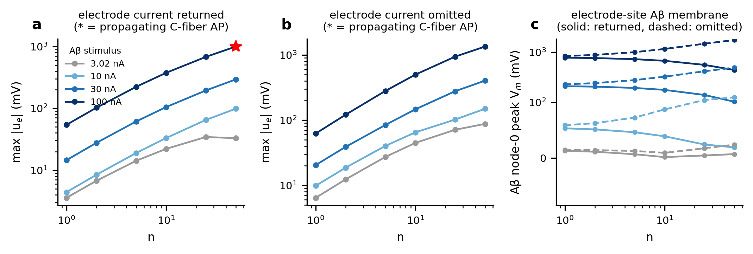
Fig. S2 Earlier full-length geometry. (a, b) Peak C-fiber membrane potential at the electrode site z = 0 vs n for Aβ stimuli of 2× threshold to 100 nA (stars: propagating C-fiber AP launched at the electrode). (c) Peak Aβ membrane potential at the stimulated node.
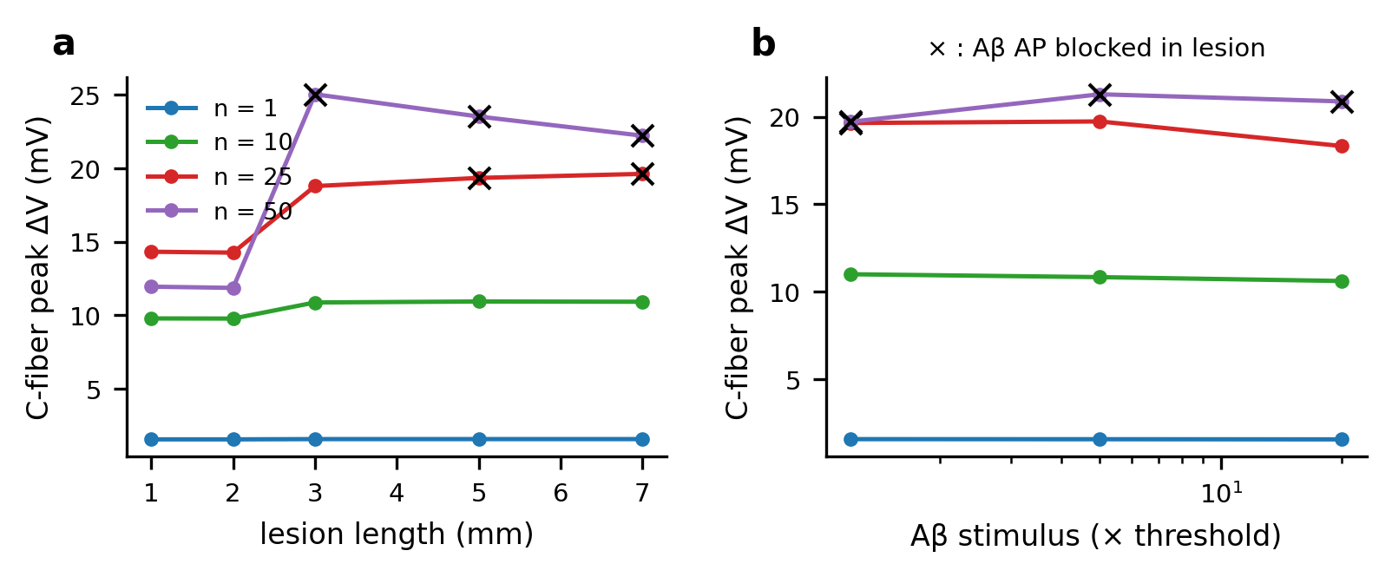
Fig. S3 Lesion length (a) and Aβ stimulus strength (b) in the production configuration (NavC). No C-fiber action potential occurred.

