- Install k8s cluster (minikube) (optional you can use https://www.katacoda.com/courses/kubernetes/playground)
Done
- Create a pod with the name redis and with the image redis.
- Create a pod with the name nginx and with the image “nginx123” Use a pod-definition YAML file.
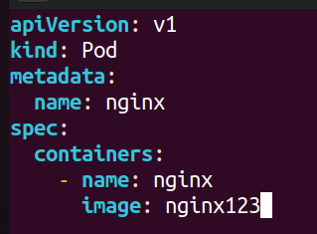
- What is the nginx pod status?
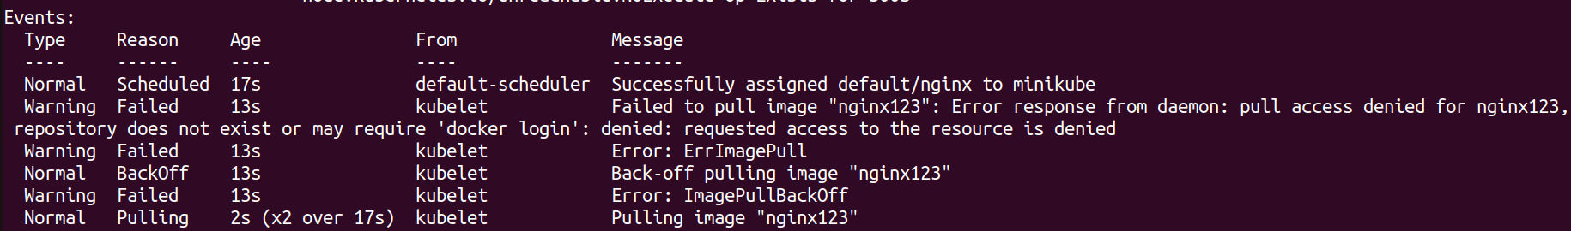
- Change the nginx pod image to “nginx” check the status again
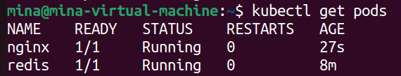
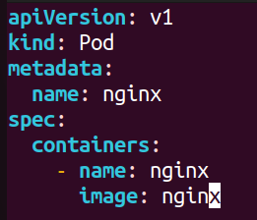
- How many ReplicaSets exist on the system?
- create a ReplicaSet with name= replica-set-1 image= busybox replicas= 3
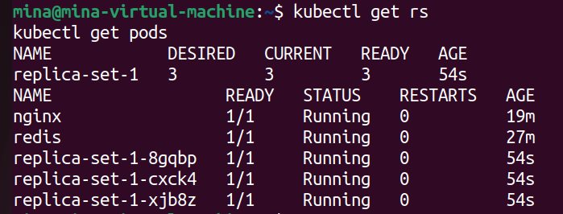
- Scale the ReplicaSet replica-set-1 to 5 PODs.
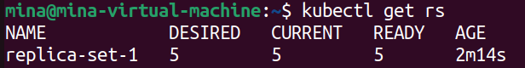
- How many PODs are READY in the replica-set-1?
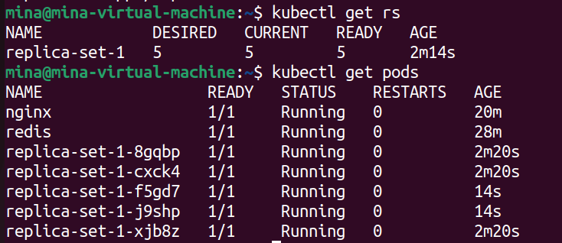
- Delete any one of the 5 PODs then check How many PODs exist now? Why are there still 5 PODs, even after you deleted one?
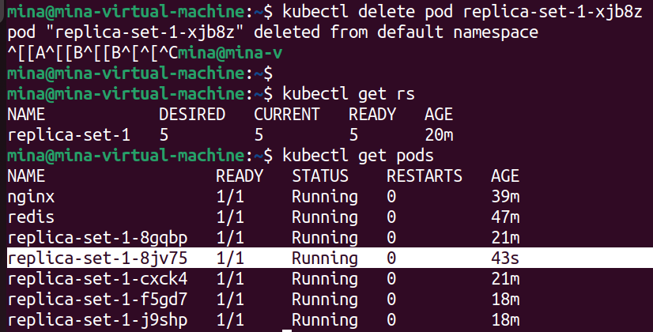
Because ReplicaSets are self-healing controllers, so after deleting 1 pod it creates another one

- How many Deployments and ReplicaSets exist on the system?
- create a Deployment with name= deployment-1 image= busybox replicas= 3
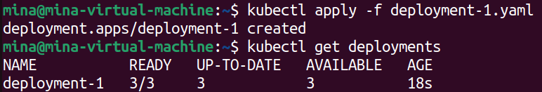
- How many Deployments and ReplicaSets exist on the system now?
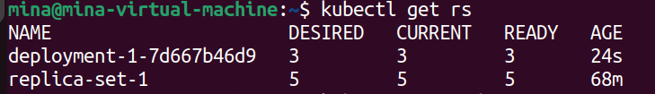
- How many pods are ready with the deployment-1?
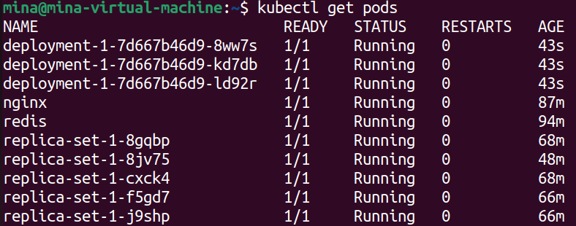
- Update deployment-1 image to nginx then check the ready pods again
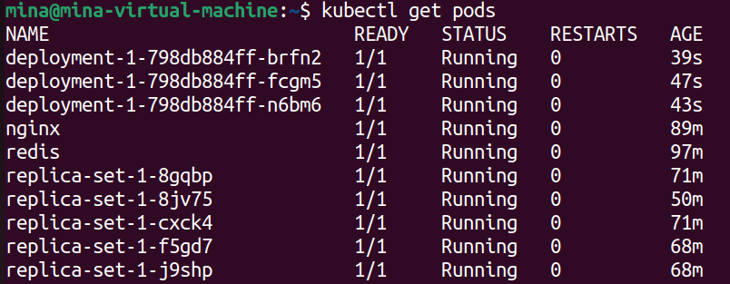
- Run kubectl describe deployment deployment-1 and check events What is the deployment strategy used to upgrade the deployment-1?
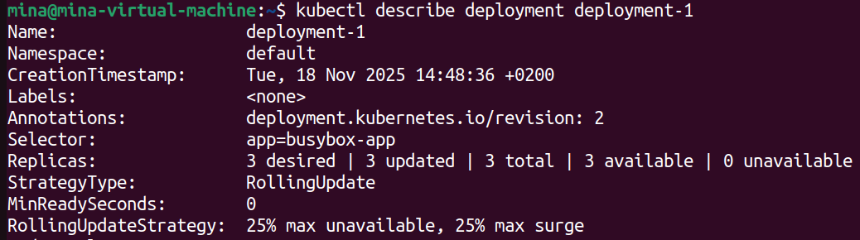
- Rollback the deployment-1 What is the used image with the deployment-1?
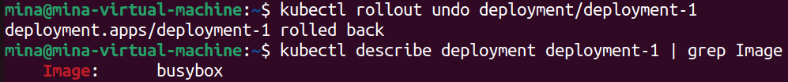
- Create a deployment using nginx image with latest tag only and remember to mention tag i.e nginx:latest and name it as nginx-deployment. App labels should be app: nginx-app and type: front-end. The container should be named as nginx-container; also make sure replica counts are 3.
