- How many Namespaces exist on the system?
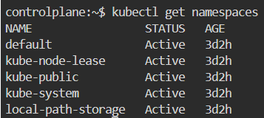
- How many pods exist in the kube-system namespace?
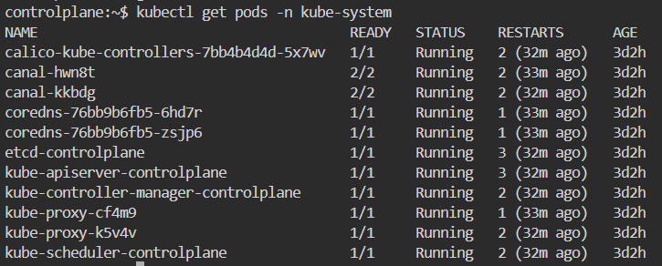
- Create a deployment with Name: beta Image: redis Replicas: 2 Namespace: finance Resources Requests: CPU: .5 vcpu Mem: 1G Resources Limits: CPU: 1 vcpu Mem: 2G

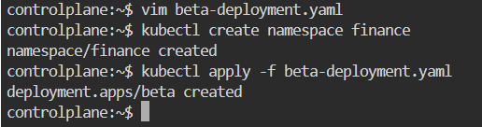
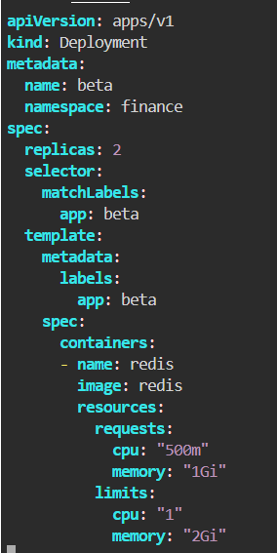
- How many Nodes exist on the system?
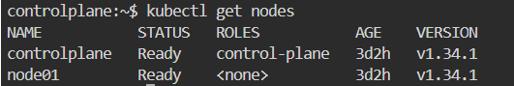
- Do you see any taints on master?
- Apply a label color=blue to the master node
- Create a new deployment named blue with the nginx image and 3 replicas Set Node Affinity to the deployment to place the pods on master only NodeAffinity: requiredDuringSchedulingIgnoredDuringExecution Key: color values: blue
