- How many DaemonSets are created in the cluster in all namespaces?
- what DaemonSets exist on the kube-system namespace?
- What is the image used by the POD deployed by the kube-proxy DaemonSet
- Deploy a DaemonSet for FluentD Logging. Use the given specifications. Name: elasticsearch Namespace: kube-system Image: k8s.gcr.io/fluentd-elasticsearch:1.20
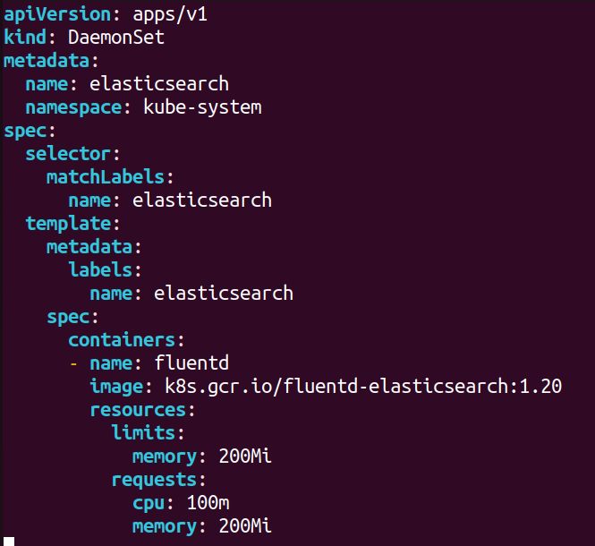
- Deploy a pod named nginx-pod using the nginx:alpine image with the labels set to tier=backend.
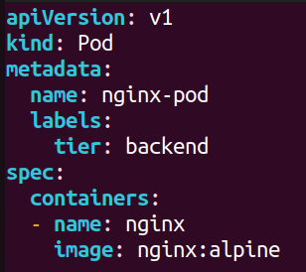
- Deploy a test pod using the nginx:alpine image.
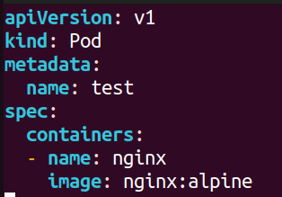
- Create a service backend-service to expose the backend application within the cluster on port 80.
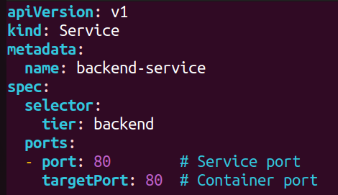
- try to curl the backend-service from the test pod. What is the response?
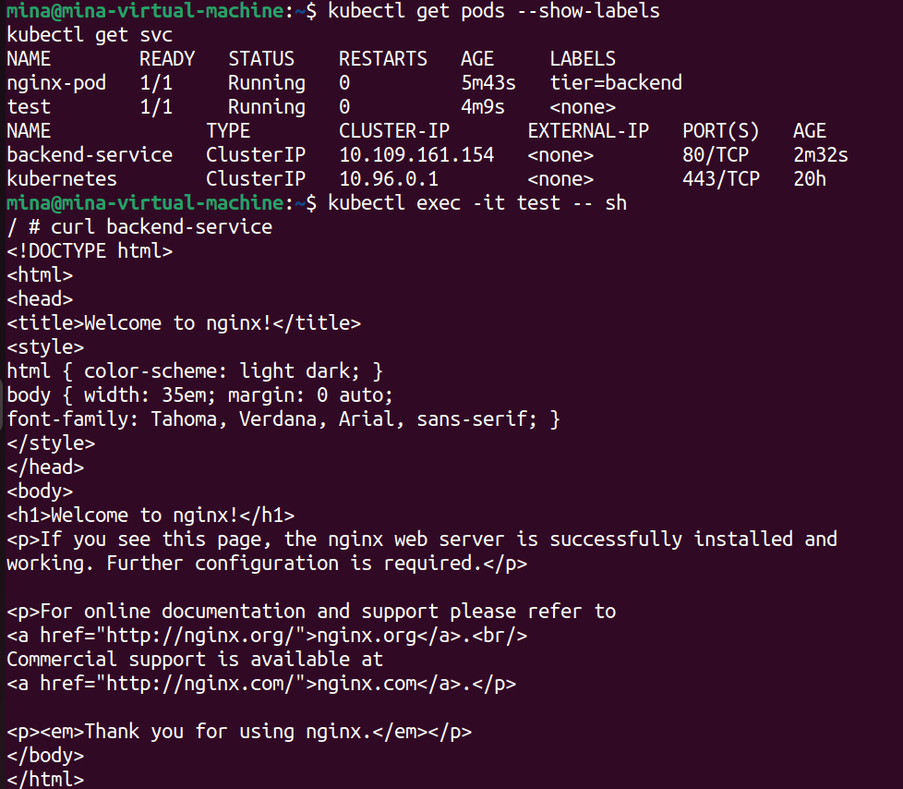
- Create a deployment named web-app using the image nginx with 2 replicas
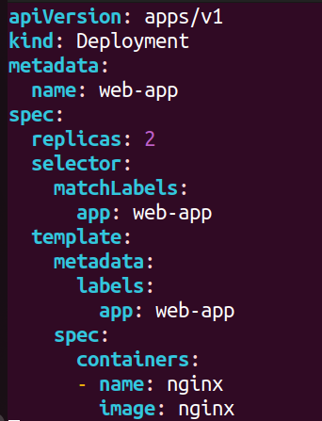
- Expose the web-app as service web-app-service application on port 80 and nodeport 30082 on the nodes on the cluster
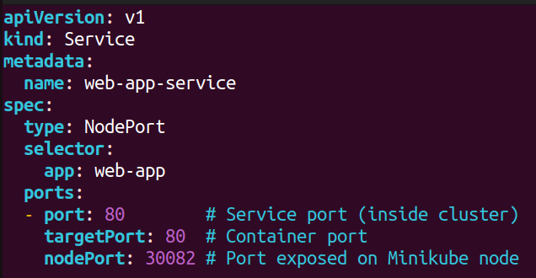
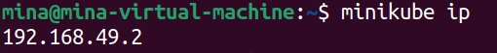
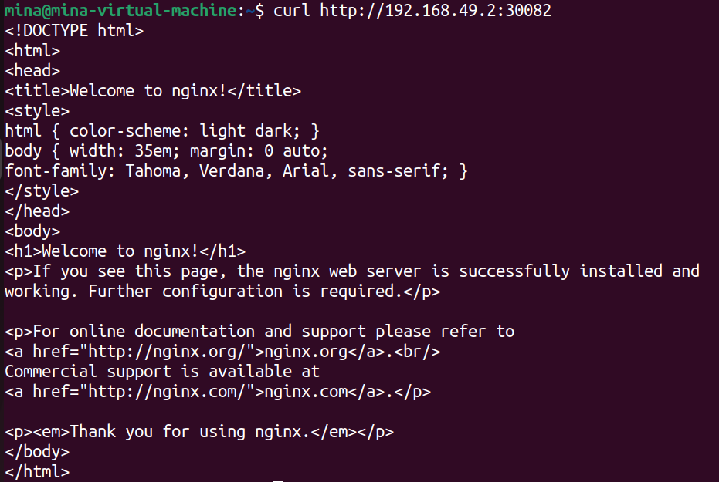
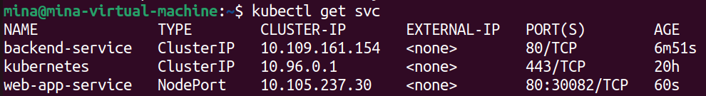
- access the web app from the node

- How many static pods exist in this cluster in all namespaces?
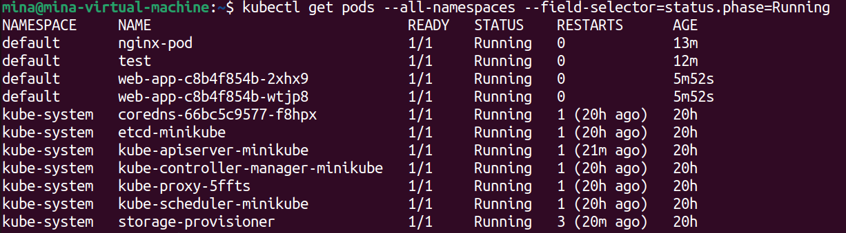
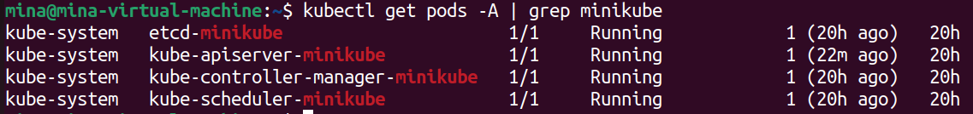
- On which nodes are the static pods created currently?
Should be on /etc/kubernetes/manifests
