- How many ConfigMaps exist in the environment?
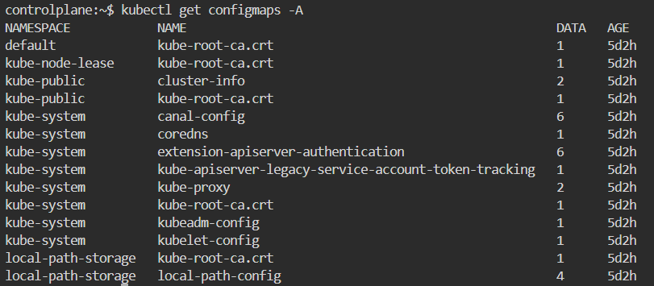
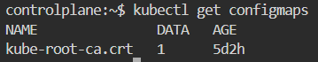
- Create a new ConfigMap Use the spec given below. ConfigName Name: webapp-config-map Data: APP_COLOR=darkblue
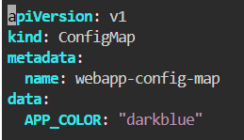
- Create a webapp-color POD with nginx image and use the created ConfigMap
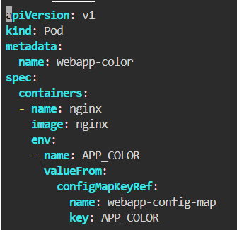
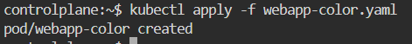
- How many Secrets exist on the system?
- How many secrets are defined in the default-token secret?
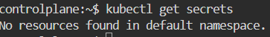
- create a POD called db-pod with the image mysql:5.7 then check the POD status
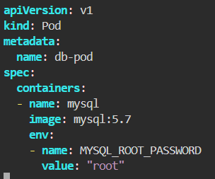
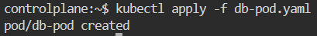
- why the db-pod status not ready
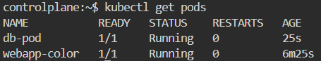
- Create a new secret named db-secret with the data given below. Secret Name: db-secret Secret 1: MYSQL_DATABASE=sql01 Secret 2: MYSQL_USER=user1 Secret3: MYSQL_PASSWORD=password Secret 4: MYSQL_ROOT_PASSWORD=password123
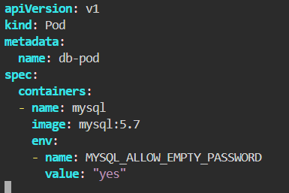
- Configure db-pod to load environment variables from the newly created secret. Delete and recreate the pod if required.
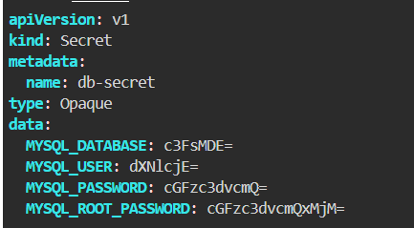
- Create a multi-container pod with 2 containers. Name: yellow Container 1 Name: lemon Container 1 Image: busybox Container 2 Name: gold Container 2 Image: redis
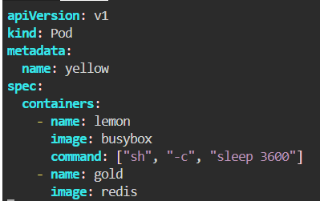
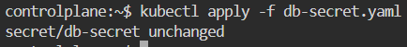
- Create a pod red with redis image and use an initContainer that uses the busybox image and sleeps for 20 seconds
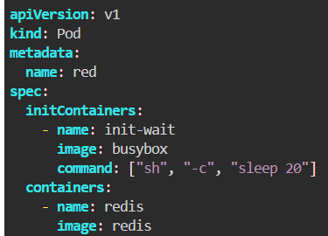
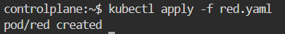
- Create a pod named print-envars-greeting. 1. Configure spec as, the container name should be print-env-container and use bash image. 2. Create three environment variables: a. GREETING and its value should be “Welcome to” b. COMPANY and its value should be “DevOps” c. GROUP and its value should be “Industries” 4. Use command to echo ["$(GREETING) $(COMPANY) $(GROUP)"] message. 5. You can check the output using command.
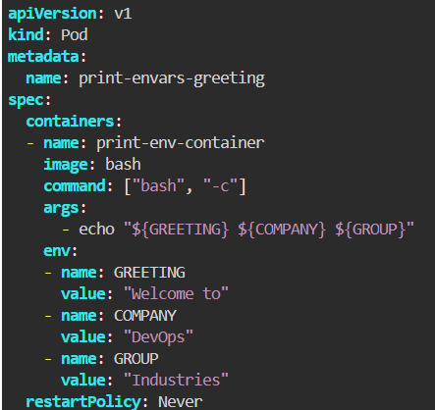
- Where is the default kubeconfig file located in the current environment?
/home/controlplane/.kube/config
- How many clusters are defined in the default kubeconfig file?
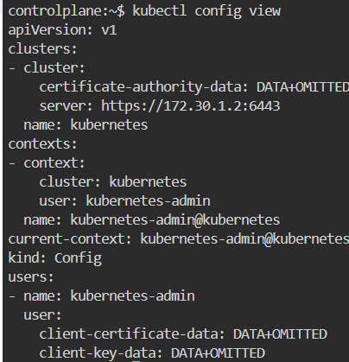
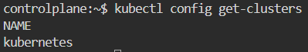
- What is the user configured in the current context?
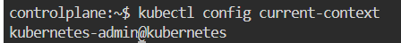
- Create a Persistent Volume with the given specification. Volume Name: pv-log Storage: 100Mi Access Modes: ReadWriteMany Host Path: /pv/log
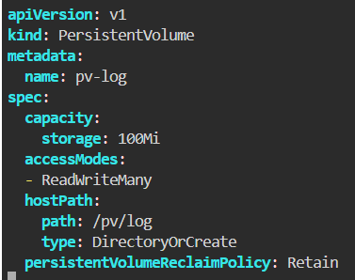
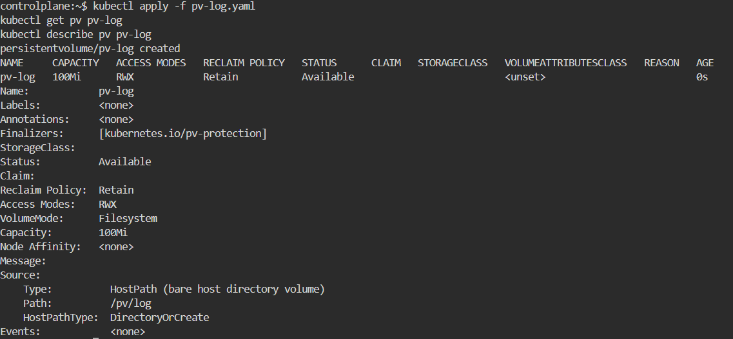
- Create a Persistent Volume Claim with the given specification. Volume Name: claim-log-1 Storage Request: 50Mi Access Modes: ReadWriteMany
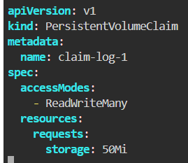
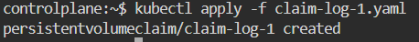
- Create a webapp pod to use the persistent volume claim as its storage. Name: webapp Image Name: nginx Volume: PersistentVolumeClaim=claim-log-1 Volume Mount: /var/log/nginx
