1:  
**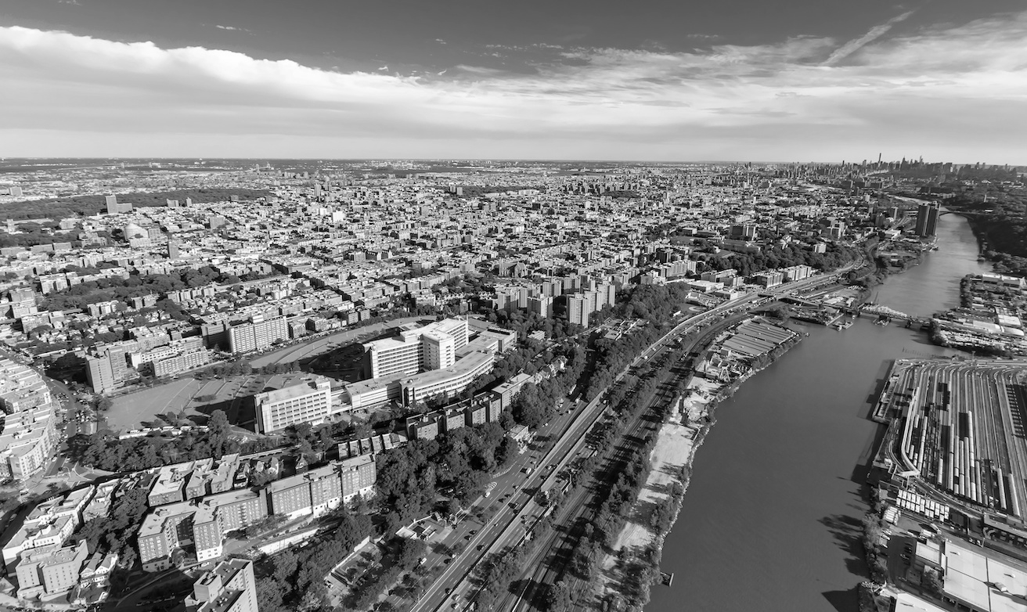  
  
2:  
An Analysis of Community Resilience and Response Capacity to Systemic Air Quality Threats in the South Bronx**

**3:**

**Charlotte Boulanger**

**Miaojing (Mina) Wei**

**Shu Yin**

**4:**

**Columbia University**

**5:**

**Planning Method**

**6:**

The South Bronx continues to be disproportionately affected by poor air quality as a result of a long history of exclusionary planning practices, putting an already vulnerable population at heightened risk of health complications. Using the South Bronx as a case study, this research operates under the assumption that efforts to mitigate the impacts of environmental hazards in vulnerable communities need to be understood in tandem with inherited injustices affecting resilience. It seeks to address the central question: *how to characterize the effects of social vulnerability on resilience-exposure dynamics in the South Bronx?* Our investigation is rooted in understanding the spatial relationships between demographics, infrastructure, health data, and environmental challenges, with the aim to quantify community vulnerability and develop an index for risk assessment.  
  
7：  
见文件，删除（7）这个字