1:  
**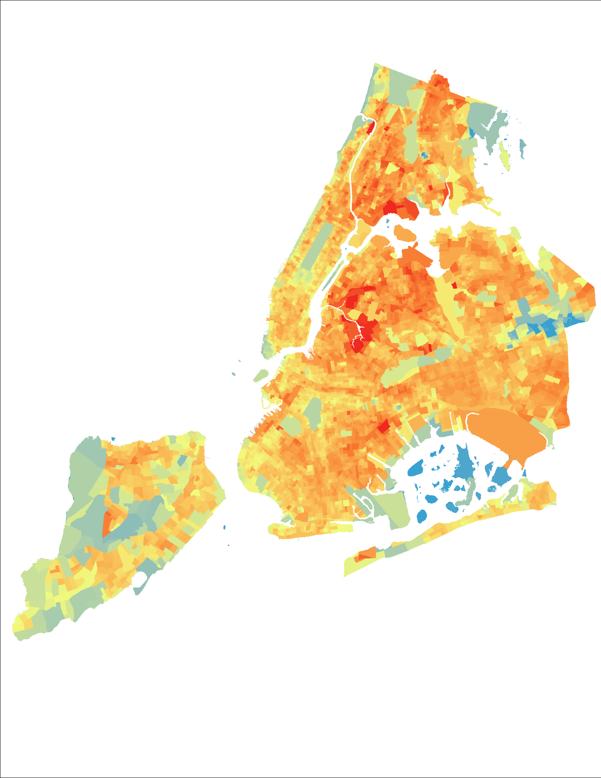  
  
2:  
(Re)Detecting & (Re)Examining Heat Vulnerability Index Mapping Vulnerability and Adaptive Capacity in New York City**

**3:**

**Eric Xia, Hui Chen & Mina Wei**

**4:**

**Columbia University**

**5:**

**Advanced Spatial Analysis**

**Spring 24**

**6:**

Assessing and mitigating urban heat vulnerability is increasingly vital amid climate change and rapid urbanization. Inspired by McHarg’s Ecological Method, this research integrates natural and built environment layers through transparency mapping and advanced geospatial analysis to enhance our understanding of heat risk.

Focusing on the Heat Vulnerability Index (HVI), this study critiques the NYC Environmental & Health Data Portal’s census-tract-level HVI for its coarse resolution and limited variable inclusion. To improve spatial precision and methodological rigor, we apply geoprocessing techniques such as Principal Component Analysis (PCA), ISO Clustering, Anselin Local Moran’s I, and Natural Breaks Reclassification.

By comparing outputs across tools, data resolutions, and modeling assumptions, this research examines how technical decisions influence HVI construction and interpretation—ultimately proposing refined methods for more accurate, fine-scale heat vulnerability assessment.

7：  
见文件