1:  
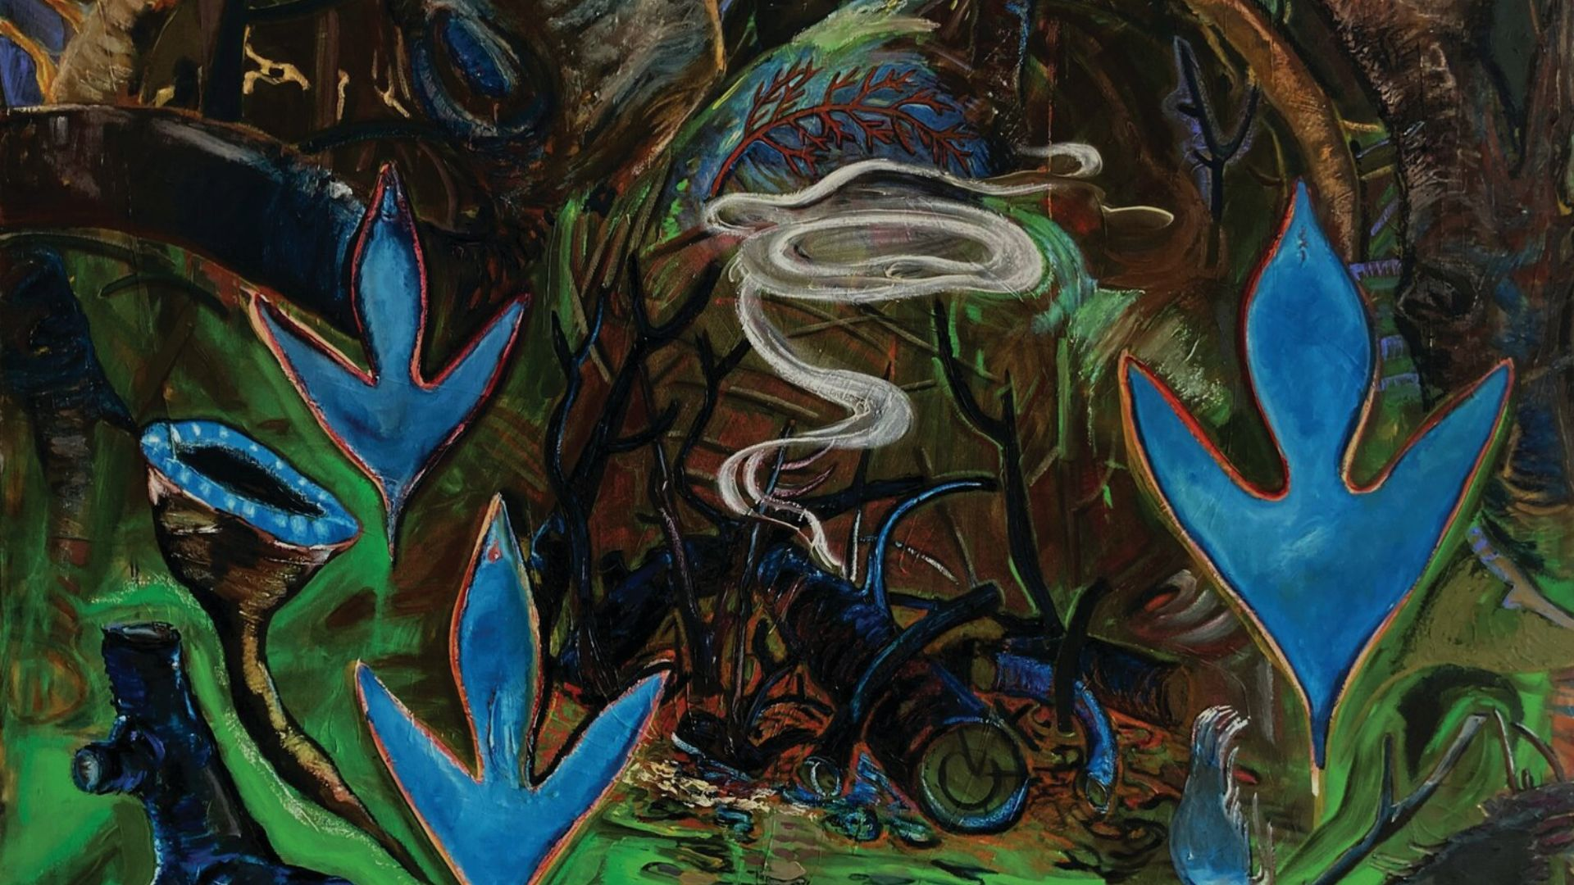 **2:  
Home in Lenapehoking: Planning for a Continued Lenape Presence in New York**

**3:**

**Rachel Aaronson, Atsede Assayehgen, Jane Cole, Steven Duncan, Caspar, Goldman-Nedergaard, Mumtaz Hammad, Jaron Kaplan, Julia Qian, Andrea Sze, Wendy Wang, Mina Wei, and Ki-Sang Yi**

**4:**

**GSAPP Urban Planning Spring Studio**

**5:**

**Course 改成Advisors:**

**Professors Sybil Wa and Anthony Borelli**

**6:**

As settlers studying planning in Lenapehoking, we acknowledge that conventional planning frameworks are deeply rooted in colonial systems of land control and erasure. This studio, in partnership with The Lenape Center, reimagines planning as a tool for repair and futurity.

Over the semester, we supported the Lenape Center in envisioning a cultural and artistic home within their ancestral territory. Through land-use analysis, site design, cost modeling, and decolonial research, we explored how to support embodied sovereignty—one rooted not in ownership, but in reciprocal, consensual relationships with land.

The project reflects an effort to navigate Western land mechanisms while uplifting Lenape epistemologies and resisting extractive paradigms. Our vision is not to dictate space, but to help co-create it—centered on healing, cultural practice, and indigenous self-determination.

7:

Slides

将链接插入，点击跳转  
<https://www.canva.com/design/DAGBwKAyj-s/Y392gEncwOKK1WFLzQvoqQ/view?utm_content=DAGBwKAyj-s&utm_campaign=designshare&utm_medium=link2&utm_source=uniquelinks&utlId=h79c53f06b5>

Report

将链接插入，点击跳转

<https://www.canva.com/design/DAGHA3CR_I4/IMgK1btXlB6x2Dp7pIitbg/watch?utm_content=DAGHA3CR_I4&utm_campaign=designshare&utm_medium=link2&utm_source=uniquelinks&utlId=hc232a39aff>