1:  
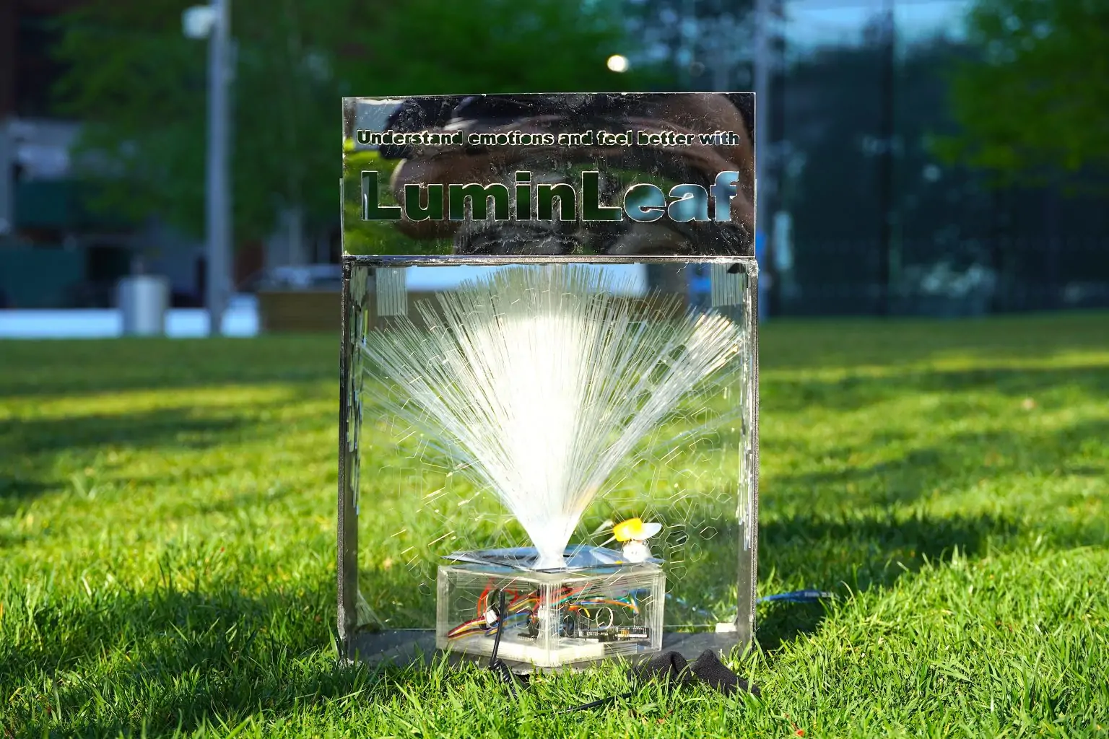 **2:  
LuminLeaf**

**3:**

**Daoxin Chen, Hongqian Li, Miaojing Wei, Zihao Zhang,**

**4:**

**GSAPP**

**5:**

**URBAN SENSING AND DATA  
另开一栏**

**Professor:**

**Anthony Vanky**

**6:**

In fast-paced urban life, emotional stress often goes unnoticed until it escalates. LuminLeaf introduces a novel, real-time emotional feedback installation that bridges technology and mental wellness. Using Galvanic Skin Response (GSR) sensors, it visualizes users’ emotional states through interactive lighting and movement, offering immediate, nonverbal support in public and private spaces. Developed and tested across Columbia University, LuminLeaf demonstrates how responsive environments can promote self-awareness, social empathy, and emotional resilience—making it a valuable prototype for future smart, compassionate cities.

7:

三个附件加上一个链接，都是点击跳转

Project Website

<https://urbandata.me/urbansensing/2024/05/05/luminleaf/>