1:  
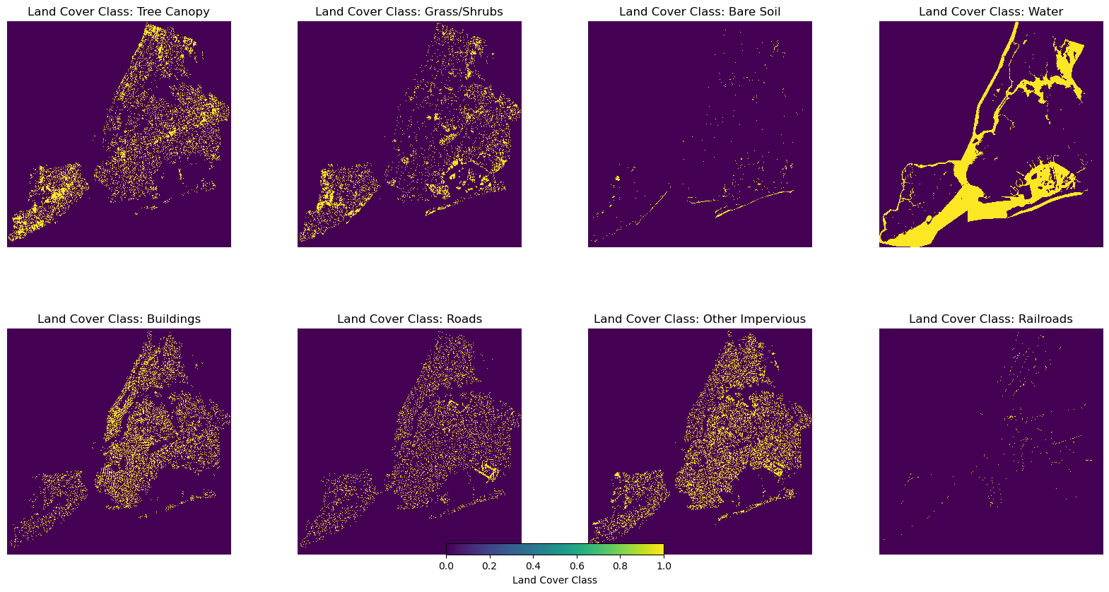 **2:  
Comparative Analysis of Machine Learning Approaches for Urban Heat Island Prediction: Random Forest, XGBoost, and Convolutional Neural Networks (CNN)**

**3:**

**Miaojing(Mina) Wei, Deepesh Dinesh Theruvath Kanhangad, Xiaoya Pan**

**4:**

*Columbia University & Earth and Environmental Engineering Dept*

**5:**

**Machine learning in Environmental science  
另开一栏**

**Professor:**

**Conrad M. Albrecht**

**6:**

In this study, we evaluated the performance of Random Forest, XGBoost, and Convolutional Neural Networks (CNN) in predicting urban heat distribution across New York City using high-resolution (1-meter) data, including NDVI, elevation, and land cover. To ensure robust spatial validation, we employed a spatial holdout design by dividing the city into distinct training and testing zones. Model performance was assessed using MAE, RMSE, and R² metrics. Results showed that CNN outperformed traditional methods in capturing spatial heat patterns, while Random Forest and XGBoost provided greater interpretability, particularly in analyzing feature importance. Vegetation coverage and proximity to water bodies emerged as the most influential predictors of urban heat, offering valuable insights for targeted planning strategies to mitigate urban heat island effects in dense metropolitan settings.

7:

附件