1:  
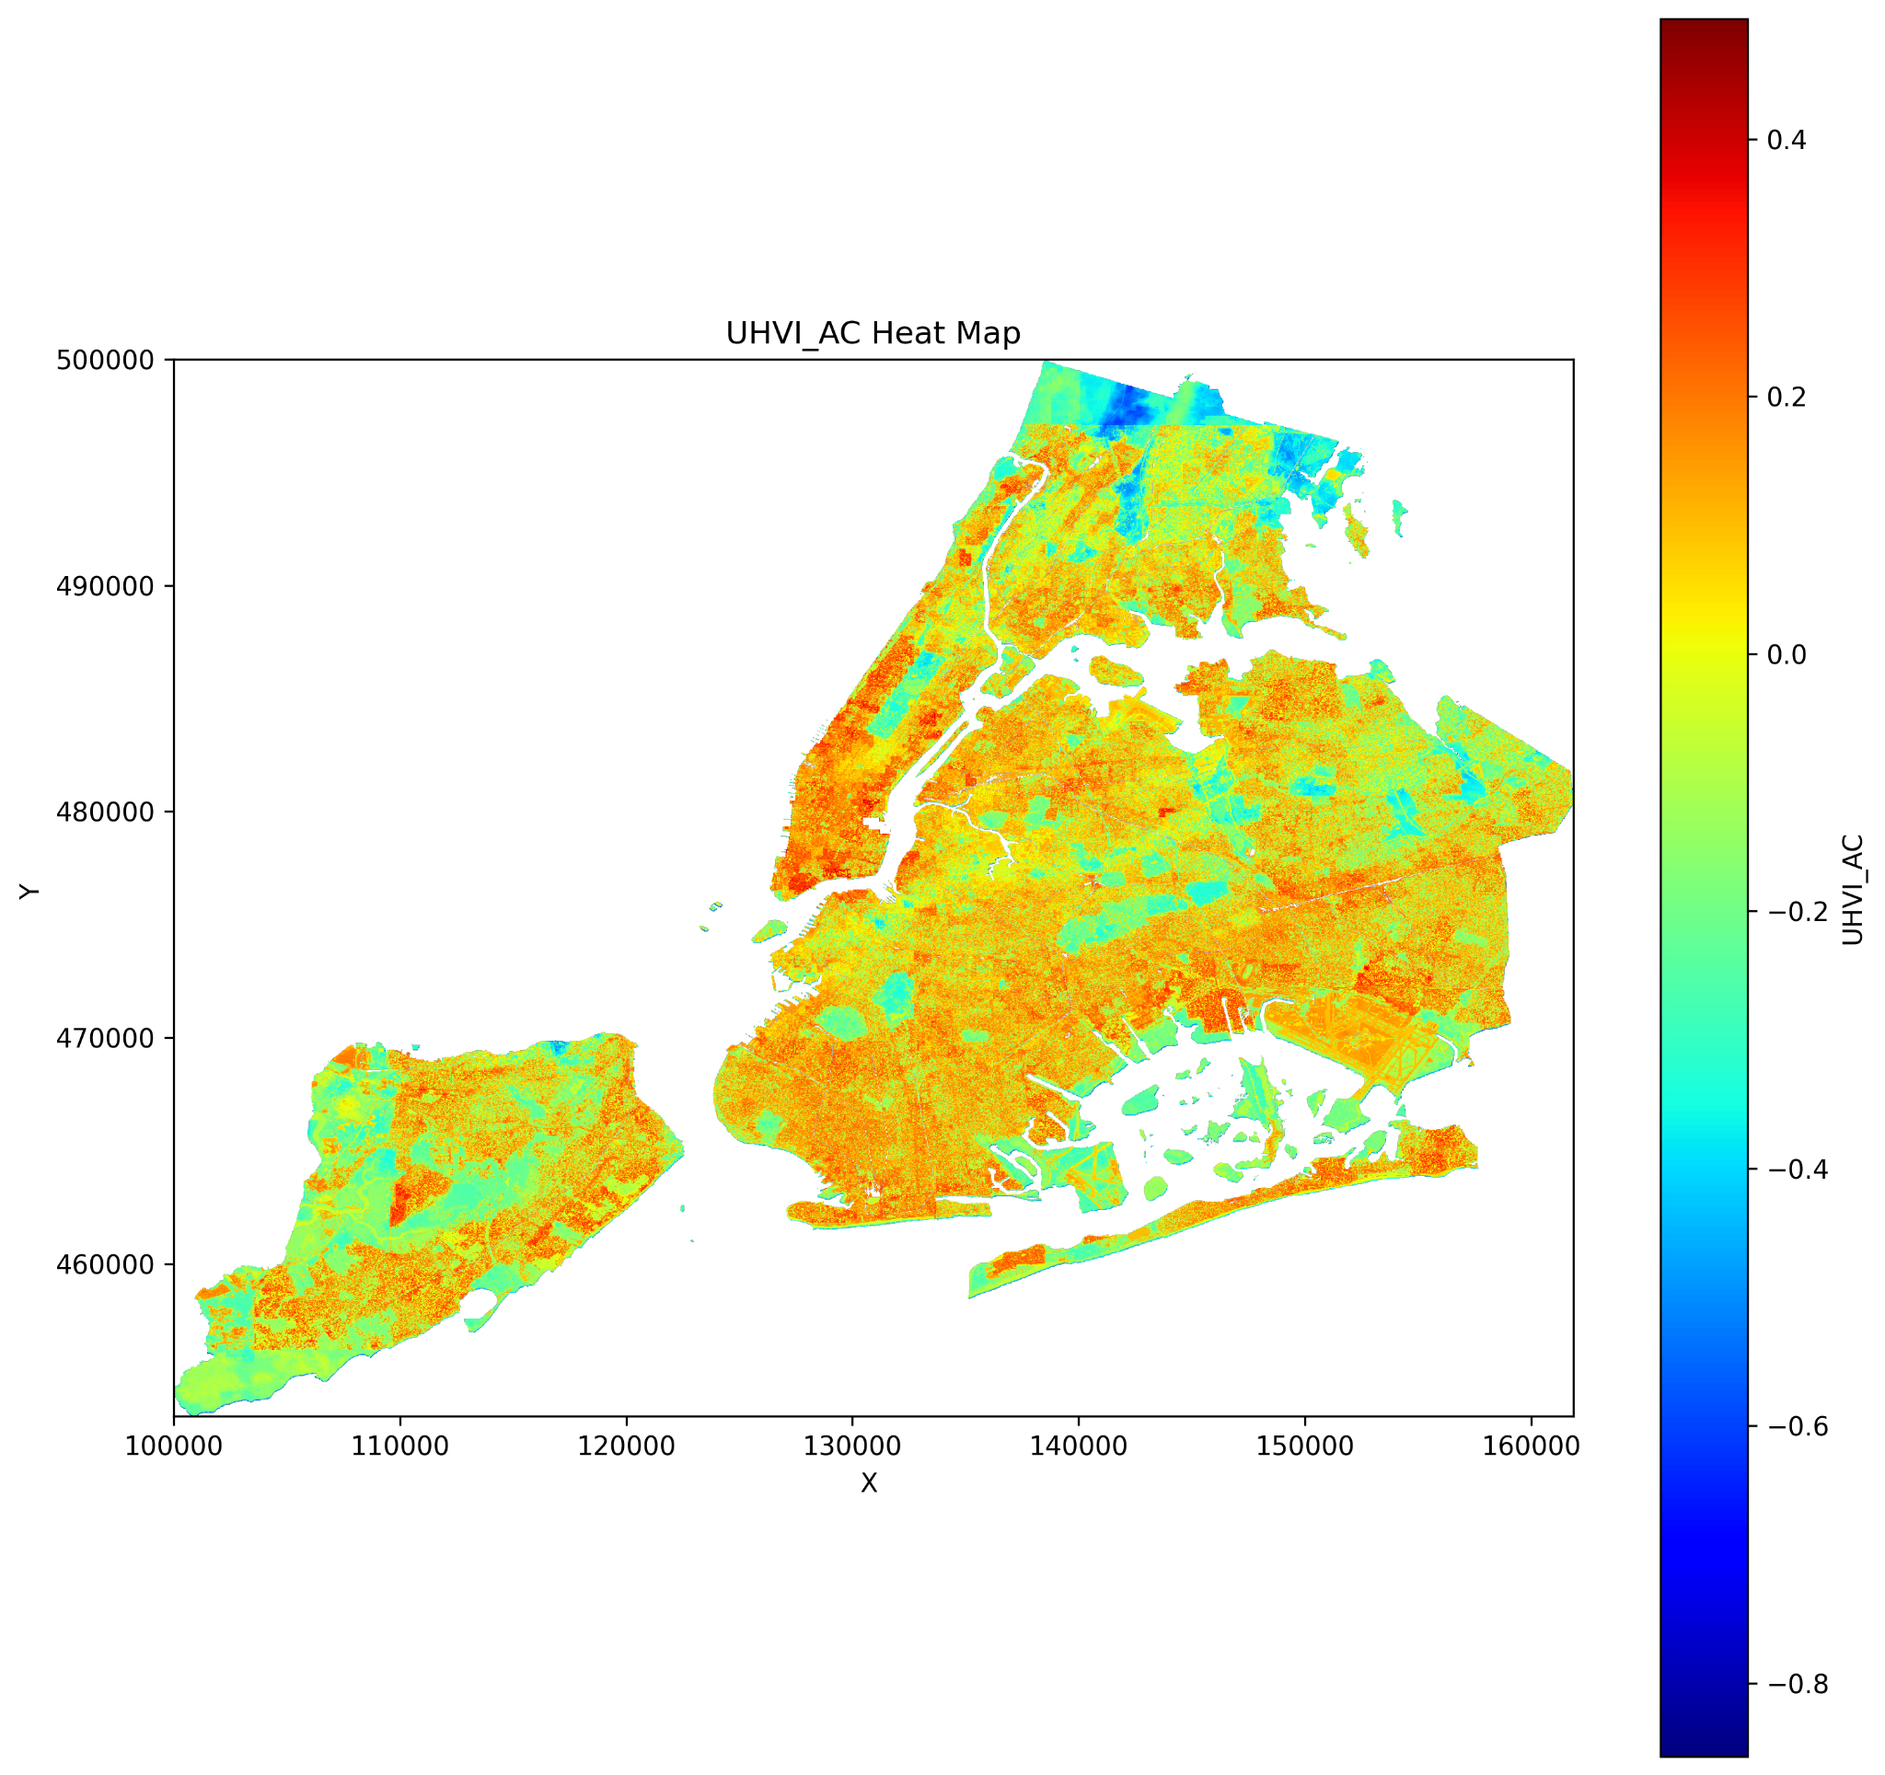 **2:  
Mapping Micro-Scale Heat Risk in New York City: A Fine-Grained Index Incorporating Adaptive Capacity**

**3:**

**Miaojing(Mina) Wei**

**4:**

*Graduate School of Architecture, Planning and Preservation, Columbia University*

**5:**

**Graduate Thesis  
另开一栏**

**Professor:**

**Anthony Vanky**

**6:**

Developed a 30-meter resolution Urban Heat Risk Index (UHRI) by integrating Landsat-derived land surface temperature (LST), NDVI, LiDAR elevation, dasymetric population mapping, and Citi Bike trip data. This micro-grid (30×30 m) assessment framework enabled block-level analysis, uncovering spatial disparities that are often masked in traditional census-tract-based Heat Vulnerability Index (HVI) models. A key innovation involved incorporating human mobility data into the adaptive capacity dimension, capturing real-world heat exposure based on commuter behavior. Using spatial-statistical methods, I modeled the interaction between exposure, vulnerability, and adaptive capacity through a weighted composite index. The analysis revealed patterns of environmental injustice, where heat-vulnerable populations face heightened exposure due to limited mobility and infrastructure. Based on these findings, I proposed spatially targeted interventions, including cool corridors and reflective pavements, to mitigate urban heat risk in underserved areas.

7:

附件